20260409-HDFS+ Unix_Command+ Hadoop_Ecosystem
启动Oracle-启动Ambari-确保HDFS + YARN+MapReduce2 + zookeeper✔
启动PuTTY-pwd-建自己的文件夹mkdir mica-然后输出vi trail.txt到编辑界面—然后输入小写i(insert插入内容) -然后用ESC + :x! 保存—然后cat trail.txt回到编辑的界面，x是小写。

然后在PuTTY输入hadoop fs -ls 查阅文件夹（file view）的情况
然后在file view 建立一个文件夹然后用hadoop fs –mkdir ml-100k 建立一个同名文件夹，这样是不行的。
在file view 复制对应文件夹的位置信息，然后到PuTTY 单击鼠标右键，就能看到对应的文件夹的位置信息
Hive file-upload table-上传资料-先点设置键设置对应的参数，然后再上传。成功后到Query 编写代码：
SELECT *
FROM my_employees_v1
WHERE salary >40000;

Ambari—pig view—worCount—input next code in the Script:
data = LOAD '/user/maria_dev/mica/word.txt' AS (text:chararray);
tokenized_data = FOREACH data GENERATE FLATTEN(TOKENIZE(text)) AS word;
grouped_words = GROUP tokenized_data BY word;
word_counts = FOREACH grouped_words GENERATE group AS word, COUNT(tokenized_data) AS count;
DUMP word_counts;

data = LOAD '/user/maria_dev/mica/word.txt' AS (line:chararray); tokenized_data = FOREACH data GENERATE FLATTEN(TOKENIZE(line)) AS word; grouped_words = GROUP tokenized_data BY word; word_counts = FOREACH grouped_words GENERATE group AS word, COUNT(tokenized_data) AS count; DUMP word_counts;

老师上课还给了一个版本的代码不是用txet使用line，回去试一下 照片
在文档HDFS 中找到Putting all together 然后在PuTTY sandbox机器中输入Putting all together代码：
from mrjob.job import MRJob
from mrjob.step import MRStep

class RatingsBreakdown(MRJob):
def steps(self):
return [
MRStep(mapper=self.mapper_get_ratings,
reducer=self.reducer_count_ratings)
]

def mapper_get_ratings(self,_, line):
(userID, movieID, rating, timestep) = line.split('\t')
yield rating, 1

def reducer_count_ratings(self, key, values):
yield key, sum(values)

if __name__ == '__main__':
RatingsBreakdown.run()

然后保存Esc+ :/! 然后回到sandbox那里输入python MapReducer.py u.data 然后enter就能显示结果：

用sudo -u hdfs hdfs dfsadmin -safemode leave 确认safe mode 是不是关闭

使用full directory path

Test--20260430
Data center

20260416--Apache_PIG
Tuple—in order
Bag—unorder
Ambari—pig view—worCount—input next code in the Script:
data = LOAD '/user/maria_dev/mica/word.txt' AS (text:chararray);
tokenized_data = FOREACH data GENERATE FLATTEN(TOKENIZE(text)) AS word;
grouped_words = GROUP tokenized_data BY word;
word_counts = FOREACH grouped_words GENERATE group AS word, COUNT(tokenized_data) AS count;
DUMP word_counts;

然后老师查看了u.data ---查看timestamp
Schema—确认是什么数据类型
• Schema -> assigns name to the field (column) and declares data type of the field
（上传文件的时候，文件名称都必须是小写字母，不能是大写字母！！！）

Create a relation named "ratings" with a given schema
Pig view—worcount—script-输入以下：
ratings = LOAD '/user/maria_dev/ml-100k/u.data' AS (userID:int,
movieID:int, rating:int, ratingTime:int);
DUMP ratings;
-- DUMP ratings;（前面加—意思是不需要输出结果）
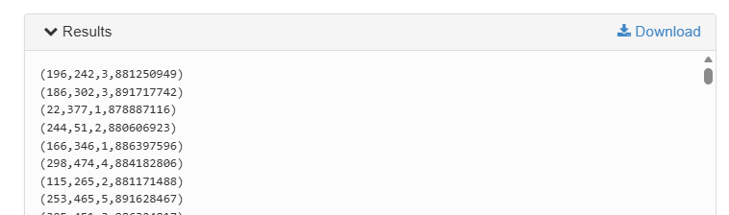

Use PigStorage if we need a different delimiter
然后再尝试以下代码：
metadata = LOAD '/user/maria_dev/ml-100k/u.item' USING
PigStorage('|') AS (movieID:int, movieTitle:chararray,
releaseDate:chararray, videoRelease:chararray,
imdbLink:chararray);
DUMP metadata;
输入结果如下：
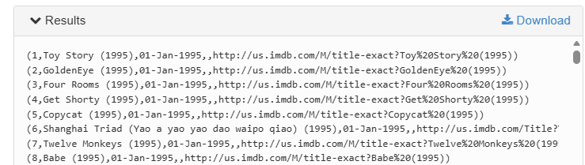

Create a relation from another relation; FOREACH /GENERATE
然后输入如下代码：
ratings = LOAD '/user/maria_dev/ml-100k/u.data' AS (userID:int,
movieID:int, rating:int, ratingTime:int);
--DUMP ratings;

metadata = LOAD '/user/maria_dev/ml-100k/u.item' USING
PigStorage('|') AS (movieID:int, movieTitle:chararray,
releaseDate:chararray, videoRelease:chararray,
imdbLink:chararray);
--DUMP metadata;

nameLookup = FOREACH metadata GENERATE movieID, movieTitle,
ToUnixTime(ToDate(releaseDate, 'dd-MMM-yyyy')) as releaseTime;
DUMP nameLookup

输出如下：
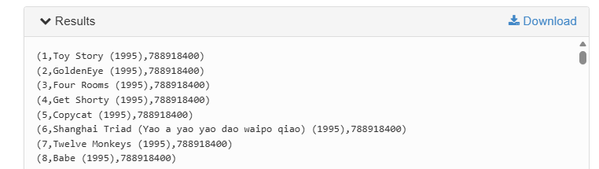

然后分组（Group By），输入如下代码：
-- 加载评分数据（注意是 \t 分隔）
ratings = LOAD '/user/maria_dev/ml-100k/u.data'
USING PigStorage('\t')
AS (userID:int, movieID:int, rating:int, ratingTime:int);

-- 加载电影信息
metadata = LOAD '/user/maria_dev/ml-100k/u.item'
USING PigStorage('|')
AS (movieID:int, movieTitle:chararray,
releaseDate:chararray, videoRelease:chararray,
imdbLink:chararray);

-- 处理时间
nameLookup = FOREACH metadata GENERATE
movieID,
movieTitle,
ToUnixTime(ToDate(releaseDate, 'dd-MMM-yyyy')) AS releaseTime;

-- 按电影分组评分
ratingsByMovie = GROUP ratings BY movieID;

-- 输出结果
DUMP ratingsByMovie;

结果如下：
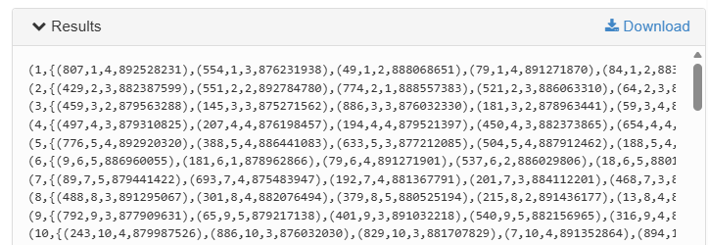

然后AVG（Compute the average ratings for each movie）输入如下代码：
avgRatings = FOREACH ratingsByMovie GENERATE group AS movieID,
AVG(ratings.rating) AS avgRating;
DUMP avgRatings;

输出如下：
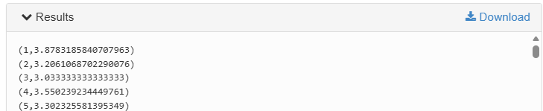

Diagnostics
继续输入如下：
DESCRIBE ratings;
DESCRIBE ratingsByMovie;
DESCRIBE avgRatings；

输出结果：
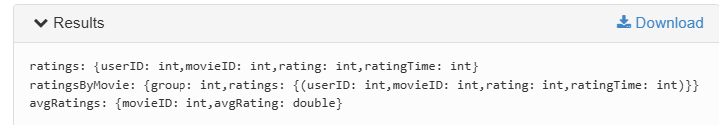
这个结果输出有个报错，回去需要再研究一下。

FILTER
继续输入：
fiveStarMovies = FILTER avgRatings BY avgRating > 4.0;
DUMP fiveStarMovies；

输出如下：
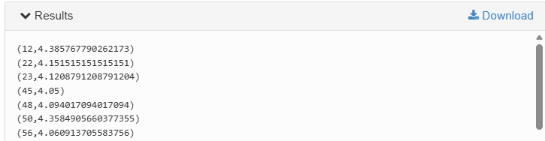

JOIN
输入如下：
fiveStarMoviesWithData = JOIN fiveStarMovies BY movieID, nameLookup BY movieID;
DESCRIBE fiveStarMoviesWithData;
DUMP fiveStarMoviesWithData;

Output
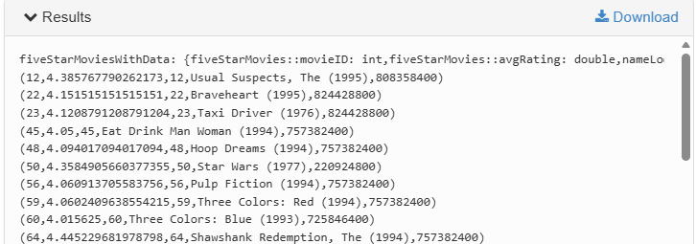

ORDER BY
Input:
oldestFiveStarMovie = ORDER fiveStarMoviesWithData BY
nameLookup::releaseTime;
DUMP oldestFiveStarMovie;

Output:
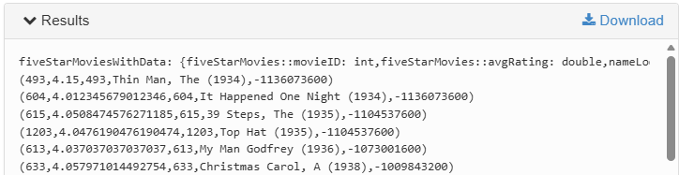
Find DISTINCT records using PIG：
--- mkdir mica
--- cd mica
--- vi student_details.csv
---然后复制如下代码：
001Rajiv,Reddy,9848022337,Hyderabad
002,siddarth,Battacharya,9848022338,Kolkata
002,siddarth,Battacharya,9848022338,Kolkata
003,Rajesh,Khana,9848022339,Delhi 003,Rajesh,Khanna,9848022339,Delhi 004,Preethi,Agarwal,9848022330,Pune
005,Trupthi,Mohanthy,9848022336,Bhuwaneshwar
006,Archana,Mishra,9848022335,Chennai
006,Archana,Mishra,9848022335,Chennai
点击右键然后Esc + :x! 保存
--- /home/maria_dev/mica/student_details.csv
--- hdfs dfs -mkdir -p /user/maria_dev/mica
--- hdfs dfs -put /home/maria_dev/mica/student_details.csv /user/maria_dev/mica/
--- hdfs dfs -ls /user/maria_dev/mica
然后转到
Pig
输入如下代码：
students = LOAD '/user/maria_dev/mica/student_details.csv'
USING PigStorage(',')
AS (id:chararray, fname:chararray, lname:chararray, phone:chararray, city:chararray);
distinct_students = DISTINCT students;
DUMP distinct_students;
输出结果：
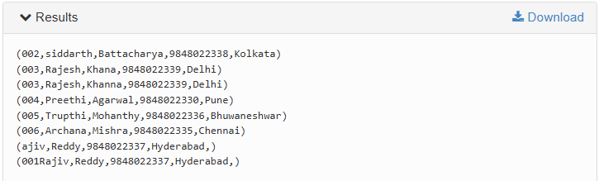
保存结果：
STORE distinct_students INTO '/user/maria_dev/mica/output'
USING PigStorage(',');

Another Challenge—排序+输出个别类别
ratings = LOAD '/user/maria_dev/ml-100k/u.data'
USING PigStorage('\t')
AS (userID:int, movieID:int, rating:int, ratingTime:int);

metadata = LOAD '/user/maria_dev/ml-100k/u.item'
USING PigStorage('|')
AS (movieID:int, movieTitle:chararray,
releaseDate:chararray, videoRelease:chararray,
imdbLink:chararray);

ratingsByMovie = GROUP ratings BY movieID;

movieStats = FOREACH ratingsByMovie GENERATE
group AS movieID,
AVG(ratings.rating) AS avgRating,
COUNT(ratings) AS ratingCount;

badMovies = FILTER movieStats BY avgRating < 2.0;

sortedBadMovies = ORDER badMovies BY ratingCount DESC;

joined = JOIN sortedBadMovies BY movieID, metadata BY movieID;

finalResult = FOREACH joined GENERATE
metadata::movieTitle AS movieTitle,
avgRating,
ratingCount;

DUMP finalResult;

STORE sortedBadMovies INTO '/user/maria_dev/mica/bad_movies_2'
USING PigStorage(',');

输出结果：
