目录
Introduction 2
Data defination 2
The Scale of Data 2
Defining Data Management 3
The FAIR Principles 3
The Modern Data Lifecycle 3
Data Storage Concepts 4
Benefits of Good Data Management 4
Reproducibility & Data Provenance 5
Data Management Plan 5
Unix_Command 5
Linux vs Hadoop HDFS 5
Permissions 8
Search Commands 8
System Commands 8
Network Commands 9
Zip &Tar 9
Other Useful Commands 10
Hadoop_Ecosystem 11
三要素 11
Oracle Virtual 虚拟机 11
Ambari-Sandbox 11
PuTTY 11
HDFS 14
安装mrjob 14
写mrjob 脚本 14
Apache PIG 15
Default-获取u.data评分数据 15
PigStorage-获取u.item电影信息 16
FOREACH /GENERATE-获取电影上映时间 16
GROUP BY-按movieID分组 17
AVG-求电影评分均值 17
DESCRIBE-描述变量类别 17
FILTER-avgRating > 4.0 18
JOIN-合并变量 18
ORDER BY-按上映时间排序 19
Pig + TEZ 19
EP1_DISTINCT(学生去重) 19
EP2 _Filter(bad movies) 20

Introduction

Data defination
Data are recorded observations or facts that can be stored, processed and communicated — from raw sensor readings to curated enterprise records.
--Structured data
--Semi Structured data
--Unstructured data
--Streaming data
--Geospatial

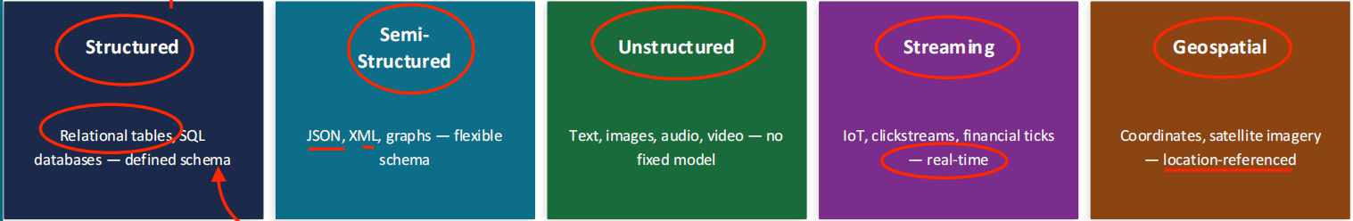

The Scale of Data
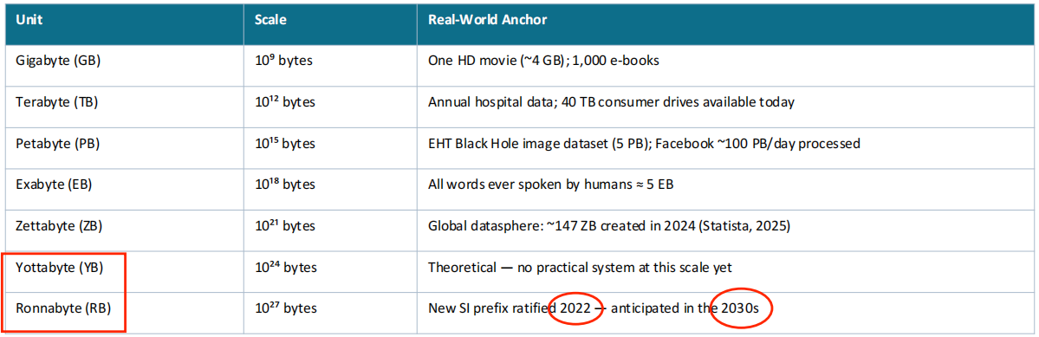

Defining Data Management


The FAIR Principles
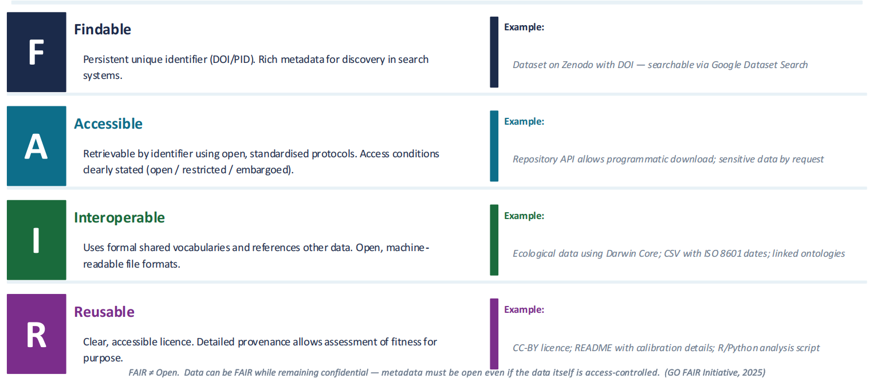

The Modern Data Lifecycle
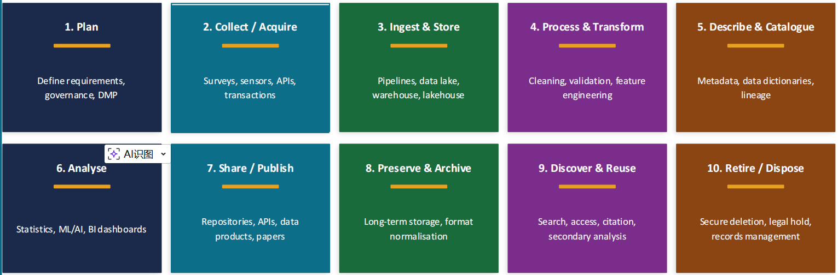

Data Storage Concepts
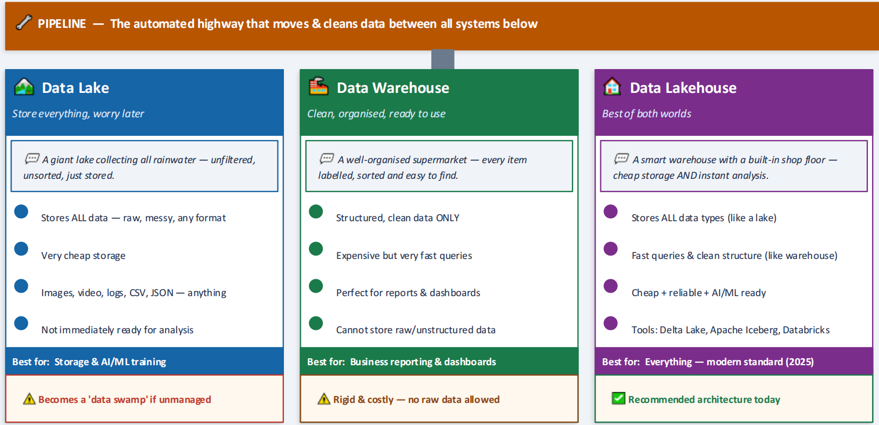

Benefits of Good Data Management
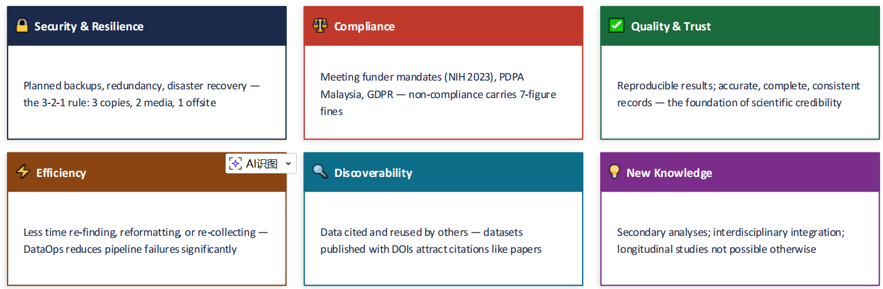Data Quality Dimensions
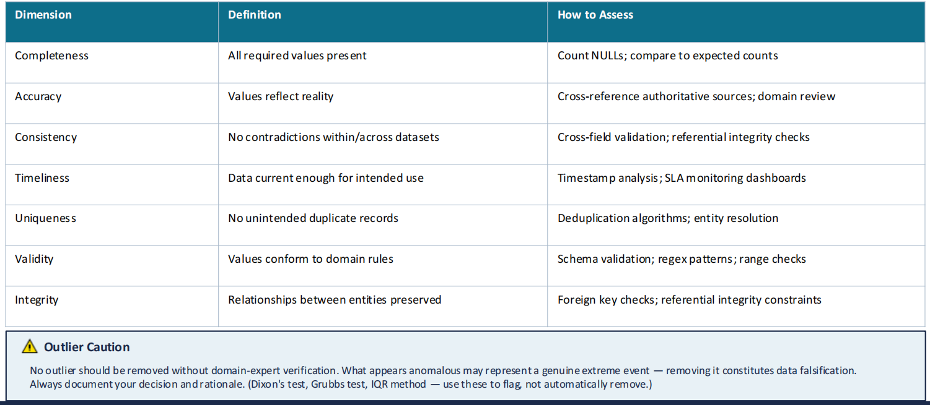

Reproducibility & Data Provenance
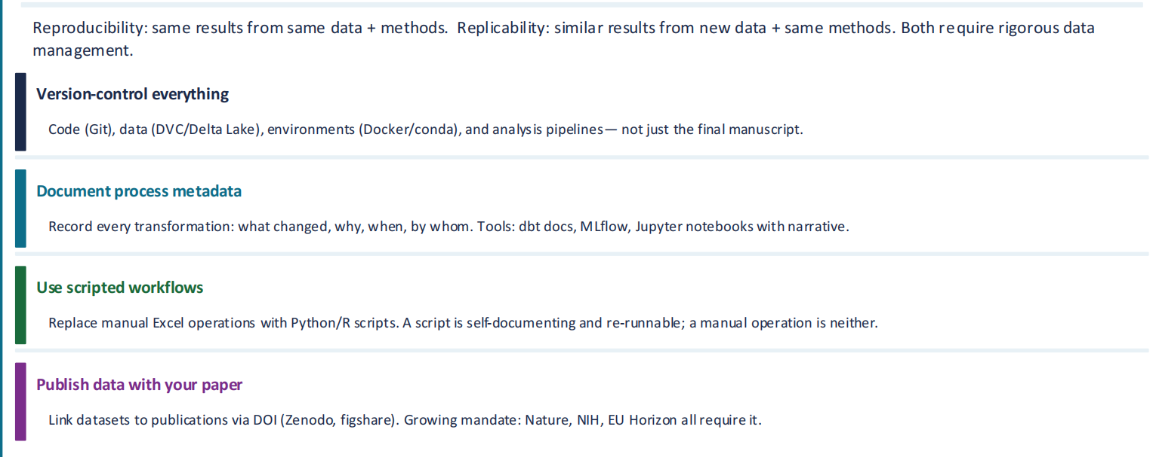

Data Management Plan
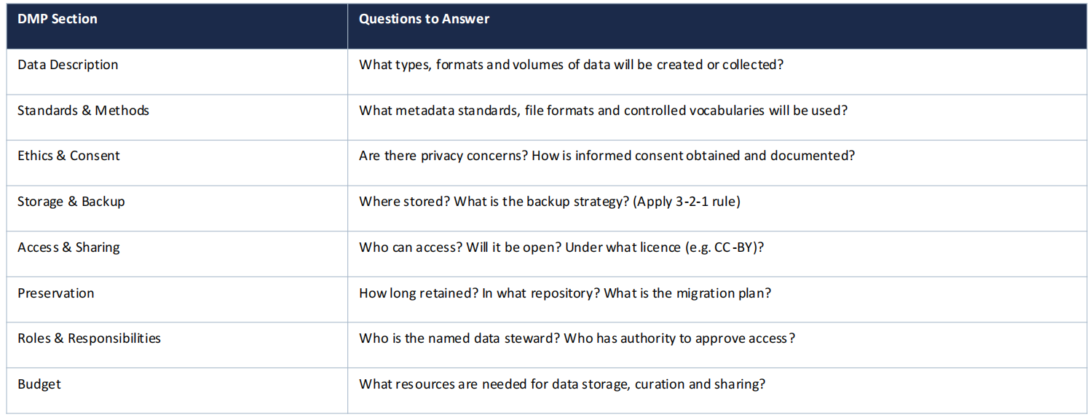

Unix_Command

Linux vs Hadoop HDFS
- 路径写法不同
Linux本地(Virtual SandBox虚拟机)：/home/maria_dev/wenda
HDFS(hadoop)：/user/maria_dev/wenda
不管在哪个问价目录下,回到主目录用cd 或者cd ~ 即可

- 最常用的几个命令
看文件列表：hdfs dfs -ls /user/maria_dev
建文件夹：hdfs dfs -mkdir -p /user/maria_dev/xxx
上传文件：hdfs dfs -put 本地文件 /user/maria_dev/xxx
下载文件：hdfs dfs -get /user/maria_dev/xxx 本地路径
如果是删除文件,需要输入y 然后enter,才能删除.
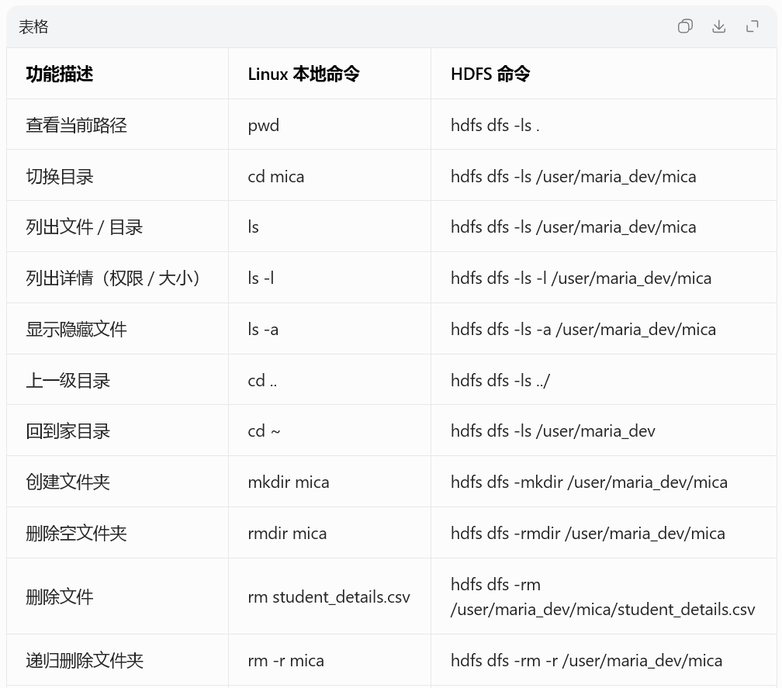
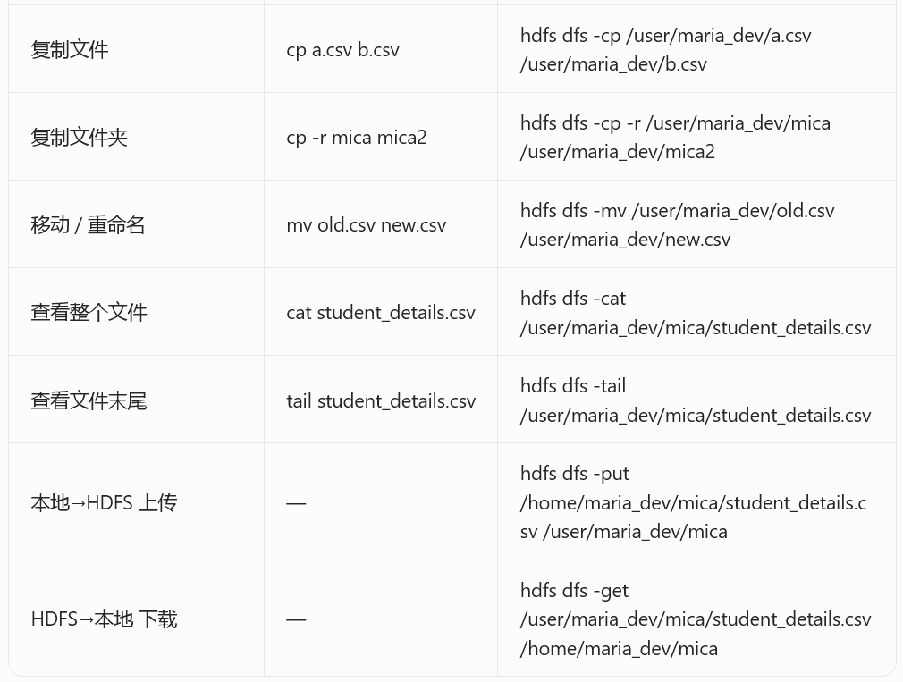

- Linux本地(Virtual SandBox虚拟机)：
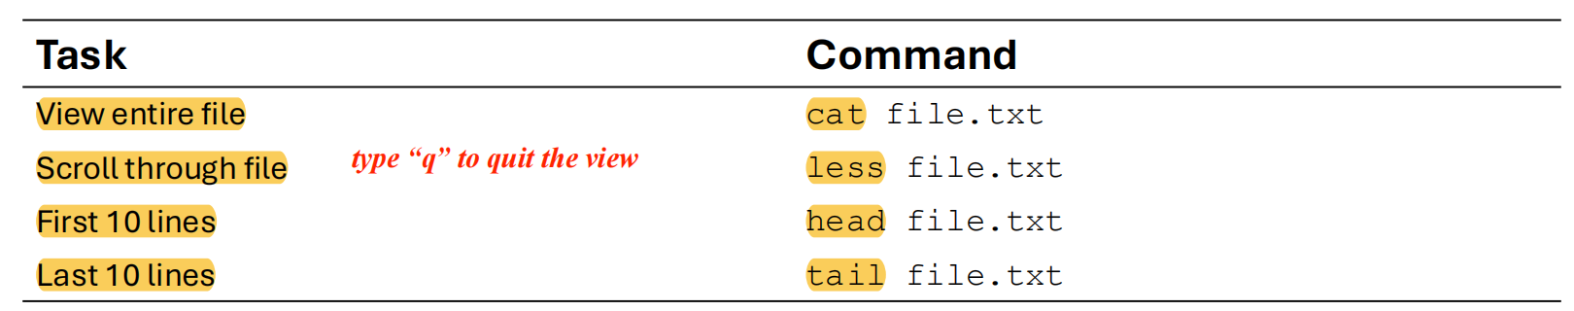

- HDFS(hadoop)：

# 1. 查看你在 HDFS 家目录下的文件
hdfs dfs -ls /user/maria_dev

# 2. 在 HDFS 创建文件夹
hdfs dfs -mkdir -p /user/maria_dev/mica

# 3. 上传本地文件到 HDFS
hdfs dfs -put /home/maria_dev/mica/student_details.csv /user/maria_dev/mica/

# 4. 查看 HDFS 文件内容
hdfs dfs -cat /user/maria_dev/mica/student_details.csv

# 5. 删除 HDFS 上的文件
hdfs dfs -rm /user/maria_dev/mica/student_details.csv

# 6. 查看 HDFS 上文件的全部内容
hdfs dfs -cat /user/maria_dev/mica/student_details.csv

# 7. 查看 HDFS 文件的前10行
hdfs dfs -head /user/maria_dev/mica/student_details.csv

# 8. 查看 HDFS 文件的后10行
hdfs dfs -tail /user/maria_dev/mica/student_details.csv

Permissions
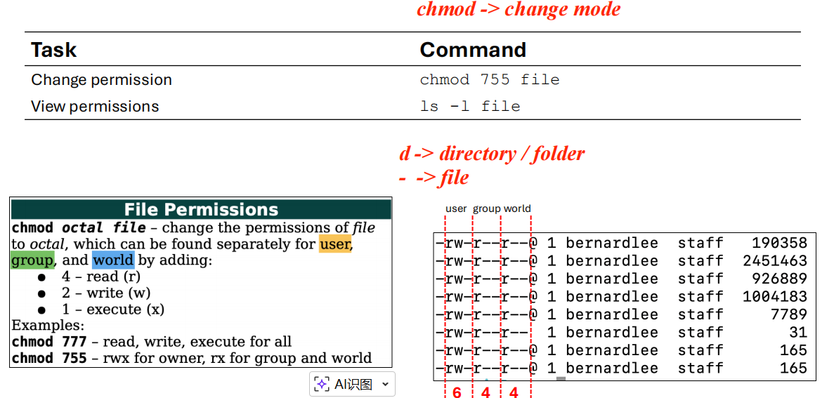

Search Commands
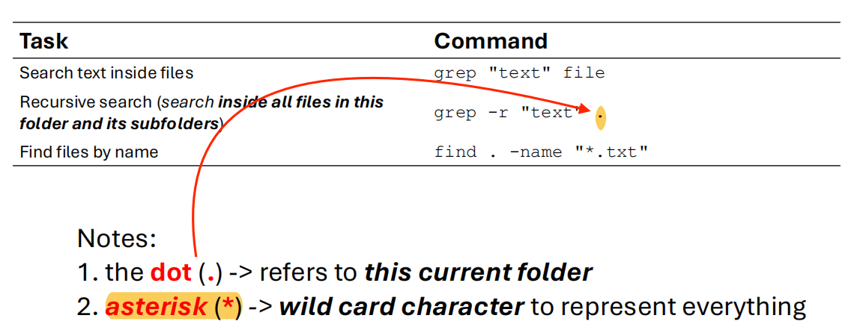

System Commands
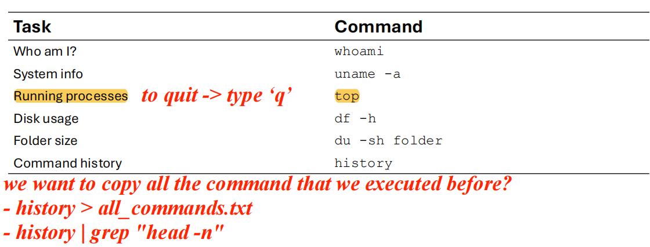

Network Commands
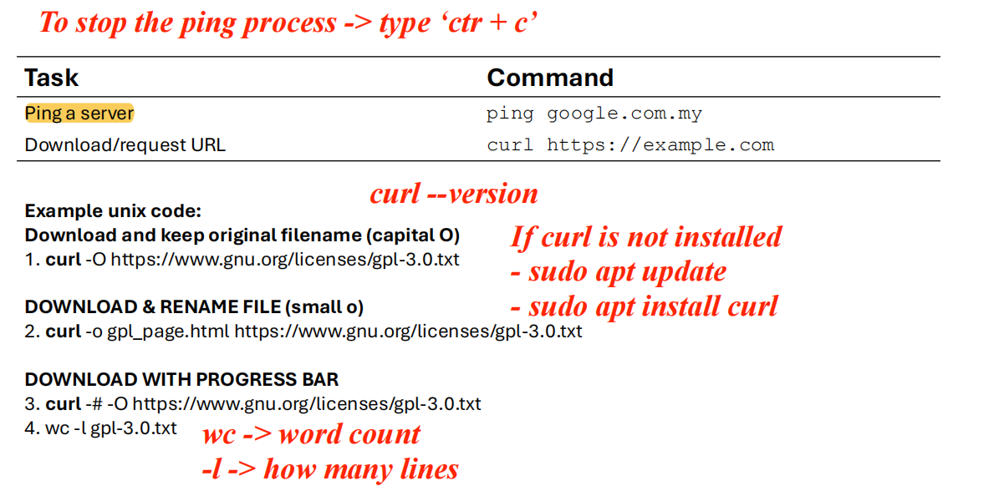

Zip &Tar
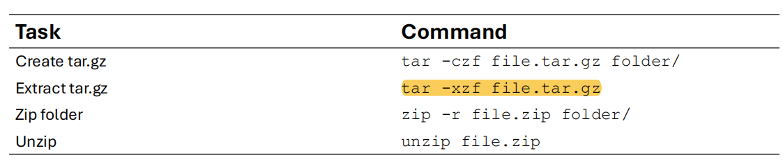
# 1. 打包 mica 文件夹为 tar.gz
tar -czf mica.tar.gz mica/

# 2. 解压 tar.gz
tar -xzf mica.tar.gz

# 3. 打包 mica 文件夹为 zip
zip -r mica.zip mica/

# 4. 解压 zip
unzip mica.zip

Other Useful Commands
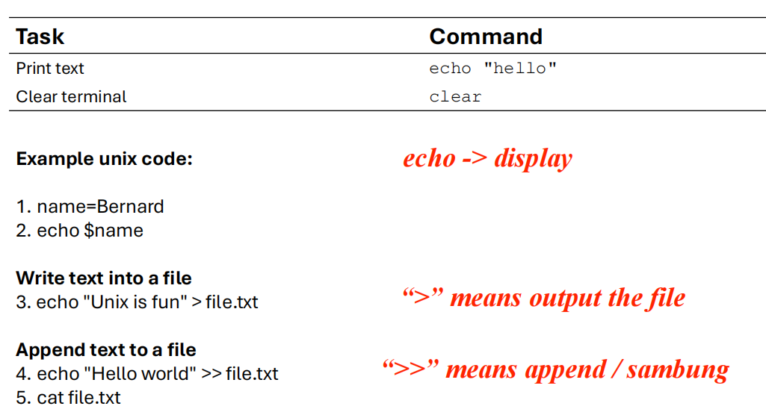
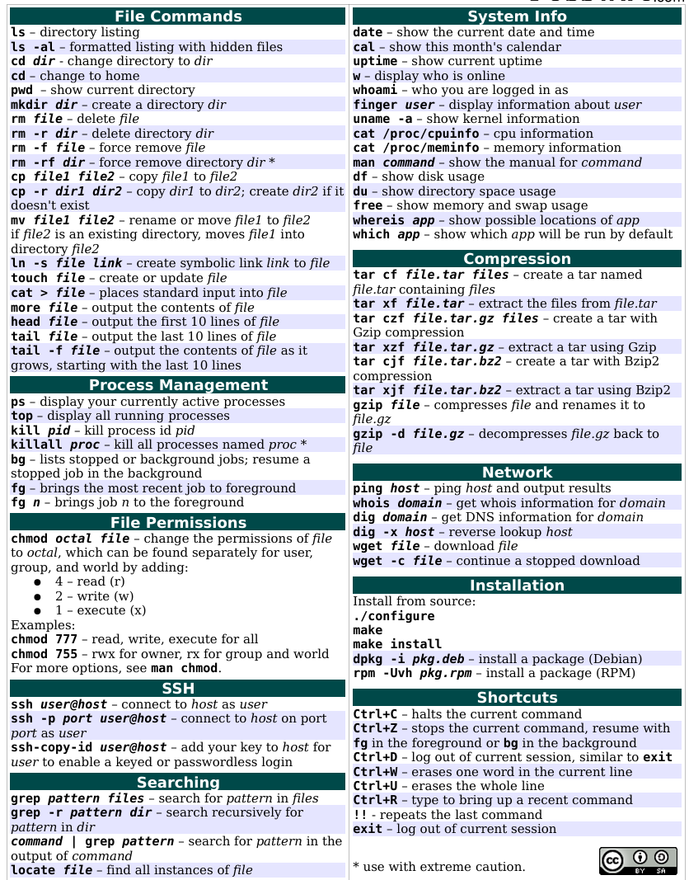

Hadoop_Ecosystem

三要素
-Oracle Virtual：是虚拟机
-Ambari-sandbox：是主要操作及可视化平台
-PuTTY：是链接Oracle Virtual 和Ambari-sandbox 的通信媒介
**开启顺序建议：Oracle Virtual--Ambari sandbox--PuTTY

Oracle Virtual 虚拟机
开启：Start--Running | 一般需要等待2-3分钟
关闭：Machine-stop-shut down(API shut down) |不能直接power off

Ambari-Sandbox
网址：http://localhost:1080 |必须先打开Oracle Virtual网址才能响应
账号&密码: maria_dev
状态：确认所有程序是否开启状态(✅) 若不是，按以下步骤全部开启，预计需要5-7分钟。
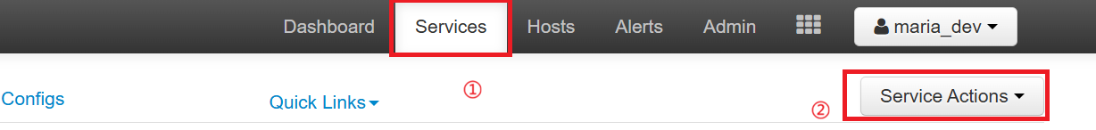

PuTTY
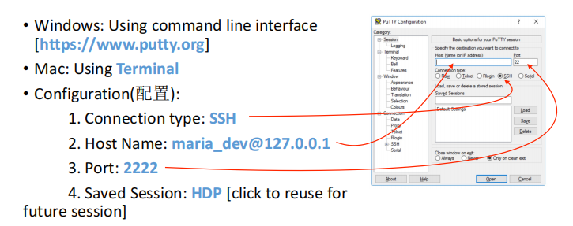

然后可以在PuTTY上执行如下操作：
• To list all files available in Hadoop cluster: hadoop fs -ls
• To create folder in Hadoop: hadoop fs –mkdir ml-100k | hadoop fs –mkdir mica/ml-100k
• To download file to local: wget http://media.sundog-soft.com/hadoop/ml-100k/u.data
• To upload data from local to hadoop: hadoop fs –copyFromLocal u.data ml-100k/u.data
• To delete file on hadoop: hadoop fs –rm ml-100k/u.data
• To delete folder on hadoop: hadoop fs –rmdir ml-100k
• List out other commands: hadoop fs

Upload data to Ambari
进入Ambari--然后按如下①--②进行
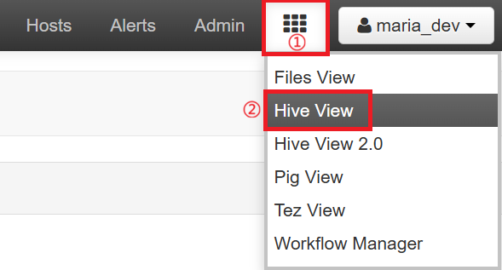
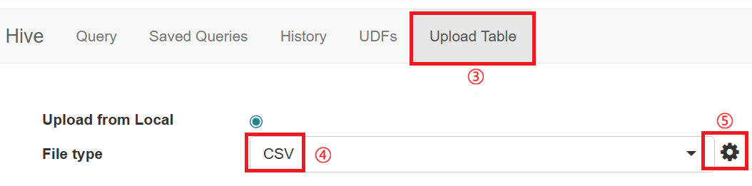
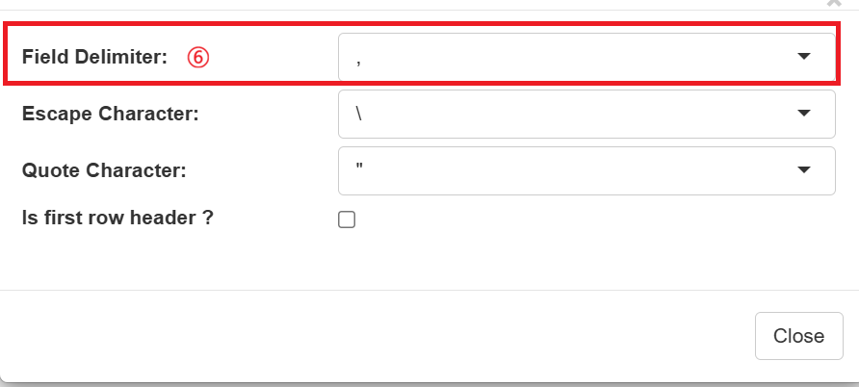
④ 需要根据文件来选择对应的File type
⑤ 需要点击后选择对应⑥的类别
⑥ 先查文件内容确认用什么符号，在PuTTY中输入如下代码：
如果文件在虚拟机中：head -5 /home/maria_dev/u.data
如果文件在hadoop：hadoop fs -cat /user/maria_dev/mica/u.item | head -5
序号 | 数据内容 | 制表符 | 例子
1 | 内容之间是一大段空白 | Tab（制表符，\t）分隔 | 196 242 3 881250949
2 | 内容之间是单个空格 | 空格分隔选 Space | 196 242 3 881250949
3 | 内容之间是逗号 , | 逗号分隔选, | 196,242,3,881250949
4 | 内容之间是竖线 | | 竖线分隔 选| | 196|242|3|881250949
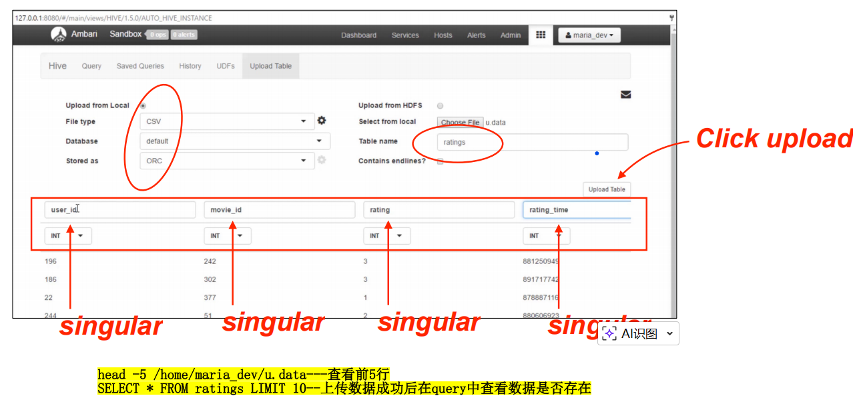

设置完成后，上传文件
列表名：必须是小写，如movie_name
确认：数据是否上传成功在query中输入：SELECT * FROM ratings LIMIT 10

Query-SQL语句
1.找评分最多的电影(dataset：u.data)

【Input】
SELECTmovie_id,
count(movie_id) as ratingCount
FROM ratings
GROUP BY movie_id
ORDER BY ratingCount
DESC;

【Onput】

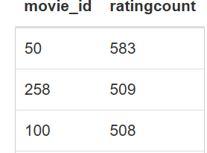
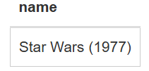
2.找movie_id=50的电影名(dataset：u.item)

SELECT name
FROM movie_names
WHERE movie_id = 50;

HDFS

安装mrjob
Mrjob是一个python库，专门用来写hadoop MapReduce程序。
# 清理缓存yum clean all
# 下载pip安装脚本curl https://bootstrap.pypa.io/pip/2.7/get-pip.py -o get-pip.py
# 安装pip python get-pip.py
# 查看pip版本（确认成功）pip --version
# 安装依赖库
pip install pathlib
pip install mrjob==0.7.4
pip install PyYAML==5.4.1
# 测试mrjob是否可用 mrjob

写mrjob 脚本
--启动 PuTTY 并登录
--查看当前所在路径： pwd
--创建自己的文件夹: mkdir mica
--进入文件夹: cd mica
--用 vi 创建并编辑 vi MapRducer.py
--然后输入如下代码：

from mrjob.job import MRJob
from mrjob.step import MRStep

class RatingsBreakdown(MRJob):
def steps(self):
return[
MRStep(mapper=self.mapper_get_ratings,
reducer=self.reducer_count_ratings)
]

def mapper_get_ratings(self, _, line):
(userID, movieID, rating, timestamp) = line.split('\t')
yield rating, 1

def reducer_count_ratings(self, key, values):
yield key, sum(values)

if __name__ == '__main__':
RatingsBreakdown.run()

--输入完成后按Esc→:x! 保存并退回PuTTY界面
--输入 python MapRducer.py u.data 回车enter
--输出结果：
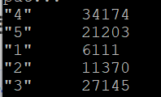

Apache PIG

Default-获取u.data评分数据
使用默认分隔符（Tab \t）→ 可以不写 PigStorage
进入Ambari主页，然后选择Pig View--New Script 创建一个新的scrript
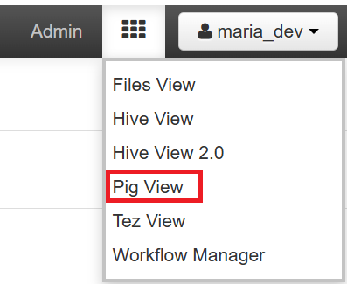
输入如下代码:
ratings = LOAD '/user/maria_dev/mica/u.data' AS (userID:int, movieID:int, rating:int, ratingTime:int);
limited = LIMIT ratings 5;
DUMP limited;

输出如下:
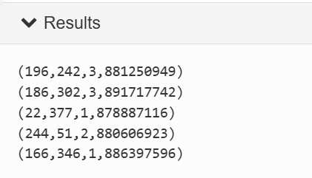

PigStorage-获取u.item电影信息
使用 | 分隔 → 必须写 USING PigStorage ('|')

输入如下代码:
metadata = LOAD '/user/maria_dev/mica/u.item' USING
PigStorage('|')AS(movieID:int, movieTitle:chararray,
releaseDate:chararray, videoRelease:chararray, imdbLink:chararray);
DUMP metadata;

输出如下:
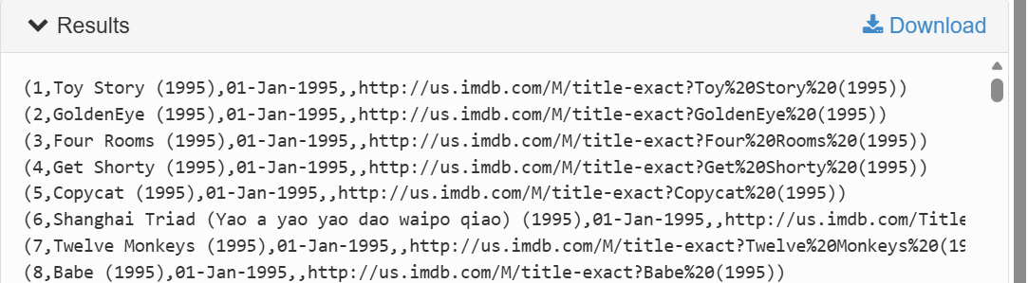

FOREACH /GENERATE-获取电影上映时间
ToDate(...) → 把字符串变成日期对象
ToUnixTime(...) → 把日期变成数字时间戳（方便排序、比较）

输入如下代码:
nameLookup = FOREACH metadata GENERATE movieID, movieTitle,
ToUnixTime(ToDate(releaseDate,'dd-MMM-yyyy'))as releaseTime;
DUMP nameLookup;

输出如下:
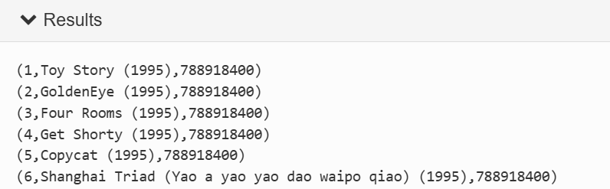

GROUP BY-按movieID分组
输入如下代码:
ratingsByMovie = GROUP ratings by movieID;
DUMP ratingsByMovie;

输出如下:
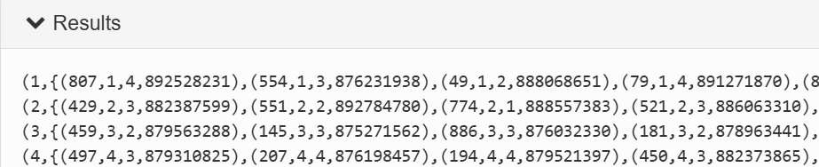

AVG-求电影评分均值
输入如下代码:
avgRatings = FOREACH ratingsByMovie GENERATE group AS movieID,
AVG(ratings.rating)AS avgRating;
DUMP avgRatings;

输出如下:
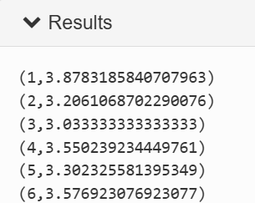

DESCRIBE-描述变量类别
输入如下代码:
DESCRIBE ratings;
DESCRIBE metadata;
DESCRIBE nameLookup;
DESCRIBE ratingsByMovie;
DESCRIBE avgRatings;

输出如下:
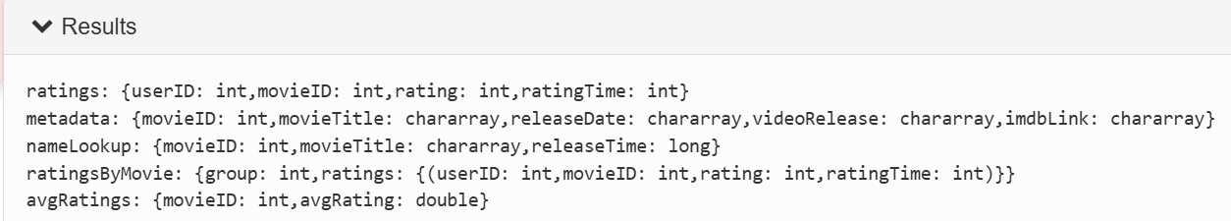

FILTER-avgRating > 4.0
输入如下代码:
fiveStarMovie = FILTER avgRatings BY avgRating >4.0;
DUMP fiveStarMovie;

输出如下:
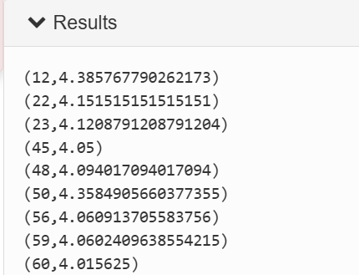

JOIN-合并变量
输入如下代码:
fiveStarMovieWithData = JOIN fiveStarMovie BY movieID, nameLookup BY movieID;
DESCRIBE fiveStarMovieWithData;
DUMP fiveStarMovieWithData;

输出结果:
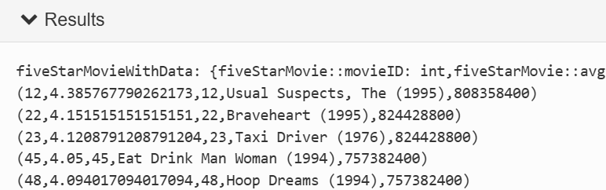

ORDER BY-按上映时间排序

输入代码如下:
oldestFiveStarMovie = ORDER fiveStarMovieWithData BY nameLookup::releaseTime;
DUMP oldestFiveStarMovie;

输出结果:
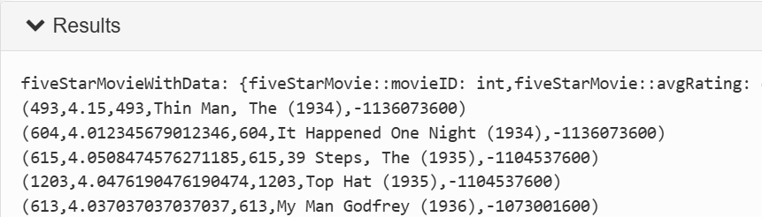

Pig + TEZ

EP1_DISTINCT(学生去重)
# 1. 创建 mica 文件夹（用于存放本地数据文件）
mkdir mica

# 2. 进入 mica 文件夹
cd mica

# 3. 使用 vi 编辑器创建 student_details.csv 文件
vi student_details.csv

进入 vi 编辑器后，粘贴以下数据内容：
001,Rajiv,Reddy,9848022337,Hyderabad
002,siddarth,Battacharya,9848022338,Kolkata
002,siddarth,Battacharya,9848022338,Kolkata
003,Rajesh,Khana,9848022339,Delhi
003,Rajesh,Khanna,9848022339,Delhi
004,Preethi,Agarwal,9848022330,Pune
005,Trupthi,Mohanthy,9848022336,Bhuwaneshwar
006,Archana,Mishra,9848022335,Chennai
006,Archana,Mishra,9848022335,Chennai
按 Esc 键 → 输入 :x! → 回车（保存并退出）

# 4. 在 HDFS 中创建 mica 目录（-p 表示递归创建，不存在则自动建）
hdfs dfs -mkdir -p /user/maria_dev/mica

# 5. 将本地 CSV 文件上传到 HDFS 指定路径
hdfs dfs -put /home/maria_dev/mica/student_details.csv /user/maria_dev/mica/

# 6. 查看 HDFS 中的文件，验证上传是否成功
hdfs dfs -ls /user/maria_dev/mica

# 7. 到Pig view中,建立一个distinct的文件,然后输入一下代码:
students = LOAD '/user/maria_dev/mica/student_details.csv'
USING PigStorage(',')
AS (id:chararray, firstname:chararray, lastname:chararray, phone:chararray, city:chararray);
unique_records = DISTINCT filtered;
DUMP unique_records;

输出结果:
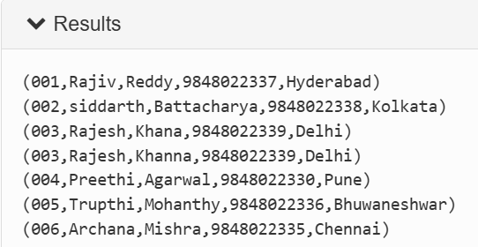
# 8. 存储到HDFS
STORE unique_records INTO '/user/maria_dev/mica/output'
USING PigStorage(',');

EP2 _Filter(bad movies)
ratings = LOAD '/user/maria_dev/mica/u.data'
USING PigStorage('\t')
AS (userID:int, movieID:int, rating:int, ratingTime:int);
--DUMP ratings;

metadata = LOAD '/user/maria_dev/mica/u.item'
USING PigStorage('|')
AS (movieID:int, movieTitle:chararray,
releaseDate:chararray, videoRelease:chararray,
imdbLink:chararray);
--DUMP metadata;

ratingsByMovie = GROUP ratings BY movieID;
--DUMP ratingsByMovie;

movieStats = FOREACH ratingsByMovie GENERATE
group AS movieID,
AVG(ratings.rating) AS avgRating,
COUNT(ratings) AS ratingCount;

badMovies = FILTER movieStats BY avgRating < 2.0;
--DUMP badMovies;

sortedBadMovies = ORDER badMovies BY ratingCount DESC;
--DUMP sortedBadMovies;

joined = JOIN sortedBadMovies BY movieID, metadata BY movieID;

finalResult = FOREACH joined GENERATE
metadata::movieTitle AS movieTitle,
avgRating,
ratingCount;

DUMP finalResult;

输出结果如下:
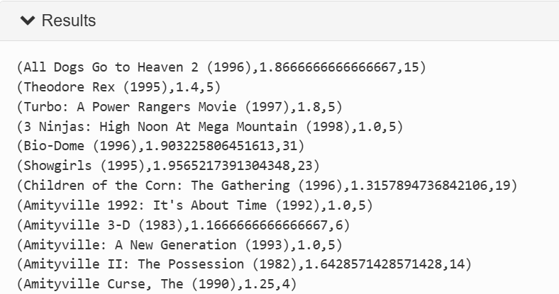

Apache_SPARK

What is Spark?
multi-language engine for executing data engineering, data science, and machine learning on single-node machines or clusters.
Intermedia file Spark & TEZ
sc. = Spark context

Spark is scalable
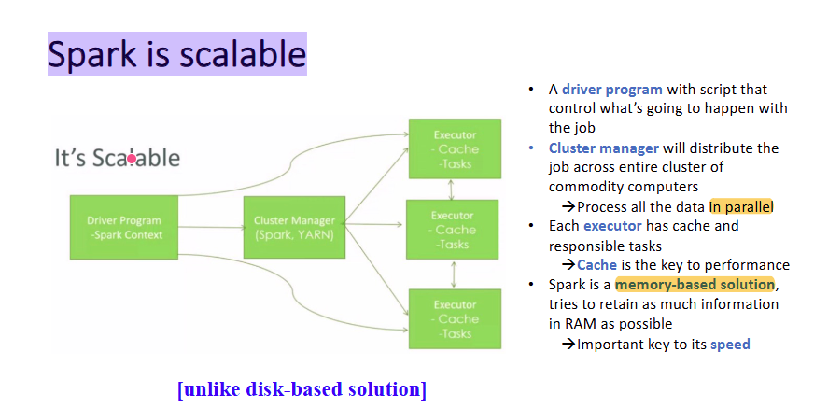

进入PuTTY，然后 输入su root—输入密码：stqd6324，然后就转变为root@sandbox-hdp maria_dev，意味着进入root. 退出用exit

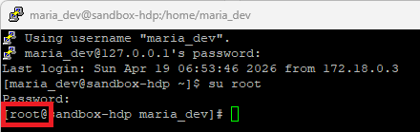
然后到hadoop 输入账号：admin，密码：maria_dev(如果不行就到Putty再重新改回maria_dev)

然后到hadoop—service—Configs--Spark2—然后找到下面的item：


进入查看：rootCategory=ERROR是否为ERROR

然后输出如下代码到PuTTY：vi mapSpark.py 然后enter I

from pyspark import SparkContext

sc = SparkContext("local", "PrintSquaredRDD")
rdd = sc.parallelize([1, 2, 3, 4])
squaredRDD = rdd.map(lambda x: x * x)
result = squaredRDD.collect()
print("Squared RDD Result:", result)
sc.stop()
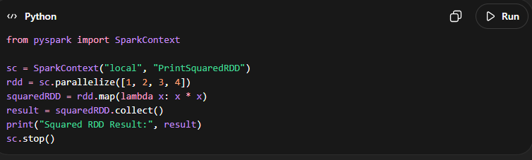
然后esc ：x！保存后，
到PuTTY 输入spark-submit mapSpark.py，然后enter就能得到答案。
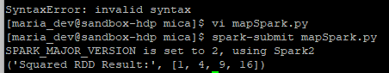

Input：
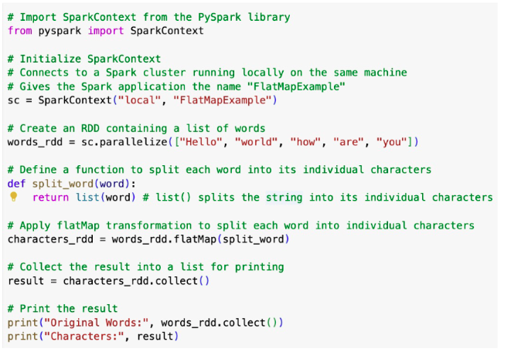
Ouput：
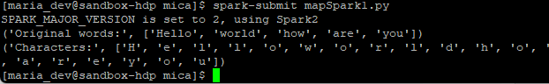

Input:
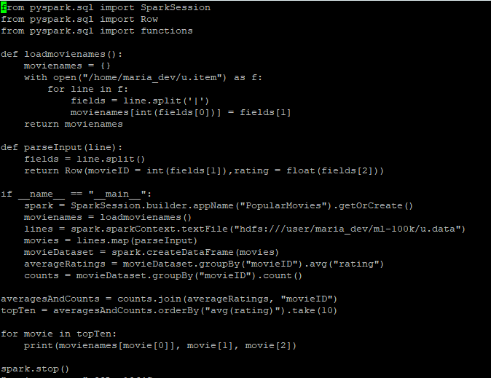
Output:

from pyspark.sql import SparkSession
from pyspark.ml.recommendation import ALS
from pyspark.sql import Row
from pyspark.sql.functions import lit

def loadmovienames():
movienames = {}
with open("/home/ml-100k/u.data") as f:
for line in f:
fields = line.split('|')
movienames[int(fields[0])] = fields[1].decode('ascii','ignore')
return movienames

def parseInput(line):
fields = line.value.split()
return Row(userID=int(int(fielsds[0]),rating = float(fields[2]))

if __name__ =="__main__":
spark = SparkSession.builder.appName("movieRecs").getOrCreate()
spark.conf.set("spark.sql.crossjoin.enabled","true")
movienames = loadmovienames()
lines = spark.read.text("hdfs:///user/maria_dev/ml-100k/u_edited.data").rdd
ratingsRDD = lines.map(parseInput)
ratings = spark.createDataFrame(ratingsRDD).cache()
als = als(maxIter=5,regParam=0.01,userCol="userID",ratingCol="rating")
model = als.fit(ratings)

print("\nRatings for user ID 0:")
userRatings = ratings

