wAIter Subproject Report

Decision Tree
Szymon Kuleczka

I. Dataset
The dataset used in the subproject is the list of 15 pizzas from Mamma Mia pizzeria with the corresponding list of 7 pizza toppings: ham, salami, pepper, mushrooms, pineapple, onion, tomato. If the topping is present on the pizza, corresponding cell value is 1, otherwise it’s 0. The data is initially stored in CSV file, then loaded to Pandas DataFrame.
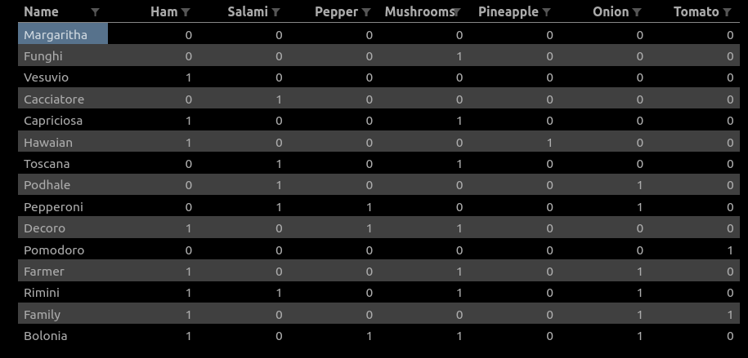
This pizza DataFrame is further used during generation of random order history for the customer. Rules are the following: firstly, random number between 6 and 11 is being chosen – it’s the number of standard pizzas from menu in the order history. Then, two random numbers are generated, lets call them pizzas_1 (0 <= pizzas_1 <= number_of_standard_pizzas) and pizzas_2 (number_of_standard_pizzas - pizzas_1). Data is sampled from pizza DF twice – first time using pizzas_1 and second time using pizzas_2. Thanks to this procedure, we can have up to two repetitions of pizzas in order history (for example two Margarithas). Afterwards, 25 - number_of_standard_pizzas custom pizzas with completely random toppings are generated. Finally, algorithm assigns 0 or 1 in column ‘Good_Pizza?’ to all of the records, with 0 corresponding to ‘Bad Pizza’, and 1 to ‘Good Pizza’. In this way, in each execution of the program we are dealing with different, randomized order history.

II. Decision Tree
The tree in the subproject is trained using DecisionTreeClassifier class, which comes from scikit-learn library. It is created using CART algorithm, which differs from ID3 in the usage of Gini impurity instead of Entropy. We can express Gini impurity with formula
Gini = 1 – Σ (Pi)2 for i=1 to number of classes

In short, gini impurity tells us what is the probability of a new data point being incorrectly classified. Instead of information gain, we calculate gini gain by taking a weighted sum of the gini impurities.
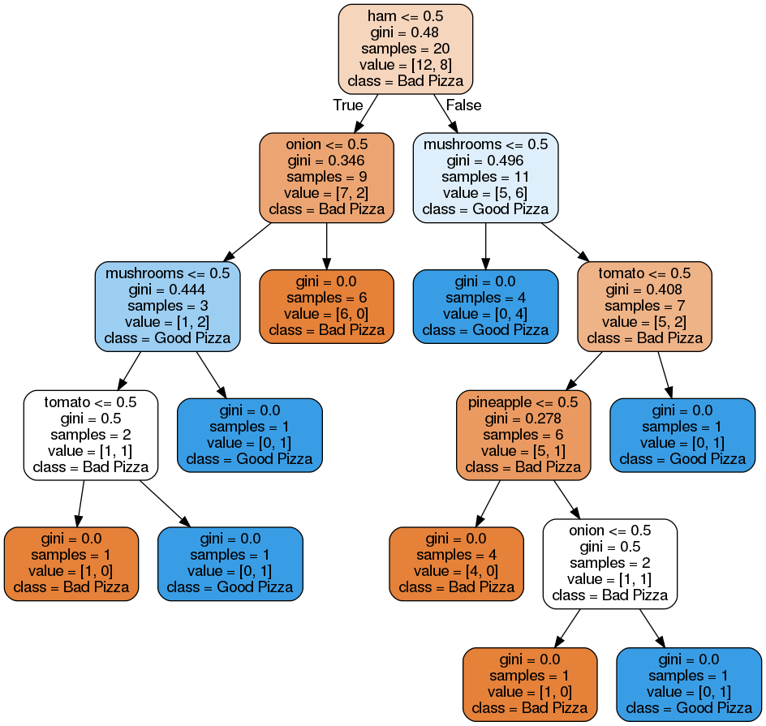
Tree is visualized by pydotplus.

III. Integration
After training decision tree for certain order history, it is used to predict whether the customer will like the pizza from menu or not. Basing on this information, waiter suggests the customer, which pizza will he like. The customer enters the restaurant, waiter approaches him, and they have a short conversation, directed for the purpose of presenting the algorithm.

