# Create new console application

Select File -> New -> Project

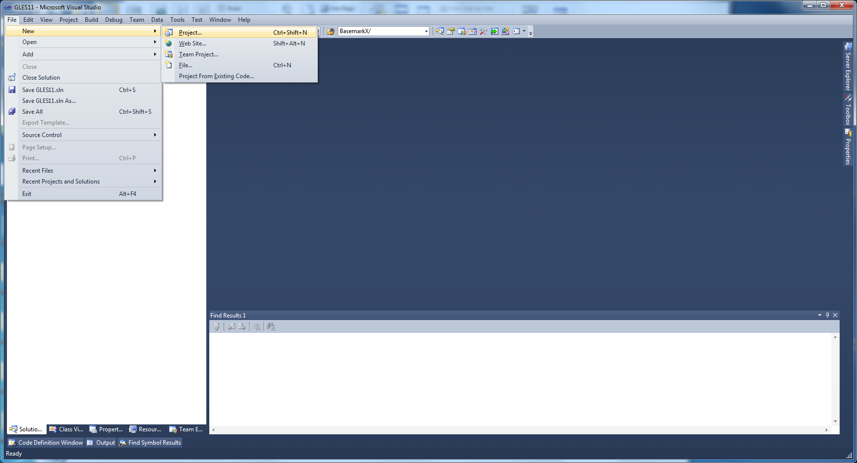

Select Win32 Console Application from the dialog. Change name of the project. Set location for the project to some-folder. Select Add to solution from Solution-combo box. Press OK.

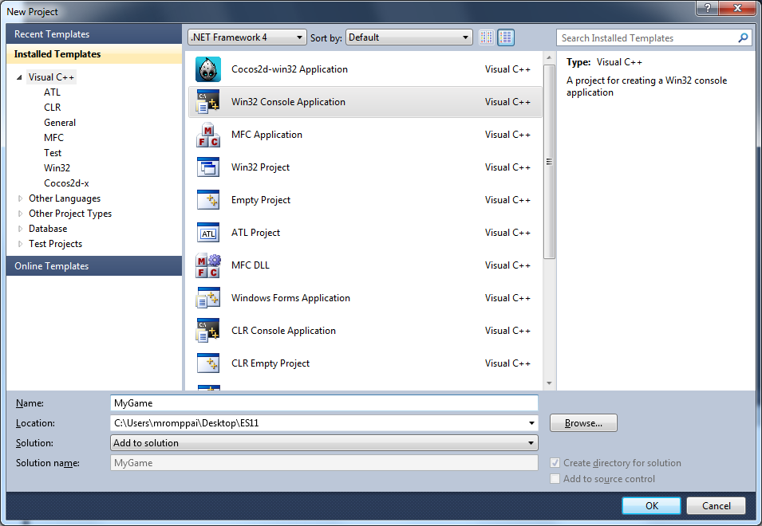

Press Next.

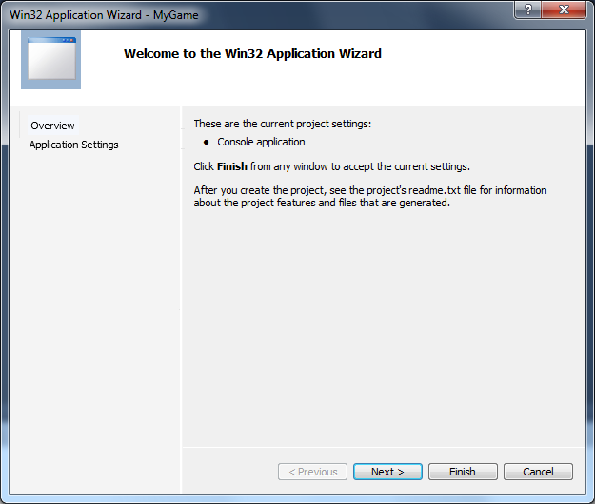

Select “Console Application” and “Empty project” from Win32 Application Wizard window. And press Finish.

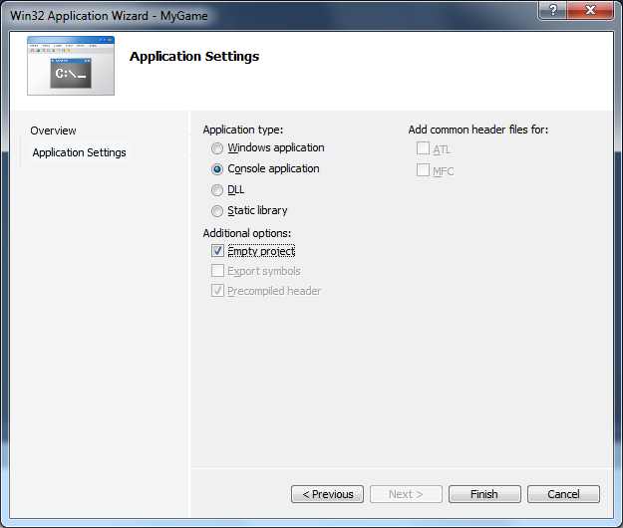

New project is created to Visual Studio Solution. Add newly created project to be as startup project for debugging by right clicking the project and select “Set as startup project”.

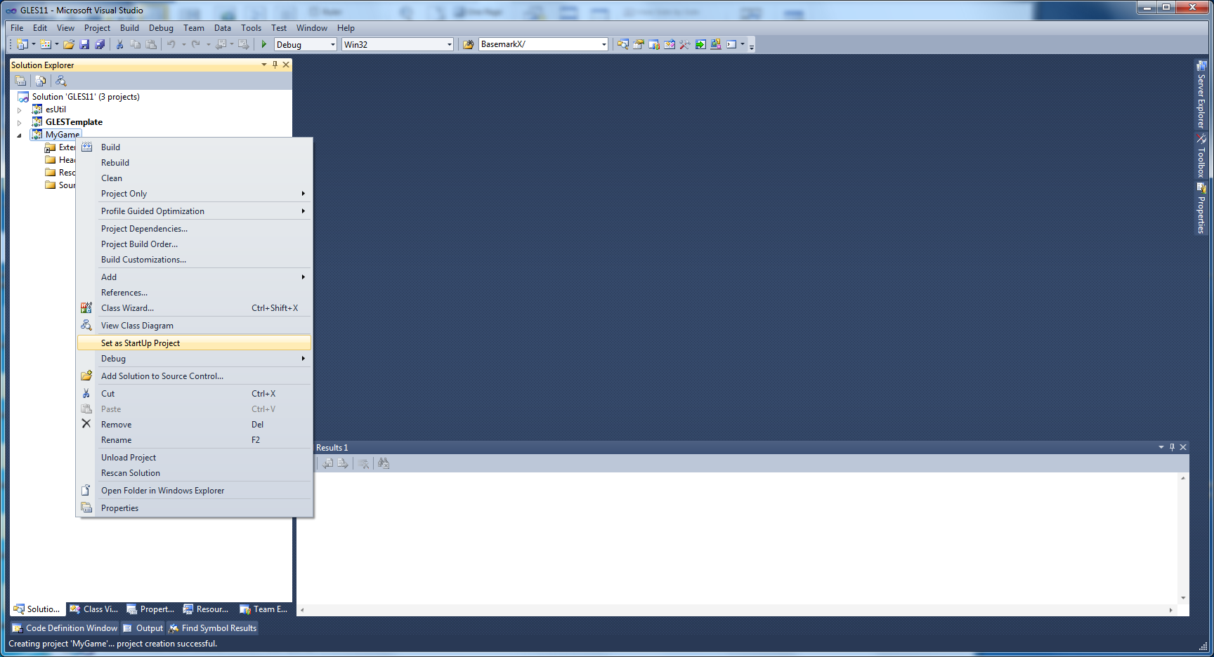

# Add new cpp file to the project

You have now project, but you do not have any code in that. Let’s add next new cpp file. Right click project. Select Add -> New Item.

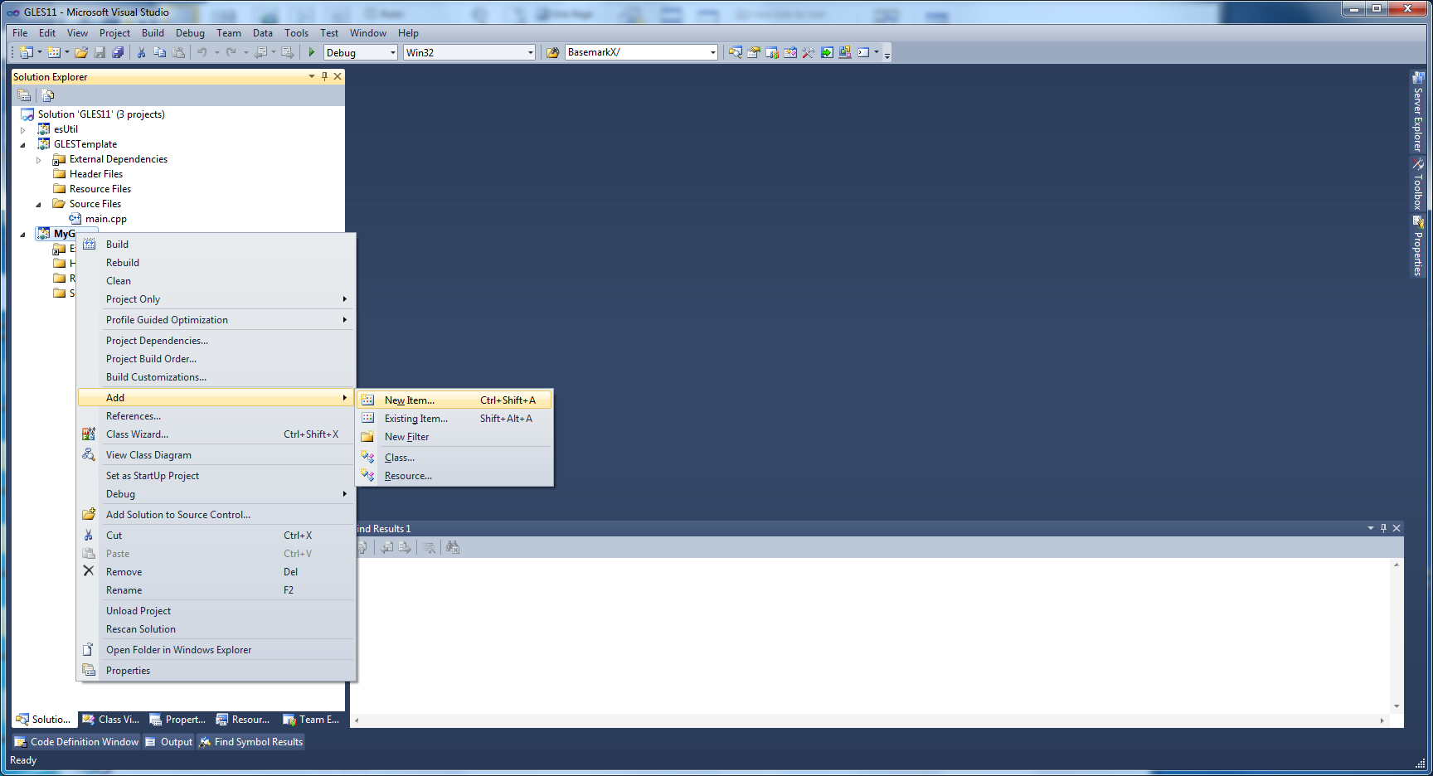

From opening Add new item window, Select “C++ File”, give some useful name to it like “main.cpp” and press “Add”.

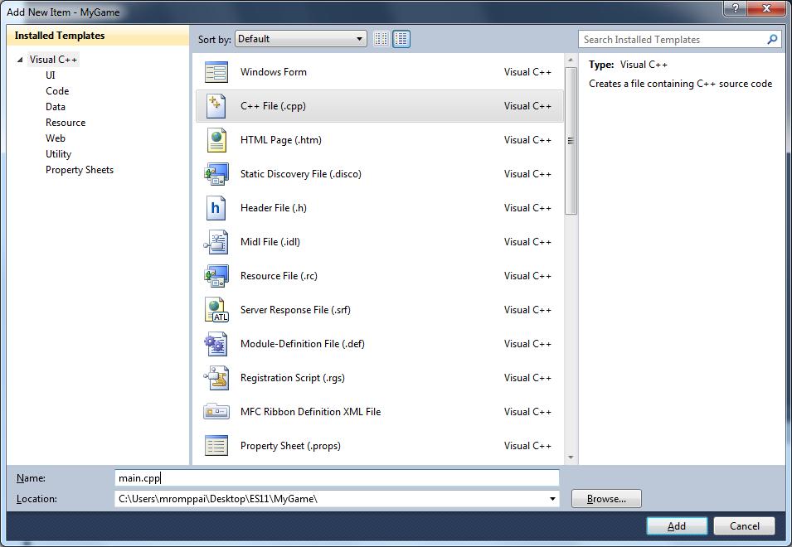

main.cpp is created to your project. Copy following code to main.cpp.

// Include OpenGL ES Engine utils

#include <es_util.h>

using namespace yam2d;

// Initialize the game

bool init ( ESContext *esContext )

{

return true;

}

// Deinitialize the game

void deinit ( ESContext *esContext )

{

}

// Draw game

void draw ( ESContext *esContext )

{

// Set the viewport

glViewport( 0, 0, esContext->width, esContext->height );

// Set OpenGL clear color

glClearColor(0.0f, 0.0f, 1.0f, 0.0f );

// Clear the color buffer

glClear ( GL_COLOR_BUFFER_BIT );

// Swap to back buffer

eglSwapBuffers ( esContext->eglDisplay, esContext->eglSurface );

}

// update game

void update( ESContext*, float deltaTime )

{

}

int main ( int argc, char *argv[] )

{

ESContext esContext;

esInitContext ( &esContext );

esCreateWindow( &esContext, "Hello Yam2D", 1280, 720, ES_WINDOW_DEFAULT );

if ( !init ( &esContext ) )

return 0;

esRegisterDrawFunc( &esContext, draw );

esRegisterUpdateFunc( &esContext, update );

esRegisterDeinitFunc( &esContext, deinit);

esMainLoop ( &esContext );

return 0;

}

If you try to build the project, you will get a compiler error “fatal error C1083: Cannot open include file: 'es_util.h': No such file or directory”. This indicates, that es_util.h, which is located in “YAM2D_ROOT\engine\Include”-folder cannot be found and you need to add some additional include directories to project.

# Add additional include directories

Right click the project and select “Properties”. Project property window is opened.

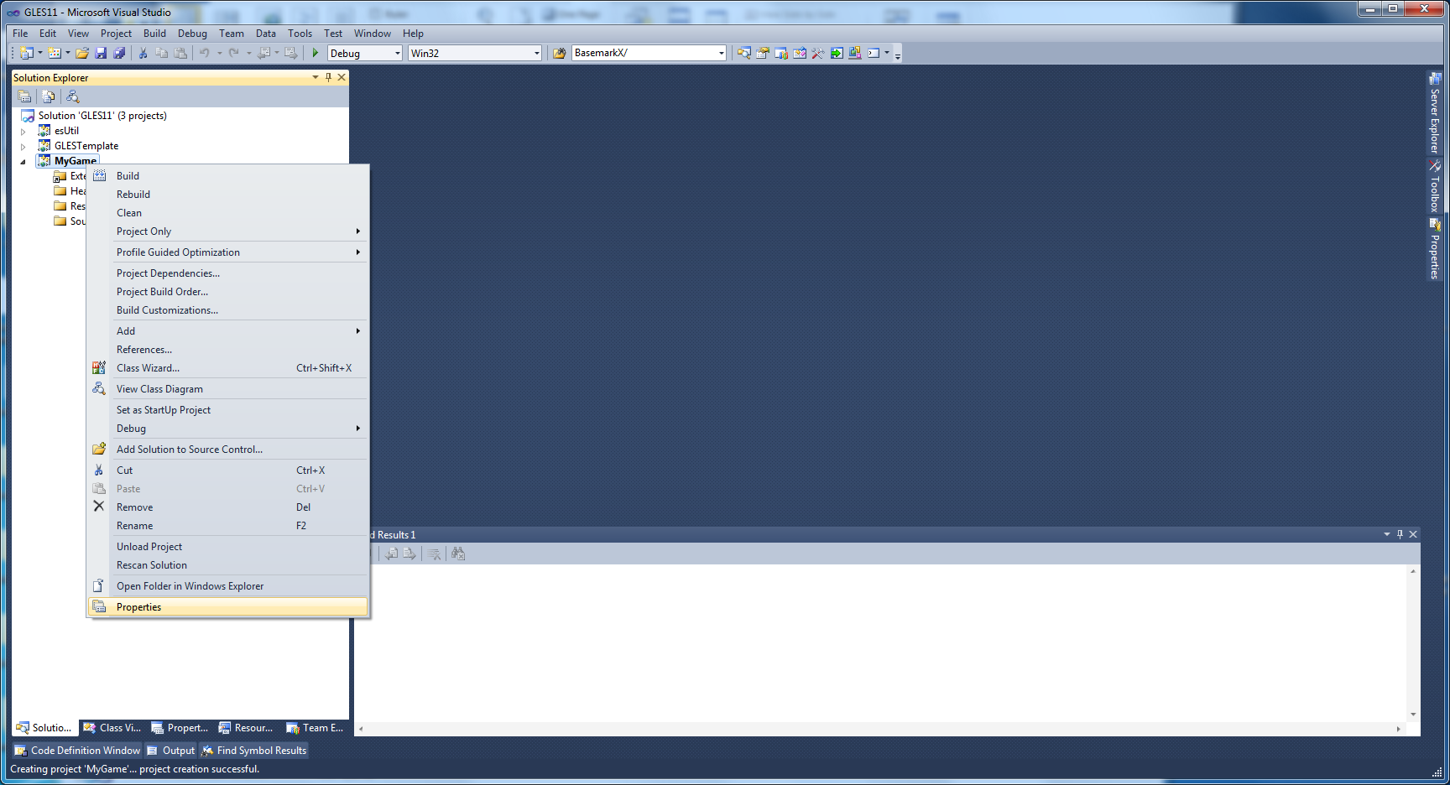

Change ”Configuration” in top left corner to ”All Configurations”. This tells that all settings we are making are applicable to both, Release and Debug builds. Add Additional Include Directories as shown in picture below.

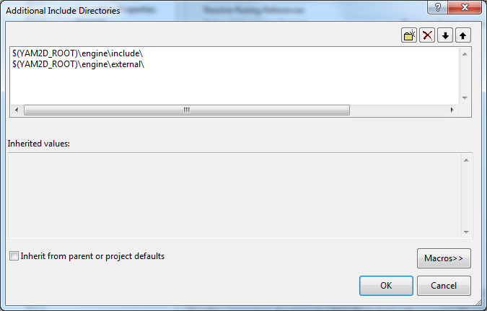

Now, if you try to build the project, you will get an error ”unresolved external symbol __imp__eglSwapBuffers@8 referenced in function "void __cdecl draw(struct ESContext *)" (?draw@@YAXPAUESContext@@@Z)” This indicates, that function called “eglSwapBuffers” cannot be found. This error can be fixed by adding some OpenGL ES emulation libraries to project.

# Add needed EGL libraries

Open Project properties. Change configuration to “All Configurations”. Add additional library directories as shown in picture below. This will tell the linker to search lib-files from those folders.

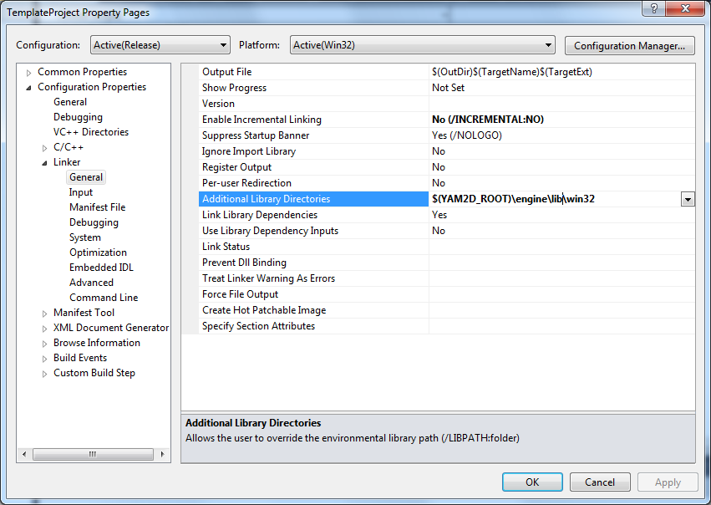

You need to add libraries itself to “Additional Dependencies” as shown in picture below.

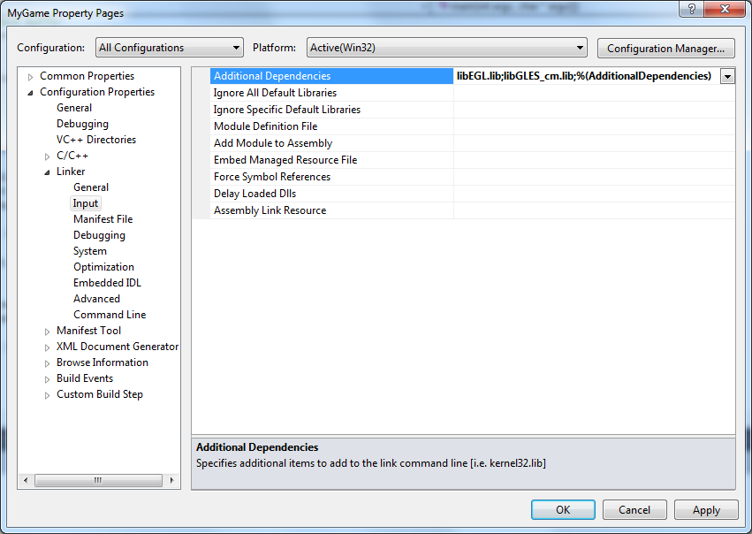

If you try to build the project, you will get an error ” unresolved external symbol "void __cdecl esMainLoop(struct ESContext *)" (?esMainLoop@@YAXPAUESContext@@@Z) referenced in function _main” This indicates, that function called “esMainLoop” cannot be found. This error can be fixed by adding reference to engine project.

# Add reference to engine project

Open project properties and Select “Add New Reference” from “Common Properties” -> “Framework and References”.

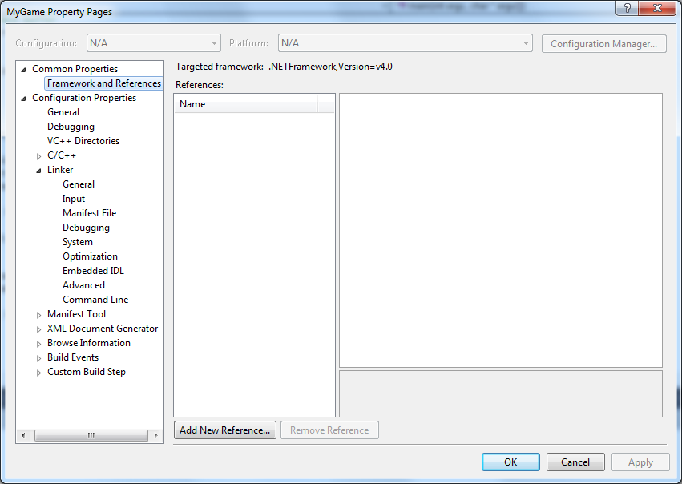

From opening dialog select “yam2d” and press OK.

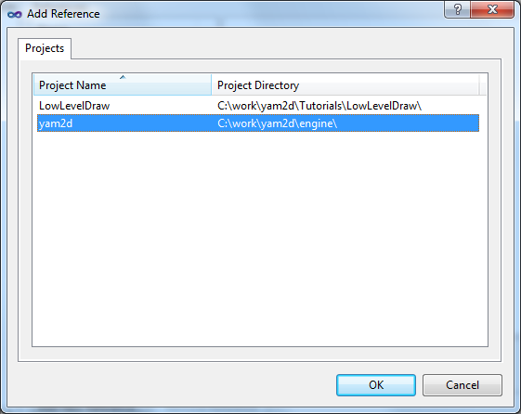

Now you can see new reference under “References”. Press OK.

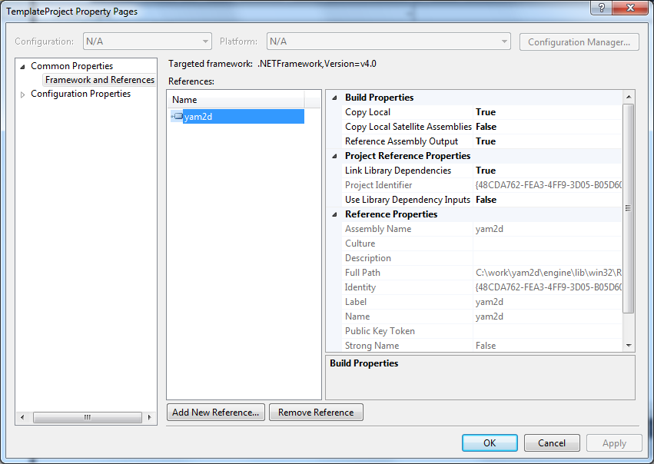

Now if you build and run the project you get an error that some dll is missing.

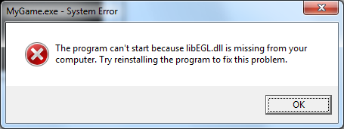

You can fix this problem by copying dll:s from folder “YAM2D_ROOT\engine\lib\” to folder, where your visual studio project file (.vcxproj) exists. Dlls must be always in same directory, which is specifies ad program “working directory”.

After copying the dll-files, you should get screen like this:

