# Download Yam2D using tortoise svn

Open my computer and browse to your working directory (e.g. desktop etc.). Right-click mouse and select SVN Checkout. Type URL of repository to ***https://yam2d.googlecode.com/svn/trunk*** and press OK.

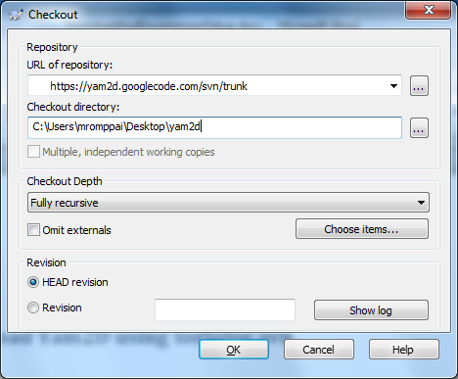

Files should be copied to your checkout directory.

# Setting up environment variables

In order to compile Yam2D using visual studio, you need to set ***YAM2D_ROOT*** –environment variable to point to your checkout directory. The easiest way to do this is just click ***set_yam2d_env.bat***, found in your Yam2D checkout directory.

# Building the engine and all examples & tutorials

Open AllProjects.sln to Visual Studio and rebuild solution.

# Android environment setup

In order to build yam2d-applications for Android you need to have Android SDK and NDK installed. It is recommended to use ADT bundle, which can be downloaded from: <http://developer.android.com/sdk/installing/bundle.html>. ADT bundle contains all needed stuff (SDK + Eclipse IDE) for making Android Java applications. Because yam2d is coded using C++, it is needed to have also Android NDK installed. Android NDK can be downloaded from: <http://developer.android.com/tools/sdk/ndk/index.html>.

The NDK must have certain installation location. Currently, all examples and tutorials assumes that the NDK Revision 9c is installed to location: ***C:\work\android-ndk-r9c\***. If you use different NDK version or if you have different installation location, then you need to modify ***build.bat*** and ***rebuld.bat*** files by changing the addressed ***NDK_ROOT***-environment variable to match to NDK installation path. Also build script for the engine library is needed to modify. The engine build script can be found from folder: ***YAM2D_ROOT\engine\build\android***. Batch files for examples are located in ***build\android*** folder of each example.

# Building for Android

First step is to build yam2d engine library. It can be done by clicking or running ***YAM2D_ROOT\engine\build\android\rebuild.bat***. This will generates static library for Android named ***libyam2d.a***.

Then you need to build you application by using script in build/android –folder using either ***build.bat*** or ***rebuld.bat***. See tutorials or example games, that how the folder structure is done.

In rest of this chapter, we will go through, how to build YA-Arkanoid example game to Android.

In this case the build script for application is located at: ***YAM2D_ROOT\ExampleGames\YA-Arkanoid\build\android\rebuild.bat***. By clicking that batch file, NDK build for application dynamic library named ***libnative-activity.so*** is started.

Next step for Android build is to start Eclipse IDE from ADT bundle. When starting Eclipse, you need to specify workspace. Safest way to do it, is to declare workspace folder to some other folder, than where you project is. Like in figure below:

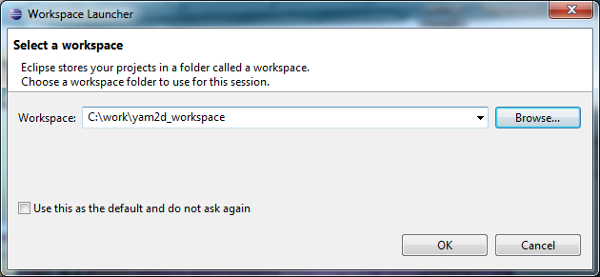

Next step is that you import the project to Eclipse. You can do it from menu, by clicking: ***File -> Import…***

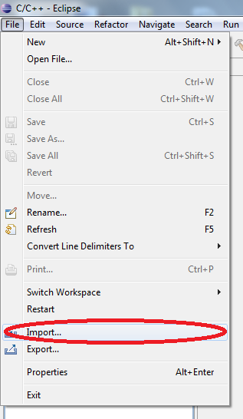

From opening dialog select: ***Android -> Existing Android Code into Workspace*** and click ***Next***.

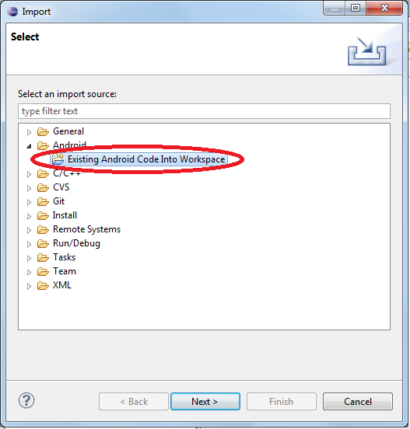

You should see similar window as below. Browse to you project build\android folder and select it as Root Directory and click Finish.

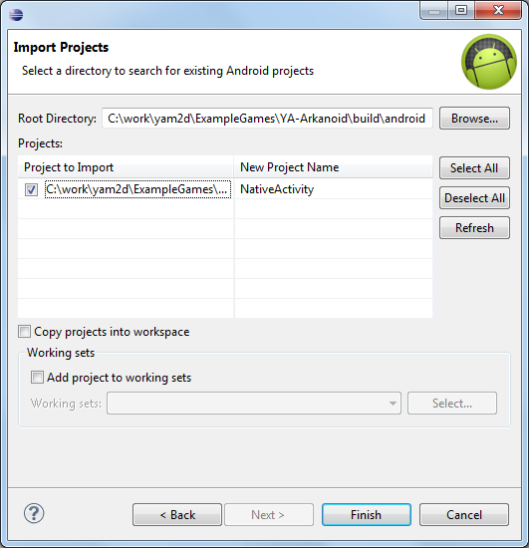

The Android project will be imported to you Eclipse workspace.

Then you can run your application by Right clicking the ***NativeActivity*** in Package Explorer and selecting ***Run As -> Android Application***.

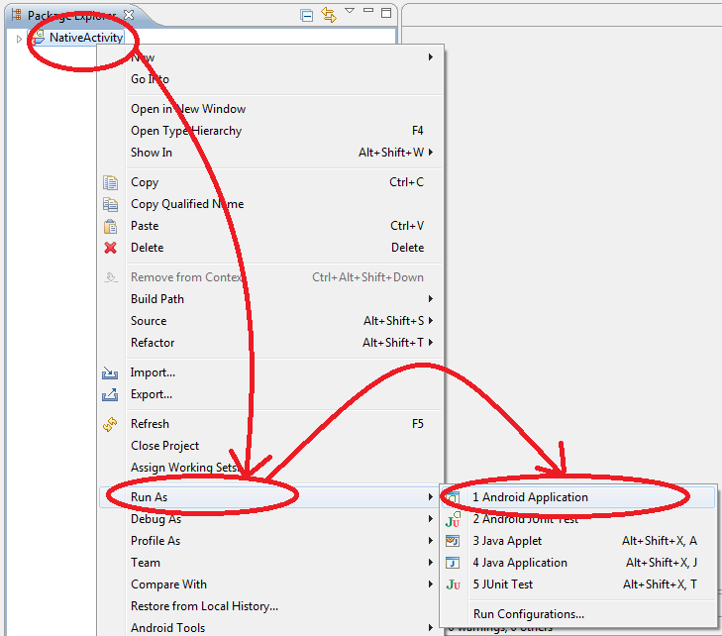

If you have not connected Android device to you PC, then following dialog is shown. You can now create new Android Virtual Device or either press No and connect Android phone to you PC and try Run again.

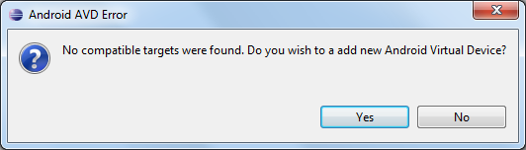

If there is either AVD or real Android device connected, the following Device Chooser dialog is shown, where you can select the device, where you deploy the application by pressing OK-button.

