# Integrating TmxMapViewer tool to Tiled

You can integrate TmxMapViewer-tool with tiled, so it is easy to see instantly, what does the level looks like rendered with yam2d engine. You can also use TmxMapViewer as a template for your own viewing program, if you want to add custom functionality to your viewer. Typically you can integrate game play mechanics with Tiled. In that case game designer or artist etc. can easily see how different kind of changes, to level affects to gameplay etc.

First you need to add custom command to Tiled. This can achieve by Clicking an arrow next to “Execute Command”-tool button. And select “Edit commands…”



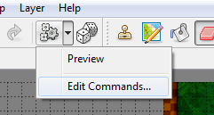

New dialog “Edit Commands” appears to screen. Add some descriptive name in Name section and insert executable command followed by command argument ***%mapfile. %mapfile*** is replaced with actual map file name, when command is executed.

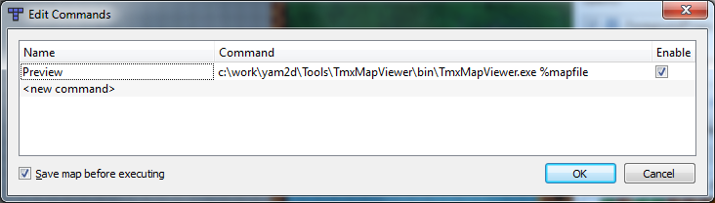

When you have typed correct data to properties, press OK. Now you can execute your command by pressing “Execute Command” –button.

