**Personal Information**

Michelle Watson

s3632469

[s3632469@student.rmit.edu.au](mailto:s3632469@student.rmit.edu.au)

<https://github.com/Mich610/mich610.github.io>

<https://mich610.github.io/>

Completing a Bachelor of Business (Financial Planning) with 5 subjects to go. I already work in the financial planning industry as a paraplanner and will reach senior status in April 2021.

I have a 7 year old white bi-eyed Siberian husky named Memphis.

I am currently completely obsessed with 'Hamilton the musical', so my Christmas present will be tickets to see the show in Sydney next year.

**Interest in IT**

In all honesty, I have no interest in IT and never really have. Mostly my lack of interest comes from my lack of knowledge. That lack of knowledge makes this subject so daunting to me.

I would never have considered this course, if it wasn’t a core subject in my Bachelor of Business (Financial Planning). I have actually been avoiding this subject for about three years now.

Although I feel this subject is rather irrelevant to my current work and future endeavours, I hope to gain a greater understanding and interest in IT.

**Ideal job**

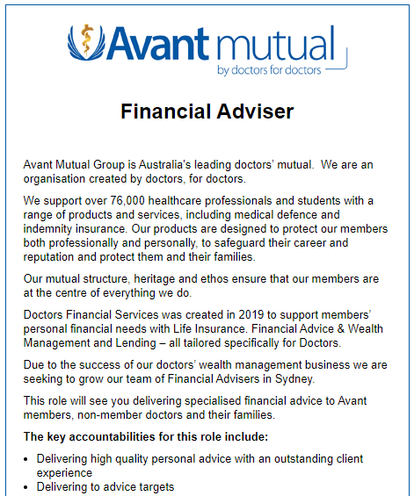<https://www.seek.com.au/job/51056080?tracking=TMC-SAU-eDM-SharedJob-13246>

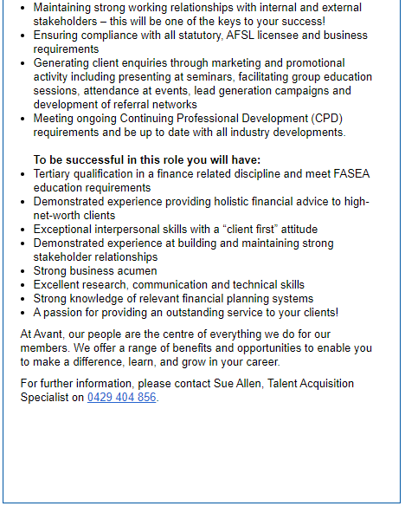

The position

Seeking a financial adviser to provide financial advice in regards to personal wealth management (superannuation, retirement and personal investment) and insurance needs (life, total and permanent disability, trauma and income protection)

Required skills, qualifications and experience.

Skills:

* Interpersonal; ie – listening, teamwork, responsibility.
* Research, communication and technical; - ie ability to use financial planning software.

Qualifications:

* Completed a FASEA approved degree
* Undertaken a Professional year
* Passed the FASEA exam.

Experience:

* Although the ad doesn’t specify years of experience required, it does read, they require an adviser that meets all FASEA education requirements. Therefore, at least one years' experience would be required; ie completed their professional year.

Existing skills, qualifications and experience.

Skills:

I believe I have all relevant skills required and will continue to build on these skills through further training and practice.

Qualifications:

I have 5 subjects remaining of a FASEA approved degree.

Experience:

I currently have 4 ½ years in the financial planning industry where I work as paraplanner, working hand in hand with the advisers to develop the most ideal strategies for clients.

How to get the job.

I will continue to work as a paraplanner, which allows me to continually build my on the job training, whilst also completing my degree. Upon completion of the degree, I will need to complete the professional year and pass the FASEA exam. Ideally, I will work myself up at my current workplace and eventually take the role of Financial Adviser.

**Personal Profile**

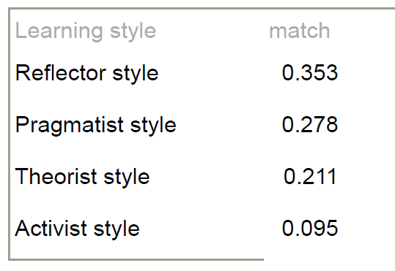<https://www.16personalities.com/profiles/f29a35146c3bc>

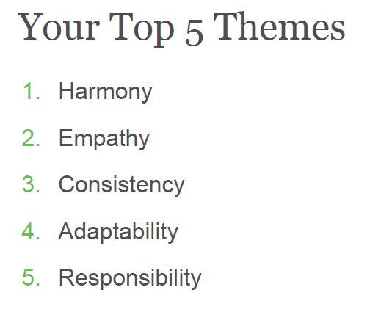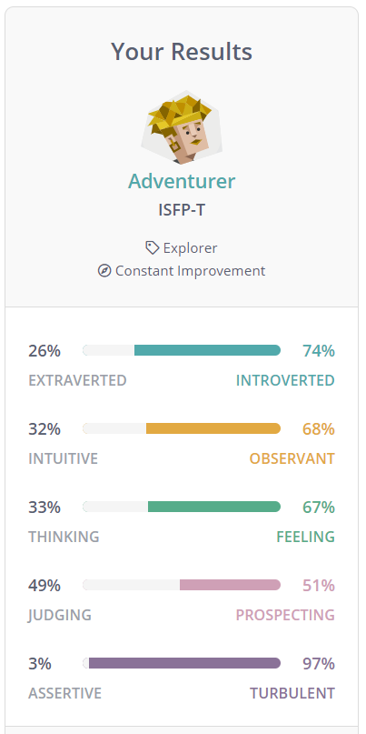

*PDF attched in GitHub

The results of the three tests should be taken with a grain of salt. These types of results will never be 100% accurate, they are taken out of context at a random point in time. I have previously taken the Myers-Briggs and learning styles quizzes and have received different results, due to my different mindset when completing the quizzes. However, in saying that, I do see truth in the results.

Take the Myers-Briggs 16 personalities strengths and weaknesses. When it comes to the strengths, I believe all bar Artistic are spot on. With the weaknesses, the majority also ring true to a degree, except for unpredictable and overly competitive. I feel the workplace habits are note worthy in regard to working within a team.

I found the learning styles quiz interesting, in the sense that it indicates I'm a bit of everything, which I do agree with, when reading each style. I believe Reflector does represent me the most though, as indicated.

I completed the Clifton Strengths a few months after starting my new job. Again, these results mostly highlighted things I already knew about myself, for instance, at the top of the list,Harmony, which reiterates the fact, I don't enjoy conflict.

I don't personally believe the results will necessarily influence my behaviour in a team. The results just confirm who I am as a person, ie - working together, rather than being controlled. The results have made me more aware, which may allow me to identify when my weaknesses are coming through before they take control.

When forming a team, I believe it is best to have a mixture of people - ie different personalities and learning styles. Different ideals can complement each other, as different ideas and views can be put forward. However, mixing too many differences brings to mind 'too many cooks spoil the broth' and could actually result in conflict or personalities that clash. This needs to be considerd when forming a group.

**Project Idea**

Overview

A simple super comparison tool that will allow the user to compare super funds. In many cases a person will simply consolidate their funds into which ever fund their employer is currently paying into, however, this super fund may not be the most appropriate. In addition, when these accounts are created, they are often invested within a default option, which may not reflect the desired investment strategy. The user will be able to compare these multiple funds and consolidate into the most appropriate fund for their needs. It will also allow for a user with a single fund to compare different investment options.

Motivation

Many young adults, in particular millennials, have been entering the workforce but often changing jobs and each time, a new super fund was created. The government's 'Protecting your Super' scheme has helped to reduce the number of Australians with multiple super funds. However, under this scheme, funds were automatically consolidated into their existing active super fund, which may not be the most appropriate. Many of these young adults, think that planning for their retirement is not relevant as it is so far off, therefore, they are not willing to seek or pay for professional advice. The aim is to help people with this frame of mind, to organise their retirement savings without the pressure of paying for professional advice.

Description

The user would first complete a risk profile questionnaire, there is no stock standard across the industry, so one will need to be created that has simple and easy questions for the user. Followed by an explanation of the different risk tolerances and investment strategies. The user can select their risk profile based on the results of the questionnaire or simply by the description, if they do not completely agree with the result. The selected profile will ensure that only investments with that profile are compared.

The user will be prompted to add their existing fund/s and input the current balance, investment option and any known contributions - ie super guarantee, salary sacrifice or member. The user can then select the super funds they wish to compare - this can be multiple funds, if they are wanting to consolidate or one fund, if they just wish to compare investments.

The comparison will show;

* the appropriate investments as per the selected risk profile.
* all fees and costs associated with the fund
* death benefit nominations available (binding, non-binding, lapsing), an explanation of these nominations and the importance of them will also be included.
* insurance available - (default cover or whether an amount can be chosen and any underwriting requirements)

For each selected super fund, links will be included below the comparisons to;

* the website
* The Product Disclosure Statement (PDS)
* The forms page of the website - change of investment, consolidation/rollover, beneficiary , insurance etc.

The idea is to make the comparison tool user friendly not Financial Planner friendly. If the user is overwhelmed by all the information, they may not understand what they are reading and make the wrong choice or they may just give up and not follow through. The basic information will be shown that will allow the user to make a decision with the links to provide further clarification if required.

Tool and Technologies

The proposed superannuation comparison tool needs to be easily discoverable and available for anybody with access to the internet and a modern web browser. Therefore, the tool will predominantly be built using web development technologies. In addition, the tool will also need to be:

* Mobile friendly across most modern mobile devices
* Usable with accessibility tools (screen readers etc)
* Intuitive and easily understood user interface

After some industry research, it seems there are quite a number of technologies to choose from in order to complete this project. An option for building this solution would be with:

* ReactJS - Facebook's Javascript UI framework
* Bootstrap 4 - CSS styling framework
* GitHub Pages - Free hosting service
* *(optional) AWS Route53 - DNS provider to eventually host the tool under a marketable name*

Skills Required

In order to build this tool in the above technologies, one would need to know:

* HTML and Javascript with experience in React JS, if possible
* CSS experience
* Git experience to work with hosting on GitHub pages
* *(optional) Networking skills to set up hosting and domain name configuration*

Outcome

This comparison tool will allow people who are either not wanting to seek or cannot afford professional advice to gain a deeper understanding of their super funds. They can ensure their funds are invested in a product and manner they are comfortable with, putting themselves on a positive track until they are ready to receive professional financial advice.

**References**

16 personalities, 2011-2020 NERIS Analytics Limited, viewed 11 December 2020 <[https://www.16personalities.com/](https://www.16personalities.com/%20)>

Avant Mutual Group 2020, *Financial Adviser*, Seek, viewed 14 December 2020, <https://www.seek.com.au/job/51056080?tracking=TMC-SAU-eDM-SharedJob-13246>

FASEA n.d. *Financial Adviser Standards and Ethics Authority*, Financial Adviser Standards and Ethics Authority Ltd. viewed 14 December 2020, <[https://www.fasea.gov.au/](https://www.fasea.gov.au/%20)>

Indeed Career Guide 2019, *Interpersonal Skills: Definitions and Examples*, Indeed, viewed 14 December 2020, <<https://au.indeed.com/career-advice/resumes-cover-letters/interpersonal-skills>>

LifeTrain n.d. *Learning styles quiz*, Emtrain, viewed 18 December 2020, <[http://www.emtrain.eu/learning-styles/](http://www.emtrain.eu/learning-styles/%20) >

Rath, T 2017, Strengths Finder 2.0, Gallup Press, New York, USA <<https://my.gallup.com/_Home/RedeemAccessCode>>

*React Bootstrap,* c1.4.0(Bootstrap 4.5), viewed 19 December 2020 < [https://react-bootstrap.github.io/](https://react-bootstrap.github.io/%20)>