| **Intensity** | **Red** | **Green** | **Blue** | **Intensity** | **Red** | **Green** | **Blue** |
| --- | --- | --- | --- | --- | --- | --- | --- |
| 0 | 255 | 255 | 255 | 1 | 255 | 255 | 255 |
| 1 | 255 | 255 | 255 | 2 | 191 | 204 | 255 |
| 2 | 191 | 204 | 255 | 3 | 160 | 230 | 255 |
| 3 | 160 | 230 | 255 | 4 | 128 | 255 | 255 |
| 4 | 128 | 255 | 255 | 5 | 122 | 255 | 147 |
| 5 | 122 | 255 | 147 | 6 | 255 | 255 | 0 |
| 6 | 255 | 255 | 0 | 7 | 255 | 200 | 0 |
| 7 | 255 | 200 | 0 | 8 | 255 | 145 | 0 |
| 8 | 255 | 145 | 0 | 9 | 255 | 0 | 0 |
| 9 | 255 | 0 | 0 | 10 | 200 | 0 | 0 |
| 10 | 200 | 0 | 0 | 13 | 128 | 0 | 0 |

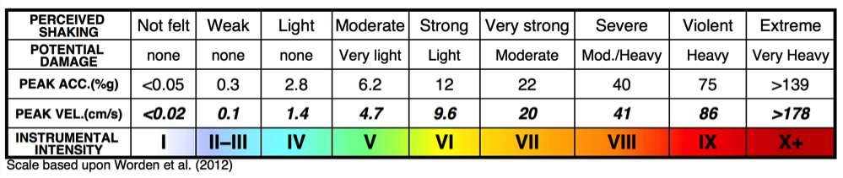

{"type":"FeatureCollection","metadata":{"generated":1616163951000,"url":"https://earthquake.usgs.gov/earthquakes/feed/v1.0/summary/all_month.geojson","title":"USGS All Earthquakes, Past Month","status":200,"api":"1.10.3","count":10744},"features":[{"type":"Feature","properties":{"mag":1.3,"place":"143 km NNW of Yakutat, Alaska","time":1616163378381,"updated":1616163746573,"tz":null,"url":"https://earthquake.usgs.gov/earthquakes/eventpage/ak0213l8clv2","detail":"https://earthquake.usgs.gov/earthquakes/feed/v1.0/detail/ak0213l8clv2.geojson","felt":null,"cdi":null,"mmi":null,"alert":null,"status":"automatic","tsunami":0,"sig":26,"net":"ak","code":"0213l8clv2","ids":",ak0213l8clv2,","sources":",ak,","types":",origin,","nst":null,"dmin":null,"rms":0.39,"gap":null,"magType":"ml","type":"earthquake","title":"M 1.3 - 143 km NNW of Yakutat, Alaska"},"geometry":{"type":"Point","coordinates":[-140.3995,60.7944,20.6]},"id":"ak0213l8clv2"},