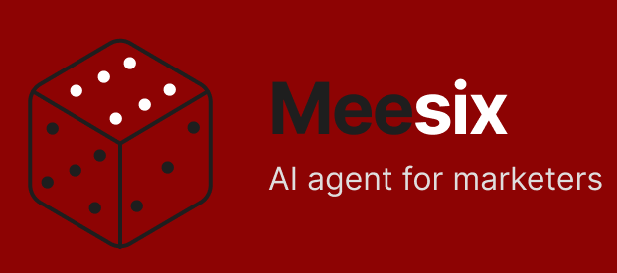
Why buyers care
Wrong budgets, geos, dates, or URLs
waste real spend.
Broken UTMs and tracking pollute
reporting before anyone notices.
Manual QA takes up to 60 to 110
minutes per launch and still misses
things.
Approval often lives in scattered Slack
messages with no audit trail.

Checks, explains, and approves campaigns before money is spent.
Meesix is the control layer for paid media launches. It validates campaign settings, protects attribution hygiene, flags expensive errors before spend goes live, and records a clean approval trail across Meta, Google Ads, and LinkedIn.
Spend protection
Faster QA
Cleaner attribution
Approval trail
02
The pain is operational, expensive, and mostly invisible.
Meesix exists because campaign launch quality still depends on manual checklists, tribal knowledge, and hurried review windows. The result is wasted spend, broken tracking, and approval processes nobody can audit later.
60
–110 min
Manual QA per multi-platform launch
Teams often spend an hour or more
checking budgets, targeting, UTMs,
schedules, landing pages, and naming
conventions before a campaign can go live.
375–1
,125 hrs
Annual QA time per team
That manual review burden can absorb the
equivalent of months of skilled campaign
manager time every year, even before error
costs are counted.
USD 5–20B
Estimated preventable configuration
waste
Misconfigured budgets, geos, scheduling,
broken destinations, and corrupted tracking
create a hidden but material waste layer
across global paid media operations.
What actually goes wrong
Budgets are set to the wrong level or against the wrong objective.
Geo targeting and schedules drift from the approved launch plan.
UTM hygiene and tracking setup fail silently, corrupting attribution.
Landing pages break, redirect, or timeout after the ad is already approved.
03
Meesix becomes the control plane before launch.
Instead of relying on a person to remember every check, Meesix runs the campaign through a repeatable read-only validation flow, summarises the result in plain language, and routes a human decision before money is exposed.
1
Connect and select
Connect Meta, Google Ads, and LinkedIn in
read-only mode, then choose the
launch-ready campaign to validate.
2
Run validation
Check budget, scheduling, geo rules, naming,
UTM hygiene, and destination health against
the workspace rule set.
3
Approve with context
Return a pass, warn, or fail verdict, explain
every issue clearly, push the summary to
Slack, and store the decision trail.
What the buyer gets
Spend protection
Catch preventable launch errors before budget is spent.
Time compression
Turn an hour of manual QA into a few minutes of review.
Attribution integrity
Protect tracking, naming, and taxonomy before data is corrupted.
Approval accountability
Create a timestamped record of what was checked and who signed off.
04
Who it is for and why it wins the first meeting.

Positioning line
Best initial buyers
Performance marketing agencies
High campaign volume, repeated launches, many clients, and
visible downside when QA fails.
Mid-market in-house paid media teams
Multi-platform spend with lean teams that cannot afford waste,
delay, or bad attribution.
Multi-brand e-commerce operators
Frequent launches and strict naming and tracking conventions
make repeatable QA valuable fast.
Meesix prevents paid media teams from shipping broken campaigns by checking, explaining, and approving launches before spend goes live.
- It leads with a concrete operational outcome, not a vague AI claim.
- It is anchored to measurable pain: wasted spend, slow QA, broken attribution, weak approval control.
- It positions Meesix as risk-control infrastructure rather than another metric dashboard.
- It gives buyers a safe adoption path because the MVP stays read-only while still proving value.
Why the message is stronger than generic "AI marketer”

