🪲 COLLEMBOT
Standard Operating Procedure
Automated counting & size analysis of Folsomia candida · OECD 232
Tool | COLLEMBOT app v0.2.3 · online: huggingface.co/spaces/MichaWehrli/COLLEMBOT · desktop: github.com/MichaWehrli/collembot_huggingface (folder desktop)
Paper | Wehrli et al. (2026) · Environ. Toxicol. Chem. · DOI: 10.1093/etojnl/vgag068
Weights | Zenodo DOI: 10.5281/zenodo.17987886 · AGPL-3.0
Date | October 2026 (updated for app v0.2.3; first version April 2026)

1. Purpose
This SOP describes how to use COLLEMBOT for automated counting and body-size measurement of
Folsomia candida in OECD 232 ecotoxicity tests. It covers imaging requirements, the three analysis tabs (Compare groups, Hand correction, Calibrate threshold), quality validation, manual correction, and reporting.
⚠️ COLLEMBOT is in beta. Validate counts against a manual count on a representative image subset before publication.

Online and desktop version
Online version (huggingface.co/spaces/MichaWehrli/COLLEMBOT): free to use, but it runs on a cloud GPU that the developers pay for by the hour. Please run only what you need and download results straight away. The app goes to sleep after 15 minutes without use; the next visitor wakes it up (this may take a few minutes), and results that were not downloaded may be lost.
Desktop version (Windows 10/11 or macOS 13 and newer): the same app, model and default settings on your own computer; images stay on your computer. Recommended for large or routine analyses. Download and instructions: github.com/MichaWehrli/collembot_huggingface (folder desktop), which also describes running the online version's container with Docker. run_settings.json in the results ZIP records whether the online or the desktop version and which device (GPU or CPU) were used.
Usage log: for functional analysis only, the online version logs one anonymous line per analysis (time, tab, browser or script, number of images, run time). No personal data, IP addresses, file names or image content are logged.

2. Imaging Setup Requirements
COLLEMBOT was trained exclusively on images matching the photobox protocol below. Images that deviate significantly — especially rectangular containers or different lighting — will result in poor detection performance that cannot be fixed by threshold adjustment.

Parameter | Required | Why it matters
Container shape | Round glass jar or Petri dish | Model trained only on round containers — circle boundary detection fails on rectangular dishes
Water | Black ink added for contrast | Organisms must be white on dark background for detection — no ink = poor contrast
Lighting | Diffuse flash or ring light (no direct overhead) | Hard shadows cause missed detections and false positives
Camera angle | Directly overhead, centred on dish | Tiling algorithm assumes flat projection — angles cause geometric distortion
Camera distance | Consistent across entire experiment | Required for px/mm scale to remain valid across all images
Resolution | ≥ 12 MP (APS-C sensor or larger) | Small juveniles become invisible below ~10px body length — YOLO cannot detect them
Optional: Ruler | Visible in frame | Needed to measure the px/mm scale (ImageJ) for mm lengths and adult/juvenile classes

✅ Supported setup
- Round glass jar or Petri dish (50–90 mm inner diameter)
- Black ink dissolved in flotation water
- Diffuse flash or ring light, no direct overhead lamp
- Camera mounted directly above, fixed distance
- Whole dish inside the image, with a margin to the right and bottom image edges (see 11. Limitations)
- Ruler visible along one edge of the image

❌ Not currently supported
- Rectangular or square dishes — circle filter cannot locate dish boundary
- Images without black ink — insufficient contrast for organism detection
- Angled or hand-held shots
- Screenshots or re-photographs of printed images

⚠️ If your images use a different setup (e.g. rectangular dishes), the calibration curve will be flat at high error regardless of threshold — this indicates a domain mismatch, not a settings problem. Contact the authors about contributing images for the next training dataset.

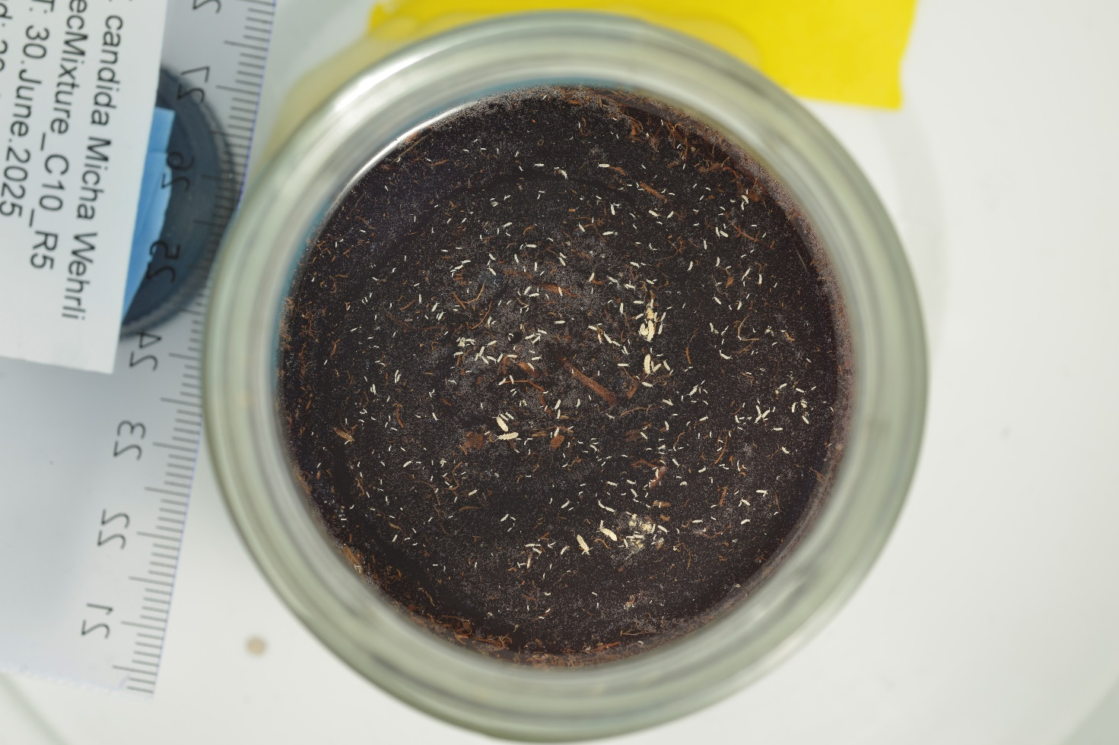
Figure 1: Example picture of a good setup

3. Standard Workflow
Step | Tab | Action | When
1 | 🎯 Calibrate | Find optimal confidence threshold | First time with a new imaging setup
2 | Compare groups | Run full experiment | Every experiment
3 | Compare groups | Review quality flags | Every experiment
4 | Optional: Hand correction | Fix flagged images | When ⚠ flags appear
5 | Compare groups | Download results (CSV or ZIP) | For every experiment

4. Image Scale (px/mm)
Scale is required for body-length measurements in mm and biology-based adult/juvenile classification. Ruler auto-detection was removed in app v0.1.1: measure the scale once per camera setup as below and enter it in the px/mm field (0 = unknown).

Manual (ImageJ)
- Open image in ImageJ · select Line tool · draw line between two known ruler marks
- Analyze → Measure · note Length in pixels
- Scale = Length ÷ known distance (mm) e.g. 480 px between the 50 and 60 mm marks = 480 ÷ 10 = 48 px/mm. Measure over 10 mm or more for precision.

5. Confidence Threshold Calibration
The default threshold is 0.732 (from the model configuration; shown in ⚙️ Advanced settings and recorded in run_settings.json). Calibrate if your imaging setup differs from the training data. Calibrate once per imaging setup; apply consistently to all images from that setup.

Procedure
- Open 🎯 Calibrate threshold tab
- Upload up to 3 images: 🟢 high count (control ~800) · 🟡 mid count (~300) · 🔴 near-zero (high-dose)
- Enter known manual count for each · the px/mm fields are optional and do not change the sweep
- Click Run calibration sweep — tests 15 thresholds (0.10–0.80)
- Review count-vs-threshold curves and sensitivity rating
- Click ✅ Apply to all tabs
💡 Sensitivity rating: Low = model is robust on your images. High = validate carefully on multiple images.

6. Batch Analysis — Compare Groups
- Upload all images from one experiment
- Group labels (comma-separated, one per image): control, control, treatment_5, treatment_5
- Enter scale · verify threshold in ⚙️ Advanced settings · click Run comparison
- Review the quality flags table — any ⚠ YES rows should be checked in Hand correction
- Download the CSV, or click Download all results (ZIP): every image annotated at full resolution (outline and ID matching the CSV), the CSV and run_settings.json (threshold, scale, versions, device)

Plot panels: (1) KDE distributions by group · (2) stacked adult/juvenile bar chart (with a px/mm scale; without a scale, adults and juveniles are shown as N/A* and the chart shows total counts) · (3) egg clutch analysis (when scale provided). With >8 images the bar chart automatically switches to per-group mean ± SD with replicate dots.

Quality flags
Flag | Trigger | Action
grid | Grid divergence >20% | Check for clumping or uneven distribution
conf | Mean confidence <0.55 | Check image quality — lighting, focus
fusion | Fusion ratio outside [0.45, 0.82] | Check for very dense or very sparse organisms
count | Count <10 | Verify organisms are visible in image
circle | Dish boundary not detected | Count may include organisms outside dish
Grubbs | Outlier within replicate group | Verify this replicate manually
adults>10 🔴 | More than 10 adults (only evaluated with a px/mm scale) | OECD 232 adds exactly 10 — check fusion errors

Note (v0.2.x): the grid and fusion flags were set for app v0.1 and can also fire on correctly counted images; treat them as hints until they are recalibrated.

7. Optional: Hand Correction
- Upload image → verify threshold in ⚙️ Advanced settings → click ▶ Run inference
- Remove mode: click a yellow detection to mark as false positive (turns red). Click again to restore.
- Add mode — Auto-polygon: click near a missed organism. Promotes grey sub-threshold candidate if one is within 40px, otherwise auto-fits a polygon using Otsu thresholding.
- Add mode — Circle marker: places a dot. Use when auto-polygon fails or organism is partially hidden.
- Bulk-remove: type IDs in the bulk-remove field and press Enter · Undo / Reset available
- Click 💾 Export — produces corrected CSV, timestamped audit log, and summary JSON
💡 The audit log records every correction with UTC timestamp. Include as supplementary material in publications for GLP traceability.

8. Size Classification & Egg Clutch Analysis
Class | Criterion | Biological basis
Adult | ≥ 1.2 mm | Original 10 animals; ~1.2–1.8 mm at OECD test end (day 37–40)
Uncertain | 1.0–1.2 mm | Transition zone — large juvenile or small adult
Juvenile | < 1.0 mm | Offspring produced during the 28-day test

Thresholds derived from DEB data for F. candida at 20°C (Hamda 2014, Add-my-pet). Without scale, Compare groups does not classify adults and juveniles (shown as N/A*); the Hand correction tab still shows a 2-component GMM size class, which may split egg clutches rather than life stages.

Egg clutch detection: when scale is provided and ≥8 juveniles detected, a BIC-selected GMM (up to 4 components) identifies distinct hatching cohorts. Clutch 1 = oldest/largest (laid ~day 7–14), Clutch 2 = next cohort (~7–10 days later).

9. OECD 232 Validity Criteria
Check these manually from the exported CSV for control replicates:
Criterion | Requirement | How to check
Adult mortality in controls | ≤ 20% | Adults column: OECD adds 10; ≥8 detected = ≤20% mortality
Mean juveniles per vessel | ≥ 100 | Count column, control rows
CV of juvenile counts | < 30% | Calculate from Count column across control replicates

10. Reporting Requirements
Include the following in your methods section:
- Software: COLLEMBOT, app version as shown in the app title and in run_settings.json (e.g. v0.2.3), online or desktop version (Wehrli et al. 2026, DOI: 10.1093/etojnl/vgag068)
- Model weights: Zenodo DOI: 10.5281/zenodo.17987886
- Confidence threshold used (recorded in run_settings.json in the Compare-groups results ZIP; not in the CSV or the Hand-correction export, so note it yourself for Hand correction)
- Scale (px/mm) and how it was determined (e.g. measured in ImageJ)
- Classification method: biology-based (adults ≥1.2 mm) or GMM fallback
- Number of manual corrections and basis (attach audit log as supplementary)
- Validation: whether counts were compared to manual counts and agreement (%)
- Archive run_settings.json from the results ZIP with your data (threshold, scale, app and software versions, online or desktop version, device)

Example methods text
"Collembola were counted using COLLEMBOT (app version X.X.X, online/desktop version; Wehrli et al. 2026). The confidence threshold was calibrated against manually counted images from our imaging setup (threshold: X.XX). Images were analysed in batch using the Compare groups function at XX px/mm. Quality-flagged images were reviewed and corrected in the Hand correction tab; all corrections are in the supplementary audit log. COLLEMBOT counts were validated against manual counts on [N] images (mean absolute difference: [X]%)."

11. Limitations
Issue | Details | Mitigation
Domain generalisation | Model trained on 6 specific labs; novel setups may reduce accuracy | Calibrate threshold; report limitations
Dense clusters | Touching organisms may be merged or missed | Review fusion-flagged images in Hand correction
Length accuracy | Minimum bounding rectangle underestimates curled organisms | Use size class trends, not absolute lengths
No scale provided | GMM may split clutches rather than life stages | Always provide px/mm for classification
Near-zero counts | Large % errors when counts are 0–10 | Use absolute error, not % error, at high doses
Image edges | Tiles do not cover a strip along the right and bottom image edges (up to one tile, 576 px); animals there are not counted (same in the published pipeline) | Keep the whole dish inside the image with a margin to the right and bottom edges
Dish detection | The dish circle is not always found (e.g. very dark water) and can include the jar wall; objects outside the jar or on the wall can then be counted | Check images with the circle flag; remove false detections in Hand correction

