EE445L – Lab 11: Final Project (Smart Display)
Michael Park and Jack Zhao
05/06/16

1.0 OBJECTIVE
Requirements document
1. Overview
1.1. Objectives: Why are we doing this project? What is the purpose?
The objectives of this project are to design, build and test an embedded system.
Educationally, we are learning how to create a stand-alone system using PCB. It also serves as a
comprehensive review of the materials we learned throughout this semester, such as ADC, Speaker,
LCD, switch interfacing. Our goal is to create a stand-alone smart display system.

1.2. Process: How will the project be developed?
The project will be developed using a TM4C123GH6PM microcontroller, PCB, and relative circuits, LCD, and a Wifi module. The system will be battery-powered and will have four external swtiches, a slide pot, and a speaker. There will be at least four hardware/software modules: switch input, slide pot input, LCD graphics, and a sound output.The process will be to design and test each module independently from the other modules. After each module is tested, the system will be built and tested.

1.3. Roles and Responsibilities: Who will do what? Who are the clients?
The client is our TA Mahesh. Michael and Jack will deisgn the smart display system
together. Michael will design the system software and build prototype. Jack will design PCB and
write software to pull data from web servers. Together Michael and Jack will integrate the entire
system.

1.4. Interactions with Existing Systems: Include this if you are connecting to another board
Our system will be connected to a ESP mini Wifi board.

1.5. Security: How will intellectual property be managed?
The software written for our projects will be kept in our cloud and hard drive.

2. Function Description
2.1. Functionality: What will the system do precisely?
The system is a stand-alone device to display real-time information and also act as an alarm clock. More precisely, it will be placed on a desk or a night stand. It will pull data from open servers and display information. The information and functionalities include weather forcast, temperature, calendar, Reddit Shower thought, stock information, and an alaram clock. There will be buttons to set time and to snooze the alarm. There will be a slide pot on the side of our box to change screens to see different information.

2.2. Scope: List the phases and what will be delivered in each phase.
Phase 1 is the preparation; phase 2 is the demonstration; and phase 3 is the lab report. Details can be found in the lab manual.

2.3. Prototypes: How will intermediate progress be demonstrated?
A prototype system running on the TM4C controller soldered on our PCB board will be demonstrated. Progress will be judged by the preparation, demonstration and lab report.

2.4. Performance: Define the measures and describe how they will be determined.
The performance will be measured based on the time it takes to retreive data from a server
, ADC jitter, and Input/Output current/voltage for speaker.

2.5. Usability: Describe the interfaces. Be quantitative if possible.
Our system will be interfaced with ESP wifi module. There will be four switches interfaced,
used for setting time, setting alarm, snoozing alarm, and updating information. It will also be
interfaced to an LCD screen and to a speaker. Our speaker will simply be interfaced with a
transistor circuit to make buzzing sound for alarm. Lastly, there will be a slidepot used to scroll the
screen display sideways. We will use an LCD screen to display time, alarm, weather, calendar, news, stock, gas price, and currency exchange rate. There will be two ISRs. One for switch interface and the other for making sound.

2.6. Safety: Explain any safety requirements and how they will be measured.
The alarm sound will be VERY quiet in order to respect other people in the room during testing. The box that contains our system should not be shaken or dropped.

3. Deliverables
3.1. Reports: Simply state the reports for Lab11 will be written
This document is a deliverable that entails the details of our final project.

3.2. Outcomes: Simply copy/paste the Lab 11 deliverables.
A) Objectives
2-page requirements document
B) Hardware Design
Detailed circuit diagram of the system (from Lab 7)
C) Software Design (no software printout in the report)
Briefly explain how your software works (1/2 page maximum)
D) Measurement Data
Include data as appropriate for your system. Explain how the data was collected.
E) Analysis and Discussion (none). The YouTube video is required

2.0 HARDWARE DESIGN
Detailed circuit diagram of the system (from Lab 7)
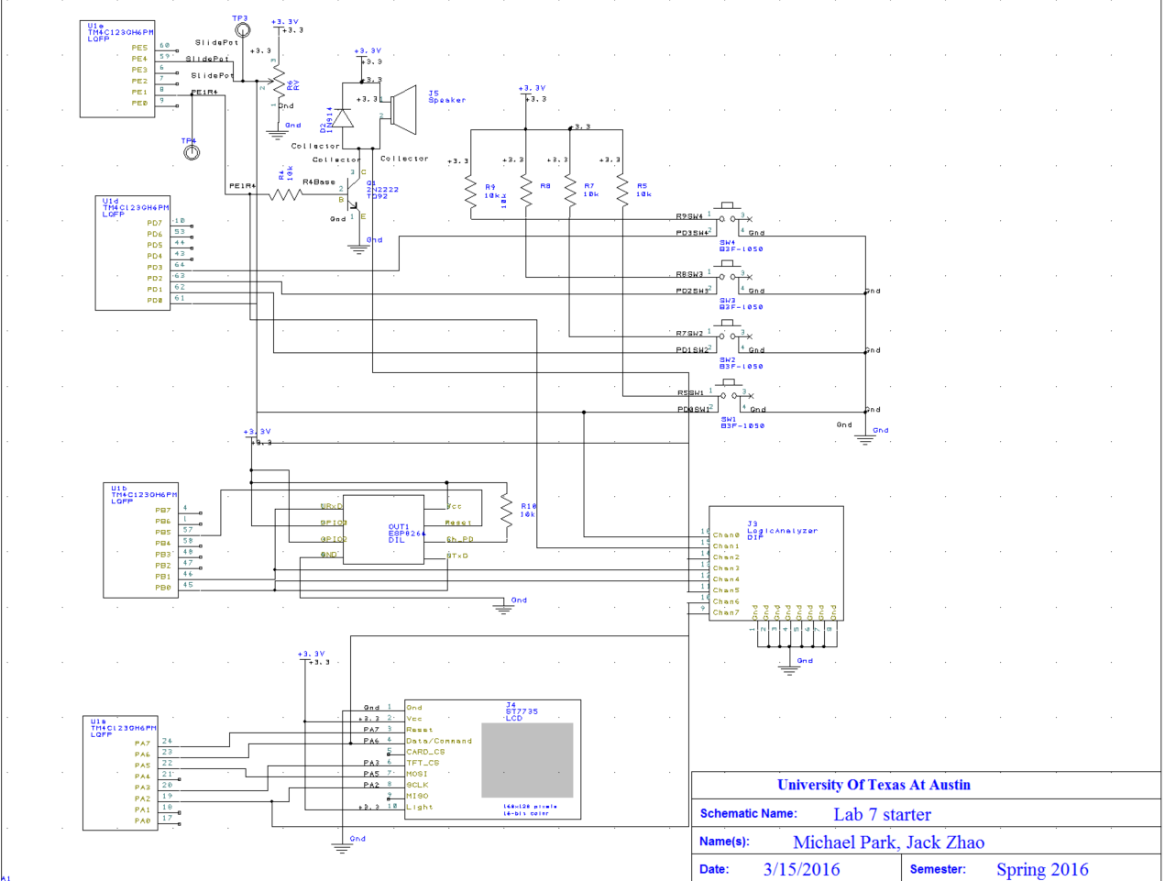
Figure 1: Schematic Final Project
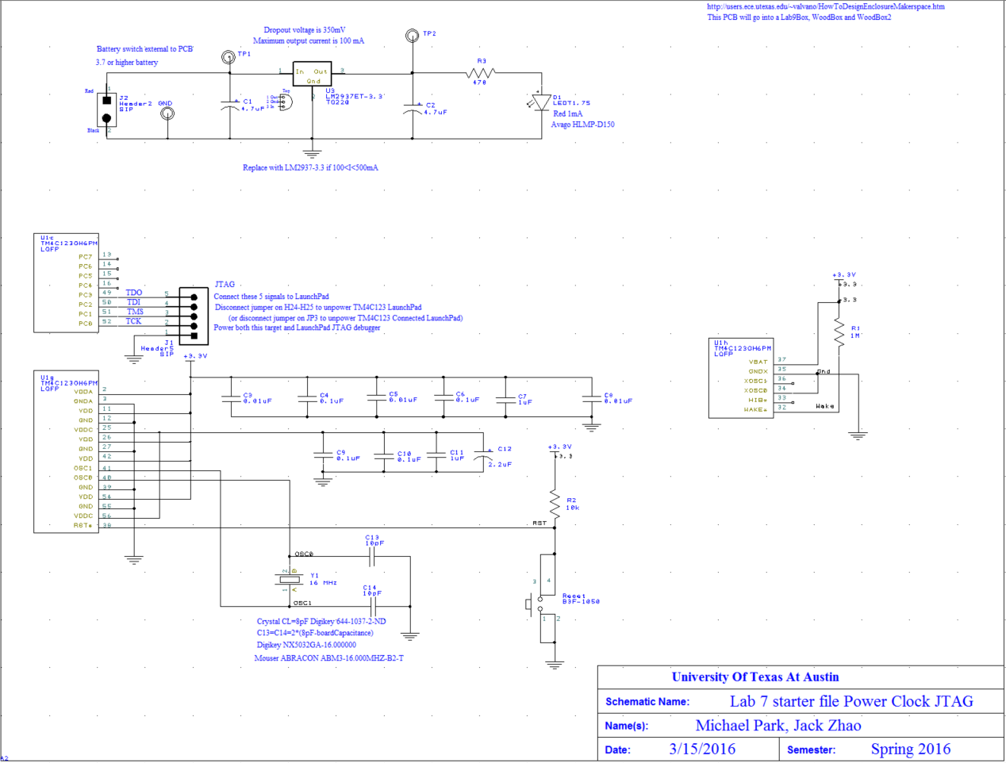
Figure 2:Schematic -power, reset, JTAG

3.0 SOFTWARE DESIGN

Our software includes the device drivers for the ESP Wifi module and the ST7735 LCD display. It also includes modules for the ADC software trigger, switches, and four timers. The timers are used respectively for generating a sound, updating time, updating display periodically, and debouncing switches (Systick). All modules mentioned will be initialized with the start of the system, and in a main while loop, the program will either wait for the interrupts or retreive data from servers every hour.

4.0 MEASUREMENT DATA

1) Time To pull all the data:
- 1minute 26 seconds
- Our system prints a bootpage that shows initialization of the Wifi module on the LCD. After the initialization, we measured the time to load all the pages using a stop watch.

2) ADC jitter:
- 8 raw ADC values.
- 1000 ADC values were sampled with no hardware averaging. Jitter was measured by the difference between the maximum ADC value and the minimum ADC value sampled.

5.0 YOUTUBE VIDEO

Link : https://www.youtube.com/watch?v=H84XfKYSuqw&feature=youtu.be

