EE445L – Lab 7: Design and Layout of an Embedded System
Michael Park and Jack Zhao
4/1/16

1.0 OBJECTIVE
Requirements document
1. Overview
1.1. Objectives: Why are we doing this project? What is the purpose?
The objectives of this project are to design, build and test an embedded system.
Educationally, we are learning how to create a stand-alone system using PCB. It also serves as a
comprehensive review of the materials we learned throughout this semester, such as ADC, Speaker,
LCD, switch interfacing. Our goal is to create a stand-alone smart display system.

1.2. Roles and Responsibilities: Who will do what? Who are the clients?
The client is our TA Mahesh. Michael and Jack will deisgn the smart display system
together. Michael will design the system software and build prototype. Jack will design PCB and
write software to pull data from web servers. Together Michael and Jack will integrate the entire
system.

1.3. Interactions with Existing Systems: Include this if you are connecting to another board
Our system will be connected to a ESP mini Wifi board.

2. Function Description
2.1. Functionality: What will the system do precisely?
The system is a stand-alone display device used for news updates, weather forcast,
temperature, social media notifications, and an alaram clock. More precisely, it will be placed on a
desk or a night stand. It will pull data from open servers and display notable information. It will be
capable of displaying different time zones and weather zones. It also has an alarm clock
functionality. There will be buttons to set alarm and refresh updates on notable information. There
will be a light sensor to automatically audjust the brightness of a screen.

2.4. Performance: Define the measures and describe how they will be determined.
The performance will be measured based on the time it takes to retreive data from a server
and data loss, ADC jitter, and switch response time.

2.5. Usability: Describe the interfaces. Be quantitative if possible.
Our system will be interfaced with ESP wifi module. There will be four switches interfaced,
used for setting time, setting alarm, snoozing alarm, and updating information. It will also be
interfaced to an LCD screen and to a speaker. Our speaker will simply be interfaced with a
transistor circuit to make buzzing sound for alarm. Lastly, there will be a slidepot used to scroll the
screen display sideways. We will use an LCD screen to display time, alarm, weather, calendar, news, stock, gas price, and currency exchange rate. There will be two ISRs. One for switch interface and the other for making sound.

3. Deliverables
3.1. Reports: Simply state the reports for Labs 7 and 11 will be written
Reports for Labs 7 and 11 will be written.
3.2. Outcomes: Simply copy/paste the Lab 7 and Lab 11 deliverables.
Lab7:
A) Objectives
1-page requirements document
B) Hardware Design
Regular circuit diagram (SCH file)
PCB layout and three printouts (top, bottom and combined)
C) Software Design
Include the requirements document (Preparation a)
D) Measurement Data
Give the estimated current (Procedure d)
Give the estimated cost (Procedure e)
E) Analysis and Discussion (none)
Lab11:
A) Objectives
2-page requirements document
B) Hardware Design
Detailed circuit diagram of the system (from Lab 7)
C) Software Design (no software printout in the report)
Briefly explain how your software works (1/2 page maximum)
D) Measurement Data
Include data as appropriate for your system. Explain how the data was collected.
E) Analysis and Discussion (none). The YouTube video is required

2.0 HARDWARE DESIGN
Regular circuit diagram (SCH file)
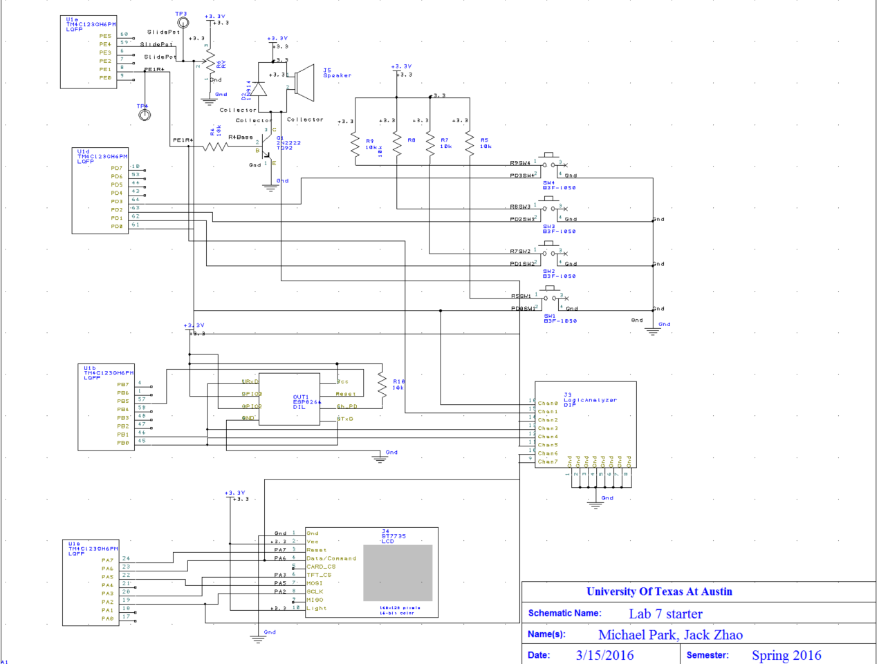
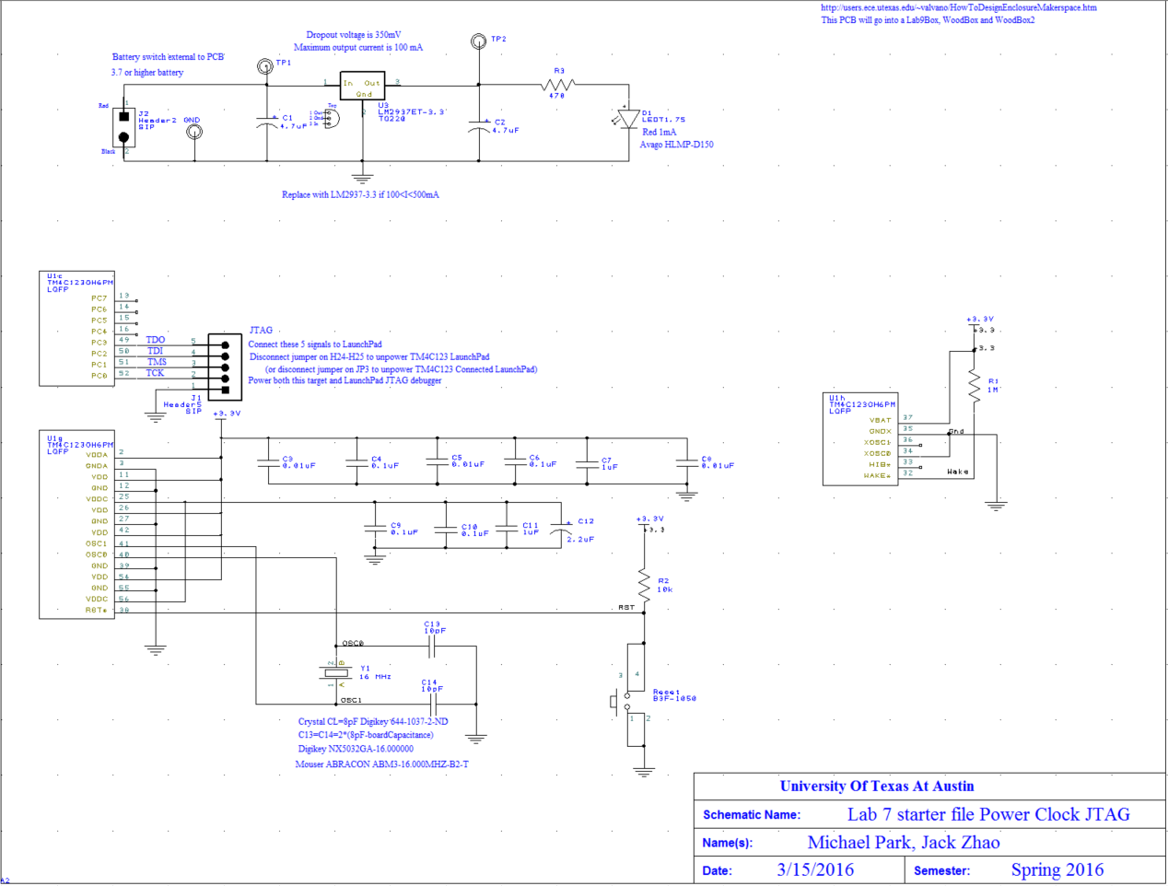
PCB layout and three printouts (top, bottom and combined)
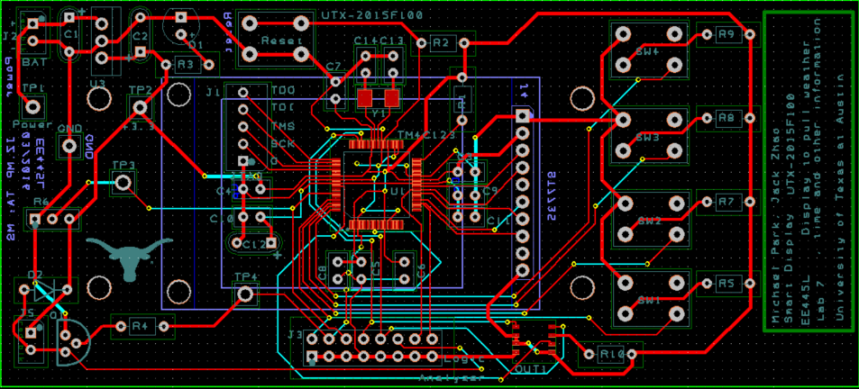

3.0 SOFTWARE DESIGN
Include the requirements document (Preparation a)
-Refer to 1.0 Requirements Document under objectives

4.0 MEASUREMENT DATA
Give the estimated current (Procedure d)
From Lab3, the estimated current required with alarm is 0.071A
ESP Wifi module requires 80mA or 0.08A
Therefore total estimated current is 0.151A

Give the estimated cost (Procedure e)

