PreLab2 Questions
Michael Park, Jack Zhao
a) What is the purpose of all the DCW statements?
DCW places the 16-bit half-word into memory. This is useful because it allows us to assist and control the assembly process. In this case this is helpful in storing large expressions into memory for us to call and use later, even if a certain execution requires more space to run than is available in the registers.

b) The main program toggles PF1. Neglecting interrupts for this part, estimate how fast PF1 will toggle.
The main program executes at a clock rate of 80Mhz frequency. This means that the program will execute a line every 12.5 ns. If there are 6 asm lines to execute the while loop, the program will toggle PF1 at approximately every 75 ns.

c) What is in R0 after the first LDR is executed? What is in R0 after the second LDR is executed?
This instruction will store the pc or the Program counter into r0 and will increment it by #24. After the second LDR is called, the r0 will store the r0 with an index of #0x08 back into r0.

d) How would you have written the compiler to remove an instruction?
Remove STR r0,[r1,#0x08], because at that point r1 + #0x08 is equal to the program counter reloaded on the first line (pc + #24). It is redundant.

e) 100-Hz ADC sampling occurs in the Timer0 ISR. The ISR toggles PF2 three times. Toggling three times in the ISR allows you to measure both the time to execute the ISR and the time between interrupts. See Figure 2.1. Do these two read-modify write sequences to Port F create a critical section? If yes, describe how to remove the critical section? If no, justify your answer?
Yes the non-reentrant read-modify-write sequence creates a critical section. We can eliminate the critical section by either removing the access to the global variables (PF2, ADCvalue) or implementing mutual exclusion. Since we need the global variables for the desired function, we can create a mutual exclusion by disabling the interrupt before measuring the ADC value (critical section) and then enable it right after.

This assembly code was obtained by observing the assembly listing in the debugger. You may see different assembly on your machine because of differences in the compiler version or optimization settings. You are allowed to solve the preparation with either this assembly or the assembly you see on your computer.

0x0000067E 4806 LDR r0,[pc,#24] ; @0x0000068C  0x00000680 6880 LDR r0,[r0,#0x08]  0x00000682 F0800002 EOR r0,r0,#0x02  0x00000686 4904 LDR r1,[pc,#16] ; @0x0000068C  0x00000688 6088 STR r0,[r1,#0x08]  0x0000068A E7F8 B 0x0000067E  0x0000068C E608 DCW 0xE608  0x0000068E 400F DCW 0x400F  0x00000684 5400 DCW 0x5400  0x00000686 4002 DCW 0x4002  0x00000688 551C DCW 0x551C  0x0000068A 4002 DCW 0x4002  0x0000068C 5000 DCW 0x5000  0x0000068E 4002 DCW 0x4002 | while(1){  PF1 ^= 0x02;  }

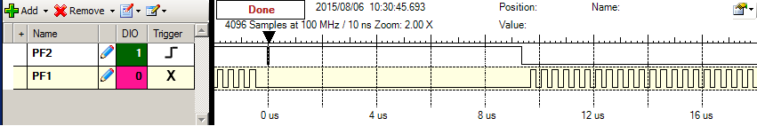Figure 2.1. Zoomed in view of the PF1 PF2 recording to see a) the main program does not run while the ISR is running and b) the time to execute the ISR is about 10us (most of this 10us occurs converting the ADC).

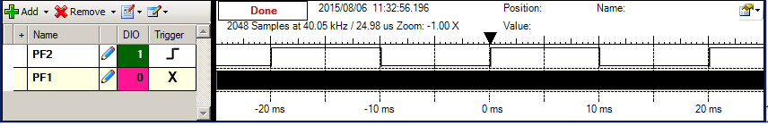Figure 2.2. Zoomed out view of the PF1 PF2 recording to see a) the ISR runs every 10ms and b) most of the processor time is allocated to running the main program.

