**DATE:** September 09, 2016

**TO:** Jonathan Valvano

Amal Kouttab

**FROM:** Corey Cormier

Thomas Ermis

Albert Marzullo

Michael Park

Makeila Sorensen

Anish Vaghasia

**SUBJECT:** Design Implementation Plan for a Data Acquisition System

**INTRODUCTION**

This report details the design and implementation plan of a data acquisition system that will aid in research environments that use lab animals, specifically rats, for testing purposes. This system will allow the user to wirelessly collect measurements from lab animals to store and display the data to the user. In normal lab environments, it can be difficult for researchers to take multiple internal measurements of lab animals for experimental purposes. Therefore, a system that will allow the researcher to make several quick measurements from lab animals without having to manually test the subject would provide a great benefit to many research companies.

This report also serves as a review of the efforts made so far, and defines what the team will deliver by the end of the semester. The design of the system was created after careful consideration and will be implemented according to a detailed schedule. The system design was shaped by the various needs of the client and the conditions which the system will operate under. The final deliverables given at the end of the semester will include a prototype that meets these needs and specifications as well as the documentation for the system. The proposed design calls for a three subsystem approach including an implant, a base station, and a web application. The implant will be surgically implanted inside the rat and will collect data. The base station will wirelessly power and communicate with the implant and, in turn, wirelessly relay the data to a web application. The web application will store and display information to the user. To finish this complex design in time for the ECE Open House, our team created a detailed implementation plan. First the project was broken up into tasks that were individually assigned based on each team member’s expertise and interest. Then, timeframes and dependencies were estimated for each task to map out a schedule for the semester. Next, a budget table was created to track the costs of the project. Finally, steps were taken and plans were made to mitigate the risks of lacking parts, time, and data loss. Having finished the design, we will use this implementation plan to ensure that we deliver a functioning prototype and its associated documentation by the ECE Open House.

**OVERVIEW OF DESIGN PROBLEM**

In order to make the collection of data from laboratory rats less expensive and more efficient, Dr. Valvano asked our team to design a data acquisition system. Ultimately, the system will need to allow scientists to collect and view data from laboratory rats. The following sections elaborate on the current problem, the design specifications, and the final deliverables.

**Description**

Current methods that scientists use to acquire and analyze data from laboratory rats are expensive and inefficient. Each time a scientist wants to collect data from a rat, he or she needs to manually collect blood and urine samples. Once the samples have been processed, the scientist needs to filter through and analyze the results. Furthermore, this procedure needs to be consistently repeated in order to have up-to-date and accurate data. As previously stated, these methods are both time-consuming and expensive. Therefore, our team is responsible for designing a system that will allow scientists to accurately and efficiently collect and view data from laboratory rats.

As the primary stakeholder of our project, Dr. Valvano, needs the system to consist of three subsystems. The first subsystem is a small, battery-less, and wireless implant embedded in a rat that collects the temperature and acceleration of the rat. The second subsystem is a base station, external to the rat, that wirelessly powers the implant and communicates with it. The third subsystem is a web application that wirelessly communicates with the base station and displays and stores the temperature and acceleration data collected from the rat. With such a system, scientists would be able to inexpensively and efficiently monitor the temperature and acceleration of a rat from a web application.

**Specifications**

In order for the system to operate as accurately and efficiently as possible, both the overall system and the individual subsystems need to adhere to certain performance specifications. For example, because the system will be used by scientists in research laboratories, it is vital that the temperature and acceleration data is accurate, precise, and reliable. In addition, the process of collecting the data from the rat and displaying it back to the user needs to be efficient and user-friendly. Table 1 outlines the specifications for the overall system in more detail.

**Table 1. System Specifications**

|  |  |  |
| --- | --- | --- |
| **Name** | **Description** | **Specification** |
| Maximum Response Time | Maximum length of time in which the system has to respond to the user | 60 seconds |
| Measurement Accuracy | Accuracy of the temperature and acceleration measurements | ≥ 95% |

In the following subsections, we describe the performance specifications for each of the three subsystems: the implant, the base station, and the web application.

***Implant Specifications***

Because the implant will be embedded in a rat, it has the most requirements and constraints to comply with. First, the implant must have a decent lifespan so that it does not need to be constantly replaced. Second, the implant needs to be sterile, biocompatible, small, battery-less, and wireless so that it does not adversely affect the rat. Finally, the implant must be able to operate independent of the temperature of the rat and its surroundings. Table 2 explains the specifications for the implant in more detail.

**Table 2. Implant Specifications**

|  |  |  |
| --- | --- | --- |
| **Name** | **Description** | **Specification** |
| Minimum Lifespan | Minimum length of time in which the implant has to operate from the time of implantation | 6 months |
| Sterility | Minimum sterility assurance level of the implant | SAL of 10-6 [1] |
| Biocompatibility | Minimum standard of biocompatibility of the implant | ISO 10993 [1] |
| Maximum Length | Maximum length of the implant | 5 cm |
| Maximum Width | Maximum width of the implant | 5 cm |
| Maximum Height | Maximum height of the implant | 0.3 cm |
| Operating Temperature | Range of temperature in which the implant has to operate | 0° to 45° C |

***Base Station Specifications***

Unlike the implant, the base station will be outside of the rat, most likely attached to the cage. The main purpose of the base station is to wirelessly power the implant and communicate with it. Therefore, the base station needs to transmit power and data from minimum distance and at a minimum bandwidth. In addition, because the base station needs to accommodate the layout of the laboratory, it needs to be portable. Furthermore, the base station must be able to operate independent of the temperature of its environment. Table 3 describes the specifications for the base station in more detail.

**Table 3. Base Station Specifications**

|  |  |  |
| --- | --- | --- |
| **Name** | **Description** | **Specification** |
| Maximum Length | Maximum length of the base station | 30 cm |
| Maximum Width | Maximum width of the base station | 30 cm |
| Maximum Height | Maximum height of the base station | 30 cm |
| Operating Temperature | Range of temperature in which the implant has to operate | 0° to 45° C |
| Distance | Distance at which the base station is required to wirelessly power and communicate with the implant | 12 cm |
| Minimum Bandwidth | Minimum frequency at which the base station and implant have to be able to wirelessly communicate | 1 Hz |

***Web Application Specifications***

In order to accommodate the number of users and volume of data traffic, the web application needs to be universal and scalable. First, it needs to run on a wide range of platforms and browsers so that a variety of users can access the web application regardless of the type of machine they are using. Second, the web application needs to be vertically and horizontally scalable so that it can handle large quantities of users and transactions. Table 4 outlines the specifications for the web application in more detail.

**Table 4. Web Application Specifications**

|  |  |  |
| --- | --- | --- |
| **Name** | **Description** | **Specification** |
| Platforms | Minimum platforms the web application needs to be accessed on | Windows 7, Mac OS X, Linux |
| Browsers | Minimum browsers the web application needs to be accessed on | Chrome 49, Firefox 45 |
| Scalability | Level of scalability offered by the web application | Horizontal, Vertical |

**Deliverables**

The deliverables for our project include a prototype of the system and the associated documentation. The prototype of the system will consist of three subsystems. The first subsystem will be a small, battery-less and wireless implant that collects the temperature and acceleration from an external sensor. The second subsystem will be a base station that uses induction coils to wirelessly power the implant and communicate with it. Additionally, it will use Wi-Fi to wirelessly communicate with the web application. The third subsystem will be a web application that allows the user to request data from the implant, stores the data in a database, and displays the data back to the user.

The documentation will include documentation for both our stakeholder, Dr. Valvano, and for the typical user of our system. For Dr. Valvano, we will provide block diagrams, circuit schematics, PCB layouts, and the code for both the implant and the base station. Furthermore, we will provide full access to the web application and its code. For the user, we will provide documentation containing instructions for installing, operating, and maintaining the system. We plan to deliver the prototype and the associated documentation by December 5, 2016, the last day of the Fall 2016 semester.

**DESIGN CONCEPT**

The prototype of the system will be comprised of three subsystems will provide the user with data from the implant. As illustrated in Figure 1, the three subsystems are an implant, a base station, and a web application. The web application allows the user to request data from the implant. Once the data request is initiated, the web application sends a command to the base station. From there, the base station uses induction coils to wirelessly power the implant and relay the command. Upon collecting the requested data from the rat, the implant then uses induction coils to wirelessly transfer the data back to the base station. The base station then relays the data back to the web application. Finally, the web application stores the data in a database and displays the data back to the user.

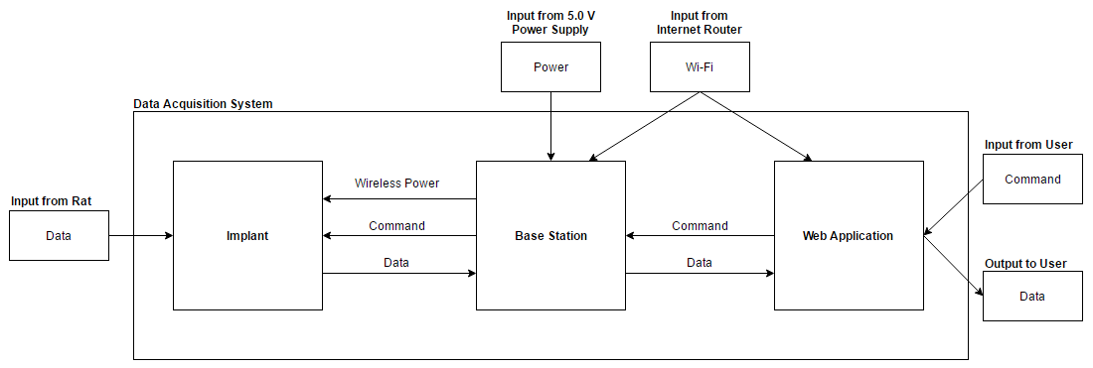

**Figure 1. System Block Diagram**

In the following subsections, we describe the design for each subsystem in more detail. For each subsystem, we explain the functionality, the input and output specifications, and the implementation. Furthermore, we discuss alternative designs that our team had considered for each subsystem.

**Implant Design**

The implant subsystem consists of a microcontroller and an accelerometer with a thermistor on a two-layer PCB with the appropriate bypass capacitors. The coil used for power transfer and communication is etched onto the PCB in a spiral design on the bottom layer. This approach is the simplest design necessary to fulfill the specifications. As shown in Figure 2 below, the base station will send a one-byte command to the implant using the ISO15693 protocol. A value of 0 will prompt the microcontroller to retrieve a temperature measurement, and a value of 1 will prompt the microcontroller to retrieve an acceleration measurement. The microcontroller communicates with the accelerometer using I2C.  Once the microcontroller has the data, it sends the data to the base station using the same protocol.

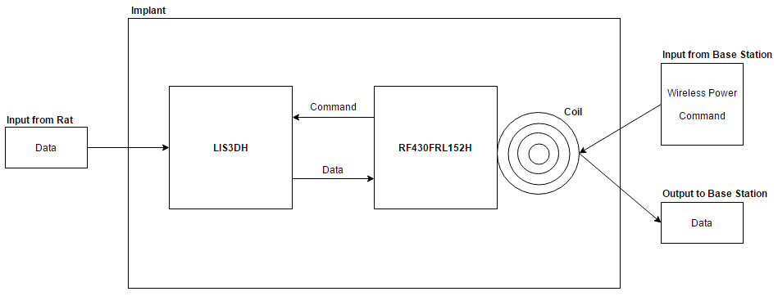

**Figure 2. Implant Block Diagram**

In order to ensure that the implant can perform the tasks listed above, there are certain input and output specifications that it must meet. In order for the implant to do anything, enough power must be transferred through the induction coils to power the microcontroller and accelerometer. The implant must also be able to operate within a certain distance from the base station so that the implant will continue to function even as the rat moves around. Finally, the implant must be able to take data in from the rat as well as send that data to the base station so that the user will receive the data that was requested. Tables 5 and 6 outline the input and output specifications for the implant in more detail.

**Table 5. Implant Input Specifications**

|  |  |  |  |
| --- | --- | --- | --- |
| **From** | **Name** | **Description** | **Specification** |
| Base Station | Wireless Power | Amount of power transferred within a certain distance | Range   * 0 to 200 mW * 0 to 12 cm   Accuracy   * ± 0 mW * ± 0.01 cm |
| Base Station | Command | Command to collect data from the rat | See Table D-1  “Command Specifications” in Appendix D “Further Specifications” |
| Rat | Data | Data collected from the rat | See Table D-2  “Data Specifications” in Appendix D “Further Specifications” |

**Table 6. Implant Output Specifications**

|  |  |  |  |
| --- | --- | --- | --- |
| **To** | **Name** | **Description** | **Specification** |
| Base Station | Data | Data collected from the rat | See Table D-2  “Data Specifications” in Appendix D “Further Specifications” |

For the microcontroller, our design is using the RF430FRL152H. This chip is very similar to the MSP430 but with the ISO15693 stack and power management system internally implemented. Our alternative design was using an MSP430 microcontroller and two separate coils for power and communication. The power management side would consist of a voltage doubler and a regulator, and the communication side would consist of a transistor that the microcontroller would control to detune the coil by shorting part of it. The reason we chose the RF430 is because it greatly simplifies the design, allowing us to make the implant smaller.

The accelerometer our design uses is the LIS3DH. We chose this chip because it requires a very small amount of power, it can communicate over I2C, and its footprint is very small. This helps us meet our size and maximum power specifications. There are other alternative accelerometers that fit our requirements, but there is no reason to switch because this one is simple and we had already written code to interface to it.

The coil design is still undergoing design changes as we continually reevaluate the tradeoff between coil size and the maximum distance from the base station that the implant can operate. As of writing, the current design was created with the following procedures. First we used a network analyzer to measure the equivalent capacitance of the circuit. Then to find the required inductance, we used the formula fr =12LC. Fr, the resonant frequency in Hertz, must be 13.56MHz for the ISO15693 protocol. Solving for L with our measured capacitance of approximately 45pF, we obtained a required inductance of 3μH. Using an online spiral inductor calculator, we iteratively added turns until the inductance was correct [9]. Using a trace spacing of 0.2mm, the closest inductance we could get was around 2.8μH, so we added a 2-10pF tunable capacitor to allow for a correction.

**Base Station Design**

The second subsystem of the data acquisition system is the base station. As depicted in Figure 3 below, the base station will serve as the power source for the implant and as a relay for communication between the implant and the web application. The specifications that the base station needs to adhere to are explained below.

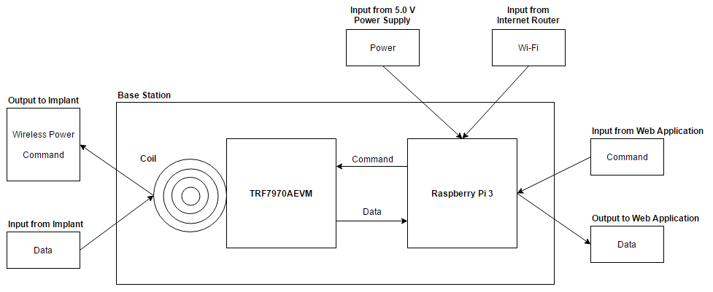

**Figure 3. Base Station Block Diagram**

The base station will accept inputs from a power supply, an internet router, the web application, and the implant, and will send outputs back to the implant and the web application. The power supply will provide power to the base station whereas the internet router will provide the base station with access to Wi-Fi. The base station will always be in standby to receive data commands from the web application. The data command will be 0 for collecting a temperature data and 1 for collecting an acceleration data. Upon receiving a data command, the base station will wirelessly power the implant and relay the data command to the implant. When the implant responds with temperature and acceleration data, the base station will output that data back to the web application. Tables 7 and 8 outline the input and output specifications for the base station in more detail.

**Table 7. Base Station Input Specifications**

|  |  |  |  |
| --- | --- | --- | --- |
| **From** | **Name** | **Description** | **Specification** |
| Power Supply | Power | Power supply for the base station | Value   * 5.0 V * 1 A   Accuracy   * ± 0 V * ± 0 A |
| Internet Router | Wi-Fi | Wi-Fi for the base station | Wi-Fi |
| Web Application | Command | Command that collects data from the rat | See Table D-1  “Command Specifications” in Appendix D “Further Specifications” |
| Implant | Data | Data collected from the rat | See Table D-2  “Data Specifications” in Appendix D “Further Specifications” |

**Table 8. Base Station Output Specifications**

|  |  |  |  |
| --- | --- | --- | --- |
| **To** | **Name** | **Description** | **Specification** |
| Implant | Wireless Power | Amount of power transferred within a certain distance | Range   * 0 to 200 mW * 0 to 12 cm   Accuracy   * ± 0 mW * ± 0.01 cm |
| Implant | Command | Command to collect data from the rat | See Table D-1  “Command Specifications” in Appendix D “Further Specifications” |
| Web Application | Data | Data collected from the rat | See Table D-2  “Data Specifications” in Appendix D “Further Specifications” |

The base station will be implemented using a NFC/RFID transceiver evaluation board, a coil, a single board computer (SBC) with a built-in Wi-Fi module, and a power supply.  The power supply will power both the SPC and NFC/RFID transceiver evaluation board (which is plugged into the SBC), while the coil will be powered by the evaluation board. The data collected from the implant will travel through the coil, NFC/RFID transceiver evaluation board, and the SBC to reach the web application. The coil will receive a signal containing the collected data which, in turn, will be converted into binary and decoded into decimal data by the NFC/RFID transceiver evaluation board. Once the SBC receives the decoded data from the evaluation board (through USB serial communication), the SBC will pack the data into JavaScript Object Notation **(**JSON) and use Wi-Fi to transmit it to the web application. When the web application sends commands to the implant, the data will go through the base station modules in the opposite order with identical communication protocols and data formats.

We chose the components for our base station modules to meet all the requirements and the specifications mentioned previously. Firstly, we used TRF7970AEVM for the NFC/RFID transceiver evaluation board. This component allows us to directly power and control the coil to communicate with the implant. Secondly, we used the Raspberry Pi 3 for the SBC because of its built-in Wi-Fi module and easy programmability. The Raspberry Pi 3 allows us to interface the base station with the web application and control the evaluation board in a reliable manner. Thus, our combined implementation of the base station using TRF7970AEVM and Raspberry Pi 3 allows us to simultaneously wirelessly power the implant and communicate with the implant and web application.

We considered a few alternatives for the base station: including other SBCs and microcontrollers. We considered using a BeagleBone, an Odroid XU4, or a TM4C123 and ESP8266 Wi-Fi module. However, we decided to opt out the TM4C123 and the ESP8266 in favor of SBCs for simplicity in the design. We picked Raspberry Pi 3 over BeagleBone and Odroid XU4 because it is the only SBC with a built-in Wi-Fi module, which eliminated the cost of purchasing an extra external Wi-Fi attachment.

**Web Application Design**

The third subsystem is the web application, which also doubles as the user interface. The main purpose of the web application is to allow the user to control and interact with the data acquisition system. The web application receives inputs from an internet router and the user, and will send outputs to the base station and the user. Tables 9 and 10 outline the input and output specifications for the web application in more detail.

**Table 9. Web Application Input Specifications**

|  |  |  |  |
| --- | --- | --- | --- |
| **From** | **Input** | **Description** | **Specification** |
| Internet Router | Wi-Fi | Wi-Fi for the web application | Wi-Fi |
| User | Command | Command to collect data from the rat | See Table D-1  “Command Specifications” in Appendix D “Further Specifications” |
| Base Station | Data | Data collected from the rat | See Table D-2  “Data Specifications” in Appendix D “Further Specifications” |

**Table 10. Web Application Output Specifications**

|  |  |  |  |
| --- | --- | --- | --- |
| **To** | **Output** | **Description** | **Specification** |
| Base Station | Command | Command to collect data from the rat | See Table D-1  “Command Specifications” in Appendix D “Further Specifications” |
| User | Data | Data collected from the rat | See Table D-2  “Data Specifications” in Appendix D “Further Specifications” |

The web application is built on IBM Bluemix, a cloud platform for developing scalable web and mobile applications. As depicted in Figure 4, the web application consists of four components. Two of the components form the actual web application while the other two components are back-end services. For the web application, the first component runs on Node.js and leverages HTML, CSS, and JavaScript. It allows the user to request data from the implant and then processes and displays the returned data. The second component runs on Node-RED and leverages JavaScript to store the returned data in a database. For the back-end services, we used IBM Watson IoT Platform and IBM Cloudant. The IBM Watson IoT Platform allows the web application to send commands to and receive data from the base station over the MQTT messaging protocol, while IBM Cloudant offers powerful data storage and search capabilities.

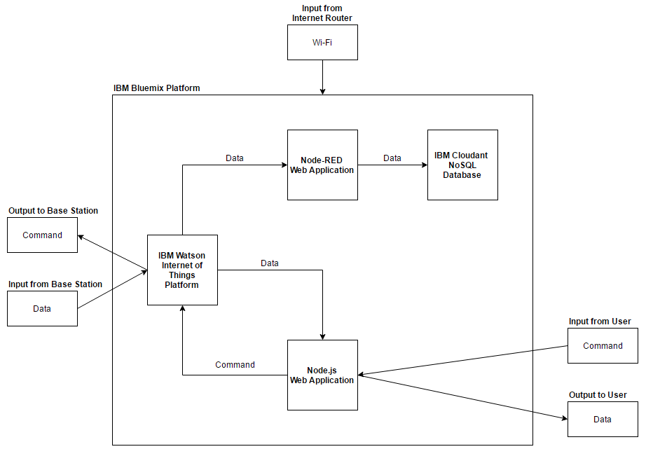

**Figure 4. Web Application Block Diagram**

During the design of the web application, our team considered several alternative technologies. For example, we chose to use IBM Bluemix for our development platform rather than Amazon Web Services or Microsoft Azure because Bluemix offers a robust catalog of application runtimes, services, and APIs. In addition, we selected IBM Cloudant over an SQL database because we are simply storing raw measurement data. Furthermore, a couple team members have experience working with the majority of the selected technologies used.

**Design Assessment**

Since EE 364D, we have successfully built and tested a prototype of our system using the evaluation boards. We changed a few aspects of the design of our system that we outlined in EE 364D. First, we used a Raspberry Pi 3 with a built-in Wi-Fi module for the base station instead of using a TM4C123 microcontroller and the ESP8266 Wi-Fi module. We have also decided to use a thermistor that is included in the external accelerometer instead of using the internal temperature sensor in the RF430 to measure temperature. Overall, our system is mostly complete. However, we still need to embellish the front-end of the web application, attach a larger coil to the base station to increase the range of near field communication, and test our custom made implant. Our largest concern lies on the communication between the base station and our custom made implant. To resolve this issue, we started designing the custom implant PCBs early in the summer, and are currently waiting for the second version to arrive from a PCB manufacturer. In case this version does not meet our specifications, we have several backup coil designs that may increase the reliability and range of power transfer and communication.

**IMPLEMENTATION PLAN**

In the following sections, we describe our plan to complete a prototype of our design by the end of the semester. First, we discuss our division of labor, and list the person(s) responsible for completing each project activity. Second, we use a Gantt chart to lay out a schedule for these activities, and highlight key milestones in our project timeline. Third, we detail a budget table, and discuss the resources we need for project completion. Finally, we review potential risks that may prevent us from completing our project on time, and the methods and tools we will use to mitigate these risks.

**Project Responsibilities Table**

Our team divided project labor to match each team member’s skillsets and technical experience. In our project responsibilities table (see Appendix A), we have assigned each team member their responsibility for each activity. These responsibilities are represented with a 1-3 numeric scale: where 1 indicates the most responsibility, and 3 indicates the least responsibility. For project reports and presentations, Tom will be the project lead in most of these areas, and Anish and Makeila will be secondary resolvers. Mike, Albert, and Corey have extensive experience with circuits and microcontrollers, so they will be responsible for the implant and base station design. Finally, Makeila and Anish have the most experience with Web applications, so they will be responsible for designing our project’s web application.

**Gantt Chart**

As depicted in Appendix B, our Gantt chart outlines a schedule to complete the implementation phase of our Senior Design project in 12 weeks. To build, integrate, and test our data acquisition prototype, we have organized our activities around several key milestones. First, we will dedicate the first three weeks in September to finalizing the design for our implant and base station coils. Assigning this task first will allow us to order PCBs earlier and add a second revision phase later on. We will then complete and test the implant and base station coils by September 30. By this point, we will be able to make final revisions to our coils. On October 28, we will finish soldering and testing the final PCB for our implant. Concurrently, we will have also completed our web application subsystem by November 2. Next, we will focus on interfacing our implant to the base station and our base station to the web application by November 9. We have allocated the largest amount of time to interfacing the three subsystems due to expected difficulty in connecting them. Finally, during the two weeks prior to Open House on November 21, we will allocate our time to testing our integrated system. This will ensure our system is thoroughly tested while also giving the team enough time to create a good demonstration for Open House. We will then deliver a final written report and oral presentation by end of the Fall semester, December 5, 2016.

**Budget Table**

All of the materials needed for our data acquisition system will be provided by our faculty sponsor or our team members. These materials include the Raspberry Pi 3 kit, evaluation boards, additional microcontrollers, a flash programmer for the microcontrollers, PCBs, resistors, capacitors, and accelerometers. Although these materials will be of no cost to us, the total market value for these materials is $551.09, as shown in Appendix C. In order to connect the base station to the web application, we need one Raspberry Pi 3 Kit, which is valued at $74.99 [2]. For the base station microcontroller, we will purchase two TRF7970A evaluation boards, each valued at $99.00 [3]. Similarly, for the implant microcontroller, we will buy two RF430 evaluation boards, each valued at $19.90 [4]. In order to flash program and debug these evaluation boards and microcontrollers, we need one MSP430 flash programmer, valued at $115.00 [5]. Because the size of the RF430 evaluation board will be too large for our prototype, we will have to design and order our own PCB. Assuming we create three versions of the PCB and order 10 of each version, the total cost of the PCBs is $99.00 [6]. In addition, we will also buy no more than $8.00 worth of resistors and capacitors, which we will incorporate to our PCB design [7]. Finally, we will purchase 10 LIS3DH accelerometers, each valued at $1.63, which the implant will use to measure acceleration and temperature [8]. By ordering two or more of each material, except for the Raspberry Pi 3 Kit and the MSP430 flash programmer, we hope to prevent unnecessary project delays that result from waiting for parts.

**Risk Reduction**

In order to ensure that we will complete the data acquisition system by December 5, 2016, we have taken several preventative measures against potential risks. First, we will hold multiple, weekly team meetings to prevent project delays. In these team meetings, we will discuss approaching deadlines, devise a plan of action to accomplish project activities, seek advice from our faculty mentor, and use our Gantt chart to compare our current progress to our expected progress. We will use a mobile application, GroupMe, to coordinate meeting times and ensure fluid communication amongst team members. Second, we will order duplicate parts and test each of our components to mitigate the risk of system failure. We will test each component, as per accordance with our testing plan, to verify it will perform to our specifications: thereby reducing the risk for system failure when all the parts are integrated together. Third, we will commit all our written documentation and software code to a central GitHub repository to prevent the risk of data loss. If data loss were to occur, our team would be able to instantly access and restore from the repository: thereby eliminating the need to potentially alter our proposed project schedule. The steps that we will take will help to ensure that we finish our data acquisition system on time.

**CONCLUSION**

This design and implementation plan has outlined our proposed design and implementation strategy for a wireless data acquisition system for research labs. We created our design to fit the needs of the client and the design specifications. The proposed design consists of a three-part system: an implant, a base station, and a web application. The implant will be small enough to fit inside a lab rat and will collect temperature and acceleration data. The implant and the base station will have a set of inductor coils to wirelessly send power and data between the two subsystems. The base station will then send the data to a web application where it can be viewed by the user. The web application would provide a layer of abstraction between the operation of the system and the user, thus allowing for ease of use. The implementation plan was created after careful consideration of the design, budget, and risks associated with the project. First, the tasks were broken up into different modules and assigned to different members based on their background skills. The dependencies for each task was taken into consideration and a Gantt chart was created to schedule out all the tasks. A budget was created to show potential costs, but the team was able to take advantage of free parts to drastically lower the expenses for this project. Finally, weekly meetings to discuss deadlines, ordering duplicate parts, and backing up data on GitHub will help to mitigate risks and ensure we meet our deadlines.

Our proposed system will revolutionize the way data is collected in research labs that work with animals and has a high chance of being completed due to the work done over the summer. Current methods require researchers to manually collect measurements from lab animals. Our proposed system automates this task and makes data collection easy for the researcher. Our design allowed for the implant to be powered and communicated with wirelessly. This results in small implants that work for a variety of purposes and have incredibly long lifespans. In addition, the web app provides an easy interface for data collection as well as storage, keeping all the information in one place. Finally, the design of the entire system allows for scaling to any number of implants and/or base stations proving extremely versatile. Our team was able to accomplish a great deal over the summer to put us on track for completing the project. We worked on the most time dependent tasks, such as coil design and PCB layouts, over the summer to insure we would not be held up during the semester. Because we were able to do this, our team is on track to finish the complex project by the deadlines set on the Gantt chart.

**REFERENCES**

[1] (2014, December 22). *Guidance for Industry and FDA Staff – Class II Special Controls Guidance Document: Implantable Radiofrequency Transponder System for Patient Identification and Health Information* [Online]. Available: <http://www.fda.gov/MedicalDevices/DeviceRegulationandGuidance/GuidanceDocuments/ucm072141.htm>

[2] “CanaKit Raspberry Pi 3 Complete Starter Kit - 32 GB Edition.” [Online]. Available: <https://www.amazon.com/CanaKit-Raspberry-Complete-Starter-Kit/dp/B01C6Q2GSY>

[3] “NFC Transceiver Evaluation Module.” [Online]. Available: <http://www.ti.com/tool/trf7970aevm>

[4] “NFC ISO 15693 Sensor Transponder Evaluation Module.” [Online]. Available: <http://www.ti.com/tool/rf430frl152hevm>

[5] “MSP430 USB Debugging Interface,” [Online]. Available: <http://www.ti.com/tool/msp-fet430uif>

[6] “Dirt Cheap Dirty Boards.” [Online]. Available: <http://dirtypcbs.com/>

[7] “Electronic Goldmine.” [Online]. Available: <http://www.goldmine-elec-> products.com/default.asp

[8] “LIS3DH.” [Online]. Available: <http://www.digikey.com/product-> detail/en/stmicroelectronics/lis3dhtr/497-10613-1-nd/2334355?enterprise=44

[9] “Single Layer Planar Spiral Coil Inductor Calculator” [Online]. Available: http://www.circuits.dk/calculator_planar_coil_inductor.htm

**APPENDIX A – PROJECT RESPONSIBILITIES TABLE**

**APPENDIX A – PROJECT RESPONSIBILITIES TABLE**

Table A-1 lists the major tasks for our project which include designing and constructing the implant and base station coils, designing the PCB for the implant, building the web application, and interfacing the three subsystems. Responsibility for each task was determined by the expertise and interest of individual teammates.

**Table A-1. Project Responsibilities Table**

|  |  |  |  |  |  |  |  |
| --- | --- | --- | --- | --- | --- | --- | --- |
| **Category** | **Activity** | **Corey** | **Tom** | **Albert** | **Mike** | **Makeila** | **Anish** |
| **Reports and Presentations** | Create Mid-Project Demo Milestone | 3 | 2 | 3 | 3 | 2 | 1 |
| Rehearse Mid-Project Demo Milestone | 3 | 2 | 3 | 3 | 2 | 1 |
| Present Mid-Project Demo Milestone | 3 | 2 | 3 | 3 | 2 | 1 |
| Write Testing and Evaluation Plan | 3 | 2 | 3 | 3 | 1 | 2 |
| Revise Testing and Evaluation Plan | 3 | 2 | 3 | 3 | 1 | 2 |
| Submit Testing and Evaluation Plan | 3 | 2 | 3 | 3 | 1 | 2 |
| Create Oral Progress Report Presentation | 3 | 2 | 3 | 3 | 2 | 1 |
| Rehearse Oral Progress Report | 3 | 2 | 3 | 3 | 2 | 1 |
| Present Oral Progress Report | 3 | 2 | 3 | 3 | 2 | 1 |
| Create Final Project Demo Milestone | 3 | 2 | 3 | 3 | 2 | 1 |
| Rehearse Final Project Demo Milestone | 3 | 2 | 3 | 3 | 2 | 1 |
| Present Final Project Demo Milestone | 3 | 2 | 3 | 3 | 2 | 1 |
| Create Open House Poster | 3 | 2 | 3 | 3 | 1 | 2 |
| Create Oral Final Report Presentation | 3 | 2 | 3 | 3 | 2 | 1 |
| Rehearse Oral Final Report | 3 | 2 | 3 | 3 | 2 | 1 |
| Present Oral Final Report | 3 | 2 | 3 | 3 | 2 | 1 |
| Write Written Final Report | 3 | 2 | 3 | 3 | 1 | 2 |
| Revise Written Final Report | 3 | 2 | 3 | 3 | 1 | 2 |
| Submit Written Final Report | 3 | 2 | 3 | 3 | 1 | 2 |
| **Implant Design** | Order Implant PCB | 2 | 3 | 1 | 3 | 3 | 3 |
| Solder and Test Implant | 2 | 3 | 1 | 3 | 3 | 3 |
| Revise Implant Coil | 2 | 3 | 1 | 3 | 3 | 3 |
| Order Second Implant PCB | 2 | 3 | 1 | 3 | 3 | 3 |
| Solder and Test Second Implant | 2 | 3 | 1 | 3 | 3 | 3 |
| Write RF430 Code | 2 | 3 | 2 | 1 | 3 | 3 |
| Test RF430 Code | 2 | 3 | 2 | 1 | 3 | 3 |
| Order Accelerometer | 1 | 3 | 2 | 3 | 3 | 3 |
| **Base Station Design** | Design Base Station Coil | 1 | 3 | 2 | 2 | 3 | 3 |
| Test Base Station Coil | 1 | 3 | 2 | 2 | 3 | 3 |
| Revise Base Station Coil | 1 | 3 | 2 | 2 | 3 | 3 |
| Write Raspberry Pi Script | 2 | 3 | 3 | 2 | 1 | 3 |
| Test Raspberry Pi Script | 2 | 3 | 3 | 2 | 1 | 3 |
| **Web App Design** | Create Base Web App | 3 | 2 | 3 | 3 | 1 | 2 |
| Connect Web App to Base Station | 3 | 2 | 3 | 3 | 1 | 2 |
| Create Database | 3 | 2 | 3 | 3 | 1 | 2 |
| Connect Web App to Database | 3 | 2 | 3 | 3 | 1 | 2 |
| Design User Interface | 3 | 2 | 3 | 3 | 1 | 2 |

**APPENDIX B – GANTT CHART**

**APPENDIX B – GANTT CHART**

Figure B-1 illustrates the Gantt chart that we will follow in order to complete our data acquisition system by November 23, 2016. The selected timings will ensure that our team will make continuous progress and complete tasks concurrently when possible.

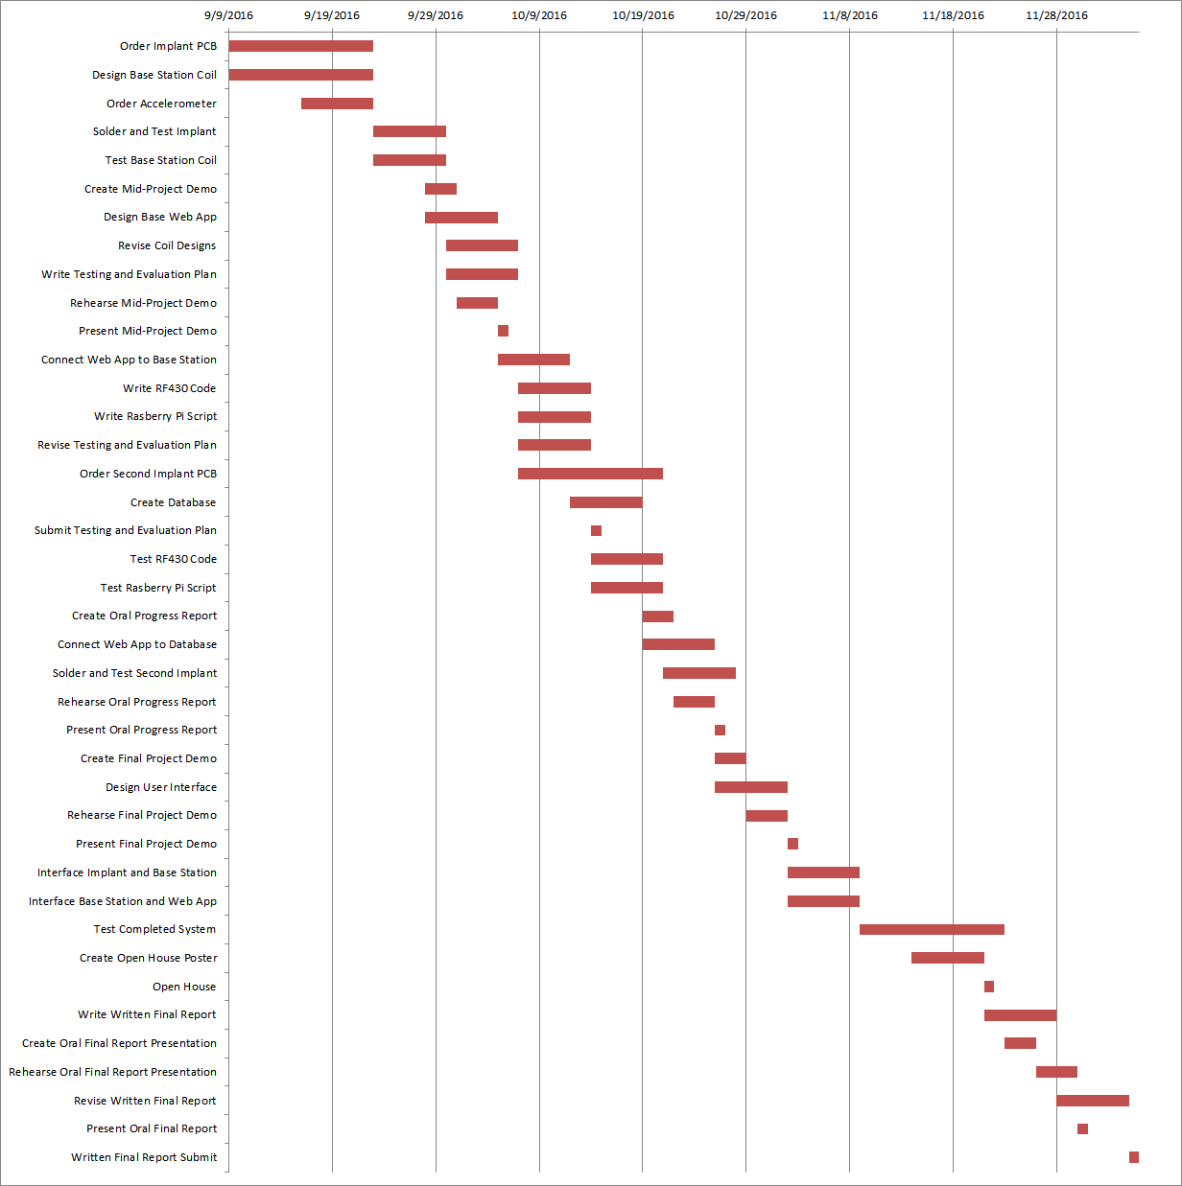

**Figure B-1. Gantt Chart**

**APPENDIX C – BUDGET TABLE**

**APPENDIX C – BUDGET TABLE**

Table C-1 details the budget for our data acquisition system. All of the items we need will be provided by either our faculty sponsor or team members and will be at no cost to us. These items include a Raspberry Pi, the evaluation boards, a flash programmer for the microcontrollers, PCBs, resistors, capacitors, and accelerometers.

**Table C-1. Budget Table**

|  |  |  |  |  |  |  |  |
| --- | --- | --- | --- | --- | --- | --- | --- |
| **Name** | **Description** | **Part Number** | **Quantity** | **Value** | **Original Subtotal** | **Compensated Total** | **Final Subtotal** |
| CanaKit Raspberry Pi 3 Complete Starter Kit - 32 GB Edition | Raspberry Pi 3 (RPi3) Model B + WIFI/LAN | LYSB01C6Q2GSY-ELECTRNCS | 1 | $74.99 | $74.99 | $74.99 | $0.00 |
| TRF7970A Evaluation Board | Base Station Evaluation Board | TRF7970AEVM | 2 | $99.00 | $198.00 | $198.00 | $0.00 |
| RF430 Evaluation Board | Implant Evaluation Board | RF430FRL152HEVM | 2 | $19.90 | $39.80 | $39.80 | $0.00 |
| MSP430 Flash Programmer | Microcontroller Flash Programmer | MSP-FET430UIF | 1 | $115.00 | $115.00 | $115.00 | $0.00 |
| Custom PCBs | Custom Implant PCBs | N/A | 3 | $33.00 | $99.00 | $99.00 | $0.00 |
| Resistors and Capacitors | Resistors and Capacitors for PCB Design of the Implant | N/A | 100 | $0.08 | $8.00 | $8.00 | $0.00 |
| LIS3DH Accelerometer | Accelerometer for the Implant | LIS3DH | 10 | $1.63 | $16.30 | $16.30 | $0.00 |
|  |  |  |  | **Total** | **$551.09** | **$551.09** | **$0.00** |

**APPENDIX D - FURTHER SPECIFICATIONS**

**APPENDIX D - FURTHER SPECIFICATIONS**

The following appendix provides further elaboration on the major inputs and outputs of the data acquisition system. Table D-1 describes the properties of the command that is sent from the web application to the base station and from the base station to the implant. Table D-2 describes the properties of the data that is sent from the implant to the base station and from the base station back to the web application. Finally, Table D-3 describes the specifications for the different types of data that are being sent.

**Table D-1. Command Specifications**

|  |  |  |  |
| --- | --- | --- | --- |
| **From** | **Name** | **Description** | **Specification** |
| Web Application | Base Station ID | Unique identification number for the base station that the command was sent to | 16 digit sequence of numbers |
| Base Station | Implant ID | Unique identification number for the implant that the command was sent to | 16 digit sequence of numbers |
| Web Application | Data Type | Name of measurement | String |
| Web Application | Data Timestamp | Date and time the command was sent to the base station | Year, Month, Day, Hour, Minute, Second, Millisecond |

**Table D-2. Data Specifications**

|  |  |  |  |
| --- | --- | --- | --- |
| **From** | **Name** | **Description** | **Specification** |
| Web Application | Data ID | Unique identification number for the data | 16 digit sequence of numbers |
| Web Application | Base Station ID | Unique identification number for the base station that the data came from | 16 digit sequence of numbers |
| Base Station | Implant ID | Unique identification number for the implant that the data came from | 16 digit sequence of numbers |
| Implant | Data Type | Type of the data | String |
| Rat | Data Value | Value of the data | See Table D-3  “Data Type Specifications” in Appendix D “Further Specifications” |
| Base Station | Data Timestamp | Date and time the data was received by the base station | Year, Month, Day, Hour, Minute, Second, Millisecond |

**Table D-3. Data Type Specifications**

|  |  |  |
| --- | --- | --- |
| **Type** | **Description** | **Specification** |
| Temperature | Measured temperature of the rat | Range   * 0° to 45° C   Accuracy   * ± 0.01° C |
| Acceleration | Measured acceleration of the rat | Range   * ± 2 g   Accuracy   * 0.01 g |