**DATE:** October 14, 2016

**TO:** Jonathan Valvano

Amal Kouttab

**FROM:** Corey Cormier

Thomas Ermis

Albert Marzullo

Michael Park

Makeila Sorensen

Anish Vaghasia

**SUBJECT:** Test and Evaluation Plan for a Data Acquisition System

**INTRODUCTION**

This paper details the testing and evaluation plan for the eventual assessment of a data acquisition system to be used in laboratory environments. It will serve not only as an overall evaluation of the system’s success, but also as a methodology for testing the system during implementation. Our design problem, as designated by Dr. Valvano, was to create a three module system that would measure data from inside a rat and display it to the user in a quick, cost-effective manner. In order to accomplish this, the system design needed to meet specific requirements determined by the client’s needs and the environmental specifications. Additional performance specifications were created by the team after thorough research during the development of the design plan.

These specifications are used as the main testing points for which the system will be evaluated. The tests focus on areas where signals travel from one area to another so that specific components and modules can be isolated during testing. Input signals are controlled for every test and output signals are measured against predetermined values. In this way we start testing with components, move on to modules, and then finally test the system as a whole. As of today, the team has successfully completed testing on the coil component and the base station module. A few of the other tests, specifically for the implant and web app, have also been completed. The team will implement the rest of the tests as further progress is made on the project. The goal will be to have the testing and evaluation of the project finished before open house.

**SUMMARY OF DESIGN**

In order to make the collection of data from laboratory rats less expensive and more efficient, Dr. Valvano asked our team to design a data acquisition system. More specifically, we were asked to design an implant, that is wirelessly powered, to collect data from sensors inside of a rat, and relay that information to a base station and, eventually, a web application. Ultimately, the system will need to allow scientists to collect and view data from laboratory rats. The following sections elaborate on the current problem, the design specifications, and our design solution to the problem.

**Design Problem**

Current methods that scientists use to acquire and analyze data from laboratory rats are expensive and inefficient. Each time a scientist wants to collect data from a rat, he or she needs to manually collect blood and urine samples. Once the samples have been processed, the scientist needs to filter through and analyze the results. Furthermore, this procedure needs to be consistently repeated to ensure that the data is current and accurate. As previously stated, these methods are both time-consuming and expensive. Therefore, our team will design a system that allows scientists to accurately and efficiently collect and view data from laboratory rats.

In order for the system to operate as accurately and efficiently as possible, both the overall system and the individual subsystems need to adhere to certain performance specifications. For example, because the system will be used by scientists in research laboratories, it is vital that the temperature and acceleration data is accurate, precise, and reliable. In addition, the process of collecting the data from the rat and displaying it back to the user needs to be efficient and user-friendly. Appendix A-1 outlines the specifications for the overall system in more detail. In the following subsections, we describe the performance specifications for each of the three subsystems: the implant, the base station, and the web application.

*Implant Specifications*

Because the implant will be embedded in a rat, it must comply with the most requirements and constraints. First, the implant must have a decent lifespan so that it does not need to be constantly replaced. Second, the implant needs to be sterile, biocompatible, small, battery-less, and wireless so that it does not adversely affect the rat. Finally, the implant must be able to operate independent of the temperature of the rat and its surroundings. Appendix A-2 explains the specifications for the implant in more detail.

*Base Station Specifications*

Unlike the implant, the base station will be outside of the rat, most likely attached to the cage. The main purpose of the base station is to wirelessly power the implant and communicate with it. Therefore, the base station needs to transmit power and data from minimum distance and at a minimum bandwidth. In addition, because the base station needs to accommodate the layout of the laboratory, it needs to be portable. Furthermore, the base station must be able to operate independent of the temperature of its environment. Appendix A-3 describes the specifications for the base station in more detail.

*Web App Specifications*

In order to accommodate the number of users and volume of data traffic, the web application needs to be universal and scalable. First, it needs to run on a wide range of platforms and browsers so that a variety of users can access the web application regardless of the type of machine they are using. Second, the web application needs to be vertically and horizontally scalable so that it can handle large quantities of users and transactions. Appendix A-4 outlines the specifications for the web application in more detail.

**Design Solution**

The prototype of the system will be comprised of three subsystems and provides users with data from the implant. As illustrated in Figure 1, the three subsystems are an implant, a base station, and a web application. The web application allows the user to request data from the implant. Once the data request is initiated, the web application sends a command to the base station. From there, the base station uses induction coils to wirelessly power the implant and relay the command. Upon collecting the requested data from the rat, the implant then uses induction coils to wirelessly transfer the data back to the base station. The base station then relays the data back to the web application. Finally, the web application stores the data in a database and displays the data back to the user.

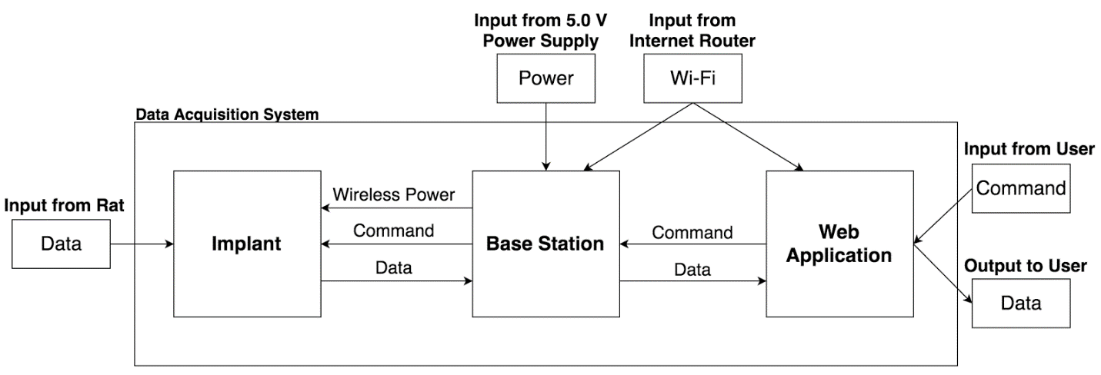

**Figure 1. System Block Diagram**

In the following subsections, we describe the design for each subsystem in more detail. For each subsystem, we explain its functionality, input and output specifications, and the implementation. Furthermore, we discuss alternative designs that our team had considered for each subsystem.

**Implant Design**

The implant subsystem consists of a microcontroller and an accelerometer with a thermistor on a two-layer PCB with the appropriate bypass capacitors. The coil used for power transfer and communication is etched onto the PCB in a spiral design on the bottom layer. As shown in Figure 2 below, the base station sends a one-byte command to the implant using the ISO15693 protocol. The microcontroller then communicates with the accelerometer using I2C.  Once the microcontroller has the data, it sends the data to the base station using the same protocol.

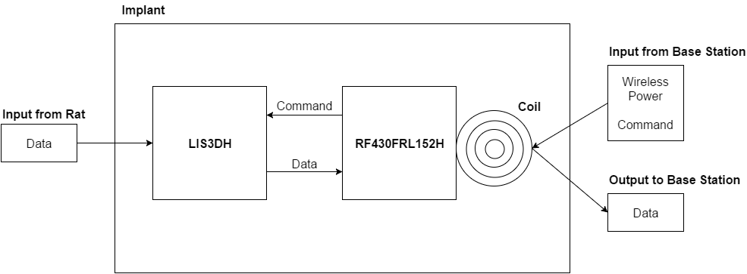

**Figure 2. Implant Block Diagram**

In order to ensure that the implant can perform the tasks listed above, certain input and output specifications must be met. In order for the implant to function, enough power must be transferred through the induction coils to the microcontroller and accelerometer. The implant must also operate within a certain distance from the base station for it to continue to function even as the rat moves around. Finally, the implant must collect data from the rat, as well as send that data to the base station. Appendix A-5 and A-6 outline the input and output specifications for the implant in more detail.

For the microcontroller, our design uses the RF430FRL152H. This chip is similar to the MSP430 but with the ISO15693 stack and power management system internally implemented. The reason we chose the RF430 is because it greatly simplifies the design, allowing us to make the implant smaller (approximately 10 cm2). The accelerometer our design uses is the LIS3DH. We chose this chip because it requires a small amount of power, it can communicate over I2C, and its footprint is small. This helps us meet our size and maximum power specifications. We decided to use this accelerometer because of its simplicity. Additionally, we have already written code to interface with this one. The coil design is still undergoing design changes as we continually reevaluate tradeoffs between coil size and the maximum distance from the base station that the implant can operate. To create the current design, we used an online spiral inductor calculator to iteratively add turns until the inductance matched the desired value of 3 μH [2]. Using a trace spacing of 0.2 mm, the closest inductance we could get was around 2.8 μH, so we added a 2-10 pF tunable capacitor to allow for a correction.

**Base Station Design**

The second subsystem of the data acquisition system is the base station. As depicted in Figure 3 below, the base station will serve as the power source for the implant and as a relay for communication between the implant and the web application. The specifications that the base station needs to adhere to are explained below.

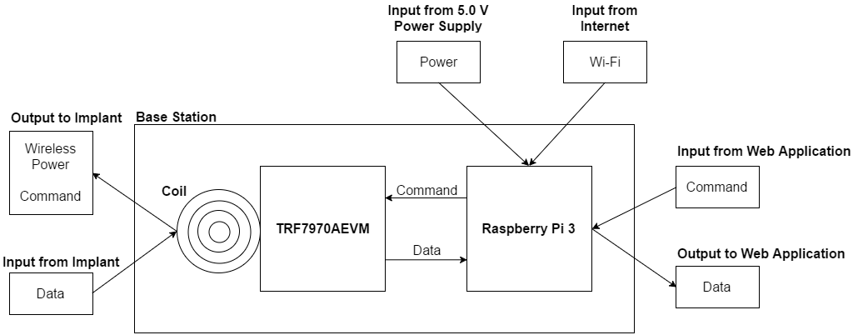

**Figure 3. Base Station Block Diagram**

The base station will accept inputs from a power supply, an internet router, the web application, and the implant, and send outputs back to the implant and the web application. The power supply will provide power to the base station whereas the internet router will provide the base station with access to Wi-Fi. The base station will always be in standby to receive data commands from the web application. Upon receiving a command, the base station will wirelessly power the implant and relay the command to the implant. When the implant responds with temperature and acceleration data, the base station will output that data back to the web application. Appendix A-7 and A-8 outline the input and output specifications for the base station in more detail.

The base station will be implemented using a NFC/RFID transceiver evaluation board, a coil, a single board computer (SBC) with a built-in Wi-Fi module, and a power supply.  The power supply will power both the SBC and NFC/RFID transceiver evaluation board, which is plugged into the SBC, while the coil will be powered by the evaluation board. The data collected from the implant will travel through the coil, NFC/RFID transceiver evaluation board, and the SBC to reach the web application. The coil will receive a signal containing the collected data which, in turn, will be converted into binary and decoded into decimal data by the NFC/RFID transceiver evaluation board. Once the SBC receives the decoded data from the evaluation board (through USB serial communication), the SBC will pack the data into JavaScript Object Notation **(**JSON) and use Wi-Fi to transmit it to the web application. When the web application sends commands to the implant, the data will go through the base station modules in the opposite order with identical communication protocols and data formats.

We chose the components for our base station modules to meet all the requirements and the specifications mentioned previously. Firstly, we used TRF7970AEVM for the NFC/RFID transceiver evaluation board. This component allows us to directly power and control the coil to communicate with the implant. Secondly, we used the Raspberry Pi 3 for the SBC because of its built-in Wi-Fi module and easy programmability. The Raspberry Pi 3 allows us to interface the base station with the web application and control the evaluation board in a reliable manner. Thus, our combined implementation of the base station using TRF7970AEVM and Raspberry Pi 3 allows us to simultaneously wirelessly power the implant and communicate with the implant and web application.

**Web Application Design**

The third subsystem is the web application, which also doubles as the user interface. The main purpose of the web application is to allow the user to control and interact with the data acquisition system. The web application receives inputs from an internet router and the user, and will send outputs to the base station and the user. Appendix A-9 and A-10 outline the input and output specifications for the web application in more detail.

The web application is built on IBM Bluemix, a cloud platform for developing scalable web and mobile applications. As depicted in Figure 4, the web application consists of four components. Two of the components form the actual web application while the other two components are back-end services. For the web application, the first component runs on Node.js and leverages HTML, CSS, and JavaScript. It allows the user to request data from the implant and then processes and displays the returned data. The second component runs on Node-RED and leverages JavaScript to store the returned data in a database. For the back-end services, we used IBM Watson IoT Platform and IBM Cloudant. The IBM Watson IoT Platform allows the web application to send commands to and receive data from the base station over the MQTT messaging protocol, while IBM Cloudant offers powerful data storage and search capabilities.

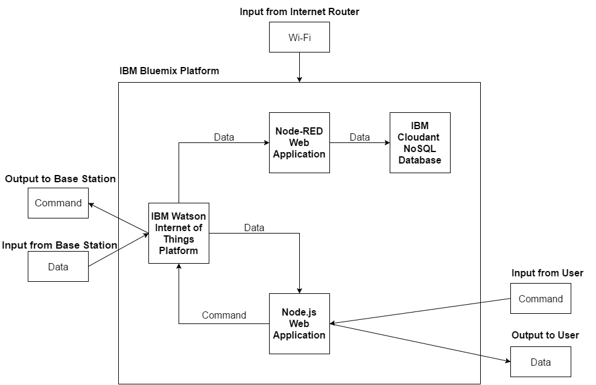

**Figure 4. Web Application Block Diagram**

We chose to use IBM Bluemix for our development platform because Bluemix offers a robust catalog of application runtimes, services, and APIs. In addition, we selected IBM Cloudant because we are simply storing raw measurement data. Furthermore, a couple team members have experience working with the majority of the selected technologies used.

**TESTING AND EVALUATION**

In order to prepare for an eventual assessment of our data acquisition system, we developed a testing plan that focuses on the signals being passed throughout our system. Focus was put on the signals due to the high modularity of the system. On a larger scale, key components such as the coils are tested before moving on to the different modules of the system. Finally, a few tests are run on the system level with multiple measuring points located at key areas to confirm correct functionality.

**Component Acceptance Testing**

Since most of the components of our system are tightly coupled, the coils were the only components that could feasibly be tested by themselves. Since the coils were designed on a PCB with a target inductance of 3μH, this was the main quantity that needed to be tested. In order to confirm that the PCBs we ordered matched this expected value, Albert and Corey brought our PCBs to the Pickle Research Campus and used a network analyzer to determine the equivalent RLC circuit of our coils. From these tests we concluded that our coils were close, but slightly lower than the target 3 uH, ranging from 2.7 μH to 2.9 μH. We determined that these values were acceptable as the slightly lower inductance of the coils could be compensated by the 2-10 pF tuning capacitor we added to our implant design.

**Module Level Testing**

Before integrating the different parts of the system, we will conduct several tests to establish that that each independent module functions as expected. By controlling the inputs, we feed into each module and measuring key outputs, we will be able to validate the operations of each module. Each test will rely on previously verified components or modules to ensure the accuracy of the test. Input signals and data manipulation will also be controlled for the tests in order to show reliable results. The following sections expand on the tests we will perform for the implant, the base station, and the web application.

***Implant Testing***

To confirm that the implant will operate correctly, we need to test the resonant frequency of the implant, the voltage output by the implant coil, and the operation of the RF430 chip. We first tested the resonant frequency of the chip as soon as we got all of the parts soldered onto the implant. Albert, Corey, and Mike did this by measuring the peak impedance of the implant using the network analyzer at the Pickle Research Campus. Since the inductance of the coils were a bit lower than we expected, the resonant frequency of the implants was slightly over the 13.56 MHz necessary to communicate with the base station. By adding capacitance to our implant with the 2-10 pF tuning capacitor, we were able to get the resonant frequency of our implants within 0.1 MHz of our desired frequency. We calculated the amount of capacitance we needed to add by using the equation

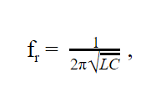

**Equation 1. Resonant Frequency**

where fr is the resonant frequency, L is the inductance, and C is the capacitance of the RLC circuit. After tuning the resonant frequencies of the implants to acceptable ranges, we tested the voltage generated by the implant coil when held above the base station evaluation board. By attaching oscilloscope probes across the implant coil, Corey was able to confirm that the voltage output was between 1.5 V and 3.3 V, which was in the operating range of the RF430, within the required distance of 8 cm. Lastly, after determining that the RF430 was receiving the necessary voltage, we tested to see if the RF430 was functioning as we expected. To do this, Albert first measured the VDDD voltage output of the chip. This voltage is supposed to be close to 1V whenever the chip is powered on. Using a multi-meter Albert confirmed that the VDDD on our RF430 was 1 V and that the chip was being powered on. Finally, Corey and Mike sent dummy data to the RF430 from the base station and had the RF430 echo the value back to the base station. When we successfully did this, we confirmed that the RF430 was able to communicate in both directions with the base station through the induction coils.

***Base Station Testing***

The quality of the base station will be assessed based on its functionality and performance. The purpose of the base station is to wirelessly power the implant and interface the implant and the web application. In order to ensure the functionality of the base station, first, Corey and Devin leveraged an oscilloscope to measure the amount of power supplied, which should be 200 mW at maximum. In addition, Corey and Mike wrote C code and used an oscilloscope to test the wireless communication to the implant. Finally, Makeila wrote Python functions to test the base station’s connection and communication with Watson IoT Platform and thus the web application. We were able to confirm that the base station could transfer data to and from the implant and web application using the oscilloscope to monitor output lines on the base station and print statements to read out the data that was sent and received by the base station.

For performance, it is important that the base station is able to transfer and process data quickly. Therefore, we will measure the time it takes for the base station to receive and process a command, the time it takes for the base station to publish a command, and the time it takes for the base station to receive, process, and relay an event.  These measurements will be taken by printing the timestamps immediately before and after the process executes and calculating the difference. Individually, each process should be at most half of a second. Combined, however, they should be at most one second.

***Web App Testing***

We will evaluate the quality of the web application based on its accessibility, functionality, and performance. For accessibility, we will test that it can be accessed from different platforms and browsers. At a minimum, the web application needs to function on the Windows 7, Mac OS X, and Linux platforms, as well as the Chrome 49 and Firefox 45 browsers. These are simple binary tests that will be performed by Tom. In addition, the web application needs to be horizontally and vertically scalable. The platform that we leveraged to build the web application allows us to automatically scale out by clicking a button to increase the number of instances and scale up by increasing the amount of memory per instance. Again, these tests will be performed by Tom.

With regards to functionality, the web application needs to interface with the user, the Watson IoT Platform, and the Cloudant NoSQL Database. For the user interface, we will test that each of the input boxes and buttons perform the dedicated function. Makeila will test this by entering in text and clicking on buttons to make sure the correct callback functions were initiated. In addition, the web application needs to be able to connect to, publish commands to, and receive events from the Watson IoT Platform. Makeila will test this functionality by printing debug statements to confirm when each of those tasks are executed and what data was transferred. Finally, the web application needs to be able to connect to, store data in, and retrieve views from the Cloudant NoSQL database. Makeila will perform tests for the Cloudant NoSQL database similar to those for the Watson IoT Platform.

For performance, we will evaluate the response time of the web application. First, Makeila will measure the time it takes for the web application to publish a command to the Watson IoT Platform. Second, she will measure the time it takes for the web application to receive an event from the Watson IoT Platform. Third, Makeila will measure the time it takes for the web application to store data in the database as well as update the data on the web application. These measurements will be performed by printing the timestamps immediately before and after the process executes and taking the difference. Individually, each process should be at most half of a second. Combined, however, they should be at most one second.

**System Level Testing**

Once each subsystem has been tested independently, we will combine the subsystems and conduct tests on the system as a whole. In order to do test the flow of our system, Corey will first attach an oscilloscope to the communication channel of the implant (so he can view the data that the implant is collecting). Similarly, Corey will attach an oscilloscope to the communication channel of the base station so that he can verify the data that the base station is receiving. Makeila will then send power (to turn on the base station) and data commands from our web application to collect data from the implant. As the implant collects data and the web application displays it, Corey will compare the data displayed on the oscilloscopes to that displayed on the web application and confirm that they match. If all components are interacting correctly, our system’s returned value will be approximately 95% accurate when compared to a measurement taken with an external instrument: such as using a digital thermometer to measure temperature. Thus, our test will be a “success”. If the returned value is not correct, Corey and Makeila will look at the oscilloscope and web application data to pinpoint where the failure is in the data flow. They will then run component tests on the failing components, and ensure communications between the components are running smoothly.

Once our system is “successfully” working, Makeila and Anish will run a series of tests to confirm our system is both timely and versatile. In order to test for timely responses, Makeila will run a series of automated scripts that will call multiple commands from our web application simultaneously: effectively load testing our system. Makeila will then look at the response times for our system under these conditions, and ensure they are all under two minutes. Anish will test to make certain our system remains functional: both when the distances are varied between the implant and the base station coils, and when our implant is placed under different operating conditions. This includes verifying that our system can operate when the implant is placed in temperatures between 0° to 45° C. Ultimately, this suite of tests will confirm the correct operation of our system as a whole.

**CONCLUSION**

This testing and evaluation plan has outlined the verification methods that will be used to test our data acquisition system, based on the design and specifications created by this team. In this paper, we briefly discussed the design and outlined exactly what requirements our data acquisition system needs to meet in order to be considered successful. These specifications were created upon careful review of the client’s needs and the environmental considerations surrounding the system. They shaped our design and were used to create a concrete testing plan that fully evaluates the functionality of our system.

The testing plan focuses on tests that evaluate the signals traveling between the different components and modules of our project. This allows us to take advantage of the modular nature of our design and isolate specific areas during testing. By starting with smaller components, like the coil, we allow for simple tests that involve very little complexity. Then, after verifying the functionality of the smaller inner components, we are able to build on these tests and perform larger tests on each of the modules themselves. This creates a rigid testing structure that also aids in the debugging process. The approach will provide reliable results and also reduce the complexity of the tests themselves.

Having already completed the testing for the coil component and the base station module, the team will continue to perform tests as they make progress on the project. The team is dedicated to finishing the testing and evaluation of the project by ECE Open House.

**REFERENCES**

[1] (2014, December 22). *Guidance for Industry and FDA Staff – Class II Special Controls Guidance Document: Implantable Radiofrequency Transponder System for Patient Identification and Health Information* [Online]. Available: <http://www.fda.gov/MedicalDevices/DeviceRegulationandGuidance/GuidanceDocuments/ucm072141.htm>

[2] “Single Layer Planar Spiral Coil Inductor Calculator” [Online]. Available: http://www.circuits.dk/calculator_planar_coil_inductor.htm

**APPENDIX A - SPECIFICATIONS**

**APPENDIX A - SPECIFICATIONS**

The following appendix provides elaboration on the system and component specifications of the data acquisition system. Table A-1 describes the specifications our system must meet at a system level. Table A-2, Table A-3, and Table A-4 each describe implant, base station, and web application specifications that must be met respectively. Finally, Table A-5 and Table A-6, Table A-7 and Table A-8, and Table A-9 and Table A-10 describe the input and output specifications of our implant, base station, and web application respectively.

**Table A-1. System Specifications**

|  |  |  |
| --- | --- | --- |
| **Name** | **Description** | **Specification** |
| Maximum Response Time | Maximum length of time in which the system has to respond to the user | 2 minutes |
| Measurement Accuracy | Accuracy of the temperature and acceleration measurements | ≥ 95% |

**Table A-2. Implant Specifications**

|  |  |  |
| --- | --- | --- |
| **Name** | **Description** | **Specification** |
| Minimum Lifespan | Minimum length of time in which the implant has to operate from the time of implantation | 6 months |
| Sterility | Minimum sterility assurance level of the implant | SAL of 10-6 [1] |
| Biocompatibility | Minimum standard of biocompatibility of the implant | ISO 10993 [1] |
| Maximum Length | Maximum length of the implant | 8 cm |
| Maximum Width | Maximum width of the implant | 8 cm |
| Maximum Height | Maximum height of the implant | 0.3 cm |
| Operating Temperature | Range of temperature in which the implant has to operate | 0° to 45° C |

**Table A-3. Base Station Specifications**

|  |  |  |
| --- | --- | --- |
| **Name** | **Description** | **Specification** |
| Maximum Length | Maximum length of the base station | 30 cm |
| Maximum Width | Maximum width of the base station | 30 cm |
| Maximum Height | Maximum height of the base station | 30 cm |
| Operating Temperature | Range of temperature in which the implant has to operate | 0° to 45° C |
| Distance | Distance at which the base station is required to wirelessly power and communicate with the implant | 8 cm |
| Minimum Bandwidth | Minimum frequency at which the base station and implant have to be able to wirelessly communicate | 1 Hz |

**Table A-4. Web Application Specifications**

|  |  |  |
| --- | --- | --- |
| **Name** | **Description** | **Specification** |
| Platforms | Minimum platforms the web application needs to be accessed on | Windows 7, Mac OS X, Linux |
| Browsers | Minimum browsers the web application needs to be accessed on | Chrome 49, Firefox 45 |
| Scalability | Level of scalability offered by the web application | Horizontal, Vertical |

**Table A-5. Implant Input Specifications**

|  |  |  |  |
| --- | --- | --- | --- |
| **From** | **Name** | **Description** | **Specification** |
| Base Station | Wireless Power | Amount of power transferred within a certain distance | Range  ●      0 to 200 mW  ●      0 to 8 cm  Accuracy  ●      ± 0 mW  ●      ± 0.01 cm |
| Base Station | Command | Command to collect data from the rat | See Table B-1  “Command Specifications” in Appendix B “Further Specifications” |
| Rat | Data | Data collected from the rat | See Table B-2  “Data Specifications” in Appendix B “Further Specifications” |

**Table A-6. Implant Output Specifications**

|  |  |  |  |
| --- | --- | --- | --- |
| **To** | **Name** | **Description** | **Specification** |
| Base Station | Data | Data collected from the rat | See Table B-2  “Data Specifications” in Appendix B “Further Specifications” |

**Table A-7. Base Station Input Specifications**

|  |  |  |  |
| --- | --- | --- | --- |
| **From** | **Name** | **Description** | **Specification** |
| Power Supply | Power | Power supply for the base station | Value  ●      5.0 V  ●      1 A  Accuracy  ●      ± 0 V  ●      ± 0 A |
| Internet Router | Wi-Fi | Wi-Fi for the base station | Wi-Fi |
| Web Application | Command | Command that collects data from the rat | See Table B-1  “Command Specifications” in Appendix B “Further Specifications” |
| Implant | Data | Data collected from the rat | See Table B-2  “Data Specifications” in Appendix B “Further Specifications” |

**Table A-8. Base Station Output Specifications**

|  |  |  |  |
| --- | --- | --- | --- |
| **To** | **Name** | **Description** | **Specification** |
| Implant | Wireless Power | Amount of power transferred within a certain distance | Range  ●      0 to 200 mW  ●      0 to 8 cm  Accuracy  ●      ± 0 mW  ●      ± 0.01 cm |
| Implant | Command | Command to collect data from the rat | See Table B-1  “Command Specifications” in Appendix B “Further Specifications” |
| Web Application | Data | Data collected from the rat | See Table B-2  “Data Specifications” in Appendix B “Further Specifications” |

**Table A-9. Web Application Input Specifications**

|  |  |  |  |
| --- | --- | --- | --- |
| **From** | **Input** | **Description** | **Specification** |
| Internet Router | Wi-Fi | Wi-Fi for the web application | Wi-Fi |
| User | Command | Command to collect data from the rat | See Table B-1  “Command Specifications” in Appendix B “Further Specifications” |
| Base Station | Data | Data collected from the rat | See Table B-2  “Data Specifications” in Appendix B “Further Specifications” |

**Table A-10. Web Application Output Specifications**

|  |  |  |  |
| --- | --- | --- | --- |
| **To** | **Output** | **Description** | **Specification** |
| Base Station | Command | Command to collect data from the rat | See Table B-1  “Command Specifications” in Appendix B “Further Specifications” |
| User | Data | Data collected from the rat | See Table B-2  “Data Specifications” in Appendix B “Further Specifications” |

**APPENDIX B - FURTHER SPECIFICATIONS**

**APPENDIX B - FURTHER SPECIFICATIONS**

The following appendix provides further elaboration on the major inputs and outputs of the data acquisition system. Table B-1 describes the properties of the command that is sent from the web application to the base station and from the base station to the implant. Table B-2 describes the properties of the data that is sent from the implant to the base station and from the base station back to the web application. Finally, Table B-3 describes the specifications for the different types of data that are being sent.

**Table B-1. Command Specifications**

|  |  |  |  |
| --- | --- | --- | --- |
| **From** | **Name** | **Description** | **Specification** |
| Web Application | Base Station ID | Unique identification number for the base station that the command was sent to | 16 digit sequence of numbers |
| Base Station | Implant ID | Unique identification number for the implant that the command was sent to | 16 digit sequence of numbers |
| Web Application | Data Type | Name of measurement | String |
| Web Application | Data Timestamp | Date and time the command was sent to the base station | Year, Month, Day, Hour, Minute, Second, Millisecond |

**Table B-2. Data Specifications**

|  |  |  |  |
| --- | --- | --- | --- |
| **From** | **Name** | **Description** | **Specification** |
| Web Application | Data ID | Unique identification number for the data | 16 digit sequence of numbers |
| Web Application | Base Station ID | Unique identification number for the base station that the data came from | 16 digit sequence of numbers |
| Base Station | Implant ID | Unique identification number for the implant that the data came from | 16 digit sequence of numbers |
| Implant | Data Type | Type of the data | String |
| Rat | Data Value | Value of the data | See Table B-3  “Data Type Specifications” in Appendix B “Further Specifications” |
| Base Station | Data Timestamp | Date and time the data was received by the base station | Year, Month, Day, Hour, Minute, Second, Millisecond |

**Table B-3. Data Type Specifications**

|  |  |  |
| --- | --- | --- |
| **Type** | **Description** | **Specification** |
| Temperature | Measured temperature of the rat | Range   * 0° to 45° C   Accuracy   * ± 0.01° C |
| Acceleration | Measured acceleration of the rat | Range   * ± 2 g   Accuracy   * 0.01 g |