Alcohol Consumption’s Effect on Labor Market Outcomes

California Polytechnic University – San Luis Obispo

Michael Earl and Shreya Ravilla

03/15/2024

**Abstract**

This study investigates the impact of alcohol consumption on labor market outcomes, focusing on wages. Building on the economic theory of the trade-off between leisure and labor, we analyze data from the National Longitudinal Survey of Youth, 1997 Cohort, utilizing linear models with individual fixed effects. Preliminary results suggest a negative relationship between alcohol consumption and wages, with each additional drink predicting a decrease in earnings. The significance of this association varies across model specifications, emphasizing the need for nuanced analysis in understanding the intricate connections between alcohol habits and labor market outcomes.

*JEL classification*: C5

*Key words and phrases*: Alcohol consumption, labor market, panel data, fixed effects model

**1. Introduction**

The research question motivating this study is how does alcohol consumption effect labor market outcomes. By delving into this inquiry, we aim to contribute to the existing literature and provide insights into the intricate relationship between alcohol habits and labor market outcomes. This is a relevant topic because the literature indicates that this effect may be more pronounced for individuals that recently joined the labor market (i.e. new college graduates). Figure 5 appears to show a negative relationship between alcohol consumption and wages with the effects getting more negative over time. We are studying because we are interested in how this relationship evolves over time.

Our literature review encompasses a diverse range of studies that have delved into the complex relationship between alcohol consumption and labor market outcomes. Sloan and Grossman (2011) explore the long-term implications of early adult alcohol consumption, finding that heavy alcohol use in early adulthood correlates with diminished earnings for Black men. In contrast, Ormond and Murphy (2016) discover higher household income among drinkers compared to non-drinkers in Ireland, with marginal disparities between moderate and heavy drinkers. Sun and Zhang (2022) reveal a significant and positive association between alcohol consumption and wage rates, noting gender differences in this relationship. Yörük (2015) investigates the impact of minimum legal drinking age laws on alcohol consumption and labor market outcomes among young adults. Bray (2005) explores the effects of alcohol use on wages mediated through human capital accumulation. Despite the contradicting results found in existing literature, we hypothesize a negative relationship between alcohol consumption and wages, with potential variations across demographic groups.

The study utilizes data from the National Longitudinal Survey of Youth, 1997 Cohort, sourced from the United States Bureau of Labor and Statistics. The dataset spans the years 2011, 2013, and 2015, offering a robust longitudinal perspective on individuals' alcohol consumption and labor market outcomes. Key variables include wages, drinks per day, demographic information, Armed Services Vocational Aptitude Battery (ASVAB) scores as a proxy for intelligence, and the number of weeks worked per year. The empirical approach employs linear models with cluster robust standard errors and individual fixed effects to account for potential omitted variable biases. Preliminary results indicate a negative coefficient for the drinks per day variable, suggesting a predicted decrease in wages for each additional drink. However, the significance of this relationship is contingent upon the model specification, with the fixed effects model revealing a non-significant association between alcohol consumption and wages, emphasizing the importance of nuanced modeling to capture the complexity of the relationship.

The paper is structured to provide a comprehensive exploration of the intricate relationship between alcohol consumption and labor market outcomes. Beginning with a clear articulation of the research question and motivation, the paper begins by examining existing literature on the topic. The subsequent section outlines the data and methodology, explaining the choice of the National Longitudinal Survey of Youth, 1997 Cohort, and detailing the empirical approach employed, including key variables and statistical techniques. Preliminary results, depicted in figures and tables in the appendix, are discussed in the results section, shedding light on the initial findings concerning the impact of alcohol consumption on wages. The paper concludes with reflections on the limitations of the current approach, proposes avenues for future research, and emphasizes the broader implications of the study's contributions to the existing body of literature on the intersection of alcohol habits and labor market outcomes. This structured approach ensures a comprehensive and insightful exploration of the research question from multiple angles.

**2. Literature Review**

Sloan and Grossman (2011) explore the long-term ramifications of early adult alcohol consumption. This is done by examining alcohol’s influence on educational achievement and labor market outcomes during middle age, this study has several interesting findings. The research finds that heavy alcohol consumption in early adulthood can lead to diminished earnings for Black men. This relationship is not observed among Black women or White individuals in the study.

Ormond and Murphy (2016) analyze the impact of alcohol consumption on household income in Ireland. The study categorizes individuals into groups based on their adherence to the recommended weekly drinking levels outlined by the Irish Health Promotion Unit. The study finds that household income is higher among drinkers compared to non-drinkers or individuals who have never consumed alcohol. The study finds that the income disparities between moderate and heavy drinkers are marginal.

The focus by Sun and Zhang (2022) shifts to wage rates as a specific measure of employment attainment. This study finds a significant and positive association between alcohol consumption and wage rates. This study finds “inverse U-shaped relationship” between individuals alcohol consumption and wage rate. Moreover, the study finds differences between men and women in within this relationship.

The Yörük (2015)investigates the impact of minimum legal drinking age (hereafter MLDA) laws on alcohol consumption and labor market outcomes among young adults. This study finds that granting legal access to alcohol at age 21 leads to an increase in several measures of alcohol consumption among young adults. This increase in alcohol consumption also has negative effects on the individuals labor market outcomes. Specifically, there is a documented decrease in weekly working hours.

Bray (2005) attempts to isolate the effects of alcohol use on wages as mediated through human capital accumulation. This study finds that while generally insignificant, moderate alcohol use while in school or work may have a positive effect on the returns to education or experience, contributing to human capital accumulation. However, the heavier drinking slightly reduces this gain. This study's approach indicates that alcohol use does not seem to adversely affect the efficiency of education or experience in forming human capital.

In this project we will be working with panel data as we have many observations over several years. We have selected the years 2011, 2013, and 2015 for our analysis as these were the most recent years that were comparable to each other. We believe that incorporating the theory of the trade-off between leisure and labor into our examination of the connection between alcohol consumption and labor market performance will be beneficial. This theory involves time allocation, productivity, decisions regarding labor supply, and wage disparities. By considering these variables, we aim to enhance our understanding of how alcohol consumption impacts labor market outcomes, such as wages.

We believe that incorporating the theory of the trade-off between leisure and labor into our examination of the connection between alcohol consumption and labor market performance will be beneficial. This theory involves time allocation, productivity, decisions regarding labor supply, and wage disparities. By considering these variables, we aim to enhance our understanding of how alcohol consumption impacts labor market outcomes, such as wages. Our hypothesis is that alcohol consumption negatively affects an individuals’ earnings. In other words, the coefficients on the alcohol consumption variables, regardless of model specification, should be negative.

**3. Data and Methodology**

*Data Source*

We are analyzing data from the United States Bureau of Labor and Statistics (Hereafter BLS). The specific dataset is the National Longitudinal Survey of Youth, 1997 Cohort (Hereafter NLSY97). We started by downloading all relevant alcohol, labor market and demographic variables. In this paper we plan on regressing wage on drinks per day while controlling for the demographic variables. Our key dependent variable is wage which has a median of $35850 while the mean wage is $42423 which indicates some skewness which is to be expected with a variable such as wage. Our key explanatory variable is the drinks per day the respondent reported drinking in the last 30 days. This variable has a median of 2 while the mean is 3.246, which once again indicates skewness in the data but does not raise any alarms. We are hoping to control for intelligence, reasoning that more intelligent individuals will have higher wages and know the harmful effects of alcohol which leads to them avoiding it. We are attempting to do this using the Armed Services Vocational Aptitude Battery (Hereafter ASVAB) scores of individuals in 1999. The median of this variable is 54.944 and the mean is 53.693. We are also controlling for the number of weeks an individual works in a year (Hereafter weeks worked). An overwhelming number of individuals work 52 weeks of the year, with a few outliers. More detailed statistics of aforementioned variables can be seen in *Table* 3 of the Appendix.

The rest of the demographic variables we are controlling for were all categorical. We are also controlling for race as this has a large effect on individuals wages as well as cultural difference leading to different levels of alcohol consumption. As shown in Figure 1, the survey is primarily composed of white individuals with a relatively equal number of Hispanic and black individuals and with minimal individuals falling under ‘other’. We are also controlling for sex as men typically receive higher salaries while the different sexes metabolize alcohol differently. *Figure 2* shows that there were slightly more men in this study, but the distribution is not too far off from being equal. We are also controlling urban vs rural as higher paying jobs are typically located in an urban environment and differences in drinking behaviors in the different regions. *Figure 3* shows that most respondents lived in an urban environment.

After initial analysis we determined that we should expand our data set which we did by finding data for the wage and drinks per day variable for every year from 1997 to 2015. This expansion resulted in 42474 observations consisting of 7367 individuals from 15 years as opposed to 8381 observations with 4121 from 3 years from our original dataset. A table comparing the fixed effects model using both the expanded and original datasets can be seen in *Table 6* of the Appendix. There was no need to gather demographic variables on the subjects in these years as the previous analysis had shown that we should be using a fixed effects model and including demographic variables in such a model would be redundant.

*Empirical Regression*

We are utilizing a panel of data with several thousand observations across 2011, 2013, and 2015. To accurately perform this analysis, we restricted our data to only observations without missing values for each of our given variables. We use a linear model with the cluster robust standard errors, as covered in the panel data section of this, with individual fixed effect and year effect. A detailed description of the coefficients can be seen in *Table 1* of the Appendix. This pooled regression without the individual fixed effect in the preliminary analysis yields the following equation:

$$\hat{wage}=2847.41-278.69drink_{perday}+weeks_{worked212.90}+1792.55Hispanic+8245.92Other + 3281.53White+1249.16Male+2136.15Urban+4416.51year2013+10539.02year2015+288.11asvab$$

This regression was estimated using OLS with robust Huber-White standard errors. This model makes several assumptions, the first being the data is a random sample which means the variables are identically and independently distributed. The second assumption is mean independence which means εI has zero conditional mean. The third assumption is that large outliers are unlikely. The fourth assumption is that there is no perfect multicollinearity which means there is no linear relationship between the explanatory variables.

In the panel analysis, we consider the individual fixed effect to guard against the possible omitted variable issues as follows:

$${Wage}_{it}=A_{i}+B_{t}+\sum_{k=1}^{K}{β_{k}X_{it}}+ε_{it}$$

where ${Wage}_{it}$ is the wage for individual i in year t, $A_{i}and B_{t}$ are the individual fixed effect and year effect respectively, and are the drink variable of interest and control variables. This model was estimated using clustered standard errors for the individual. This analysis yields the coefficient of -53.70 (p-value = 0.330) for wage. The coefficient can be interpreted as the wage is predicted to decrease by $53.70 for each additional drink an individual consumes. However, the large p-value means that drinks per day is not a significant predictor of wage. These values can be seen in *Table 4* of the Appendix.

Dissatisfied with our insignificant results, we chose to expand our dataset. Through a process of pivoting and joining, we append our expanded dataset to our original data and reconsider the fixed effects model to guard against possible omitted variable issues as follows:

$${Wage}_{it}=A_{i}+B_{t}+\sum_{k=1}^{K}{β_{k}X_{it}}+ε_{it}$$

where is the wage for individual i in year t, are the individual fixed effect and year effect respectively, and are the drink variable of interest and control variables. This model was estimated using clustered standard errors for the individual. This analysis yields the coefficient of -48.46 (p-value = 0.0031) for wage. The coefficient can be interpreted as the wage is predicted to decrease by $48.46 for each additional drink an individual consumes per day. The small p-value indicates that drinks per day is a significant predictor of wage. These values can be seen in *Table 5* of the Appendix.

**4. Results**

The coefficient for the drink variable in the pooled regression is –252.04. This means holding weeks worked, race, sex, urban/rural, year, and asvab constant, wage is predicted to decrease by $252.04 for each additional drink an individual consumes per day. A scatter plot of this regression can be seen in f*igure 4* of the appendix. There is a clear negative trend with wages decreasing as the number of drinks per day increases. This model explains 13.21% of total variation which is not as high as we would like but it is a significant amount with a large F-statistic of 87.10. These values can be seen in *Table 2* of the Appendix. The negative coefficient on drinks is what we expected because it means that wage decreases as an individual drinks more. The race dummy variables are also in line with what we expected due to minorities typically earning lower salaries. However, it is interesting that the other group has such a large coefficient on the other race variable. The large positive coefficient on male is of very little surprise given what we know about the gender wage gap. The positive coefficient on urban areas is also unsurprising since high paying jobs are typically located in urban environments. The positive ASVAB coefficient was what we expected with more intelligent individuals earning higher wages. The positive coefficient on weeks worked makes sense as people work more they will earn more.

The coefficient from the original fixed effects regression can be interpreted as the predicted wage decreases by $53.70 for each additional drink an individual consumes per day. The predicted wage once again decreases with each additional daily drink, but the magnitude of the decrease is much smaller. More importantly, the large p-value means that drinks per day is not a significant predictor of wage in this model. The model as a whole is significant with an F-statistic of 6.553 and an R-squared of 73.2%. The fixed effects model explains more variation but has a smaller F-statistic. These values can be seen in *Table 4* of the Appendix. These discrepancies are indicative of an omitted variable bias in our pooled regression. This highlights the importance for more sophisticated modeling as opposed to our initial approach of a pooled regression such as the fixed effects model that guards against this very issue.

With the expanded data set, the fixed effects regression can be interpreted as the predicted wage decreases by $48.45 for each additional drink an individual consumes per day. As with the previous models, each additional daily drink decreases an individuals predicted wage. However, with this model we have a small p-value which means that drinks per day is a significant predictor in this expanded model. The model has an F-statistic of 8.677 and an R-squared of 57.2%. This model explains less variation than the original fixed effects model while being overall more significant. These values can be seen in *Table 4* of the Appendix. These

**5. Conclusion**

In this paper we examine the effects of alcohol consumption on an individual's wages. We believe that incorporating the theory of the trade-off between leisure and labor into our examination of the connection between alcohol consumption and labor market performance will be beneficial. This theory involves time allocation, productivity, decisions regarding labor supply, and wage disparities. The pooled regression and both fixed effects model yield negative coefficients for the alcohol consumption variable. Drinks per day is significant in the pooled regression model and expanded fixed effects model. For the pooled regression, there is omitted variable bias and not much weight should be given to any findings of this model. The fixed effects model guards against such biases and through expansion of our data we were able to find significant results.

**References**

Bray, J. W. (2005). Alcohol use, human capital, and wages. *Journal of Labor Economics*, *23*(2), 279–312. https://doi.org/10.1086/428025

Ormond, G., & Murphy, R. (2016, October 5). *The effect of alcohol consumption on household income in Ireland*. Science Direct. https://www.sciencedirect.com/science/article/pii/S0741832916301495

Sloan, F. A., & Grossman, D. S. (2011). *Alcohol Consumption in Early Adulthood and Schooling Completed and Labor Market Outcomes at Midlife by Race and Gender*. American Journal of Public Health. https://ajph-aphapublications-org.calpoly.idm.oclc.org/doi/full/10.2105/AJPH.2010.194159?role=tab

Sun, Y., & Zhang, R. (2022). The study of the impact of alcohol consumption on wage rate. *Proceedings of the 2022 7th International Conference on Financial Innovation and Economic Development (ICFIED 2022)*. https://doi.org/10.2991/aebmr.k.220307.409

Yörük, C. E. (2015, July 1). *The effect of alcohol consumption on labor market outcomes of young adults: Evidence from minimum legal drinking age laws*. De Gruyter. https://www.degruyter.com/document/doi/10.1515/bejeap-2014-0104/html?lang%3Den

**Appendix**

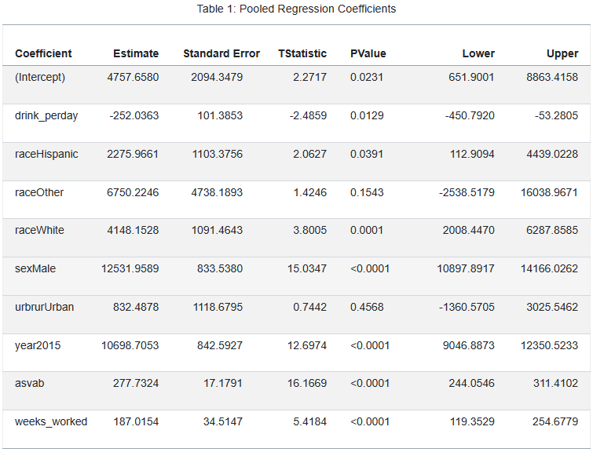

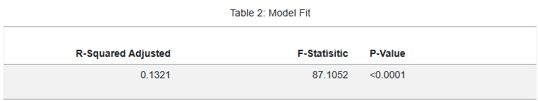

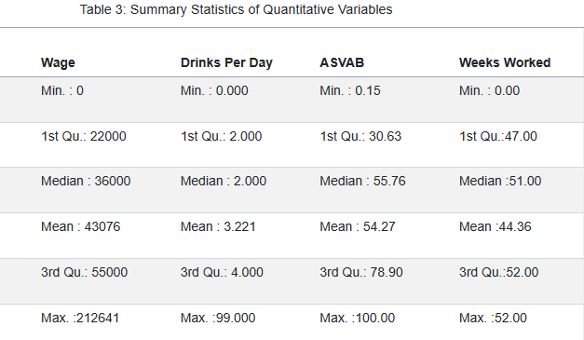

Table 4: Original Fixed Effects Model

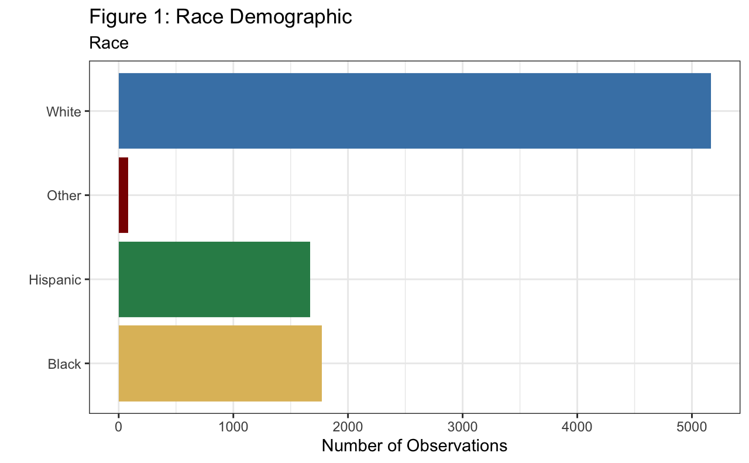

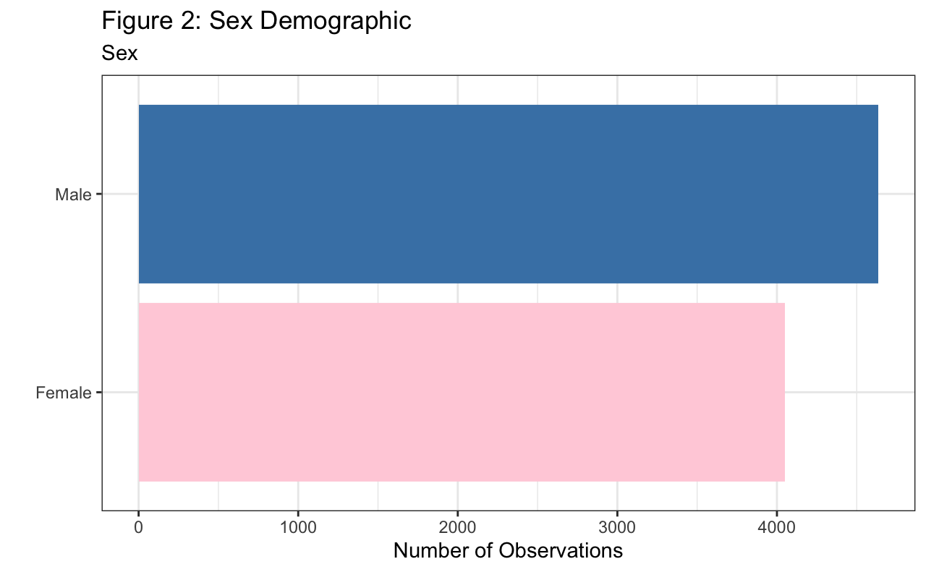

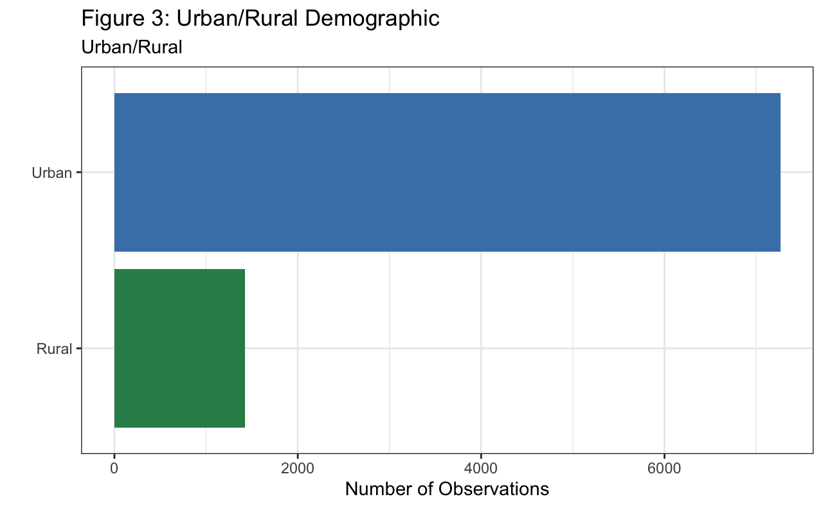

Figure 5: Scatterplot Matrix of Drinks Per Day vs Wage by Year