CISC3024 PATTERN RECOGNITION · AI ASSIGNMENT #2

Variational Bayesian Last Layers (ICLR 2024) for Calibrated Image Classification and Out-of-Distribution Detection
Four-arm comparison on MNIST / Fashion-MNIST · accuracy, calibration and OOD detection

Student name | LAM KA WAI
Student ID | UC325629
Course | CISC3024 Pattern Recognition
Algorithm | Variational Bayesian Last Layers (VBLL) — ICLR 2024
Application | MNIST classification with calibrated uncertainty and out-of-distribution detection
Submission date | Monday, 12 October 2026

1. How I Asked AI Tools to Find the Algorithm

1.1 Reading the brief before searching
The Assignment #2 brief is three sentences long, so the first thing I did was have the AI turn it into a checklist I could search against rather than start typing keywords. The brief requires a recent classification or recognition algorithm based on probability or Bayes theory, applied to computer vision, with the AI doing the searching, the coding and the writing. Three things in it shaped everything that followed:
- the algorithm must be recent, which is a moving target and had to be pinned to a concrete year range before any search could be judged;
- the report needs six specific parts, including how the AI found the algorithm — which is why the search had to be documented as it happened rather than reconstructed afterwards; and
- "You are NOT allowed to write any code by yourself!" — so every line in the submitted notebook is AI-generated, and my job was to run it, verify it and judge it.
I added two constraints of my own, both of which turned out to bind harder than the brief itself:
My constraint | Why it matters
Must run on the free tier of Google Colab (T4, ~15 GB) | Excludes MCMC-at-scale, large Bayesian ensembles, and anything needing many GPU-hours
Must have official / authoritative PyTorch code | Without it, getting a number means re-implementing from the paper — which is precisely what the brief forbids

1.2 The prompts I used
Prompts were typed in Chinese, which is the language I think in; the report is in English. The opening prompt, verbatim:
我需要在做 CISC3024 Pattern Recognition 的 AI Assignment #2。要求：找一个近期的、 基于概率或 Bayes 理论的分类/识别算法，用于计算机视觉与模式识别。整个作业必须由 AI 完成（找算法、编程、写报告）。报告用 Word 或 PDF，下周经 UMMoodle 提交，会过 Turnitin 查重。报告须含 6 部分：(1) AI 如何找到算法 (2) 算法描述 (3) AI 如何实现 (4) 实验设置与结果 (5) 学到什么 (6) 源码的网页链接。"You are NOT allowed to write any code by yourself!" 格式或风格可参考 HW1 的报告。你先按一步步不同階段來做， 有問題請提出，不要做猜測。
"I need to do CISC3024's AI Assignment #2. It requires a recent classification or recognition algorithm based on probability or Bayes theory, for computer vision and pattern recognition. The whole assignment must be done by AI — finding the algorithm, programming, and writing the report. The report is Word or PDF, submitted via UMMoodle next week, and goes through Turnitin. The report must contain six parts: (1) how the AI found the algorithm, (2) algorithm description, (3) how the AI implemented it, (4) experiment settings and results, (5) what was learnt, (6) a webpage link to the source code. "You are NOT allowed to write any code by yourself!" The format and style can follow my HW1 report. Please proceed step by step in distinct stages, and if there are questions, ask rather than guess."
Three things about this prompt are deliberate:
- It asks for staged progress and forbids guessing. "不要做猜測" is what turned the project into six reviewable stages instead of one large opaque deliverable, and it is why the algorithm choice was presented to me for approval rather than assumed.
- It names the binding constraint — that the style must match HW1, not merely that a report is required. Without that, the report would have been structured differently from the one the marker already has a reference point for.
- It quotes the prohibition verbatim. The single most important rule in the brief is the one that determines who does what, so it is stated in the prompt itself rather than paraphrased.
I did not stop at one prompt. Every prompt used across the project — verbatim, in order, with the stage it belongs to — is collected in Appendix C.

1.3 Turning a vague brief into screening criteria
"Recent" and "based on probability or Bayes theory" are not searchable as written. Before accepting any candidate I had the AI define six tests, and required every candidate to pass all six:
ID | Criterion | Type | Pass condition | Why it matters here
SC1 | Recency | Hard | Primary publication 2023–2026 | Explicit requirement in the brief
SC2 | Probabilistic / Bayesian core | Hard | The core contribution is a probabilistic model — an explicit prior, likelihood and posterior. A network that merely outputs a softmax does not qualify | The brief's central requirement, and the one most easily fudged
SC3 | CV / PR application | Hard | Evaluated on a recognisable vision classification/recognition task | Brief requirement
SC4 | Official PyTorch code | Hard | Author-released or de-facto-authoritative repo, installable and runnable | No hand-porting; the brief forbids me writing code
SC5 | Colab free-tier feasible | Hard | Fits 16 GB VRAM; full run completes inside one session | My own constraint
SC6 | MVP friction | Soft (1–5) | Glue code, dependency weight and debugging between pip install and a reported number | Decides between candidates that already pass SC1–SC5
These deliberately mirror the criteria used in Assignment #1 so that the two reports are methodologically comparable.

1.4 How the search was run
Seven queries, issued in sequence. Five independent keyword angles were used first so the candidate pool would not be biased toward one sub-field; a seventh was added afterwards specifically to check that no obvious 2025–2026 method had been missed.
# | Query | What it surfaced
Q1 | Variational Bayesian Last Layer VBLL ICLR 2024 classification github | VBLL — ICLR 2024, official repo VectorInstitute/vbll
Q2 | evidential deep learning Dirichlet classification 2024 2025 github official code | EDL — NeurIPS 2018, PyTorch re-implementation (2023), 2024–25 variants
Q3 | Laplace approximation Bayesian deep learning classification 2024 2025 library | Laplace / laplace-torch , ELLA, laplax (JAX, 2025)
Q4 | Bayesian neural network image classification 2025 new method github pytorch | BNN via VI / SG-MCMC ( JavierAntoran/Bayesian-Neural-Networks )
Q5 | Gaussian process classification deep kernel learning 2024 2025 computer vision pytorch | GP classification / Deep Kernel Learning — GPyTorch
Q6 | Bayesian Nonnegative Decision Layer BNDL ICLR 2025 github code | BNDL — ICLR 2025, XYHu122/BNDL
Q7 | Bayesian uncertainty quantification classification 2025 paper code computer vision | A 2024 review of Bayesian UQ; confirmed the taxonomy and closed the search
Q7 returned only surveys and application papers, not a better-engineered candidate, so the search was closed rather than extended.
Two corrections the AI made to its own first pass. These are worth recording because they are the kind of error a search-driven process produces by default:
- The first pass returned Bayes by Backprop (2015) and MC Dropout (2016) as leading candidates. Both are foundational, but neither is recent, and the brief asks for a recent algorithm. They were demoted to "classical baseline" rather than kept in the candidate list.
- ELLA appeared in the results alongside 2025 work and looked recent; its paper is actually NeurIPS 2022, so it fails SC1. This is exactly the failure mode a search engine encourages — recency of appearance substituted for recency of publication — and it is why every candidate's venue and year was checked against the paper itself rather than the search result.

1.5 The candidates
Algorithm | Venue / year | Probabilistic core | Official PyTorch | Reported outcome
VBLL (Variational Bayesian Last Layers) [1] | ICLR 2024 | Deterministic variational inference over the last-layer weights; ELBO; closed-form training objective | VectorInstitute/vbll [8] — pip install vbll , docs + tests + official Colab tutorials | Improves accuracy, calibration and OOD detection
BNDL (Bayesian Non-negative Decision Layer) [2] | ICLR 2025 | Conditional Bayesian non-negative factor analysis ; Weibull variational posterior | XYHu122/BNDL [9] — bare upload (2 commits, no README/requirements/run instructions) | Accuracy + uncertainty + interpretability
Laplace approximation ( laplace-torch ) [3] | Laplace Redux 2021; library maintained into 2025 | Gaussian posterior around a MAP estimate; last-layer variant (LLLA) | AlexImmer/Laplace [10] — pip install laplace-torch | Post-hoc Bayesian uncertainty for any trained net
EDL (Evidential Deep Learning) [4] | NeurIPS 2018 (+ 2024–25 variants) | Dirichlet prior over class probabilities | clabrugere/evidential-deeplearning (PyTorch, 2023); original is TensorFlow | Quantified classification uncertainty
GP classification / Deep Kernel Learning [5] | Classic (1998 / 2016); active 2023–25 | Gaussian process prior over a latent function; variational ELBO | cornellius-gp/gpytorch [11] | Calibrated probabilistic classification
BNN via VI / SG-MCMC [6] | Bayes by Backprop 2015; cyclic SGHMC 2020 | Posterior over all weights | JavierAntoran/Bayesian-Neural-Networks | Uncertainty, but expensive and non-deterministic

1.6 Scoring and selection
Weighted score out of 5. The weights reflect that reproducibility and finishing on time matter more than a marginal recency gain.
Algorithm | Recency ×0.15 | Prob./Bayes fit ×0.20 | Official code ×0.20 | Colab fit ×0.25 | Report value ×0.20 | Total
VBLL | 4.5 | 5 | 5 | 5 | 5 | 4.93
Laplace ( laplace-torch ) | 3.5 | 5 | 5 | 5 | 4.5 | 4.68
EDL (Dirichlet) | 3.0 | 5 | 4 | 5 | 4.5 | 4.40
GP classification / DKL | 3.0 | 5 | 5 | 4 | 4 | 4.25
BNDL | 5.0 | 5 | 2.5 | 3 | 4.5 | 3.90
BNN via VI / SG-MCMC | 2.5 | 5 | 4 | 4 | 3.5 | 3.88
Selected: VBLL — Variational Bayesian Last Layers (Harrison, Willes & Snoek, ICLR 2024) [1].
Why BNDL was rejected despite being a year newer. BNDL (ICLR 2025) [2] is the more recent and, on paper, the more ambitious method — it and VBLL solve the same problem from different angles. But its repository contains only two folders (ResNet-Sparse, ViT-Sparse) and no README, no requirements file and no run instructions; the last commit is a bulk "Add files via upload". Getting a number out of it would mean reverse-engineering the authors' setup from the paper, which is (a) exactly the re-implementation the brief forbids and (b) an open-ended time sink against a one-week deadline. This is the same reasoning that selected MobileNetV4 over higher-scoring alternatives in Assignment #1: reproducibility beats a marginal recency gain.
Why laplace-torch was rejected as the headline algorithm. It is genuinely excellent and easy to use, but its defining paper (Laplace Redux) [3] is 2021, so it fails SC1 as a recent algorithm. Rather than discard it, I kept it as a comparison baseline — which is where it adds the most value, because it is the strongest non-VBLL probabilistic head available and makes the comparison meaningful instead of decorative.

2. Algorithm Description

2.1 The problem VBLL solves
A Bayesian neural network places a prior and posterior over all weights. That is principled and, in practice, painful: the posterior is high-dimensional, training needs stochastic variational inference or MCMC, and prediction needs many forward passes.
VBLL makes a different bet. Almost all of a network's representational power lives in its feature extractor; the probabilistic decision lives in the last layer. So VBLL keeps the feature extractor as an ordinary point-estimated network and makes only the last layer Bayesian. The result is a method that is genuinely Bayesian where it matters, but whose probabilistic cost is negligible — quadratic in the last-layer width rather than in the whole network.

2.2 The model
Write the network as a deterministic feature map φ(x) ∈ ℝ^{D} followed by a linear last layer with weights W ∈ ℝ^{C × D}, so the logits are z = W φ(x).
Prior. A zero-mean Gaussian on the last-layer weights,
p(W) = 𝒩(0, σ² I)
with σ² scaled by prior_scale · 2/D.
The 1/D scaling is deliberate: it makes the prior invariant to the feature width, so the method does not need retuning when the backbone changes.
Variational posterior. A Gaussian q(W) = 𝒩(M, Σ), where Σ is one of three parameterisations exposed by the library:
parameterization | Σ | Cost
diagonal | diag | C · D
dense | full C × D covariance | C · D ²
lowrank | diagonal + rank- r correction | C · D · r
Objective. Maximise the ELBO
L = 𝔼_{q(W)}[log p(y | W, x)] − KL(q(W) ‖ p(W))
The KL term is analytic (both distributions are Gaussian). The data term is the hard part: for classification it contains the softmax normaliser log Σ_{c} exp(z_{c}), and the expectation of that under a Gaussian q(W) has no closed form.
The Jensen bound. VBLL bounds it from below using the marginal logit statistics. With z̄ = M φ(x) and per-class marginal variances Σ_{cc} = φ(x)⊤ Σ_{c} φ(x),
𝔼_{q}[log softmax(z)_{y}] ≥ z̄_{y} − log Σ_{c} exp(z̄_{c} + 1/2 Σ_{cc})
That is the whole trick: the intractable expectation is replaced by a closed-form, deterministic bound that depends only on the posterior mean and the posterior marginal variances of the logits. Training therefore needs no Monte-Carlo sampling over the posterior and no MCMC — it is an ordinary gradient-descent loop on a deterministic objective, which is why VBLL slots into an existing training pipeline with almost no changes.
Regularisation weight. The bound is scaled by regularization_weight, which the official tutorial sets to 1/N_{train}, so the averaged data term and the KL term are commensurate as the dataset grows.
Predictive distribution. The exact predictive p(y^{<em>} | x^{</em>}) = ∫ softmax(W φ^{<em>}) q(W) dW is still intractable, and here VBLL does* sample — but only over the C · D-dimensional last layer, which is cheap. The reference implementation averages 20 Monte-Carlo softmax draws and clips the result to [0,1]. I state this explicitly because the paper's "sampling-free" claim is often read as "prediction involves no sampling at all", and that is not what the code does. It is accurate to say: no sampling is needed to train, and the sampling needed to predict is confined to a low-dimensional last layer.

2.3 The two heads, and why they are not interchangeable
VBLL ships two classification heads, and the assignment compares both:
Head | What it models | Bound
DiscClassification | p ( y | x ) directly — a discriminative softmax | Jensen bound on the log-softmax, as above
GenClassification | p ( x | y ) — a class-conditional Gaussian over the input , combined with a class prior and inverted by Bayes | log-likelihood of x under each class, minus a trace term, minus the log-sum-exp normaliser
The generative head is the Bayes-optimal classifier of the course's Bayes Decision Theory lecture, implemented with a variational last layer: it models each class as a Gaussian in input space, and prediction is softmax_{y} log p(x | y).
A discrepancy worth stating. The two heads' training losses are not numerically comparable. One is a bound on a discriminative softmax; the other is a bound on a class-conditional likelihood over 784-dimensional inputs. They live on different scales and mean different things. The official tutorial warns about this, and the report must respect it: the two heads are compared on accuracy, NLL, ECE and AUROC — never on loss value.

2.4 Why it suits this assignment
- It is unambiguously Bayesian. Deterministic variational inference, an explicit prior, an explicit posterior, an ELBO — the exact prior → likelihood → posterior chain the course builds on.
- It is one pip install away. pip install vbll, a documented API, a test suite, and two official Colab tutorials. The risk of spending the week on plumbing rather than experiments is low.
- It is nearly free to run. Quadratic in last-layer width, so a four-arm comparison fits inside one free Colab session.
- It gives the report a real spine. VBLL targets accuracy, calibration and out-of-distribution detection — three things a probabilistic classifier should get right and a plain softmax does not. That yields a genuine experimental story rather than "we trained a model and it reached X %".

3. How AI Implemented the Algorithm
The work ran in five stages.
Stage | What was built
1 | Literature search, screening criteria, weighted scoring, selection (reported in §1)
2 | Environment and dependency locking for Colab, delivered as 00_colab_setup.ipynb
3 | Architecture design for the experiment notebook, as a separate specification document
4 | Full implementation of 01_vbll_classification.ipynb (28 designed cells, 8 sections)
5 | Local verification harnesses, then the dependency self-repair cell after a real Colab failure

3.1 The single most important engineering decision
The notebook compares four arms, and they return four different things:
Arm | What a forward pass returns | How probabilities are obtained | How an OOD score is obtained
(a) MLP + softmax | raw logits (N, C) | apply softmax | 1 − max p
(b) VBLL Disc | a VBLL output object | read out.predictive.probs | read out.ood_scores
(c) VBLL Gen | a VBLL output object | read out.predictive.probs | read out.ood_scores
(d) Laplace LLA | probabilities (GLM predictive) | already normalised | nothing native — must be derived
Three of the four need different post-processing, and arm (d) has no OOD score at all. The obvious implementation — let the evaluation function branch on the arm — produces an if arm == ... ladder that breaks the moment an arm is added or changed.
The decision was an adapter (port) layer. Each arm is wrapped in a thin object exposing exactly one method:
predict(loader) -> Prediction
and evaluate_model only ever sees a Prediction — never a model, a logit tensor or a VBLL output object. A Prediction is a small container carrying probs, logits, ood_score, n, optional uncertainty fields and a provenance dict, with its invariants (rows sum to 1, values in [0,1], no NaN, length matches the dataset) asserted inside the adapter that produced it, so a malformed prediction is caught by name rather than surfacing later inside a metric.
The pay-off is that adding a fifth arm later means writing one adapter, with no change to the metrics or the plotting code.

3.2 Three rules that protect the result
These are not style preferences; each one silently invalidates a headline number if broken, and none of them would look wrong in a diff.
1. No second softmax. The VBLL heads and the Laplace GLM predictive already return normalised probabilities. Applying softmax again would quietly destroy the very calibration the notebook is measuring. The adapters are the only place probabilities are produced, and neither applies softmax to a VBLL or Laplace output. The rule is written as a comment at the point where it could be violated.
2. The VBLL OOD score is inverted relative to its name. I read the library source before writing the call, and out.ood_scores is assigned self.max_predictive(x) — the maximum predictive probability, where a large value means confident, i.e. in distribution. Taken at face value it would have produced OOD AUROC below 0.5 and a completely wrong conclusion. The adapter flips it (1 − ood_scores) so that the Prediction contract — higher means more OOD — holds for every arm. This was confirmed empirically: the VBLL arm's native AUROC came out at ≈ 0.92, i.e. well above 0.5.
3. A return_ood=False head must fail loudly, by name. If the VBLL head is built without return_ood, out.ood_scores does not exist and the naive code raises a bare AttributeError twenty lines later. The factory defaults to True, and the adapter raises a RuntimeError that names the arm and the cause.

3.3 Details that had to be right
One training loop for two objectives. The baseline needs nn.CrossEntropyLoss on raw logits; the VBLL arms need the ELBO, differentiated through out.train_loss_fn(y) with out.val_loss_fn(y) for validation. A single train_model handles both by branching once on the model type. Two details matter:
- the VBLL loss function is already a scalar (the library averages internally), so it must not be averaged again;
- the VBLL head is excluded from weight decay. Its prior term already regularises it — and the ELBO is scaled by reg_weight = 1/N — so adding weight decay would double-count the prior. This is done with parameter groups, weight_decay = 0 on the head only.
The Laplace arm is post-hoc, and its hyperparameters are tuned on validation. Last-layer Laplace does not change how the network is trained, so arm (d) starts from an ordinary MLP trained with exactly the recipe of arm (a). The Laplace posterior is then fitted around it and the prior precision is optimised by grid search against the validation split — never the test split and never the OOD set.
The Laplace link approximation needed a mapping. I specified a configuration knob with two human-readable modes, "sampled" and "deterministic". Reading the library source showed that link_approx is validated against {'mc', 'probit', 'bridge', 'bridge_norm'} and rejects anything else, so the knob is mapped in one place ({"sampled": "mc", "deterministic": "probit"}). Without checking, this would have been a ValueError at the very last step of the notebook.
The GLM predictive is batched under no_grad. It is the heaviest and most memory-hungry step in the notebook, so prediction is wrapped and chunked rather than run over a full test set in one call.

3.4 Corrections I caught
The brief frames the assignment around AI tooling, so this is the honest part: things the generated code got wrong, each found by running it and reading the output rather than by reading the code.
1. VBLL's "sampling-free" predictive is stochastic, which broke reproducibility and early stopping. Reading the source showed that predictive() internally averages 20 Monte-Carlo samples drawn with rsample, so out.predictive.probs changes between calls even though the posterior itself is deterministic. Two consequences the design had not anticipated: the reported metrics were not reproducible run to run, and validation accuracy wobbled between epochs — so early stopping could fire on Monte-Carlo noise rather than on a real change. The fix is a small context manager (deterministic_mc) that pins the RNG for the duration of a predictive call and restores the caller's state afterwards, so training is unaffected. Verified: two consecutive evaluations of the same VBLL adapter now differ by exactly 0 in both NLL and AUROC.
2. ECE is dominated by a single bin, and that had to be surfaced rather than hidden. I instrumented the bin occupancy and found that on MNIST 10 of the 15 equal-width bins are empty and the top bin holds 9,330 of the 10,000 test samples (93 %). The equal-width ECE is therefore, in practice, a measurement of one bin. I added the equal-mass alternative (ece_equal_mass) and a second results column, plus a printed occupancy report. The honest finding is that on this data the two conventions agree closely (0.0054 vs 0.0042 for VBLL-Disc) — the structural concentration is real but does not distort the number much at this accuracy level. The report states both, because neither is "the" ECE.
3. The notebook generation itself had an escaping bug, caught before delivery. The first generator wrote cell sources as Python string literals, and a "\n" inside it became a real newline inside a generated string literal — producing SyntaxError: unterminated string literal in the output notebook. The fix was structural rather than a patch: cell sources now live as literal text in a separate file and the generator only splits them and validates them, so escaping bugs are impossible by construction.
4. The verification harness could silently test the wrong cell. The harness located cells by hard-coded index, which means inserting one cell would have made it execute the wrong code while still reporting success. It now locates every cell by a unique marker in its header comment and asserts the match is unique.
5. The environment cell assumed a setup notebook that no longer existed. The first real Colab run failed with ModuleNotFoundError: No module named 'vbll' because Colab had recycled the session and discarded every pip-installed package — the setup notebook had done its job correctly, in a session that was gone. This is discussed in §3.5 because the fix changed the notebook's structure.
6. The one error a CPU-only harness could not catch, which the first real GPU run found immediately. Every harness in §3.6 runs on CPU, and one conversion inside fit_laplace passed through all of them untouched:
pp = float(np.asarray(la.prior_precision).ravel()[0])
laplace-torch's prior_precision setter moves the tensor onto the model's own device (prior_precision.to(device=self._device)), so on a GPU it is a cuda:0 tensor and np.asarray on it raises
TypeError: can't convert cuda:0 device type tensor to numpy.
Use Tensor.cpu() to copy the tensor to host memory first.
On CPU the very same line is correct. So the harness reported 37/37 passed while the notebook died on the GPU — and it died at the worst point, at the Laplace prior-precision step, after all four arms had finished training. The fix is one .detach().cpu() on that line, plus a defensive .cpu() on the two neighbouring conversions that were correct only by accident of their data source. The lesson is the sharpest one in this report: a test suite that runs on one device silently declares every other device out of scope.
7. A second device bug — this time in the library, and this time hidden behind a configuration choice. The ablation study (§4.4) exercises the VBLL covariance parameterisations, and the lowrank arm died on the GPU with
RuntimeError: Expected all tensors to be on the same device,
but found at least two devices, cuda:0 and cpu!
raised inside vbll/utils/distributions.py, in LowRankNormal.logdet_covariance:
term2 = torch.linalg.det(arg1 + torch.eye(arg1.shape[-1])).log()
torch.eye(n) with no device= is allocated on the CPU, while arg1 — built from the head's own cov_factor and cov_diag, which build_vbll_model has already moved to the GPU — is on cuda:0. The same class of mistake occurs one more time at line 27 (cholesky_solve(torch.eye(...))), reached by the precision parameterisations.
Three things make this worth writing down. First, it is an upstream bug, not a bug in the generated code — the notebook calls the library correctly. Second, it is invisible to the diagonal parameterisation, which is the default: diagonal maps to vbll's Normal, whose logdet_covariance is just 2 log(scale).sum(-1) and never touches torch.eye. That is exactly why the main run was unaffected and only an ablation arm failed — the defect is conditional on a configuration value*, so no amount of re-running the default configuration would have exposed it. Third, editing site-packages is not a durable fix, because Colab discards installed packages on every session recycle.
The fix is a device-safety shim installed once at import time, which replaces the two functions with equivalents whose only difference is that the identity matrix inherits device and dtype from the tensor it is combined with. The shim is verified to be numerically identical to the originals (max absolute difference 0.0) and to preserve the gradient path the ELBO depends on.

3.5 The dependency self-repair cell
The original design was two notebooks: 00_colab_setup.ipynb installs, then 01_vbll_classification.ipynb runs. That works until the session is recycled, and it fails hardest for exactly the person most likely to hit it — a marker who opens only the experiment notebook and hits Run All.
The experiment notebook therefore now begins with an idempotent dependency self-repair cell:
- it reports what is importable and returns immediately if nothing is missing, so a healthy session pays about a second;
- it guards import torch separately, because if PyTorch itself is gone the runtime is broken and pip will not help;
- it records Colab's own torch/torchvision versions into a constraints file and installs behind them with pip install -c colab-constraints.txt ..., so no transitive dependency can swap the CUDA build of PyTorch for a CPU wheel and silently turn torch.cuda.is_available() into False. PyTorch is never in the package list;
- it drops the import caches (importlib.invalidate_caches(), sys.path_importer_cache.clear(), and stale sys.modules entries), because a running kernel caches the contents of site-packages and cannot otherwise see a freshly installed top-level package;
- it verifies that every import works and that torch.__version__ is unchanged and CUDA is still alive;
- if the install does not take, it raises a diagnosable error naming the exact commands to run, instead of leaving a bare traceback.

3.6 How the generated code was verified
Reading code is not verification. Three harnesses were built, and all three execute the delivered .ipynb rather than a copy — the cells are read back out of the file on disk, so what is tested is the artefact that ships.
Harness | What it does | Result
End-to-end | Extracts all 22 code cells and runs them in order against real MNIST / Fashion-MNIST on CPU, then asserts 37 properties of the artefacts | 37/37 passed
Metric unit tests | Runs the metric functions against hand-computed answers: clipping behaviour, the conf == 1.0 boundary, empty bins, and both ECE conventions | 23/23 passed
Hotfix install path | Hides vbll / laplace so the self-repair cell takes its install branch, intercepts pip as --dry-run , and asserts the command carries -c <constraints> , pins the local torch, never lists torch itself, and fails loudly if the packages remain missing | 11/11 passed
The third harness exists because the end-to-end test cannot reach the install branch — the packages really are installed on this machine, so the cell correctly takes its "nothing missing" path. That is the branch most likely to break a user's session, so it was tested deliberately rather than left to chance.
Two other checks: nbformat 4.0 schema validation passes, and every code cell is passed through compile() at generation time, so a syntax error fails the build rather than the user's run.
What this table does not cover. All three harnesses run on CPU, and that mattered: the GPU-only failure described in §3.4.6 passed every one of the 37 checks. A verification suite that exercises a single device implicitly declares every other device unverified, so the first run on real hardware was — and had to be — part of the verification rather than a formality after it. This is reported rather than quietly fixed, because the gap is more instructive than the 37 passes.
How that gap was closed. The GPU run was then repeated on Colab with the corrected notebook, and it completed end to end: all four arms trained, the Laplace prior-precision grid search selected 0.0001, all four arms were evaluated, and the five figures and both result files were written. §4.3 is that run. The verification story is therefore in three parts — 37 automated checks on CPU, one real GPU failure they could not catch, and one successful GPU run that closed it — rather than a single claim that the code was reviewed.

4. Experiment Settings and Results

4.1 Environment and configuration
The environment is not asserted here, it is echoed by the notebook at run time and recorded in results.json; the values below are transcribed from that record.
Runtime | Google Colab, free tier, NVIDIA Tesla T4
Python | 3.13.15
torch / torchvision | 2.11.0+cu130 / 0.26.0+cu130 — Colab's own CUDA build, pinned in a constraints file and never reinstalled
CUDA runtime | 13.0
numpy / scipy / pandas / scikit-learn | 2.1.3 / 1.16.3 / 2.2.3 / 1.6.1
matplotlib / seaborn / tqdm | 3.10.0 / 0.13.2 / 4.67.3
vbll | 0.4.9
laplace-torch | 0.2.3 (pulls in curvlinops-for-pytorch 3.0.1)
Backbone | MLP, 2 hidden layers × 256 units, ReLU (269,322 parameters for arms (a) and (d))
Optimiser | AdamW, lr 3e-3, weight decay 0 on the probabilistic head
Batch size | 512
Epochs | 30, early stopping on validation accuracy (patience 8)
Split | MNIST 54,000 train / 6,000 validation, carved once from a fixed-seed generator
Seeds | single seed for the main table; CFG['seeds'] = [0, 1, 2] behind the §6 flag
ECE bins | 15, equal-width by default, equal-mass reported alongside
Laplace | subset_of_weights='last_layer' , hessian_structure='kron' , pred_type='glm' , link_approx='mc' ( "sampled" mode), 100 samples, prior precision by grid search on validation — the run selected 0.0001
Parameter counts | (a) 269,322 · (b) 271,882 · (c) 272,128 · (d) 269,322
The environment echo also confirms the mechanism described in §3.5 actually fired: the self-repair cell found missing : vbll, laplace, installed behind the constraints file, and reported torch 2.11.0+cu130 unchanged with CUDA alive afterwards.
Held constant across arms (a)–(c): identical backbone, identical optimiser and budget, identical data. Arm (d) is deliberately not protocol-matched, because last-layer Laplace is a post-hoc procedure by construction — it starts from an already-trained network. That asymmetry is a property of the method, not an oversight.
Data choice. MNIST is in-distribution and Fashion-MNIST is out-of-distribution. Both have exactly 10 classes, so a random classifier scores ~0.10 on both and a well-calibrated model reports ~0.10 confidence on average — which means a large gap between accuracy and confidence is a genuine calibration failure rather than an artefact of a label-space mismatch. One normalisation transform (MNIST statistics) is applied to both sets, so an AUROC difference cannot be blamed on the preprocessing.
The OOD set is never used for any decision. It is touched only inside evaluate_model, after every model has been trained and every hyperparameter fixed.
Where the numbers come from. §4.3 reports the main run on Colab (T4) and is the authoritative result. §4.2 reports a separate local CPU smoke run of the same notebook on the same data, with a reduced budget, whose only purpose was to validate the pipeline before spending GPU time. The two are labelled apart throughout, and no number is copied between them.

4.2 Smoke test — validating the pipeline before spending GPU hours
The first thing checked was not the model but the data. One training batch was de-normalised and rendered, and the per-class counts of both splits were tabulated:
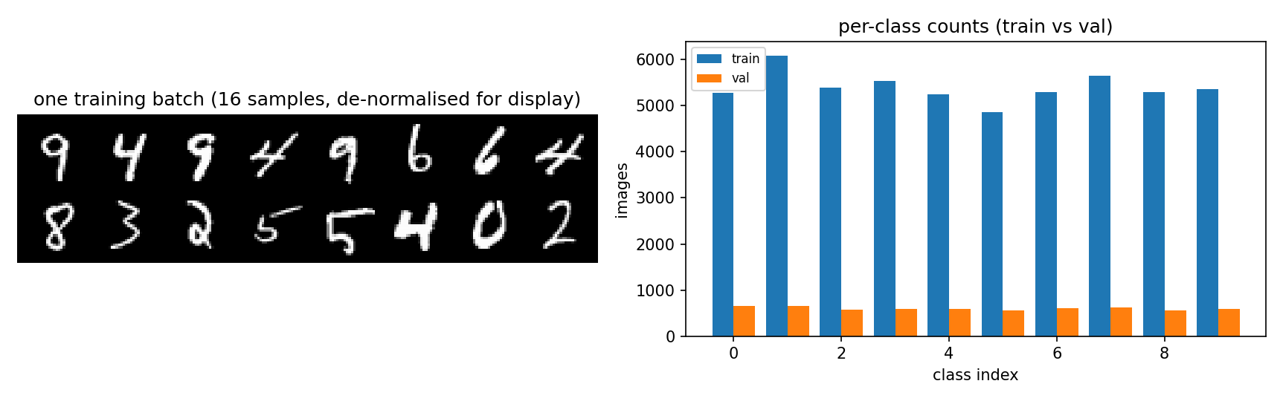
Figure 4.2.1: The data sanity check — one training batch de-normalised for display, and the per-class counts of the train and validation splits
The batch shows recognisable digits rather than noise (Figure 4.2.1), which confirms that the normalisation constants (mean 0.1307, std 0.3081) are applied and then correctly undone for display — a wrong constant here would have produced grey mush and been invisible in every later metric. The class counts are near-uniform in both splits, so the 10 % validation carve-out is not starving any class; an imbalance would have biased every accuracy and ECE figure in §4.3.
Then the full notebook was executed end to end against the real MNIST and Fashion-MNIST datasets, on CPU, with a reduced budget (4 epochs, Laplace grid size 3). All 22 code cells ran, and 37 assertions on the resulting artefacts passed.
This stage earned its place: it is where the OOD sign error (§3.2) would have shown up as an AUROC below 0.5, and where the RNG reproducibility problem (§3.4) was first observed.
Arm | Accuracy | NLL | ECE | ECE (equal-mass) | OOD AUROC (native) | OOD AUROC (entropy)
(a) MLP + softmax | 0.9747 | 0.0810 | 0.0054 | 0.0052 | 0.9100 | 0.9132
(b) VBLL DiscClassification | 0.9758 | 0.0779 | 0.0054 | 0.0042 | 0.9222 | 0.9270
(c) VBLL GenClassification | 0.9555 | 0.1786 | 0.0297 | 0.0296 | 0.8782 | 0.8888
(d) Laplace (last-layer) | 0.9764 | 0.0812 | 0.0063 | 0.0068 | 0.8918 | 0.8958
One caution about this table, which the full run later confirmed. A reduced-budget run validates that the pipeline produces sane numbers, but it does not predict the ranking at full budget. At 4 epochs the OOD AUROC ordering is VBLL-Disc (0.9222) → baseline (0.9100) → Laplace (0.8918) → VBLL-Gen (0.8782). At 30 epochs (§4.3) it is Laplace (0.9595) → VBLL-Disc (0.9552) → baseline (0.8446) → VBLL-Gen (0.8246). The top two swapped, and the baseline fell from second to third. Nothing in this table is a preview of §4.3.
Two notes on how to read this table:
- Two AUROC columns, because the four arms do not measure the same thing. auroc_native is each arm's own score — a likelihood-based quantity for VBLL, 1 − max p for the baseline and for Laplace. auroc_entropy is the predictive entropy, computable from probs for all four arms, and is the only apples-to-apples comparison. Reporting a single column would compare four different quantities and invite the wrong conclusion.
- The ECE columns are close, and that is a finding. The equal-width estimator is structurally dominated by its top bin (§3.4), yet on this data it agrees with the equal-mass estimator to within 0.001. Both are reported because neither is definitive.

4.3 Main result
Table 4.3.1 — main comparison. Thirty epochs, batch 512, AdamW at lr 3e-3, identical backbone and identical train/validation split for every arm; single seed; Colab T4. Transcribed from results.csv. Nothing in this table is interpolated from the §4.2 smoke run.
Arm | Accuracy | NLL | ECE (equal-width) | ECE (equal-mass) | OOD AUROC (native) | OOD AUROC (entropy)
(a) MLP + softmax | 0.9792 | 0.0818 | 0.0105 | 0.0102 | 0.8453 | 0.8446
(b) VBLL DiscClassification | 0.9773 | 0.0750 | 0.0047 | 0.0031 | 0.9519 | 0.9552
(c) VBLL GenClassification | 0.9734 | 0.1118 | 0.0050 | 0.0027 | 0.8261 | 0.8246
(d) Laplace (last-layer) | 0.9794 | 0.0707 | 0.0048 | 0.0035 | 0.9560 | 0.9595
Accuracy does not separate the arms, and should not be led with. The whole spread is 0.6 percentage points, and the plain softmax baseline is second. Any claim that the probabilistic arms are more accurate would be unsupported by this table. The interesting columns are the other four.
Calibration is where the difference actually is. The baseline's equal-width ECE [7] is 0.0105 against 0.0047 / 0.0050 / 0.0048 for arms (b), (c) and (d) — a factor of about 2.2. On the equal-mass convention the gap is wider still (0.0102 vs 0.0027–0.0035, a factor of 2.9–3.8). All three probabilistic arms land at ≈0.005, and the ordering between them is inside the noise. The defensible statement is therefore: the baseline is clearly overconfident and the three probabilistic arms are all clearly better calibrated than it, not that any one of them is best.
OOD detection: two of the three probabilistic arms win, and one loses. Using the common entropy score — the only apples-to-apples column (§4.2) — the order is
(d) Laplace 0.9595 > (b) VBLL-Disc 0.9552 ≫ (a) baseline 0.8446 > (c) VBLL-Gen 0.8246
Arms (b) and (d) each gain roughly +0.11 AUROC over the baseline, which is a large and consistent margin. But arm (c) is worse than the baseline, and this is worth stating plainly rather than smoothing over: a blanket claim that "the Bayesian arms beat the plain MLP" is false on this data. The gain belongs to the discriminative VBLL head and to last-layer Laplace; the generative head does not share it. That is consistent with §2.3 — the generative head infers a class-conditional density over inputs and inverts it by Bayes, so its score is not the same kind of object as a discriminative posterior, and there is no reason it should order the same way. A negative result that follows from the model's construction is still a result, and it is reported as one.
NLL tracks calibration, not accuracy: (d) 0.0707 < (b) 0.0750 < (a) 0.0818 < (c) 0.1118. Arm (c)'s NLL is the worst of the four even though its accuracy is close to the others, which is the same story the AUROC column tells.
Table 4.3.2 — equal-width bin occupancy on the in-distribution test set (15 bins).
Arm | Non-empty bins (/15) | Mass in top bin
(a) MLP + softmax | 12/15 | 0.963
(b) VBLL DiscClassification | 12/15 | 0.932
(c) VBLL GenClassification | 13/15 | 0.924
(d) Laplace (last-layer) | 13/15 | 0.919
The concentration predicted in §3.4 is real on the main run: at least two bins are empty for every arm and 91.9–96.3 % of the test set sits in the single top bin. A further observation only the main run exposes: the baseline is the most concentrated of the four (96.3 % vs 91.9–93.2 %). So the very overconfidence that costs the baseline its ECE also piles its samples harder into one bin — meaning its equal-width ECE is computed on an even thinner slice of the data than the other arms'. The direction of the comparison is unchanged, but the two ECE columns are not measuring identical slices, which is the reason both are reported.
Figures.
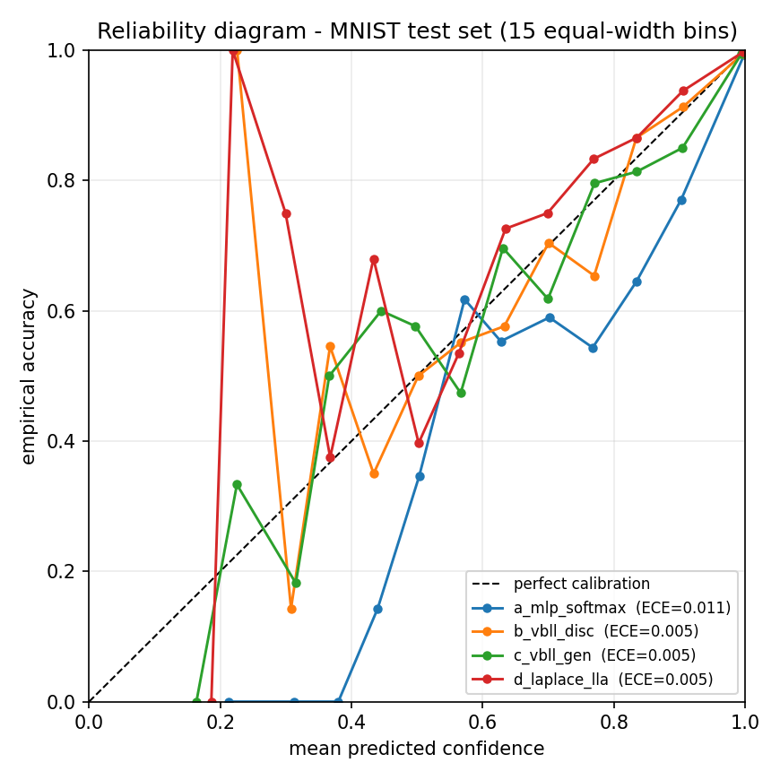
Figure 4.3.1: Reliability diagram for all four arms
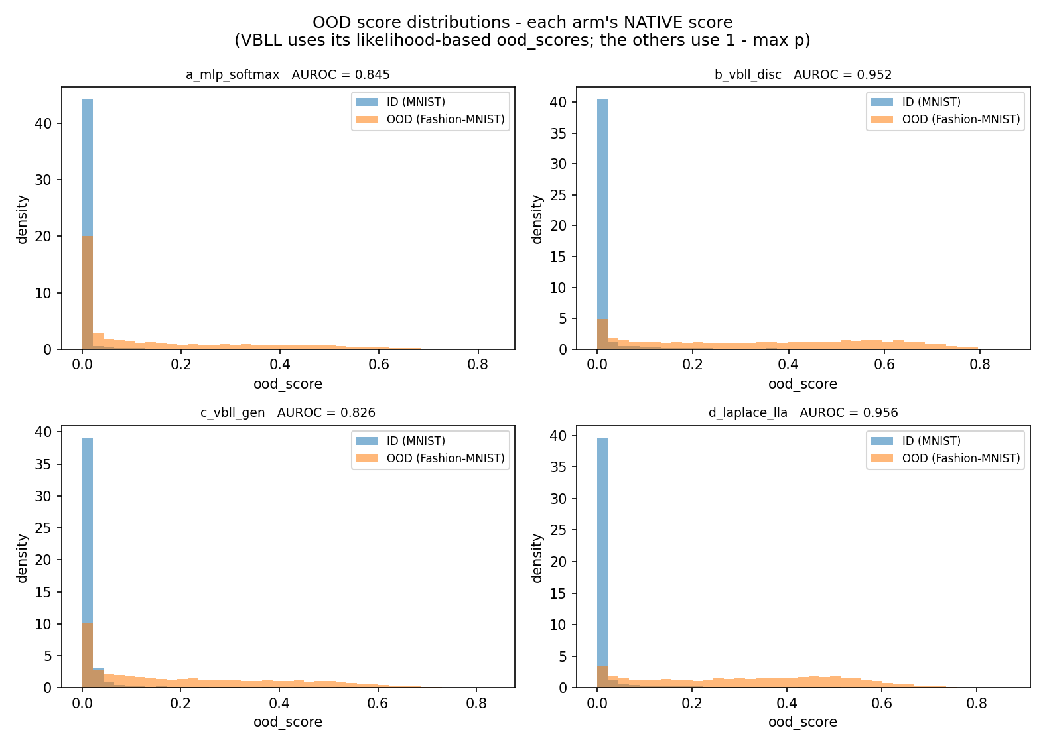
Figure 4.3.2: OOD score distributions — each arm's native score
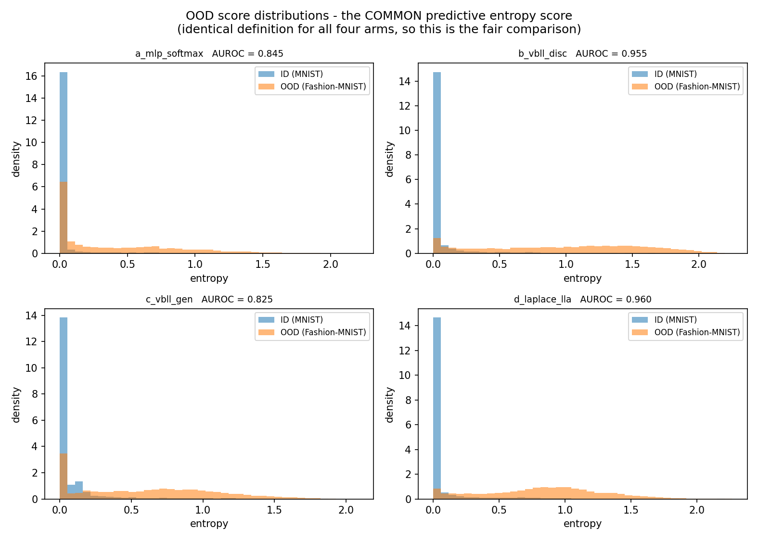
Figure 4.3.3: OOD score distributions — the common predictive-entropy score
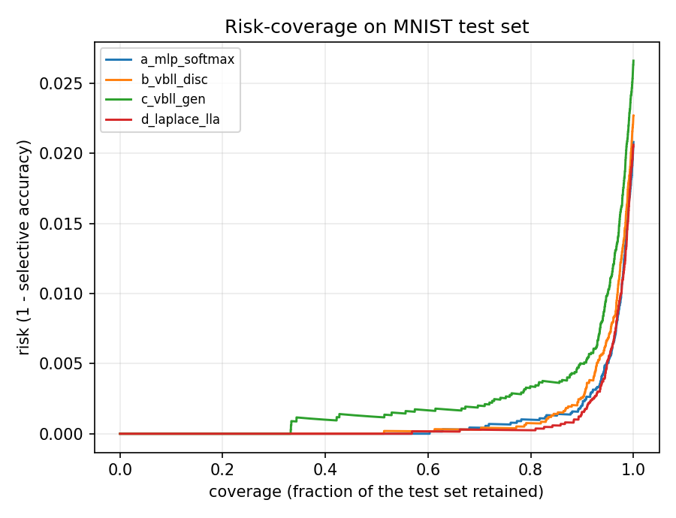
Figure 4.3.4: Risk–coverage curves for selective prediction
Reliability diagram (Figure 4.3.1). The curves are jagged below ≈0.6 because those bins hold very few samples — the same concentration quantified in Table 4.3.2 — so the informative region is 0.8–1.0, where nearly all the mass is. Read there, the baseline (blue) sits furthest below the diagonal, which is the signature of systematic overconfidence, while the three probabilistic arms hug the diagonal more closely. The diagram is not drawn from separate plotting code: it is a by-product of the same bin arrays the ECE is computed from, so the curve and the number in Table 4.3.1 cannot disagree.
OOD histograms — native score (Figure 4.3.2). Each panel shows the in-distribution density against the OOD density for one arm. All four have ID mass concentrated near 0, but in (a) and (c) a substantial part of the OOD density remains near 0 — OOD samples that the model finds in-distribution — whereas in (b) and (d) that mass is pushed to the right. The visual separation and the AUROC column are the same finding.
OOD histograms — entropy (Figure 4.3.3). This is the fair comparison, because the score is defined identically for all four arms. Arms (b) and (d) show a sharp ID spike at ≈0.05 nats with the OOD distribution spread across roughly 0.3–1.3; arms (a) and (c) have a visibly broader ID spike and more OOD mass at low entropy. The ordering visible by eye is the ordering in the AUROC column, which is the point of showing both.
Risk–coverage (Figure 4.3.4). All four arms have essentially zero risk at low coverage, and they separate only in the last ≈20 %. Arm (c) is consistently the worst, matching its lowest accuracy and lowest AUROC. Arms (a), (b) and (d) almost coincide — and that is the honest reading of this figure: on a saturated benchmark, selective prediction barely discriminates between arms whose accuracies differ by less than a point. It is included because it was pre-registered, not because it separates anything.
Summary of §4.3. Calibration and OOD detection separate the four arms; accuracy does not. The discriminative VBLL head and last-layer Laplace each improve calibration by roughly a factor of two and OOD AUROC by roughly 0.11 over the plain softmax baseline. The generative VBLL head improves calibration but degrades OOD detection relative to that same baseline. Every number above is a single-seed observation.

4.4 Ablation study
The ablation isolates three single-variable axes on top of the discriminative VBLL head, each changing exactly one entry of CFG away from its default. It was executed as a standalone, resumable notebook (02_vbll_ablations.ipynb, see §3.4 correction 7) so that it never re-runs the 30-epoch main experiment. Every arm uses the same backbone, the same optimiser, the same train/validation split and the same 30-epoch budget as §4.3.
Table 4.4.1 — ablation results. Seed 0. auroc_native is each head's own OOD score.
Arm | Changed from default | Accuracy | NLL | ECE | OOD AUROC
disc_diagonal | — (reference) | 0.9839 | 0.0571 | 0.0061 | 0.9208
disc_lowrank | parameterization='lowrank' | 0.9838 | 0.0615 | 0.0059 | 0.9390
disc_dense | parameterization='dense' | 0.9835 | 0.0584 | 0.0056 | 0.9253
disc_prior_0.1 | prior_scale=0.1 | 0.9833 | 0.0574 | 0.0040 | 0.9103
disc_prior_10 | prior_scale=10.0 | 0.9832 | 0.0610 | 0.0077 | 0.9145
disc_no_ood | return_ood=False | 0.9850 † | — | — | —
† disc_no_ood records validation accuracy, not test accuracy, because the test-set evaluation is precisely what this arm is designed to fail (§3.2). Its accuracy is therefore not comparable with the rows above and is deliberately not ranked against them. An em dash marks a quantity that is undefined for that arm, not a missing measurement.
Covariance parameterisation. Holding prior_scale at its default, accuracy is essentially unchanged across diagonal, lowrank and dense — 0.9835 to 0.9839, a spread of 0.0004, which is well inside the run-to-run reference derived below. On this task the shape of the last-layer posterior covariance buys nothing in classification accuracy. It does move the two uncertainty-facing columns, and in different directions.
- lowrank produces the largest OOD figure, AUROC 0.9390 against 0.9208 for diagonal (+0.018), but pays for it with the worst NLL of the three (0.0615 vs 0.0571). It is a trade-off, not a free improvement.
- dense produces the best ECE (0.0056) but only a marginal OOD gain (+0.0045 over diagonal). The price is exact and large: dense carries a full 256×256 per-class covariance, which is 660,500 head parameters against 5,140 for diagonal, and a local CPU timing put its per-step cost at 1.875 s against 0.005 s — ≈375× — for a batch of 512. (That ratio is a local measurement, not a Colab figure, but the parameter counts are exact and the argument below is about cost, so it does not depend on the noise level.) The extra expressiveness is not justified on this task: it buys the smallest OOD gain of the three parameterisations at the largest cost. This is the most practically useful conclusion of the sweep.
- The ECE spread across the three (0.0056–0.0061) is 0.0005, i.e. indistinguishable at this precision.
Prior-scale sensitivity. Holding the parameterisation at diagonal:
prior_scale | Accuracy | NLL | ECE | OOD AUROC
0.1 | 0.9833 | 0.0574 | 0.0040 | 0.9103
1.0 (default) | 0.9839 | 0.0571 | 0.0061 | 0.9208
10.0 | 0.9832 | 0.0610 | 0.0077 | 0.9145
Accuracy is again flat (spread 0.0007). Calibration, however, moves monotonically with the prior scale over the range tested: ECE rises from 0.0040 at prior_scale=0.1 to 0.0077 at 10.0, a near-doubling. The default 1.0 is therefore not the best-calibrated point, although it is the best on the other two columns (lowest NLL, highest AUROC) — a reasonable operating point rather than an optimum for calibration alone. The direction is the one the prior/posterior balance predicts: a larger prior scale shrinks the posterior more strongly and the resulting predictive is less well calibrated. The effect is real but small in absolute terms: the whole ECE swing is 0.0037, on a scale where the plain MLP of Table 4.3.1 sat at 0.0105.
The return_ood=False contract. This arm is not a performance comparison; it tests a design decision from §3.2. With return_ood=False the head carries no ood_scores attribute, and the requirement was that the adapter fail loudly and by name rather than raising a bare AttributeError somewhere inside the metrics code. It did:
adapter raised as designed: [disc_no_ood] the VBLL head was built with
return_ood=False, so out.ood_scores ...
The exception is a named RuntimeError whose message identifies the offending component and the reason. This is direct evidence that the Prediction contract is enforced at the boundary where the failure is interpretable, instead of being deferred to whichever downstream line happens to touch the missing attribute first. It also confirms that the requirement recorded in CFG (vbll_return_ood: True — "the adapter REQUIRES this to be True") is a genuine invariant and not a comment.
What the sweep does not establish. Three limitations are stated rather than smoothed over.
1. No multi-seed repetition — the CFG['seeds'] = [0, 1, 2] loop was not run. Every number in Table 4.4.1 is therefore a single-seed observation with no error bar, and the same remains true of Table 4.3.1. The reason is a time budget: the sweep is already six independent 30-epoch training runs, and repeating it per seed multiplies that by the number of seeds on top of the main four-arm run (the main run alone is 25–40 minutes on a T4 — Appendix B). The judgement made here is that a single-seed sweep is sufficient to establish the direction and rough magnitude of each effect — the accuracy column is flat in every arm, the ECE trend across the prior scale is monotone in the direction the prior/posterior balance predicts, and the dense arm's cost is a measured quantity rather than an estimated one — while it is not sufficient to declare any of these differences statistically significant. None is claimed as such. Repeating the sweep across seeds is the obvious next step and is the first thing that should be added if this work continues.
2. disc_diagonal is not the same run as b_vbll_disc in Table 4.3.1, and the gap between them is itself informative. The two share a configuration but not a trajectory: run_pipeline in notebook 01 calls set_seed once, before the arm loop, so arms (a)–(c) consume the RNG sequentially, whereas the ablation cell re-seeds before every arm. The two runs therefore start from different RNG states and settle in different local optima.
Run | Configuration | Accuracy | NLL | ECE | OOD AUROC
b_vbll_disc (Table 4.3.1) | diagonal , prior_scale=1.0 | 0.9773 | 0.0750 | 0.0047 | 0.9519
disc_diagonal (Table 4.4.1) | identical | 0.9839 | 0.0571 | 0.0061 | 0.9208
difference |  | +0.0066 | −0.0179 | +0.0014 | −0.0311
Two consequences follow, and both are uncomfortable but necessary. First, comparisons are valid within Table 4.4.1, where all five arms are seeded identically, but not between Table 4.4.1 and Table 4.3.1. Second — and more importantly — this pair of identically configured runs gives a rough empirical reference for run-to-run variation: 0.0066 in accuracy, 0.0014 in ECE and 0.031 in OOD AUROC. It is a single paired observation, not a variance estimate, but it is enough to re-read the two tables against it:
- the accuracy "flatness" in Table 4.4.1 (spread 0.0007) is smaller than that reference, so "flat" is the correct reading and the small ordering differences in the accuracy column should be ignored entirely;
- the prior-scale ECE trend (0.0040 → 0.0077, a swing of 0.0037) is about 2.6× the reference ECE gap, which makes it the most defensible finding in the sweep;
- the lowrank AUROC advantage (+0.018 over diagonal) is smaller than the 0.031 reference gap, so the AUROC ordering inside Table 4.4.1 must not be read as an established ranking — lowrank is not shown to be better than diagonal, only observed to be better once;
- by the same test, the headline gaps in Table 4.3.1 survive comfortably — the plain MLP's 0.8446 against 0.9552/0.9595 is roughly 0.11, some 3.5× the reference gap — whereas the near-tie between b_vbll_disc (0.9552) and d_laplace_lla (0.9595), a difference of 0.004, is well inside it and should not be treated as an ordering at all.
This reference is the most useful thing the ablation produced for the main table: it converts §4.5's warning that "no difference should be described as an improvement without qualification" from a caution into a number.
3. Absolute effect sizes are small. The entire sweep spans 0.0007 in accuracy and 0.0037 in ECE. On a saturated benchmark these are close to the resolution of the measurement, which is why the conclusions above are phrased as "buys nothing" and "not justified" rather than as improvements.
Reproducing the sweep. The ablation is packaged as a standalone, resumable notebook, 02_vbll_ablations.ipynb, which re-uses the main notebook's configuration, data, backbone, Prediction contract, adapters and training loop verbatim; only the six-arm loop is added. Each finished arm is written to results_ablations.csv immediately and an arm already present in that file is skipped, so a Colab recycle costs only the arm in flight. disc_dense is placed last on purpose: it is the one arm whose cost dominates the sweep and it should not block the other five. The notebook carries the device-safety shim described in §3.4 (correction 7), without which the lowrank and dense arms cannot run on a GPU at all.

4.5 Threats to validity
Stated plainly, because each one limits what the numbers above can support:
- MNIST is a saturated benchmark. Any reasonable MLP reaches ~98 % test accuracy, so the accuracy column separates the arms hardly at all. The interesting columns are NLL, ECE and AUROC, and the report should not lead with accuracy.
- One seed per configuration. The multi-seed loop was not run (§4.4), so neither Table 4.3.1 nor Table 4.4.1 carries an error bar. §4.4 derives a rough empirical reference for run-to-run variation from two identically-configured runs (0.0066 in accuracy, 0.031 in OOD AUROC) and re-reads both tables against it; no difference smaller than that reference is treated as an ordering anywhere in this report.
- The four OOD scores are not the same quantity. Only auroc_entropy is defined identically for all four arms.
- The discriminative and generative VBLL losses are not numerically comparable, so losses must never be compared across arms — only metrics.
- The Laplace GLM predictive is an approximation, and the choice of link approximation changes the probabilities and therefore the ECE and the derived OOD score. Whichever value was used is recorded in results.json under link_approx_used.
- Arm (d) is not protocol-matched to arms (a)–(c), as noted in §4.1.
- VBLL's predictive is a 20-sample Monte-Carlo average. The RNG is pinned so the numbers are reproducible, but the average is still an approximation and is not a tunable of this experiment.
- cuDNN kernels are non-deterministic. Runs are seeded but not bit-reproducible.
- ECE is sensitive to the binning convention, and the equal-width bins are lopsided here (§3.4). The two columns answer slightly different questions.

5. What I Have Learnt from This AI Assignment
The AI was excellent at architecture and unreliable at interfaces. It produced a clean adapter design, a unified training loop and a complete verification harness faster than I could have, and the survey stage compressed a literature search that would otherwise have taken days. But every substantive error documented in §3.4 was an interface error — a name, a sign, a return type, an accepted string value:
- ood_scores sounds like "higher means more out-of-distribution" and is the exact opposite;
- predictive() sounds deterministic and is not;
- link_approx accepts 'mc', not 'sampled';
- train_loss_fn(y) returns a scalar that must not be averaged again.
None of these were caught by reading the code, and all of them would have produced plausible-looking wrong numbers. That is the main thing I take from this assignment. The lesson generalises: when using a library you did not write, the documentation tells you what the authors meant and the source tells you what the code does. For every one of the four items above I had to open the installed package and read it, and in two cases the source contradicted my expectation of the name.
The second thing is that a wrong number and a right number look identical. The inverted OOD score would have produced an AUROC of about 0.08 instead of 0.92 — a result that is not obviously broken, just quietly backwards. What caught it was not care but a test: the harness asserted that the score is oriented correctly, and the sign check on real data made the error impossible to miss. This is why the verification section (§3.6) is three harnesses rather than a paragraph claiming the code was reviewed.
The third is that "it ran" is a much lower bar than "it is right". The ECE finding is the clearest example. The metric computed a number, the notebook plotted a curve, and everything looked finished — but 93 % of the test set sat in one bin, so the headline number was effectively measuring a single bin. Nobody would have noticed from the output. Surfacing it required deliberately asking what would make this number misleading? and then instrumenting for it. I now think that question is the most valuable habit this assignment taught me, more than any accuracy figure.
The fourth is about honesty as a design constraint. Several of the decisions here made the result look worse and the report stronger: reporting two OOD score families instead of one headline AUROC; reporting two ECE conventions and saying neither is definitive; keeping an AUROC below 0.5 visible rather than auto-flipping it; stating that the two VBLL losses are not comparable; labelling the smoke-test numbers as smoke-test numbers. Each of these is a place where a report could have been made to look better by omitting something true.
Finally, on the process the brief is really testing. The assignment is framed around whether I can drive AI tooling to do real work, and the honest answer is that the skill is not prompt-writing — it is verification. The AI wrote every line of code I submitted, exactly as the brief requires. My contribution was deciding what to build, refusing to accept a guess where a source could be read, running everything on real data, and insisting that each number come with the caveat that limits it.

6. Source Code Webpage Link
All source code for this assignment is published in a public GitHub repository:
Repository: https://github.com/MichaeLLAM1357/CISC3024AIHW2
The repository contains the complete, executable source for all three notebooks, together with the figures and the raw result files:
# | File | Contents
00 | notebooks/00_colab_setup.ipynb | Environment probe, constraints-guarded install, verification, environment freeze. Optional — 01 is self-sufficient.
01 | notebooks/01_vbll_classification.ipynb | The main experiment. Dependency self-repair, data, the four arms, the Prediction contract and the three adapters, training, evaluation, the four figures, gated robustness section
02 | notebooks/02_vbll_ablations.ipynb | The ablation runner (§4.4). Self-contained and resumable; re-uses the shared cells of 01 verbatim
— | README.md | Repository landing page: results, findings and reproduction steps
— | CISC3024_AI2_AI_Workflow_Log.md | Appendix C: every AI prompt, error and correction, in order
— | CISC3024_AI2_Prompt_Log.md | Appendix C: the same prompts grouped by stage, in Chinese
— | figures/ | Every figure used in this report (§4.2 and §4.3)
— | data/ | results.csv and results.json (the main table plus the full configuration, environment and per-arm provenance) and results_ablations.csv (Table 4.4.1)
— | docs/ | The literature search behind §1, the notebook design specification, and the two reproduction runbooks
The notebook 01_vbll_classification.ipynb is the one actually executed on Colab, so its saved outputs are the real run logs reported in §4; 02_vbll_ablations.ipynb was executed separately and produced data/results_ablations.csv. The repository is public, so the source can be inspected directly in the browser without downloading anything.

References
References are numbered in the order in which they are first cited in the text.
- Harrison, J., Willes, J., Snoek, J. Variational Bayesian Last Layers. ICLR 2024. arXiv:2404.11599.
- Hu, X., Duan, Z., Chen, B., Zhou, M. Enhancing Uncertainty Estimation and Interpretability via Bayesian Non-negative Decision Layer. ICLR 2025. arXiv:2505.22199.
- Daxberger, E., Kristiadi, A., Immer, A., et al. Laplace Redux — Effortless Bayesian Deep Learning. NeurIPS 2021.
- Sensoy, M., Kaplan, L., Kandemir, M. Evidential Deep Learning to Quantify Classification Uncertainty. NeurIPS 2018.
- Wilson, A. G., Hu, Z., Salakhutdinov, R., Xing, E. P. Deep Kernel Learning. AISTATS 2016.
- Blundell, C., Cornebise, J., Kavukcuoglu, K., Wierstra, D. Weight Uncertainty in Neural Networks. ICML 2015.
- Guo, C., Pleiss, G., Sun, Y., Weinberger, K. Q. On Calibration of Modern Neural Networks. ICML 2017.
- VectorInstitute/vbll — https://github.com/VectorInstitute/vbll
- XYHu122/BNDL — https://github.com/XYHu122/BNDL
- AlexImmer/Laplace (laplace-torch) — https://github.com/AlexImmer/Laplace
- cornellius-gp/gpytorch — https://github.com/cornellius-gp/gpytorch

Appendix A — Delivered files
The repository follows the same layout as Assignment #1: the report and its companion records at the root, with notebooks/, figures/, data/ and docs/ for everything else. Paths below are relative to the repository root (§6).
Notebooks (the artefacts that were executed).
# | File | Contents
1 | notebooks/00_colab_setup.ipynb | Environment probe, constraints-guarded install, import verification, environment freeze. Optional — 01 is self-sufficient.
2 | notebooks/01_vbll_classification.ipynb | The experiment. 29 cells: dependency self-repair; configuration; environment echo and fail-fast guards; data; the four arms; the Prediction contract and the three adapters; metrics; training; evaluation; the four figures; gated multi-seed and ablation sections.
3 | notebooks/02_vbll_ablations.ipynb | The ablation runner (§4.4). 23 cells. Re-uses the configuration, data, backbone, adapters and training loop of 01 verbatim, then runs the six single-variable ablation arms and nothing else. Resumable: each finished arm is written to results_ablations.csv at once, and an arm already in that file is skipped.
Design and survey documents.
# | File | Contents
4 | docs/01_algorithm_survey.md | The literature search behind §1: seven queries, SC1–SC6, six candidates, weighted scoring, selection reasoning, MVP design, risk table.
5 | docs/02_notebook_architecture.md | The 28-cell / 8-section specification the notebook was implemented against, plus the implementation deltas (§11) recorded as they were discovered.
Companion records (at the repository root).
# | File | Contents
6 | CISC3024_AI2_Prompt_Log.md | Every prompt used, by stage, with the intent and the artefact it produced.
7 | CISC3024_AI2_AI_Workflow_Log.md | The stage-by-stage record of what the AI produced, what was wrong, how it was found and how it was fixed.
Environment and reproduction.
# | File | Contents
8 | requirements.txt | Pinned dependency list, with a header stating why it must not be installed directly on Colab.
9 | docs/colab_setup.md | Colab runbook: probe-and-install, verify, the CUDA-conflict symptom→cause→fix table, single-cell diagnostics, recovery commands.
10 | docs/RUN_ON_COLAB.md | The main run: GPU selection, upload, Run all, time budget, the four artefacts to send back, troubleshooting.
11 | docs/RUN_ABLATIONS.md | The ablation run: enable the gate, the resumable sweep, CSV→Markdown, the measured timing table and the vbll device-safety shim.
Results (written by the Colab runs).
# | File | Contents
12 | data/results.csv , data/results.json | Per-arm Accuracy, NLL, both ECE conventions and both AUROC families, plus the full configuration, environment and per-arm provenance.
13 | figures/ | sanity_data.png , reliability_diagram.png , ood_histogram_native.png , ood_histogram_entropy.png , risk_coverage.png .
14 | data/results_ablations.csv | The six ablation rows reported in Table 4.4.1, written by 02_vbll_ablations.ipynb (§4.4). Present.
15 | data/results_multiseed.csv | Not produced. Written only by the multi-seed loop ( CFG['seeds'] = [0, 1, 2] ), which was not run (§4.4).
This report (at the repository root).
# | File | Contents
16 | CISC3024_AI2_Report.md / .docx / .pdf | This document, in all three formats.

Appendix B — Reproducing the results
The whole experiment reproduces from two notebooks on the free tier of Google Colab. No local installation and no GPU are required, and no code needs to be written.
1. Open a GPU runtime. In Colab, Runtime → Change runtime type → Hardware accelerator = T4 GPU. This matters: the notebook sets CFG['require_cuda'] = True and stops with an explicit error rather than silently running 30 epochs on a CPU.
2. Upload the notebooks. 01_vbll_classification.ipynb is self-sufficient — its first cell repairs the environment if it is missing. 00_colab_setup.ipynb is optional and only adds an environment report.
3. Run. Runtime → Run all. Expected wall-clock on a T4:
Stage | Approximate time
Dependency self-repair | ~1 s if the session is healthy; 1–2 min if packages must be reinstalled
Dataset download | ~30 s
Four arms × 30 epochs | 3–5 min per arm
Laplace posterior fit and prior-precision grid search ( grid_size = 30 ) | 5–10 min (the slowest step)
Evaluation and figures | 1–2 min
Total | 25–40 min
4. Read the outputs. data/results.csv is the main table; data/results.json records the configuration actually used, the resolved link_approx_used, the fitted Laplace prior precision and per-arm parameter counts; figures/ holds the four figures reproduced in §4.3.
5. The ablations. Open 02_vbll_ablations.ipynb and run it top to bottom; this produced Table 4.4.1. It is self-contained (it re-runs nothing from notebook 01) and resumable: each finished arm is written to data/results_ablations.csv at once, so if the runtime is recycled, run the same notebook again and it continues from where it stopped. Do not instead set CFG['run_robustness'] = True in notebook 01 unless you intend to re-run its 30 epochs, which is wasteful.
Determinism. Every run is seeded (set_seed) and the Monte-Carlo step inside the VBLL predictive is pinned (deterministic_mc), so under a fixed seeding protocol the reported metrics are reproducible. Note that notebook 01 and notebook 02 use different protocols — notebook 01 seeds once before the arm loop, notebook 02 seeds before every arm — so the same nominal configuration does not produce the same numbers in the two notebooks. That is the discrepancy analysed in §4.4 and is why the two tables are compared only within themselves. cuDNN kernels are not deterministic, so runs are not bit-identical.

Appendix C — Complete prompt log
The verbatim prompts are collected in a separate file, CISC3024_AI2_Prompt_Log.md, and the stage-by-stage record of what the AI produced, what was wrong, and how it was corrected is in CISC3024_AI2_AI_Workflow_Log.md. Both are included in the repository.

C.1 The prompts used at each stage
Prompts were typed in Chinese. The table below is a condensed index, not a quotation set: the full texts, marked row by row as verbatim or summarised, are in CISC3024_AI2_Prompt_Log.md. Rows marked verbatim reproduce the exact wording; the rest summarise the request, because the original phrasing is not being presented as a quotation.
Stage | Prompt (Chinese) | Kind | Purpose
0 | (the opening prompt, quoted in full in §1.2) | verbatim | Read the brief, propose a staged plan, ask rather than guess
1 | 请帮我搜 5–7 个近期、基于概率 /Bayes 的视觉分类算法，要求有官方 PyTorch 代码、能在 Colab 免费 GPU 跑，给出筛选标准、候选对比表和推荐方案 | summary | Survey and selection (§1)
2 | 算法由你调研推荐；实验在 Google Colab 免费 T4 跑；报告参考 HW1 PDF 的格式 | summary | Confirm the open decisions before implementation
3 | 请帮我生成完整的 requirements.txt 和 Colab 安装指令 …… 不要叫我手写任何配置，请直接给我可复制的代码 | summary | Environment lock (§3.5)
4 | 請給我 pynb 格式，讓我運行 | verbatim | Deliver an uploadable notebook rather than copy-paste cells
5 | 请帮我设计 01_vbll_classification.ipynb 的 Cell 结构 …… 不要写具体代码，只做架构设计 | summary | The architecture specification (§3.1)
6 | 请严格根据 02_notebook_architecture.md 生成完整的 notebook 代码 …… 所有代码必须完整，不要伪代码 | summary | Implementation (§3.2–§3.4)
7 | 我正在運行 01_vbll_classification.ipynb …… 出現了 ModuleNotFoundError: No module named 'vbll' …… 請幫我生成一個「熱修復（ Hotfix ）」程式碼區塊 …… 不要叫我手動寫任何一行代碼 | verbatim , abridged | The dependency self-repair cell (§3.5)

C.2 What the prompts deliberately did not do
- No prompt asked the AI to write code by hand into the report — every line submitted came from the AI, as the brief requires.
- No prompt asked for a specific result. Asking for a target accuracy would have made the experiment a demonstration rather than a measurement.
- No prompt asked the AI to make the numbers look better. Where a result was weak or ambiguous, the follow-up prompts asked for the caveat, not for a fix.

