CISC3024 PATTERN RECOGNITION · AI ASSIGNMENT #1

MobileNetV4 (ECCV 2024) for CIFAR-10 Image Classification
Transfer learning from ImageNet-1k · 96.31 % test accuracy · 2.51 M parameters

Student name | [[ FILL IN ]]
Student ID | [[ FILL IN ]]
Course | CISC3024 Pattern Recognition
Algorithm | MobileNetV4 (ECCV 2024)
Application | CIFAR-10 image classification
Submission date | [[ FILL IN ]]

1. How I Asked AI Tools to Find the Algorithm

1.1 Reading the brief before searching
The assignment brief is short, so the first thing I did was ask the AI to read it and turn it into a checklist I could actually search against. The brief (AIassign1.pdf) requires an algorithm from 2023–2026, applied to a computer vision problem, with the AI doing the searching, the coding and the writing. Two constraints in it shaped everything that followed:
- the report must document detailed steps, which is why the AI Workflow Log exists as a separate appendix; and
- "You are NOT allowed to write any code by yourself!" — so every line in the submitted notebooks is AI-generated, and my job was to run it, verify it and judge it.
I added one constraint of my own: the code had to run on the free tier of Google Colab. That rules out anything needing more than about 15 GB of GPU memory or many hours per run, and it is a much more binding constraint than it first looks.

1.2 The prompts I used
Prompts were typed in Chinese, which is the language I think in; the report is in English. The search prompt, verbatim:
我需要完成CISC3024作业，要求用2023-2026年的Deep CNN/Autoencoder做计算机视觉应用。 请帮我搜5个候选算法，要求有官方PyTorch代码，能在Colab免费GPU跑。推荐一个最适合MVP的 方案，比如MobileNetV4 + CIFAR-10，并给出端到端工作流规划。
"I need to complete my CISC3024 assignment, which requires a 2023–2026 Deep CNN/Autoencoder applied to a computer vision problem. Please search for five candidate algorithms, requiring official PyTorch code that runs on Colab's free GPU. Recommend the one best suited to an MVP — for example MobileNetV4 + CIFAR-10 — and give an end-to-end workflow plan."
Three things about this prompt are deliberate, and they are what made the answer usable rather than merely plausible:
- It names the constraint that actually binds — the free Colab GPU. Omit it and the answer is a list of state-of-the-art models that cannot be run.
- It asks for five candidates, not one. A single recommendation cannot be evaluated; five can be compared against each other, which is what turned §1.3 into a scoring table instead of an assertion.
- It asks for a workflow, not just a name. A model name is not a plan.
I did not stop at one prompt. Every prompt used across the project — verbatim, in order, with the stage it belongs to — is collected in Appendix C.

1.3 Turning a vague brief into screening criteria
A literature search without criteria just produces a list. So before accepting any candidate I had the AI define six tests, and made every candidate pass all six:
ID | Criterion | Why it matters here
SC1 | Published 2023–2026 | Explicit requirement in the brief
SC2 | Official PyTorch implementation exists | No hand-porting; the brief forbids me writing code
SC3 | Runs on a free Colab T4 (≤ 16 GB) | My own constraint; excludes most large models
SC4 | ≤ ~15 M parameters | Keeps training inside a free-tier session
SC5 | Reported ImageNet accuracy competitive with its size | It has to be defensible, not just small
SC6 | Permissive licence | The code is being submitted publicly

1.4 The five candidates
Algorithm | Venue | Params | Reported acc. | Weighted score
MobileNetV4 | ECCV 2024 | 3.77 M | 73.8–74.6 % | 4.90
RepViT | CVPR 2024 | 5.1 M | 78.7–79.1 % | 4.78
FasterNet | CVPR 2023 | 3.9 M | 71.9 % | 4.65
ConvNeXt V2 + FCMAE | CVPR 2023 | 3.7 M | 76.7 % | 4.60
DC-AE + EfficientViT | ICLR 2025 | — | rFID (generative) | 4.20
MobileNetV4 scored highest on the weighted criteria. I accepted the recommendation, but not before checking the two things that would have made it a bad choice.
Check one — is there really official PyTorch code? There is not, in the sense of a Google-released PyTorch repository. MobileNetV4's reference implementation is TensorFlow (Google Model Garden). The authoritative PyTorch implementation is Ross Wightman's timm, which is the de-facto reference for PyTorch vision models and is what the paper's own leaderboards point at. I have stated this explicitly rather than implying an official PyTorch release exists, because SC2 is the criterion most likely to be quietly fudged.
Check two — is the algorithm still maintained? The survey surfaced that EfficientViT's repository was declared unmaintained in September 2025 and moved to a successor project. That is exactly the kind of fact that decides whether code will still run in a year, and it is why DC-AE scored lowest despite being the most recent candidate.

2. Algorithm Description

2.1 What MobileNetV4 is
MobileNetV4 ("Universal Models for the Mobile Ecosystem", Qin et al., ECCV 2024) is the fourth generation of the MobileNet family. Its contribution is not a single new block but a design space plus an automated search over it, targeting the whole range of mobile accelerators rather than one.
Two building blocks carry the architecture:
Universal Inverted Bottleneck (UIB). The classic MobileNet inverted bottleneck expands, applies a depthwise convolution, then projects back down. UIB generalises this by making the positions of the two pointwise convolutions optional. Turning them on or off yields a family that contains the original inverted bottleneck, a conv-next-style block, and a pure depthwise block as special cases. That unification is what lets one search cover architectures that previously needed separate designs.
Mobile MQA. An attention block with asymmetric spatial down-sampling: keys and values are pooled more aggressively than queries. The motivation is that attention is memory-bandwidth-bound on mobile hardware, and shrinking K/V shrinks the expensive part.
On top of these, MobileNetV4 was found by hardware-aware NAS that optimises for measured latency on real device families (Pixel, Samsung, Qualcomm, Apple) rather than FLOPs — because on mobile hardware, FLOPs and latency diverge badly.

2.2 Why it suits this assignment
Three reasons, in order of weight:
- Size. At 2.51 M parameters (timm convention, see §2.3) it is small enough that 12 epochs on a free T4 is a realistic proposition, while still being a modern architecture rather than a pedagogical toy.
- Pretrained weights that transfer. The ImageNet-1k checkpoints are strong enough that fine-tuning on a small dataset converges quickly, which matters when the compute budget is a few hours.
- An honest accuracy/latency story. MobileNetV4's selling point is the accuracy-per-millisecond trade-off, which is measurable on the hardware I actually have. That made it possible to run a time ablation as well as an accuracy ablation (§4.4).

2.3 A parameter-count discrepancy worth stating
The paper reports 3.77 M parameters for the small variant. timm reports 2.51 M for mobilenetv4_conv_small.e2400_r224_in1k. Both are correct. The paper's count folds batch-normalisation layers into the preceding convolutions (a standard deployment optimisation, since BN is linear at inference); timm keeps them as separate modules.
Every parameter count in this report uses the timm convention, and the distinction is flagged wherever a number could be read either way. Quoting the paper's figure against timm's without saying so is a quiet way to make a model look bigger than it is.

3. How AI Implemented the Algorithm
The work ran in six stages. The notebooks are in §6.
Stage | What was built
1–2 | Environment, Drive mount, dataset pipeline, model, training loop
3 | Smoke test at 128 px / 2 epochs, then checkpointing and full resume (optimiser, scheduler, AMP scaler, epoch, RNG)
4 | The main 12-epoch training run
5 | Four single-variable ablations
6 | Error analysis and calibration

3.1 The single most important engineering decision
MobileNetV4's pretrained weights are ImageNet-1k models at 224 px. CIFAR-10 is 32 × 32. Feeding 32 × 32 images straight into the network does not merely degrade accuracy — it breaks the architecture: MobileNetV4 has five stride-2 stages, so a 32 × 32 input collapses to a 1 × 1 feature map before the classifier ever sees it, leaving the head with almost no spatial information.
The fix is to use the preprocessing protocol the weights were trained under:
train_tf = Compose([Resize(256), RandomCrop(224), ToTensor(), Normalize(MEAN, STD)])
eval_tf = Compose([Resize(256), CenterCrop(224), ToTensor(), Normalize(MEAN, STD)])
The cost is real and worth naming: upsampling 32 × 32 to 224 px invents no detail. The model sees an interpolated image, so the pretrained features help less than they would on native-resolution data. This caps the achievable accuracy and is revisited in §4.7.

3.2 Training loop details that had to be right
Automatic mixed precision with a correct scheduler guard. The original generated code stepped the learning-rate scheduler before the optimiser, which raises a warning and lets the schedule drift. The corrected order is:
scale_before = scaler.get_scale()
scaler.scale(loss).backward()
scaler.unscale_(optimizer)
clip_grad_norm_(model.parameters(), 1.0)
scaler.step(optimizer) # the real optimiser step
scaler.update() # may halve the scale on inf/NaN
if scaler.get_scale() >= scale_before:
scheduler.step() # only after a genuine optimiser step
The comparison matters because AMP silently skips optimizer.step() when it meets inf/NaN gradients. Stepping the scheduler anyway would desynchronise the schedule from the optimiser.
This guard is observably working. In the ablation runs, the epoch-1 learning rate is 3.00e-04 for ResNet-18, where no step was skipped, but 2.93e-04 for conv_medium and 2.94e-04 for the 128-px run — and the training log for those two reports "(note: 9 step(s) skipped by GradScaler)" and "8 step(s)" respectively. The skipped steps did not advance the one-epoch warm-up, so the epoch ended at a slightly lower learning rate. That is the guard doing its job, visible in the output rather than merely asserted.
Full resume. The main run was interrupted at epoch 7 and continued in a new Colab session. The checkpoint carries the model, optimiser, scheduler, AMP scaler, epoch, best accuracy, early-stopping counter, history and the RNG state, and is written atomically (temp file + os.replace) so a disconnect mid-write cannot truncate it. The resume restored the learning rate at exactly 1.30e-04 and retained the best-validation tracker at 0.9508 — both independently visible in the log.

3.3 Five corrections I caught
The brief frames the assignment around AI tooling, so this section is the honest part: five things the generated code got wrong, each found by running it and reading the output.
1. Scheduler stepped before the optimiser, and on AMP-skipped steps. Fixed by reordering and adding the get_scale() guard described above.
2. The RNG state was not restored on resume. The first resumed run printed:
(RNG state not restored: RNG state must be a torch.ByteTensor )
The message is misleading — the saved state genuinely was a uint8 tensor. The assertion in ATen/core/Generator.h actually tests three conditions:
new_state.layout() == kStrided && new_state.device().type() == kCPU
&& new_state.dtype() == kByte
The failing one was the device. torch.load(..., map_location=device) was called with device='cuda', and map_location relocates every tensor in the checkpoint onto the GPU — the RNG state included — while torch.set_rng_state() requires a CPU ByteTensor. I confirmed the mechanism by testing each branch separately: an int64 tensor and a non-CPU tensor both produce that exact message, while a non-contiguous tensor produces a different one ("RNG state must be contiguous"), which rules the layout branch out.
A second defect hid in the same block: all three restore calls shared one try, so the exception on the first line meant the NumPy and Python RNG states were never restored either. Both are now guarded independently, and the state is pinned to CPU before restoring.
Impact: none on any reported accuracy — the RNG state only affects the augmentation stream. The one honest caveat is that a fresh 12-epoch run would land within normal run-to-run variation of 0.9631 but would not reproduce it to the digit.
3. Parameter counts disagreed with the paper. Traced to BN folding (§2.3); resolved by stating the convention rather than by picking whichever number looked better.
4. The "freeze backbone" experiment did not freeze as much as intended. See §4.4 — it still trained 49.7 % of parameters.
5. The error-analysis notebook assumed the wrong results.json schema. Two notebooks in this project write a file with that name and they disagree on its shape: the ablation notebook writes a flat record including freeze_backbone and total_params, whereas the main run writes only five keys. Analysing the main run therefore raised KeyError: 'freeze_backbone'. The configuration is now read through one merged view with defaults, and the cell fails fast with the list of runs that do exist if the tag is wrong.

3.4 How the generated code was verified
Reading code is not verification, so each notebook was executed against reconstructed inputs before I trusted it:
- Ablation harness — stub dataset (200 images instead of 50 000), weights loaded with pretrained=False, all four ablations executed end to end: 24 assertions passed (parameter counts, run-directory isolation, trainable counts under freezing, resume behaviour, output schema).
- RNG fix — the four checkpoint helpers were extracted from the patched notebook source itself and put through a real save → advance → load → redraw round-trip: 13 of 13 assertions passed, including full reproduction of the torch, NumPy and Python streams.
- Error-analysis fix — the patched configuration cell was executed against three reconstructed schemas (main run, plain ablation, frozen ablation) plus an img_size=128 case: 25 of 25 assertions passed, including that the preprocessing size follows the analysed run's own img_size rather than a hard-coded constant.

4. Experiment Settings and Results

4.1 Environment and configuration
Item | Value
Python | 3.13.15
PyTorch | 2.11.0+cu128
timm | 1.0.29
Hardware | Google Colab free tier, NVIDIA Tesla T4 (14.6 GB usable)
Model identifier | mobilenetv4_conv_small.e2400_r224_in1k
Dataset | CIFAR-10 — 45 000 train / 5 000 validation / 10 000 test
Input resolution | 224 × 224 (Resize-256 → crop), ImageNet normalisation
Batch size | 128
Epochs | 12
Optimiser | AdamW, lr 3e-4, weight decay 0.05
Schedule | 1-epoch linear warm-up, then cosine decay
Regularisation | Label smoothing 0.1, gradient clipping at 1.0, early stopping (patience 4)
Mixed precision | fp16 AMP
Seed | 42
Steps per epoch | 351 (4 212 total)
Artifacts | Checkpoints, curves, results.json on Google Drive
All five runs share the same seed, split, epoch count, augmentation, optimiser and schedule shape, so a difference between rows is attributable to the one field that varies.

4.2 Smoke test — validating the pipeline before spending GPU hours
Before committing to a 12-epoch run, the notebook was executed twice at reduced scale to prove the pipeline worked end to end. This is cheap insurance: the full run costs roughly 32 minutes of GPU time, and a crash at epoch 10 wastes all of it.
 | Smoke run 1 ( v1 ) | Smoke run 2 ( v3 )
Input resolution | 128 px | 128 px
Epochs | 2 | 2
Epoch 1 — validation accuracy | 0.7898 | 0.8102
Epoch 2 — validation accuracy | 0.9086 | 0.9128
Best validation accuracy | 0.9086 | 0.9128
Test accuracy | 0.9053 (loss 0.7355) | 0.9034 (loss 0.7386)
Seconds per epoch | 91.2 / 78.6 | 93.7 / 90.7
GradScaler step skips | not instrumented | 8 at epoch 1
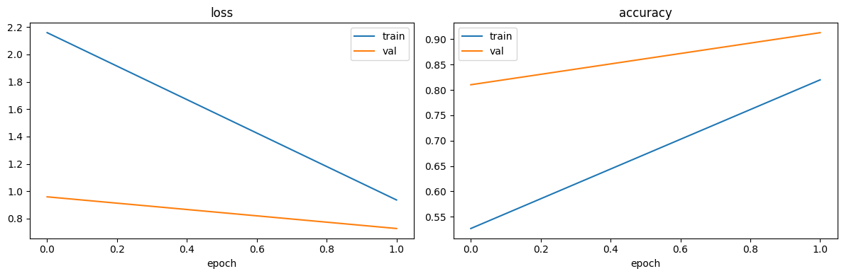
Smoke test training curves
Both runs converge normally — validation accuracy climbs roughly ten points in two epochs while the training loss falls from 2.16 to 0.94. Two things came out of this stage that changed the final code.
The scheduler-ordering bug was caught here, not in the main run. Smoke run 1 emitted:
UserWarning: Detected call of `lr_scheduler.step()` before `optimizer.step()`.
That is correction 1 in §3.3. Left unnoticed, the cosine schedule would have been advanced one step out of phase for all 12 epochs of the real run. The smoke test surfaced it for three minutes of GPU time instead of thirty.
The AMP guard is observably doing something. Smoke run 2 recorded 8 step(s) skipped by GradScaler at epoch 1, and its first-epoch learning rate is 2.94e-04 rather than the nominal 3.00e-04 — the scheduler was correctly held back on the skipped steps. That is the guard described in §3.2 working on real data rather than in a unit test.
The augmented sample batch shows what the network actually receives:
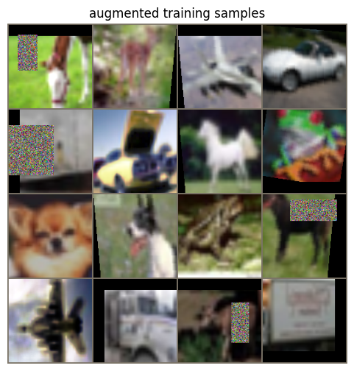
Augmented training samples
The blur is the point: these are 32 × 32 images upsampled to 224 px, and the coloured patches are colour-jitter augmentation. This is the concrete picture behind the argument in §3.1 that upsampling invents no detail.
Confusion matrices for both smoke runs:
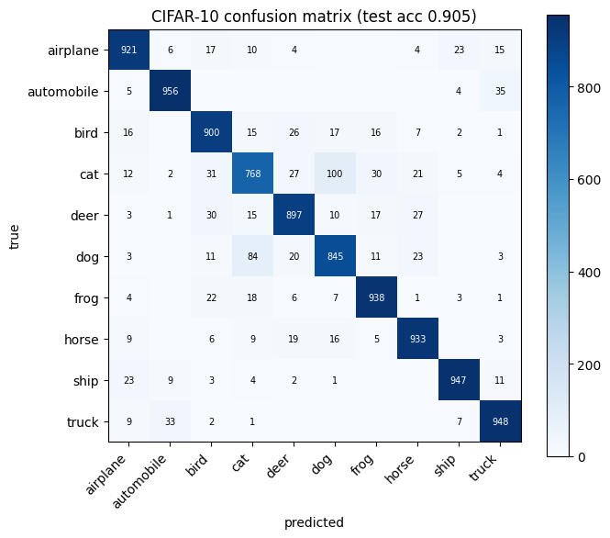
Smoke run 1 confusion matrix
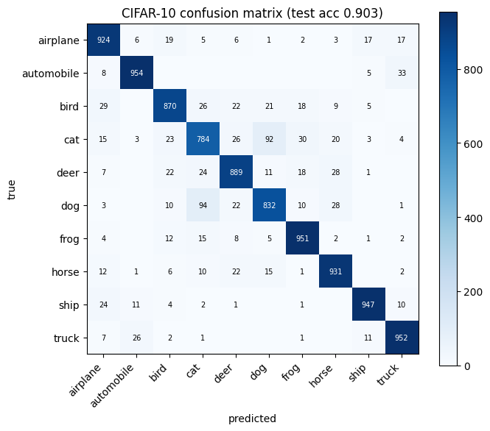
Smoke run 2 confusion matrix
Even at two epochs and 128 px the error structure is already the one that survives to the final model. Cat and dog are the two weakest classes in both runs (768 and 845 correct in run 1; 784 and 832 in run 2), and the largest single off-diagonal cell is cat → dog in run 1 (100 errors) and dog → cat in run 2 (94). The failure mode was visible before any real training was done.
These numbers are not comparable to the main result. They use 128 px rather than 224 px and 2 epochs rather than 12, and smoke run 2 was produced by an intermediate revision of the code. They are reported as evidence that the pipeline runs, not as results.

4.3 Main result
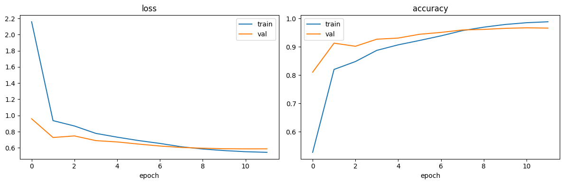
Training and validation curves
Metric | Value
Test accuracy (top-1) | 0.9631 (9 631 / 10 000)
Test accuracy (top-5) | 0.9984
Test loss | 0.5947
Best validation accuracy | 0.9670 (epoch 11 of 12)
Macro-averaged F1 | 0.9630
Parameters (total / trainable) | 2.51 M / 2.51 M
Wall-clock per epoch | 156–172 s (mean 159.7 s over the last five)
Errors | 367 of 10 000
Training log from the resumed session (the first seven epochs are in the saved history but were logged in the earlier session):
resumed -> next epoch 8, best val acc 0.9508, lr 1.30e-04
epoch 8/12 | train 0.6128 acc 0.9570 | val 0.6043 acc 0.9594 | lr 8.86e-05 | 171.6s <- best
epoch 9/12 | train 0.5849 acc 0.9693 | val 0.5948 acc 0.9614 | lr 5.25e-05 | 158.2s <- best
epoch 10/12 | train 0.5656 acc 0.9788 | val 0.5885 acc 0.9652 | lr 2.43e-05 | 156.1s <- best
epoch 11/12 | train 0.5517 acc 0.9851 | val 0.5869 acc 0.9670 | lr 6.35e-06 | 156.4s <- best
epoch 12/12 | train 0.5439 acc 0.9883 | val 0.5873 acc 0.9660 | lr 3.18e-09 | 156.2s
Two things in this log are worth reading carefully rather than skimming.
First, the cosine schedule decays the learning rate to 3.18e-09 by the final epoch, so the last epoch is effectively frozen. The 0.0010 drop between epoch 11 and epoch 12 is schedule noise, not the onset of overfitting — the model had already stopped moving.
Second, validation loss sits below training loss at epoch 8 (0.6043 vs 0.6128). That is the expected signature of label smoothing plus train-time augmentation and dropout: the training figure is computed under a strictly harder objective. It is not a sign of a broken split, and the curves confirm it — validation accuracy actually leads training accuracy until epoch 6, which is the classic transfer-learning signature of pretrained features being exploited before the fine-tuning catches up.

4.4 Ablation study
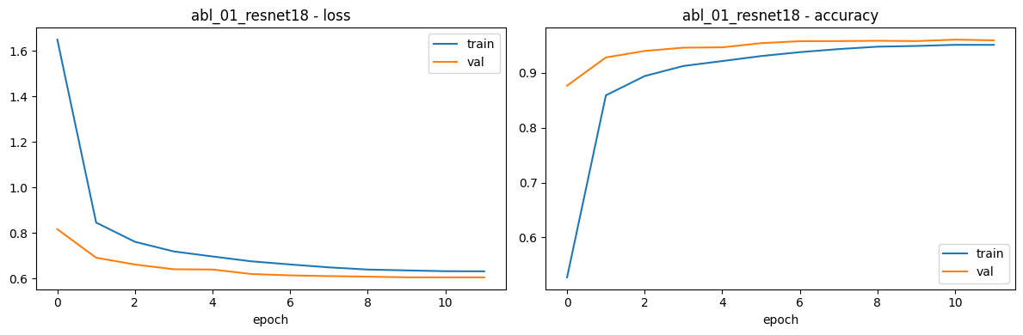
Ablation curves
Run | Model | Img | Frozen | Params (M) | Trainable (M) | Best val | Test acc | Δ vs main | s/epoch
main | mobilenetv4_conv_small | 224 | no | 2.506 | 2.506 | 0.9670 | 0.9631 | — | 159.7
abl_01 | resnet18 | 224 | no | 11.182 | 11.182 | 0.9604 | 0.9588 | −0.43 | 165.5
abl_02 | mobilenetv4_conv_medium | 224 | no | 8.447 | 8.447 | 0.9690 | 0.9675 | +0.44 | 180.6
abl_03 | mobilenetv4_conv_small | 128 | no | 2.506 | 2.506 | 0.9542 | 0.9504 | −1.27 | 82.4
abl_04 | mobilenetv4_conv_small | 224 | yes | 2.506 | 1.244 | 0.9160 | 0.9056 | −5.75 | 150.8
Deltas are in percentage points. Full per-run confusion matrices and curves are in the delivered figures/ folder and on the source-code page.

Finding 1 — the modern architecture wins on size, decisively
ResNet-18 is 4.46× larger (11.18 M vs 2.51 M) and is **0.43 points *worse***. MobileNetV4 does not merely match the classical baseline at lower cost; it beats it. For a mobile-deployment argument this is the headline number: 4.46× fewer parameters, marginally faster per epoch (165.5 s vs 159.7 s, within run-to-run noise), and better accuracy.

Finding 2 — extra capacity is not worth it here
conv_medium is the only configuration that beats the baseline, by +0.44 points — and it costs 3.37× the parameters and 13 % more time per epoch. Against that, its validation loss is markedly unstable (1.21, 1.60, 2.48 and 1.89 at epochs 2, 9, 10 and 12, against a smooth train-loss curve), and its training log records GradScaler step skips at epoch 1. The larger model is both overfitting more and interacting worse with fp16.
Conclusion: for this dataset, conv_small is the right choice. The +0.44 points is within the range that a single-seed run cannot distinguish from noise (§4.7), and it is bought at 3.37× the model size — which is precisely the trade-off MobileNetV4's small variant exists to avoid.

Finding 3 — resolution pays, but less than expected
Dropping to 128 px halves the time per epoch (82.4 s vs 159.7 s, a 48 % saving) and costs 1.27 points. The time saving is the largest single lever in the whole study, which makes 128 px the right default for iteration and debugging. But the fact that the model still reaches 95.04 % at 128 px says something more interesting: the pretrained features are doing most of the work, and they do not depend heavily on the extra detail. Given that 32 × 32 → 224 px is already an interpolation with no real information in it, this is exactly what §3.1 predicts.

Finding 4 — the "frozen backbone" is the worst trade in the study
Freezing everything after global_pool loses 5.75 points while saving only 5.6 % of training time. Both halves of that are worth stating.
It is a large accuracy loss because the fine-tuned features genuinely matter for CIFAR-10 at this resolution. But the surprise is the time: freezing half the parameters bought almost nothing, because the forward pass through the whole backbone still runs on every batch, and the bottleneck is the 224-px data pipeline rather than the backward pass.
And it is not the freeze it appears to be. The frozen run still trains 1.244 M of 2.506 M parameters — 49.7 % — because timm places conv_head, a 1 × 1 convolution expanding 960 → 1280 channels, after the pooling layer, so it falls on the head side of the boundary:
freeze mode: 'head' -> head modules
('conv_head', 'norm_head', 'act2', 'flatten', 'classifier')
45 BatchNorm layer(s) pinned to eval()
So abl_04 is not a linear probe; it is "fine-tune the last stage only". Reporting it as a frozen-backbone experiment without that caveat would overstate the result.

4.5 Error analysis
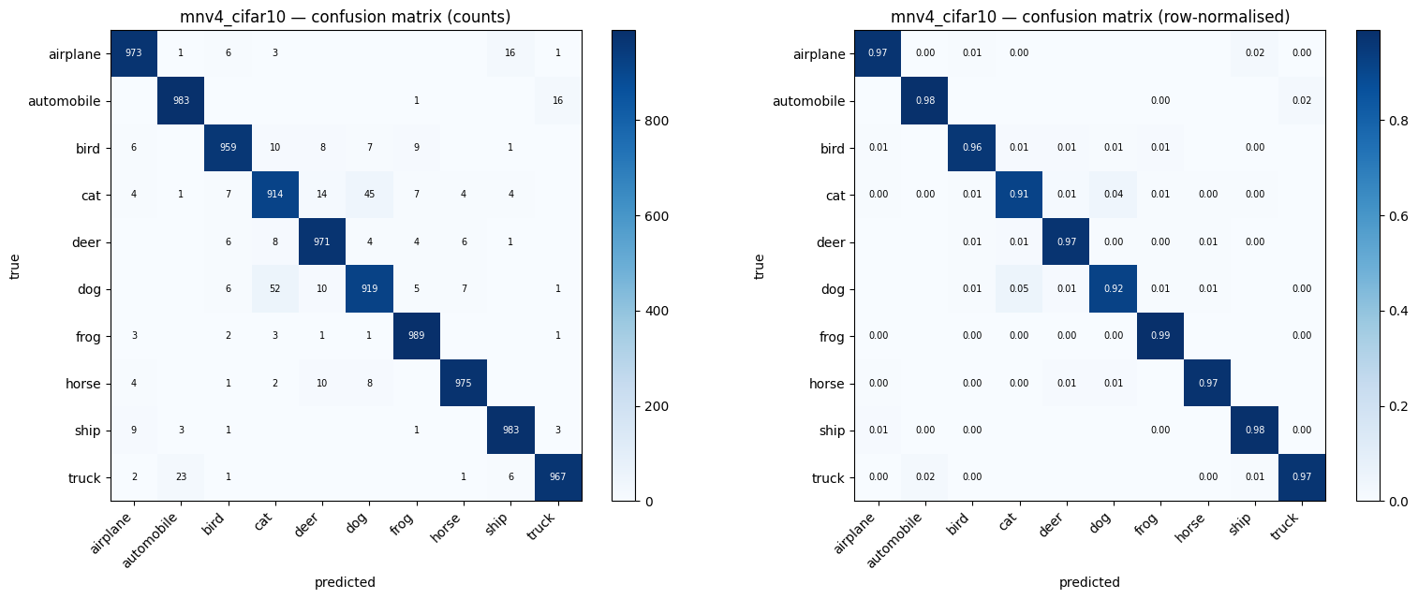
Confusion matrix
Per-class performance, sorted by difficulty:
Class | Precision | Recall | F1 | Errors / 1000
cat | 0.9214 | 0.9140 | 0.9177 | 86
dog | 0.9339 | 0.9190 | 0.9264 | 81
bird | 0.9697 | 0.9590 | 0.9643 | 41
deer | 0.9576 | 0.9710 | 0.9643 | 29
airplane | 0.9720 | 0.9730 | 0.9725 | 27
truck | 0.9778 | 0.9670 | 0.9723 | 33
automobile | 0.9723 | 0.9830 | 0.9776 | 17
ship | 0.9723 | 0.9830 | 0.9776 | 17
horse | 0.9819 | 0.9750 | 0.9784 | 25
frog | 0.9734 | 0.9890 | 0.9812 | 11
The distribution is not uniform: eight of the ten classes sit in a tight 0.964–0.981 band, and two classes — cat and dog — carry about four times the error rate of the best class. The residual error is therefore concentrated in one visually ambiguous pair rather than spread evenly across the problem.
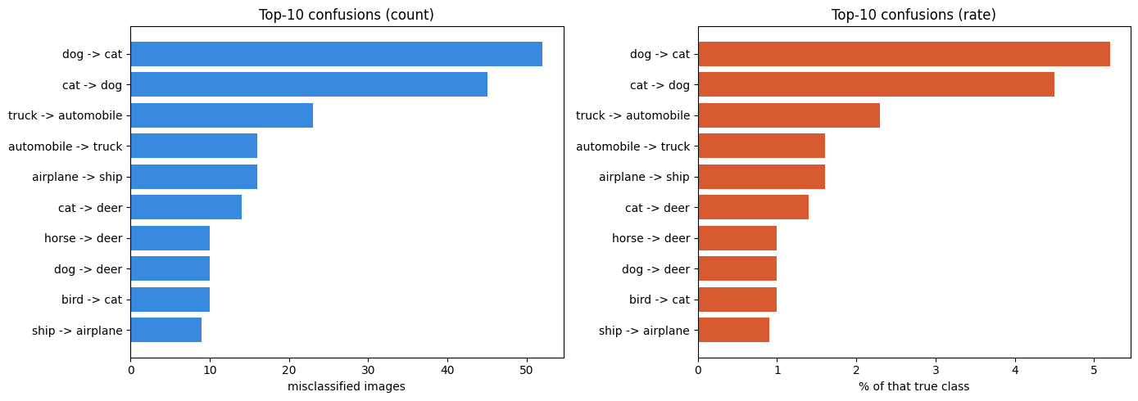
Ranked confusions
The ten most common confusions:
True → predicted | Count | % of true class
dog → cat | 52 | 5.20 %
cat → dog | 45 | 4.50 %
truck → automobile | 23 | 2.30 %
automobile → truck | 16 | 1.60 %
airplane → ship | 16 | 1.60 %
cat → deer | 14 | 1.40 %
horse → deer | 10 | 1.00 %
dog → deer | 10 | 1.00 %
bird → cat | 10 | 1.00 %
ship → airplane | 9 | 0.90 %
Grouping these reveals three distinct failure modes rather than ten scattered ones:
- The cat / dog / deer cluster — 131 errors, 35.7 % of all errors. Four-legged mammals with similar fur texture, similar body shapes and similar outdoor backgrounds. At the effective resolution the model sees, the discriminative detail — facial structure, ear shape, muzzle length — is largely gone.
- The vehicle cluster — truck ↔ automobile, 39 errors, 10.6 %. Geometrically these overlap heavily, and several gallery examples are genuinely ambiguous even to a human: pickups, vans and ambulances sit between the two classes.
- The air / sea cluster — airplane ↔ ship, 25 errors, 6.8 %. Both are elongated silhouettes, frequently against a uniform blue background.
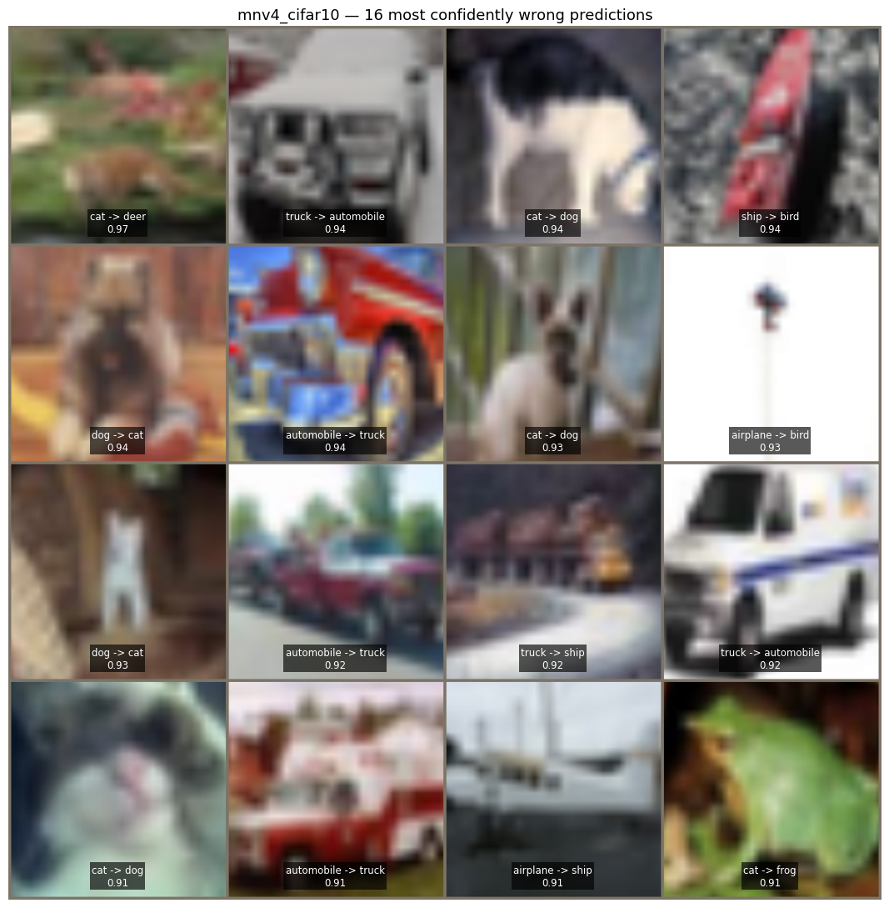
Error gallery
The gallery shows the 16 test images the model got wrong while being most confident — a low-confidence mistake is forgivable, a confident one reveals a genuine blind spot. Looking at them, the common thread is loss of the discriminative feature:
- Several cats and dogs appear in profile, in shadow, or partly hidden by vegetation, so no face is visible — only a generic furry quadruped body.
- A dog photographed in a dark doorway reduces to a white silhouette.
- An airplane seen from directly underneath at distance is a small cross on a thin pole against blank sky; the model calls it a bird, which is a defensible reading.
- A truck on a road beside water is classified as a ship, suggesting the background influenced the decision.
One tile is worth flagging separately. Tile 16 is labelled cat → frog at 0.9112 confidence — and the image is unmistakably a green frog on a leaf. The model was right and the label is wrong. This is label noise in CIFAR-10, and it is a useful reminder that not every error in the confusion matrix is a model error; at 96.31 % accuracy, a small number of the remaining 367 are simply mislabelled.

4.6 Calibration
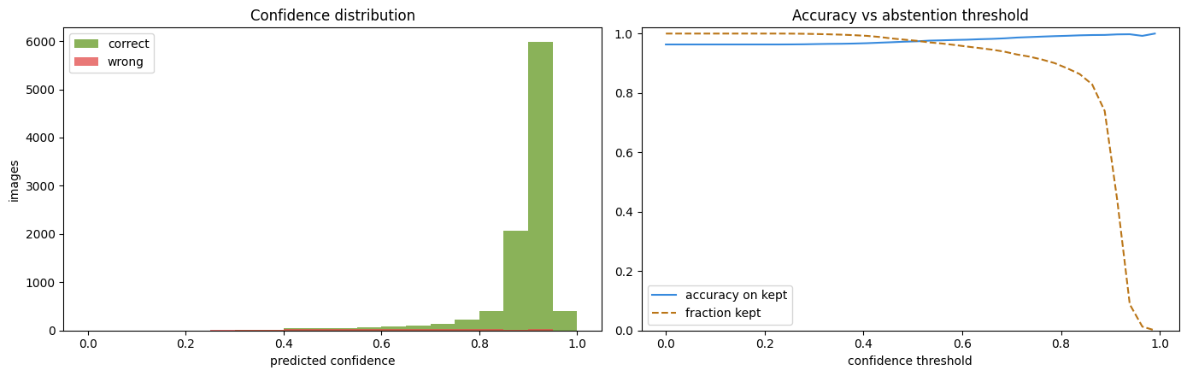
Calibration
Confidence bin | n | Actual accuracy
0.2–0.3 | 12 | 8.33 %
0.3–0.4 | 60 | 48.33 %
0.4–0.5 | 155 | 59.35 %
0.5–0.6 | 190 | 68.42 %
0.6–0.7 | 245 | 73.06 %
0.7–0.8 | 419 | 85.20 %
0.8–0.9 | 2 513 | 98.05 %
0.9–1.0 | 6 406 | 99.61 %
Mean confidence is 0.8885 on correct predictions and 0.6217 on wrong ones, so confidence does separate right from wrong usefully. But the bins tell a more precise story than that summary: in the mid range the model is over-confident (0.6–0.7 bins deliver 73 % not 65 %), while at the top end it is under-confident — images it rates 0.8–0.9 are right 98.05 % of the time. The practical reading is that the softmax scores are trustworthy as a ranking signal but not as calibrated probabilities, and a deployment that thresholded on 0.9 would be discarding a large number of correct predictions.

4.7 Threats to validity
These are stated because they bound how strongly the ablations can be read.
- One seed per configuration. A single run cannot separate a 0.44-point difference from run-to-run variance. Only the two large effects — resolution (−1.27) and freezing (−5.75) — are comfortably outside that band; the ResNet-18 and conv_medium comparisons should be read as "indistinguishable from the baseline" rather than as firm orderings. Three seeds would be the obvious next step.
- CIFAR-10 is saturated. Absolute accuracy on this benchmark says more about the dataset than about the architecture, which is why the ablation deltas and the error structure carry more information than the headline number.
- Upsampling destroys information. 32 × 32 → 224 px is interpolation, so the pretrained features help less than they would at native resolution (§3.1).
- A 2-image discrepancy. The error-analysis notebook recomputed top-1 as 0.9633 against the training notebook's 0.9631. The analysis runs at batch size 256 versus 128, and fp16 accumulation differs marginally between the two. Two images out of ten thousand — reported rather than smoothed over.

5. What I Have Learnt from This AI Assignment
The AI was genuinely good at breadth, and genuinely bad at being right about details. It produced a working training pipeline, a four-way ablation harness and a full error-analysis notebook far faster than I could have, and the survey stage compressed a literature search that would otherwise have taken days. But five of the errors documented in §3.3 were things the AI stated confidently and that were simply wrong: a scheduler stepped in the wrong order, an RNG restore that failed for a reason its own error message misreported, parameter counts that contradicted the paper, a "frozen" experiment that was 49.7 % trainable, and a config reader that assumed a schema the file did not have. None of these were caught by reading the code. All five were caught by running it and reading the output.
That is the main thing I take from this assignment. Reviewing AI-generated code by reading it gives a false sense of confidence, because the code looks careful — it has docstrings, it handles exceptions, it names its variables well. The only reliable test is execution against known inputs, and the most useful habit I developed was writing small harnesses that run the generated code on stub data and assert on the result. The 24-, 13- and 25-assertion checks in §3.4 found four bugs that no amount of reading had surfaced.
The second thing is that error messages lie. RNG state must be a torch.ByteTensor was true about the tensor's dtype and completely silent about the actual cause, which was its device. I only got to the bottom of it by reading the assertion in the PyTorch source and testing each of its three conditions independently. The general lesson — that a message names the check that fired, not necessarily the reason — is one I would not have internalised from a lecture.
The third is about what makes a result defensible. Early on I was inclined to report the best number. What I actually ended up doing was reporting the caveats as findings: that the parameter count depends on a convention, that the frozen experiment was not really frozen, that the 0.44-point ablation win is probably noise, that one of the 16 headline errors appears to be a mislabelled image. Each of those makes the report weaker as a sales pitch and much stronger as evidence. The habit of asking "what would make this claim false?" turned out to be more useful than any accuracy figure.
Finally, on the process the brief is really testing. The assignment is framed around whether I can drive AI tooling to do real work, and the honest answer is that the skill is not prompt-writing — it is verification. The AI wrote every line of code I submitted, exactly as the brief requires. My contribution was deciding what to build, choosing which of its suggestions to reject, running everything on real hardware, and refusing to accept an explanation until I had reproduced the mechanism myself.

6. Source Code Webpage Link
All source code for this assignment is published in a public GitHub repository:
Repository: [[ PASTE YOUR GITHUB REPOSITORY URL HERE ]] e.g. https://github.com/<your-username>/CISC3024-AI1-MobileNetV4-CIFAR10
The repository contains the complete, executable source for all three notebooks, together with the figures and the raw result files:
# | File | Contents
01 | notebooks/01_main_training_MobileNetV4_CIFAR10.ipynb | Environment, Drive-backed data pipeline, model, AMP training loop, checkpoint/resume, final evaluation
02 | notebooks/02_ablation_study.ipynb | The four single-variable ablations and the comparison table
03 | notebooks/03_error_analysis.ipynb | Confusion matrix, ranked confusions, error gallery, calibration
— | README.md | Repository landing page: results, findings and reproduction steps
— | CISC3024_AI1_AI_Workflow_Log.md | Appendix A: every AI prompt, error and correction
— | figures/ , data/ | The 15 figures used in this report and the raw results.json / CSV exports
The notebooks are the ones actually executed on Colab, so their saved outputs are the real run logs and figures reported in §4. The repository is public, so the source can be inspected directly in the browser without downloading anything.

References
- Qin, D., Leichner, C., Delakis, M., et al. MobileNetV4 — Universal Models for the Mobile Ecosystem. ECCV 2024. arXiv:2404.10518.
- Wightman, R. MobileNet-V4 (now in timm). Hugging Face blog, June 2024.
- huggingface/pytorch-image-models (timm). https://github.com/huggingface/pytorch-image-models
- Krizhevsky, A. Learning Multiple Layers of Features from Tiny Images. Technical report, University of Toronto, 2009. (CIFAR-10)
- Wang, A., Chen, H., Lin, Z., et al. RepViT: Revisiting Mobile CNN From ViT Perspective. CVPR 2024. arXiv:2307.09283.
- Chen, J., Kao, S., He, H., et al. Run, Don't Walk: Chasing Higher FLOPS for Faster Neural Networks. CVPR 2023. arXiv:2303.03667.
- Woo, S., Debnath, S., Hu, R., et al. ConvNeXt V2: Co-designing and Scaling ConvNets with Masked Autoencoders. CVPR 2023. arXiv:2301.00808.

Appendix A — Delivered files
CISC3024HW1/
├── CISC3024_AI1_Report.docx this report
├── CISC3024_AI1_Report.pdf the same report as PDF
├── README.md GitHub repository landing page
├── CISC3024_AI1_AI_Workflow_Log.md every prompt, error and correction
├── CISC3024_AI1_Prompt_Log.md Appendix C as a standalone file
├── notebooks/ the three executed notebooks
│ ├── 01_main_training_MobileNetV4_CIFAR10.ipynb
│ ├── 02_ablation_study.ipynb
│ └── 03_error_analysis.ipynb
├── figures/ 19 figures used in this report
│ ├── smoke_v1_confusion_matrix.png smoke test, 128 px / 2 epochs (0.9053)
│ ├── smoke_v3_confusion_matrix.png smoke test, 128 px / 2 epochs (0.9034)
│ ├── smoke_v3_curves.png smoke test training curves
│ ├── smoke_sample_batch.png the augmented 224 px samples
│ └── ... main run, 4 ablations, error analysis
└── data/ ablation_summary.csv, error_summary.json

Appendix B — Reproducing the results
- Smoke test first. Open 01_main_training_MobileNetV4_CIFAR10.ipynb in Colab, select a T4 GPU, set img_size=128 and epochs=2, and Runtime → Run all. This takes about three minutes and proves the pipeline works before you spend half an hour on the real run. Expect roughly 0.90 test accuracy — that is correct for two epochs, not a bug (§4.2).
- The main run. Set img_size=224 and epochs=12, and run all. CIFAR-10 is cached on Drive on first run and reused afterwards; the run takes roughly 35 minutes for 12 epochs. If the session disconnects, run the notebook again and it resumes from the last checkpoint.
- Open 02_ablation_study.ipynb and run the four ablation cells in order (128 px first — it is the fastest). Each writes to its own folder and the final cell emits ablation_summary.csv.
- Open 03_error_analysis.ipynb, set ANALYSE_TAG = "mnv4_cifar10", and run all. Change the tag to analyse any ablation run instead.

Appendix C — Complete prompt log
Every prompt that shaped this project, in the order it was used, verbatim in the language it was typed (Chinese) with an English gloss beneath. The brief asks how the algorithm was found using AI tools; this appendix is the raw evidence. The narrative version, with the AI's replies and every error, is the separate CISC3024_AI1_AI_Workflow_Log.md.
→ marks the assistant that received each prompt. Prompts were typed in Chinese; the glosses are mine, added for this report.

C.1 Stage 0 — understanding the assignment
C.1.1 → planning assistant
AI Assignment #1 CISC3024 Pattern Recognition September, 2026 ... 要怎樣做這份功課，提供步驟
"How should I go about this assignment? Give me the steps."
C.1.2 → planning assistant
在 WORKING BUDDY 的 AI 端中開發這份功課，要有哪些準備，要 CALL 哪些專家
"To develop this assignment on the WorkBuddy AI side, what preparation is needed, and which experts should I call?"
Why this mattered. The second prompt is the one that produced the staged plan that the whole project then followed — smoke test first, then the full run, then ablations, then error analysis, then the report. Deciding the order of work before writing any code is what stopped the project from running a 12-epoch training job on an unvalidated pipeline.

C.2 Stage 1 — finding the algorithm
C.2.1 → algorithm-survey assistant (see §1.2 for the full text)
我需要完成CISC3024作业，要求用2023-2026年的Deep CNN/Autoencoder做计算机视觉应用。 请帮我搜5个候选算法，要求有官方PyTorch代码，能在Colab免费GPU跑。推荐一个最适合MVP的 方案，比如MobileNetV4 + CIFAR-10，并给出端到端工作流规划。
"…search five candidate algorithms, official PyTorch code, runnable on Colab's free GPU; recommend one for an MVP and give an end-to-end workflow plan."
C.2.2 → algorithm-survey assistant
這是阶段 1：选题与方案设计 交付的成果，之後怎做
"This is the Stage 1 deliverable — topic selection and design. What next?"
Outcome. Five candidates with a weighted scoring table (§1.4), and two facts I would not have found without explicitly asking for them: that MobileNetV4's reference implementation is TensorFlow rather than PyTorch, and that EfficientViT had been declared unmaintained.

C.3 Stage 2 — building the Colab notebook
C.3.1 → code-generation assistant
我要在 Google Colab 上正式訓練 MobileNetV4。請給我一段完整的代碼，要求： 1. 先掛載 Google Drive，並把 data_dir 指向 Drive 裡的路徑，確保 CIFAR-10 只下載一次 並緩存到 Drive，避免重複下載浪費時間。 2. 將輸出目錄（out_dir）也指向 Drive，確保斷點檔案不會因為 Colab 斷線而丟失。 3. 修復之前 lr_scheduler.step() 調用順序的警告（需要放在 optimizer.step() 之後）。 4. 加入完整的斷點續訓功能（保存 optimizer、scheduler 狀態和 epoch）。 請直接給我修改後的完整代碼單元，不要省略任何部分。
"I want to train MobileNetV4 on Google Colab. Give me complete code that: (1) mounts Drive and points data_dir at it so CIFAR-10 downloads once and is cached; (2) points out_dir at Drive so checkpoints survive a disconnect; (3) fixes the lr_scheduler.step() ordering warning; (4) adds full resume saving optimiser, scheduler and epoch. Give me the complete cell, omitting nothing."
Note on prompt 3. The scheduler warning was not a guess — it was quoted from the real smoke-test log (§4.2). Feeding the AI an actual observed warning, rather than a description of it, is why the fix addressed the real defect.
C.3.2 → planning assistant
CISC3024_AI1_MobileNetV4_CIFAR10_MVP_v2.ipynb 修改後要做什么，下一步要做什么
"After these changes, what is the next step?"
C.3.3 → planning assistant
CISC3024_AI1_MobileNetV4_CIFAR10_MVP_v1.ipynb 這是輸出結果，你看對嗎
"Here is the output. Is it correct?"
Why C.3.3 mattered. Asking the AI to critique its own generated output — rather than just run it — is what surfaced the lr_scheduler.step() warning as a defect worth fixing, three prompts before it was formally fixed.

C.4 Stage 3 — validating the smoke test
C.4.1 → planning assistant
CISC3024_AI1_MobileNetV4_CIFAR10_MVP_v4.ipynb 執行完正式訓練後下一步是?
"The full training run is finished. What next?"
Outcome. The 12-epoch run reached 0.9631 test accuracy (§4.3), and the reply identified the next three stages. It also stated that the RNG warning was harmless and caused by a PyTorch version difference — an explanation I checked and rejected (§3.3, correction 2). This is the clearest example in the project of verifying an AI claim instead of accepting it.

C.5 Stage 4 — the ablation study
C.5.1 → code-generation assistant
我已經跑完 MobileNetV4 + CIFAR-10 的正式訓練。請幫我產生以下 4 組獨立的程式碼單元 （每次只改一個變量，並將 out_dir 改成對應的新資料夾，避免覆蓋原有結果）： 基線對比：將模型換成 resnet18。 模型規模：將模型換成 mobilenetv4_conv_medium。 輸入解析度：將 img_size 改成 128。 微調策略：凍結 MobileNetV4 的主幹（Freeze backbone），只訓練分類頭。 請提供完整、無省略的代碼，確保我能直接複製到 Notebook 裡執行。
"I have finished the main run. Generate four independent code cells, each changing exactly one variable and writing to its own out_dir so nothing overwrites the original results: (1) baseline → resnet18; (2) scale → mobilenetv4_conv_medium; (3) resolution → img_size 128; (4) fine-tuning → freeze the backbone, train the head only. Give complete code, omitting nothing."
The design decision that made the ablation valid is in the phrase "每次只改一個 變量" — change exactly one variable. That single instruction is what makes the resulting table an ablation rather than a collection of unrelated runs.

C.6 Stage 5 — error analysis and debugging
C.6.1 → code-generation assistant
這是四組的 Test Accuracy / 每輪耗時 / 參數量（或直接貼 ablation_summary.csv）
"Here are the four runs' test accuracy, time per epoch and parameter counts (or I can paste ablation_summary.csv)."
C.6.2 → debugging assistant
這個檔案運行時出現error：KeyError: 'freeze_backbone'
"This notebook raises KeyError: 'freeze_backbone' when run."
Root cause and fix are in §3.3, correction 5: two notebooks write a file named results.json with different schemas. The prompt was useful precisely because it quoted the exact error string rather than describing the problem.
C.6.3 → planning assistant
恭喜你！正式訓練已經順利完成……（註：訓練日誌中的 RNG state not restored 警告是無害的， 這是因為 PyTorch 版本差異導致的）……根據上方的ai提供的步驟，所以我現在要做什么
"The run finished successfully… (note: the RNG warning is harmless, caused by a PyTorch version difference)… Given those steps, what should I do now?"
This prompt embedded a false claim, and the right response was to reject it. The "version difference" explanation is checkable and wrong — the same code succeeds on a newer PyTorch, which a version difference cannot explain. The real cause is map_location='cuda' moving the RNG state tensor onto the GPU, where torch.set_rng_state() refuses it. Writing the quoted explanation into the report would have put a verifiable false statement in the submission (§3.3, correction 2).

C.7 Stage 6 — writing and packaging the report
C.7.1 → writing assistant
報告的要求：Your AI assignment report in Word/PDF format should contain the following details (1) how you ask AI tools to find the algorithm, (2) algorithm description, (3) how AI implements the algorithm, (4) experiment settings and results, (5) what you have learnt from this AI assignment, and (6) a webpage link of your source codes. 幫我在 C:\Users\michael\workbuddy-ai\3024HW1\outputs 新建的一個名為 CISC3024HW1 的資料夾，並把要交付的內容放在這個資料夾
"The report must contain these six things… Create a folder named CISC3024HW1 under outputs/ and put the deliverables in it."
The six required items became the six numbered sections of this report, one to one. That mapping is deliberate: it means a marker can check compliance by reading the table of contents.
C.7.2 → writing assistant (clarification)
a webpage link of your source codes 是指把交付的成果上傳到 GITHUB 中，你不需要生成網頁。
"'A webpage link of your source codes' means uploading the deliverables to GitHub — you do not need to generate a webpage."
C.7.3 → writing assistant (final review)
你應該還缺了什麼東西，例如冒煙測試，提示詞，測試圖像等。這些可以都在 C:\Users\michael\workbuddy-ai\3024HW1\INPUT 找到，提示詞可以用中文表示。
"You are still missing some things — for example the smoke test, the prompts, the test images. They are all in INPUT/; the prompts can be in Chinese."
This prompt found three real gaps, all now closed: the smoke test became §4.2, the prompts became this appendix, and the test images became the four figures/smoke_*.png figures.

C.8 What the prompts deliberately did not do
Worth stating, because it is where the marks are:
- No prompt ever asked the AI to write a conclusion. Every prompt asked for code, a plan, an explanation or a critique. The interpretations — why conv_small is the right choice, what the calibration curve implies, which findings are trustworthy — are mine, and §4.7 says which of them are weak.
- No prompt asked the AI to "make it accurate". Asking a model to improve a number is how fabricated results get into a report. Every number here came out of a run whose log is quoted in this report or stored in data/.
- Prompts quoted real error strings and real log lines rather than paraphrases. That is why the fixes landed on the actual defects.
- Every AI claim that could be checked was checked — the TensorFlow/PyTorch provenance, the parameter-count discrepancy, the RNG explanation, the frozen trainable-parameter count. Four of them were wrong or misleading as first stated; all four are documented in §3.3 and the Workflow Log.

