Comparative Analysis of Random Forest vs XGBoost Machine Learning Algorithms for Predicting ODL Student Success
Prof.Dr. Mehmet Fırat*
*Anadolu University, ORCID: https://orcid.org/0000-0001-8707-5918, mfirat@anadolu.edu.tr

abstract
This study investigates the predictive power of two ensemble machine‑learning algorithms of Random Forest and XGBoost for forecasting student achievement using the Open University Learning Analytics Dataset. We analyzed records from 3,929 students who were enrolled in online courses and collected comprehensive demographic, assessment and clickstream data. After data cleaning, categorical variables were encoded and missing values were treated. To address class imbalance, we applied random under‑sampling and derived new variables (click efficiency, credit intensity and engagement score) to capture students’ engagement patterns. Grid search with k‑fold cross‑validation was used to tune the hyperparameters of both algorithms. Model performance was evaluated with accuracy, precision, recall and f1‑score. The Random Forest model achieved 52 % accuracy on the test data, whereas XGBoost reached 61.5 %. When engineered features were added, the accuracy of XGBoost increased to 63.2 %, surpassing the Random Forest by more than 10 percentage points. Feature importance analysis revealed that click scores and total clicks were the most influential variables, while demographic attributes had limited impact. These findings underscore the value of ensemble approaches and feature engineering for early warning systems and personalized interventions in higher education.
KEYWORDS: Machine learning, learning analytics, Random Forest, XGBoost

ıntroductıon
The digitalization process in education has facilitated the transformation of student interactions, academic performance, and demographic information into extensive datasets. This development has enabled a more comprehensive analysis of learning processes. Data collected from learners through online learning platforms are processed using Learning Analytics (LA) approaches and play a crucial role in the development of early warning systems and personalized learning strategies (Siemens, 2013; Papamitsiou and Economides, 2014).
LA analyses and profiles students' multifaceted data, including online interactions, demographic information, and assessment scores, to individualize and improve learning processes based on the information obtained through this analysis. The expansion of online learning environments and tools, coupled with learners’ adaptation to online learning, has broadened the scope of LA applications. However, LA faces challenges in progressing beyond big data, data mining, and data visualization. This limitation in the current state of the art of LA constitutes the focus of this research. To translate LA processes (multifaceted learner data) into interventions (development, improvement, adaptation, etc.) in learning processes, it is feasible to effectively utilize appropriate algorithms and models from the field of Machine Learning (ML). ML can be defined as a set of algorithms and models that enable computers to learn by extracting patterns and relationships from the data. This field integrates statistics, mathematics, computer science, and artificial intelligence, facilitating tasks such as prediction, classification, and decision-making using data-derived information.
The contemporary educational landscape demonstrates an enhanced understanding and recognition of the significance of AI in education, with widespread efforts to integrate AI technologies into educational applications (Fernández and Garrido, 2024). The applications of ML methods on educational data are rapidly becoming widespread. With the increasing interest in artificial intelligence technologies in recent years, significant progress has been made in developing different algorithms for predicting student achievement. In particular, ensemble methods such as Random Forest and XGBoost (Extreme Gradient Boosting) stand out thanks to their high accuracy rates in multidimensional data sets, minimization of the risk of overfitting, and insights offered by feature importance analysis (Breiman, 2001; Chen and Guestrin, 2016). In the literature, the contribution of demographic information and student interaction data to model performance is supported by various studies (Ferguson, 2012; Gasevic et al., 2014).
Random Forest and XGBoost, which are ensemble learning methods, combine multiple base models to create a more robust and accurate predictor (Mienye and Sun, 2022). This approach can be particularly beneficial in LA, where complex relationships between various educational factors must be analyzed and predicted. For instance, these methods can be applied to predict student performance, identify at-risk students, or personalize learning pathways based on multiple input variables, such as past academic performance, engagement metrics, and demographic data.
Notably, although Random Forest and XGBoost are frequently compared, their performance can vary depending on the specific application. In some studies, XGBoost demonstrated superior results. For example, in a study on biological activity prediction, XGBoost outperformed Random Forest and other machine learning algorithms (Babajide Mustapha and Saeed, 2016). However, in other applications, such as forest microclimate prediction, Random Forest performed comparably to XGBoost (Ghafarian et al., 2022). In conclusion, ensemble methods such as Random Forest and XGBoost offer powerful tools for LA because of their ability to handle complex, multi-dimensional datasets (Kadiyala and Kumar, 2018) and provide high predictive accuracy. Their capacity to rank feature importance (Zhang et al., 2020) can also offer valuable insights into the most influential factors affecting educational outcomes. As LA often deals with diverse data types and aims to uncover intricate patterns in educational processes, these ensemble methods can provide robust and interpretable solutions for various analytical tasks in this field.
A comprehensive examination of the impact of different datasets and feature engineering approaches on model performance remains an area of ongoing research that requires further investigation. Consequently, this study aims to compare the Random Forest and XGBoost models in predicting student success using data obtained from the Open University's online learning platform. Within the scope of this research, student interaction data (e.g., click scores, total number of clicks), demographic variables (age, disability status, education level), and new variables derived through feature engineering (e.g., Click Efficiency, Engagement Score) were analyzed.
This study aims to provide important insights into the integration of ML methods into early warning systems and personalized learning applications in education. The results are also significant in terms of identifying students at risk of academic failure and developing intervention strategies for them.

Related Literature
LA has garnered significant attention in recent years by focusing on analyzing the volume of big data generated in educational processes and providing actionable insights into students' interactions, achievements, and learning needs (Gasevic et al. 2014; Sciarrone, 2018). Notably, the interaction data generated in online and blended learning environments play a crucial role in numerous areas, ranging from the early prediction of academic success to the design of personalized learning paths (Doroudi, 2024; Ferguson, 2012; Siemens, 2013). This process is further enhanced by applying ML methods to educational data. Current research demonstrates that student achievement can be predicted using ML algorithms from student interaction data, demographic variables, and previous academic data.
In recent years, ML based modeling has become a fundamental tool for shaping the essence of LA. For instance, Random Forest, with its ensemble structure consisting of decision trees, is frequently utilized for training data as it effectively manages data complexity and mitigates the risk of overfitting (Breiman, 2001). In contrast, XGBoost is distinguished by its capacity to make rapid and highly accurate predictions, particularly on large datasets, and provide comprehensive outputs in terms of feature importance analysis (Chen and Guestrin, 2016). In the literature, these methods have been demonstrated to be effective in predicting academic achievement based on LA data (Wong and Li, 2020). The potential of models that integrate student behavior, demographic factors, and interaction rates to develop early warning systems and personalized intervention approaches remains a significant research topic (Berg et al., 2018; Sailer et al. 2024).
The effectiveness of ML on educational data depends not only on the algorithm of choice but also on data preprocessing and feature engineering practices (Alalawi, Athauda, and Chiong, 2024; Papamitsiou and Economides, 2014). Deriving features that blend students' clickstream data from the learning management system, semester assessment results, and demographic characteristics can significantly improve model performance (Sailer et al., 2024). Indeed, the use of methods such as Data Balancing can also increase the overall accuracy of models in datasets with an unbalanced distribution between success and failure patterns.
Studies conducted at the high school level have also revealed the effectiveness of ML approaches in analyzing educational data. In the study conducted by Yıldız and Börekçi (2020), academic achievement predictions were made using classification models based on demographic data collected from 9th grade students, study habits, and scientific epistemological beliefs. It was reported that the Neural Network algorithm achieved a high accuracy rate of 98.6%, and the most effective features were determined by information gain analysis. This study showed that demographic data, learning behaviors, and epistemological approaches are important in predicting students' academic achievement. This result is consistent with similar applications in the literature and supports the critical role of data enrichment and proper feature engineering practices.
In addition to studies on academic data, similar machine learning approaches have been successfully applied in other fields. A study predicting the success of Kickstarter campaigns is noteworthy in this context. In a study conducted by Jhaveri et al. (2019), the success of campaigns was classified using ensemble methods such as Random Forest, CatBoost, XGBoost and AdaBoost. Notably, the integration of weighted Random Forest with AdaBoost and data subsampling strategies significantly improved the prediction accuracy on imbalanced datasets. These findings suggest that ensemble methods and advanced feature processing strategies have the potential to be utilized in educational data mining to enhance the reliability of academic achievement prediction.
In recent years, the utilization of comprehensive and open data sources, such as the Open University Learning Analytics Dataset (OULAD), has facilitated the comparative analysis of student achievement prediction models. Jawad, Shah, and Tahir (2022) combined Random Forest and SMOTE-based data balancing using this dataset, and their results demonstrate that data balancing improves academic achievement predictions, evidenced by a 5% increase in prediction performance. Such studies support the efficacy of machine learning and LA integration with empirical data experiments, highlighting the critical role of machine learning models in predicting student achievement, engagement, and interaction intensity (Gasevic et al., 2014; Doroudi, 2024). This study also contributes to the current state of knowledge in this field.

Methodology
The present study aims to systematically compare widely utilized ML models, specifically Random Forest and XGBoost, using interactional and demographic data from the Open University's online learning platform. This research seeks to evaluate the contribution of the integrated structure of LA and ML to teaching processes and student success from a comprehensive perspective by elucidating the impact of student interaction data and newly derived features (e.g., "Engagement Score,” "Click Efficiency") on model performance. The Random Forest algorithm was initially applied to the data, followed by the XGBoost algorithm. The development and ML phases were iteratively refined until the highest prediction rates were achieved for each model. This study follows a structured pipeline encompassing data collection, preprocessing, feature engineering, model training and evaluation. Analyses were conducted using Python libraries (pandas, scikit‑learn and XGBoost).
In addition to existing variables (average click score, total clicks, studied credits), three new variables were derived: (1) Click Efficiency as the ratio of total clicks to average click score; (2) Credit Intensity as the ratio of credits received to total clicks; and (3) Engagement Score as the product of studied credits and average click score. These metrics encapsulate students’ engagement and resource utilization.

Dataset
The dataset used in this study was obtained from the Open University Virtual Learning Environment (VLE) platform. The data encompass click scores, total number of clicks, semester assessment results, and demographic information reflecting students' interactions in online learning processes. The dataset was acquired from Kaggle under the CC BY 4.0 license on February 18, 2025.
Employing a unique 'student ID ' for each student, data from diverse sources were integrated using the Power Query method, and only 3,929 students with comprehensive data on all requisite variables were included in the analysis. Categorical variables were transformed into numerical formats to make them suitable for modeling. The demographic distributions are presented in Figure 1.
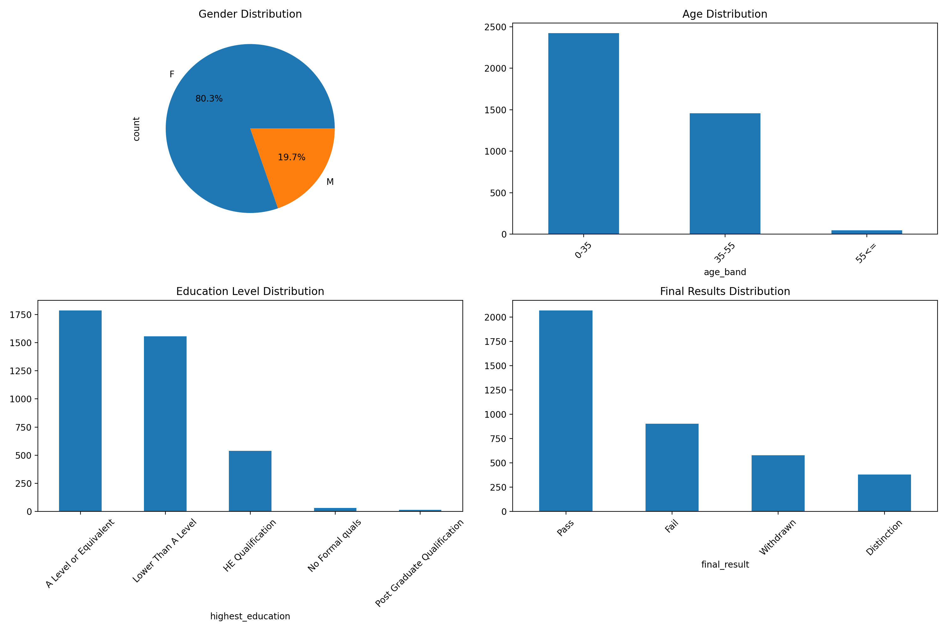Figure 1. Gender, age, education level, and final results of the OULAD dataset.
The majority of students (90.46%) did not report any disabilities. The data indicate a mean click score of 75.25, accompanied by an average of 932.2 total clicks and 83.77 credits studied. The graphical representations also illustrate the distributions of sex, age, and educational level.
The target variable comprised four classes (Pass, Fail, Withdrawn and Distinction). The dataset was highly imbalanced (Pass = 2,067, Fail = 903, Withdrawn = 579, Distinction = 380). To mitigate this, random under‑sampling was applied to reduce the majority classes to the size of the smallest class. For robustness, we also experimented with SMOTE, although the main results presented here use under‑sampling.

Algorithms and Parameters
In this study, two machine learning algorithms, Random Forest and XGBoost, were employed for success prediction. The modelling process encompasses data pre-processing, feature engineering, model training, and hyperparameter optimization. The comparison of these two machine learning algorithms is summarized in Table 1.
Feature | XGBoost | Random Forest
Type | Boosting | Bagging
Tree building | Sequential (dependent trees) | Parallel (independent trees)
Speed | Faster | Slower
Missing values | Handled internally | Requires preprocessing
Risk of overfitting | Higher if not tuned | Lower
Interpretability | Moderate | Higher
Hyperparameter tuning | More crucial | Less sensitive

Random Forest is an algorithm based on the ensemble generation of multiple decision trees. The model's capacity to mitigate overfitting and its high computational efficiency are the primary factors contributing to its selection (Breiman, 2001). The fundamental parameters used in the initial modelling phase were as follows:
- n_estimators = 100: A model with 100 decision trees.
- max_depth = None: The maximum depth of the trees is left unlimited.
- min_samples_split = 5: A minimum of 5 samples is required to split a branch.
- min_samples_leaf = 2: Leaf nodes must have at least 2 samples.
- bootstrap = True: Random sampling was used so that each tree was trained with a different dataset.
The RUS method was implemented to address the class imbalance observed in the dataset. This technique equalizes the number of observations for each class to match the least observed class, thereby enhancing the model's capacity to predict rare classes.
XGBoost, an optimized variant of the gradient boosting method, demonstrates superior performance in achieving high accuracy rates on large datasets (Chen and Guestrin, 2016). The fundamental parameters used are presented below.
- n_estimators = 200: A model with 200 trees was developed.
- max_depth = 10: The maximum depth is set to 10 to prevent over-learning.
- learning_rate = 0.1: The learning rate is set to 0.1.
- subsample = 0.8: The model uses 80% of the dataset in each iteration.
- colsample_bytree = 0.8: 80% of the features are randomly selected for each tree.
- gamma = 0.1: Increased the node splitting threshold to ensure more balanced splitting of the model.
- lambda = 1: L2 regularization parameter was used.
- alpha = 0.5: L1 regularization term was added to prevent the model from overlearning.
Python-based tools (e.g., scikit-learn and XGBoost library) were utilized for hyperparameter optimization during model training, and the optimal parameter combinations were determined using Grid Search and k-fold Cross-Validation methodologies. The following three novel variables were derived as part of the feature engineering process:

Click Efficiency was obtained by calculating the ratio of the total number of clicks to the average click score.

$$Click Efficiency=\frac{students_click_scores.click(sum)}{students_click_scores.score(avg) + 1}$$

Credit Intensity is measured as the ratio of the amount of credit received to the total number of clicks.

$$Credit Intensity=\frac{studied_credits}{students_click_scores.click(sum)+ 1}$$

Engagement Score is defined as the product of the student's credit load and the average click score.

$$Engagement Score= studied_credits×students_click_scores.score(avg)$$

These three new features allowed for more comprehensive insights into students' behavioral and academic performance. This approach is supported by similar applications in the literature (Papamitsiou and Economides, 2014).
The data were split into 80 % training and 20 % testing sets. Hyperparameter tuning for both Random Forest and XGBoost was performed using grid search with 10‑fold cross‑validation. For the Random Forest, the key parameters were the number of trees (n_estimators), maximum depth, minimum samples to split and minimum samples per leaf. For XGBoost, we tuned the number of estimators, tree depth, learning rate, subsample ratio, column sample ratio, gamma (minimum loss reduction), and L1/L2 regularization coefficients. Baseline models such as logistic regression and support vector machines were also tested but are omitted here for brevity.
Model performance was assessed using accuracy, precision, recall, f1‑score and area under the ROC curve (AUC). Class‑specific metrics were computed to evaluate the fairness of predictions across the four outcome categories. Statistical significance of differences between models was tested using the Wilcoxon signed‑rank test.

FINDINGS
The prediction performance of the models was evaluated using the accuracy rate and feature importance analysis. Before the application of the models, the data were divided into training and testing sets (80% training - 20% testing). The target variable consisted of four classes: Pass (2067 students), Fail (903 students), Withdrawn (579 students), and Distinction (380 students). In other words, instead of a binary classification (Pass/Fail), it was studied as a multi-class model.
First, the Random Forest algorithm was applied to the data. RUS was applied to improve the prediction accuracy of the model by removing the imbalance between classes in the data set. All classes were reduced to the minimum number of observed classes. This method balances the data by randomly selecting samples from majority classes.
The accuracy of the new model after RUS was 52%. Despite using a more balanced dataset, the model was still not perfect. However, we achieved a fairer prediction process because class balance was achieved. In the first application, the f1-score was high (70%) in the Pass class, but lower in the other classes. The "Pass" class was the best-predicted class. The error rate was high for "Withdrawn" and "Distinction" predictions.
Feature importance ranking was performed to determine which variables were important to the model. The variables that the model considered the most were determined as follows:
- students_click_scores.score(avg) (44.9%)
- students_click_scores.click(sum) (28.7%)
- studied_credits (8.2%)
- highest_education_Lower Than A Level (2.8%)
- gender_M (2.0%)
In the second stage, the XGBoost algorithm was applied to the data. XGBoost was trained on the OULAD data (200 trees, max_depth=10, learning_rate=0.1). The accuracy of the XGBoost model was 61.5%. This was 10% higher than that of the Random Forest model. It discriminates between the Pass and Fail classes better, but there is still room for improvement in the Withdrawn and Distinction classes.
We used Feature Engineering to increase the predictive power of the model by deriving new variables. In this context, the variables Click Efficiency, Credit Intensity, and Engagement Score, whose formulas are provided in the methodology section of the study, were derived and added to the data. The XGBoost algorithm was run again on the final version of the data. The accuracy of the new model was 63.2%. An improvement of 2% was achieved compared with the previous XGBoost model. Pass and Fail classes were predicted better after RUS. A feature importance analysis was also performed for XGBoost. The most important variables for success in XGBoost were as follows:
- students_click_scores.score(avg) %45.3
- students_click_scores.click(sum) %27.8
- studied_credits %8.5
- engagement_score %6.2
- click_efficiency %4.1
The most important variables for success in both the Random Forest and XGBoost algorithms were students_click_scores.score(avg), students_click_scores.click(sum), and studied_credits. The newly added features (engagement_score, click_efficiency, and credit_intensity) increased the predictive power of the model. Both models identified students' online e-learning interactions as the most important factor in student achievement. Demographic characteristics such as age and disability status were less influential in the model (approximately 2%). Figure 2 comparatively displays the feature importance levels of the Random Forest and XGBoost algorithms.
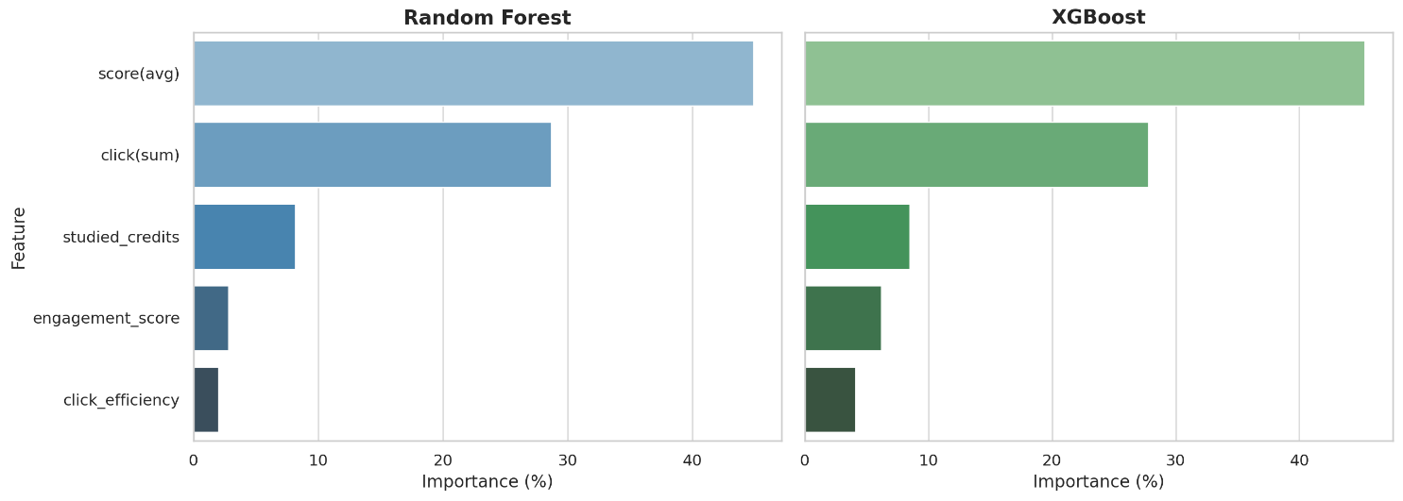Figure 2. Comparison of feature importance levels according to the Random Forest and XGBoost algorithms
In both models, students’ digital interaction data (click score and total number of clicks) are among the most influential variables for predicting success, while the XGBoost algorithm also assigns greater importance to derived variables such as "engagement score" and "click efficiency". This supports the superior capacity of XGBoost to model complex relationships.

RESULTS
This paper compared the performance of Random Forest and XGBoost in predicting multi‑class student outcomes using the OULAD. By applying rigorous preprocessing, feature engineering and hyperparameter tuning, we showed that XGBoost outperforms Random Forest and that engineered engagement metrics significantly enhance predictive power. The results indicate that the XGBoost algorithm predicts student achievement with an approximately 11% higher accuracy than the Random Forest. This finding suggests that the gradient boosting-based approach of XGBoost is more effective, particularly for complex data relationships and multidimensional interactions (Chen and Guestrin, 2016; Breiman, 2001). The dominance of clickstream features underscores the need for educational platforms to capture and analyze learners’ interaction patterns. These findings contribute to the development of data‑driven early warning systems and emphasize the value of ensemble learning in education. In Figure 3, a comparison of the main performance metrics (accuracy, precision, recall, and f1-score) of the Random Forest and XGBoost algorithms is presented.
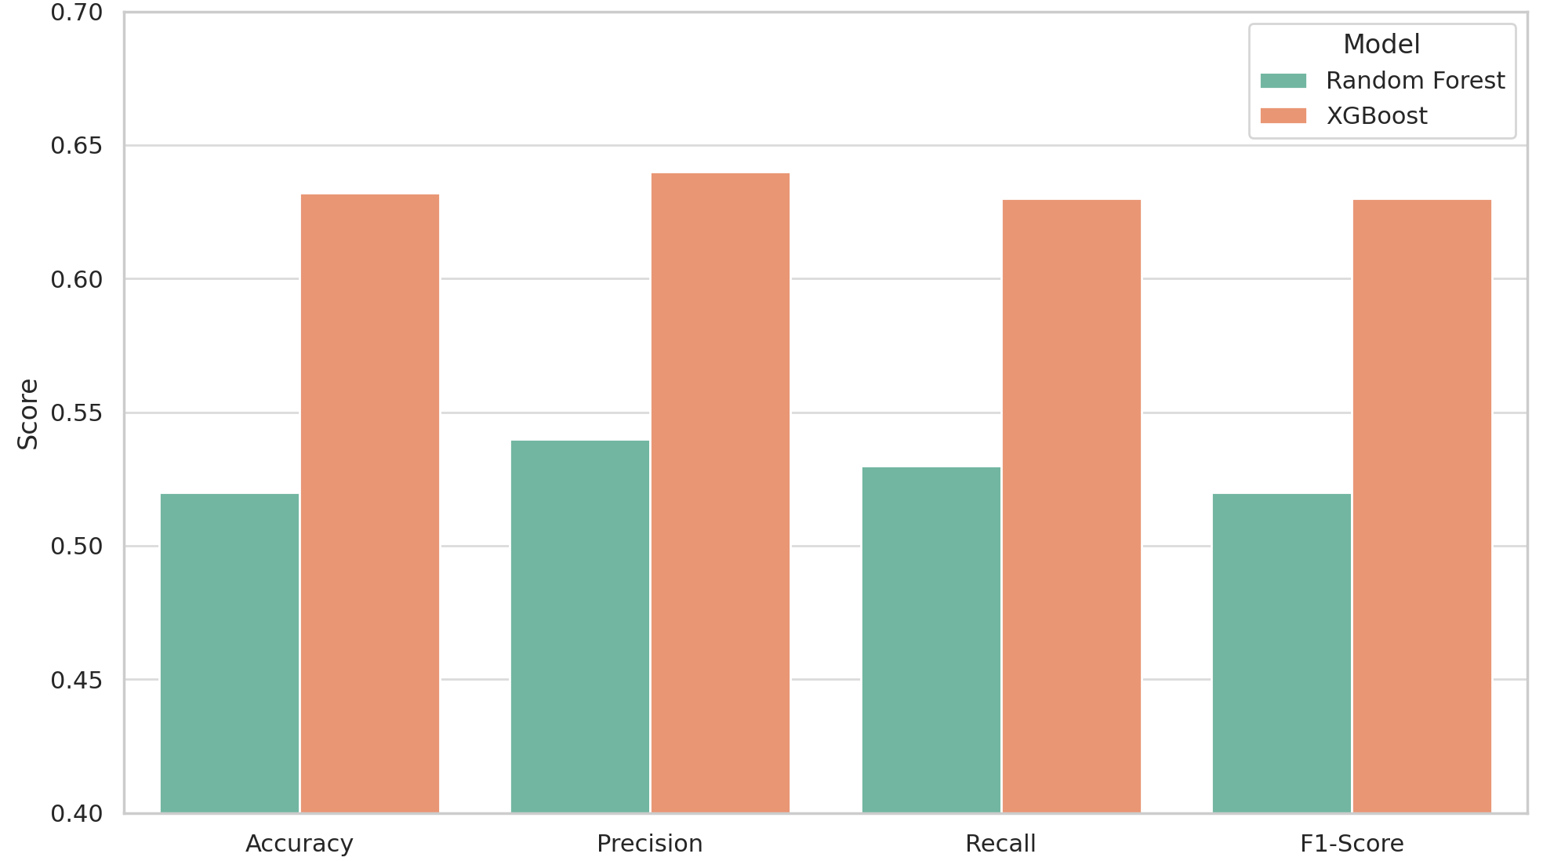Figure 3. Comparison of the basic performance metrics of Random Forest and XGBoost models
The graph clearly demonstrates that XGBoost exhibits higher performance in every metric. These results indicate that XGBoost is a more balanced and reliable model, especially in multi-class classification problems. The incorporation of engagement_score, click_efficiency, and credit_intensity variables derived from attribute engineering into the model enhanced the predictive power of the XGBoost. This observation supports the notion that data enrichment and appropriate attribute selection directly influence the efficacy of ML models (Papamitsiou and Economides, 2014). The positive contributions of data preprocessing and feature engineering applications to model performance in educational data mining studies have been frequently documented in the literature (Alalawi, Athauda, and Chiong, 2024).
The Random Forest algorithm demonstrated notably high sensitivity to students' click data. This observation aligns with the algorithm's emphasis on certain, high-value variables. For instance, the Pass group (n=2067) was the most accurately predicted class, suggesting that the algorithm operates based on interaction data and is comparatively less influenced by demographic factors such as education level and age (Gasevic et al., 2014; Siemens, 2013). However, this approach may overlook the impact of socioeconomic factors not included in the dataset. Consequently, this limitation may result in a high failure rate in predicting complex classes such as Withdrawn and Distinction. This phenomenon is frequently observed in similar studies and reflects the constraints of datasets (Doroudi, 2024).
The XGBoost algorithm exhibited a more balanced class distribution than the other algorithms. While XGBoost demonstrated high performance in the Pass and Fail classes, relatively low performance was observed in Withdrawn and Distinction classes. This discrepancy indicates that additional attributes that could be incorporated into the dataset (e.g., socioeconomic level, family support status) may enhance the model performance. The literature emphasizes the impact of data balancing and additional attributes on the predictive power. Specifically, alternative models such as SMOTE, LightGBM, and CatBoost were proposed for testing in this context.
Regarding the practical implications of this research, it is evident that the XGBoost algorithm and novel variables generated through feature engineering yield superior results in predicting student achievement. These findings provide valuable insights into the development of early warning systems and personalized learning interventions. Educators and analytics professionals can utilize these findings to identify students' risk situations at an earlier stage and optimize intervention strategies accordingly.
This study contributes significantly to the existing literature on educational data mining and the integration of ML models in LA. However, considering that socioeconomic and environmental factors not included in the dataset may also influence prediction performance, it is recommended that these variables be incorporated into the model in future research. Furthermore, comparative analyses of alternative models, such as LightGBM and CatBoost, may offer broader perspectives on model selection. This study demonstrates the importance of data enrichment in predicting student achievement and the practical applicability of advanced ML algorithms (particularly XGBoost). As emphasized in the relevant literature, the accurate processing of LA data is crucial for the development of early warning systems and personalized educational strategies.

Conflict of Interest
The authors declare no potential conflicts of interest with respect to the research, authorship, or publication of this article.

References
Alalawi, K., Athauda, R., and Chiong, R. (2024). An extended learning analytics framework integrating machine learning and pedagogical approaches for student performance prediction and intervention. International Journal of Artificial Intelligence in Education, 1–49. https://doi.org/10.1007/s40593-024-00429-7
Babajide Mustapha, I., and Saeed, F. (2016). Bioactive Molecule Prediction Using Extreme Gradient Boosting. Molecules, 21(8), 983. https://doi.org/10.3390/molecules21080983
Berg, A.M., Branka, J., Kismihók, G. (2018). Combining Learning Analytics with Job Market Intelligence to Support Learning at the Workplace. In: Ifenthaler, D. (eds) Digital Workplace Learning. Springer, Cham. https://doi.org/10.1007/978-3-319-46215-8_8
Breiman, L. (2001). Random forests. Machine Learning, 45(1), 5–32. https://doi.org/10.1023/A:1010933404324
Chen, T., and Guestrin, C. (2016). XGBoost: A scalable tree boosting system. In Proceedings of the 22nd ACM SIGKDD International Conference on Knowledge Discovery and Data Mining (KDD ’16) (pp. 785–794). Association for Computing Machinery. https://doi.org/10.1145/2939672.2939785
Doroudi, S. (2024). On the paradigms of learning analytics: Machine learning meets epistemology. Computers and Education: Artificial Intelligence, 6, 100192. https://doi.org/10.1016/j.caeai.2023.100192
Fernández, C. G., and Garrido, D. C. (2024). From Educability to Technology Acceptability and Artificial Intelligence Literacy: Validation of an Instrument. Digital Education Review, (45), 8-14. https://orcid.org/0000-0002-2860-6747
Ferguson, R. (2012). Learning analytics: drivers, developments and challenges. International Journal of Technology Enhanced Learning, 4(5/6), 304–317. https://doi.org/10.1504/IJTEL.2012.051816
Gasevic, D., Rose, C., Siemens, G., Wolff, A., and Zdrahal, Z. (2014, March). Learning analytics and machine learning. In Proceedings of the Fourth International Conference on Learning Analytics and Knowledge (pp. 287–288).
Ghafarian, F., Wieland, R., Lüttschwager, D., and Nendel, C. (2022). Application of extreme gradient boosting and Shapley Additive explanations to predict temperature regimes inside forests from standard open-field meteorological data. Environmental Modelling and Software, 156, 105466. https://doi.org/10.1016/j.envsoft.2022.105466
Jawad, K., Shah, M.A., and Tahir, M. (2022). Students’ academic performance and engagement prediction in a virtual learning environment using random forest with data balancing. Sustainability, 14(22), 14795. https://doi.org/10.3390/su142214795
Jhaveri, S., Khedkar, I., Kantharia, Y., & Jaswal, S. (2019, March). Success prediction using random forest, catboost, xgboost and adaboost for kickstarter campaigns. In 2019 3rd international conference on computing methodologies and communication (ICCMC) (pp. 1170-1173). IEEE. https://10.1109/ICCMC.2019.8819828
Kadiyala, A., and Kumar, A. (2018). Applications of python to evaluate the performance of bagging methods. Environmental Progress and Sustainable Energy, 37(5), 1555–1559. https://doi.org/10.1002/ep.13018
Mienye, I. D., and Sun, Y. (2022). A Survey of Ensemble Learning: Concepts, Algorithms, Applications, and Prospects. IEEE Access, 10, 99129–99149. https://doi.org/10.1109/access.2022.3207287
Papamitsiou, Z., and Economides, A. A. (2014). Learning analytics and educational data mining in practice: A systematic literature review of empirical evidence. Educational Technology and Society, 17(4), 49–64. https://www.jstor.org/stable/10.2307/jeductechsoci.17.4.49
Sailer, M., Ninaus, M., Huber, S. E., Bauer, E., and Greiff, S. (2024). The End is the Beginning is the End: The closed-loop learning analytics framework. Computers in Human Behavior, 108305. https://doi.org/10.1016/j.chb.2024.108305
Siemens, G. (2013). Learning analytics: The emergence of a discipline. American Behavioral Scientist, 57(10), 1380–1400. https://doi.org/10.1177/0002764213498851
Sciarrone, F. (2018, April). Machine learning and learning analytics: Integrating data with learning. In 2018 17th International Conference on Information Technology Based Higher Education and Training (ITHET) (pp. 1–5). IEEE. https://10.1109/ITHET.2018.8424780
Wong, B.Tm., Li, K.C. A review of learning analytics intervention in higher education (2011–2018). J. Comput. Educ. 7, 7–28 (2020). https://doi.org/10.1007/s40692-019-00143-7
Yıldız, M.B., Börekçi, C. (2020). Predicting Academic Achievement with Machine Learning Algorithms. Journal of Educational Technology & Online Learning, 3(3), 372-392. https://doi.org/10.31681/jetol.773206
Zhang, W., Wu, C., Zhong, H., Li, Y., and Wang, L. (2020). Prediction of undrained shear strength using extreme gradient boosting and random forest based on Bayesian optimization. Geoscience Frontiers, 12(1), 469–477. https://doi.org/10.1016/j.gsf.2020.03.007

