***Lant de magazine – DVDs & Blu-Rays***

***Răican Mihai***

***Grupa 244***

**EXERCITIUL 1**

**Proiectul va consta in modelarea unei baze de date pentru un lanț de magazine, aflate in mai**

**multe orașe din tara. Un magazin se va ocupa cu vânzarea de DVD-uri si Blu-Ray-uri ce vor conține**

**filme sau seriale. Fiecare magazin va avea un manager si mai multi angajati**

**care se vor ocupa de vânzare, vor face recomandări clienților si vor pregăti produsele care**

**urmează sa fie ridicate din magazin. Acest lanț de magazine are si un site in care clienții își pot face**

**cont si pot comanda produsele dorite: direct la domiciliu pentru orice produs de pe site, sau la**

**unul dintre magazine, probabil cel mai apropiat, daca produsul respectiv nu se afla in stocul**

**magazinului respectiv, urmând ca produsul sa fie ridicat din magazin de către client.**

**EXERCITIUL 2**

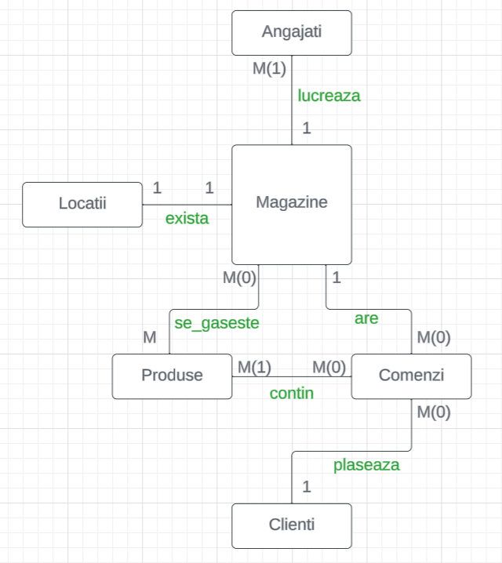

**EXERCITIUL 3**

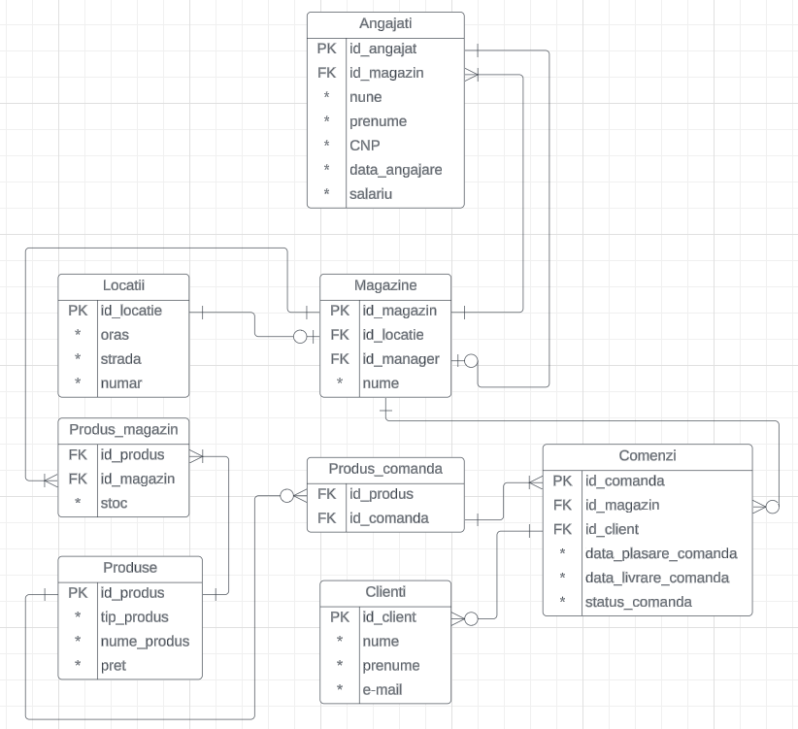

**EXERCITIUL 4**

CREATE SEQUENCE Angajat_id

START WITH 1000

INCREMENT BY 1;

CREATE SEQUENCE Magazin_id

START WITH 2000

INCREMENT BY 1;

CREATE SEQUENCE Locatie_id

START WITH 3000

INCREMENT BY 1;

CREATE SEQUENCE Comanda_id

START WITH 4000

INCREMENT BY 1;

CREATE SEQUENCE Client_id

START WITH 5000

INCREMENT BY 1;

CREATE SEQUENCE Produs_id

START WITH 6000

INCREMENT BY 1;

create table Angajati (

ID_Angajat number(4),

ID_Magazin number(4) not null,

Nume varchar2(25) not null,

Prenume varchar2(25) not null,

CNP number(13) not null,

Data_Angajare date default sysdate,

Salariu number(5) default 1900,

constraint PK_ID_Angajat primary key (ID_Angajat),

constraint UQ_CNP unique (CNP),

constraint CK_CNP check (length(CNP) = 13)

);

--------------------------------------------------------------------------------

create table Magazine (

ID_Magazin number(4),

ID_Locatie number(4) not null,

Nume varchar(50),

ID_Manager number(4),

constraint PK_ID_Magazin primary key (ID_Magazin)

);

--------------------------------------------------------------------------------

create table Locatii (

ID_Locatie number(4),

Oras varchar2(20) not null,

Strada varchar2(20) not null,

Numar number(4) not null,

constraint PK_ID_Locatie primary key (ID_Locatie)

);

--Magazine

ALTER TABLE Magazine

ADD CONSTRAINT FK_ID_Manager FOREIGN KEY (ID_Manager) REFERENCES Angajati(ID_Angajat);

ALTER TABLE Magazine

ADD CONSTRAINT FK_ID_Locatie FOREIGN KEY (ID_Locatie) REFERENCES Locatii(ID_Locatie);

--------------------------------------------------------------------------------

create table Produse (

ID_Produs number(4),

Tip_Produs varchar(20),

Nume_Produs varchar(50),

Pret number(3),

constraint PK_ID_Produs primary key (ID_Produs)

);

--------------------------------------------------------------------------------

create table Clienti (

ID_Client number(6),

Nume varchar2(25),

Prenume varchar2(25),

Email varchar2(50),

constraint PK_ID_Client primary key (ID_Client)

);

--------------------------------------------------------------------------------

create table Comenzi (

ID_Comanda number(6),

ID_Magazin number(4),

ID_Client number(6),

Data_Plasare_Comanda date default sysdate,

Data_Livrare_Comanda date,

Status_Comanda varchar2(100),

constraint PK_ID_Comanda primary key (ID_Comanda)

);

ALTER TABLE Comenzi

ADD CONSTRAINT FK_ID_Magazin_Comenzi FOREIGN KEY (ID_Magazin) REFERENCES Magazine(ID_Magazin);

ALTER TABLE Comenzi

ADD CONSTRAINT FK_ID_Client FOREIGN KEY (ID_Client) REFERENCES Clienti(ID_Client);

--------------------------------------------------------------------------------

create table Produs_Magazin (

ID_Produs number(4),

ID_Magazin number(4) not null,

Stoc number(4)

);

ALTER TABLE Produs_Magazin

ADD CONSTRAINT FK_ID_Produs_Magazin FOREIGN KEY (ID_Produs) REFERENCES Produse(ID_Produs);

ALTER TABLE Produs_Magazin

ADD CONSTRAINT FK_ID_Magazin_Produs FOREIGN KEY (ID_Magazin) REFERENCES Magazine(ID_Magazin);

--------------------------------------------------------------------------------

create table Produs_Comanda (

ID_Produs number(4),

ID_Comanda number(6),

Cantitate number(3)

);

ALTER TABLE Produs_Comanda

ADD CONSTRAINT FK_ID_Produs_Comanda FOREIGN KEY (ID_Produs) REFERENCES Produse(ID_Produs);

ALTER TABLE Produs_Comanda

ADD CONSTRAINT FK_ID_Comanda FOREIGN KEY (ID_Comanda) REFERENCES Comenzi(ID_Comanda);

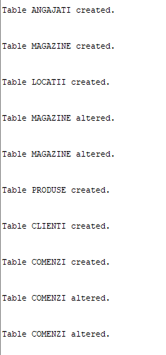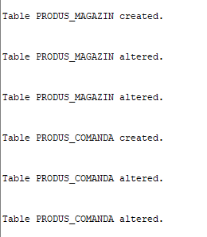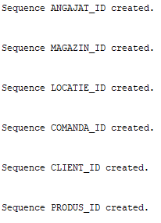

**EXERCITIUL 5**

**ANGAJATI**

insert into Angajati (ID_Angajat, ID_Magazin, Nume, Prenume, CNP, Data_Angajare, Salariu)

values (Angajat_id.nextval, 2007, 'Vasilescu', 'Ionut', 1004071523456,

TO_DATE('2011-08-20', 'YYYY-MM-DD'), 3200);

insert into Angajati (ID_Angajat, ID_Magazin, Nume, Prenume, CNP, Data_Angajare, Salariu)

values (Angajat_id.nextval, 2008, 'Popescu', 'Maria', 1885060826789,

TO_DATE('2019-05-10', 'YYYY-MM-DD'), 2500);

insert into Angajati (ID_Angajat, ID_Magazin, Nume, Prenume, CNP, Data_Angajare, Salariu)

values (Angajat_id.nextval, 2004, 'Ionescu', 'Andrei', 1782100229876,

TO_DATE('2008-12-01', 'YYYY-MM-DD'), 3000);

insert into Angajati (ID_Angajat, ID_Magazin, Nume, Prenume, CNP, Data_Angajare, Salariu)

values (Angajat_id.nextval, 2002, 'Dragomir', 'Elena', 1891051023456,

TO_DATE('2013-07-18', 'YYYY-MM-DD'), 2700);

insert into Angajati (ID_Angajat, ID_Magazin, Nume, Prenume, CNP, Data_Angajare, Salariu)

values (Angajat_id.nextval, 2001, 'Stoica', 'Gabriel', 1989080323456,

TO_DATE('2010-09-23', 'YYYY-MM-DD'), 2900);

insert into Angajati (ID_Angajat, ID_Magazin, Nume, Prenume, CNP, Data_Angajare, Salariu)

values (Angajat_id.nextval, 2006, 'Dumitru', 'Adriana', 1990021723456,

TO_DATE('2017-03-14', 'YYYY-MM-DD'), 2800);

insert into Angajati (ID_Angajat, ID_Magazin, Nume, Prenume, CNP, Data_Angajare, Salariu)

values (Angajat_id.nextval, 2003, 'Radulescu', 'Mihai', 1986093023456,

TO_DATE('2012-11-05', 'YYYY-MM-DD'), 3100);

insert into Angajati (ID_Angajat, ID_Magazin, Nume, Prenume, CNP, Data_Angajare, Salariu)

values (Angajat_id.nextval, 2009, 'Constantin', 'Ana', 1937070723456,

TO_DATE('2021-02-19', 'YYYY-MM-DD'), 2600);

insert into Angajati (ID_Angajat, ID_Magazin, Nume, Prenume, CNP, Data_Angajare, Salariu)

values (Angajat_id.nextval, 2005, 'Florescu', 'Dragos', 1913021023456,

TO_DATE('2018-09-30', 'YYYY-MM-DD'), 2700);

insert into Angajati (ID_Angajat, ID_Magazin, Nume, Prenume, CNP, Data_Angajare, Salariu)

values (Angajat_id.nextval, 2000, 'Ilie', 'Daniel', 1831010123456,

TO_DATE('2014-02-27', 'YYYY-MM-DD'), 2800);

insert into Angajati (ID_Angajat, ID_Magazin, Nume, Prenume, CNP, Data_Angajare, Salariu)

values (Angajat_id.nextval, 2001, 'Ionescu', 'Alexandra', 1925051523456,

TO_DATE('2016-07-08', 'YYYY-MM-DD'), 3000);

insert into Angajati (ID_Angajat, ID_Magazin, Nume, Prenume, CNP, Data_Angajare, Salariu)

values (Angajat_id.nextval, 2003, 'Popescu', 'Marian', 1963072123456,

TO_DATE('2009-12-15', 'YYYY-MM-DD'), 2500);

insert into Angajati (ID_Angajat, ID_Magazin, Nume, Prenume, CNP, Data_Angajare, Salariu)

values (Angajat_id.nextval, 2004, 'Radoi', 'Ana', 1889100223456,

TO_DATE('2013-06-19', 'YYYY-MM-DD'), 3200);

insert into Angajati (ID_Angajat, ID_Magazin, Nume, Prenume, CNP, Data_Angajare, Salariu)

values (Angajat_id.nextval, 2002, 'Dragomir', 'Mihai', 1846071623456,

TO_DATE('2010-05-21', 'YYYY-MM-DD'), 2700);

insert into Angajati (ID_Angajat, ID_Magazin, Nume, Prenume, CNP, Data_Angajare, Salariu)

values (Angajat_id.nextval, 2006, 'Neagoe', 'Andreea', 1900040323456,

TO_DATE('2017-01-10', 'YYYY-MM-DD'), 2900);

insert into Angajati (ID_Angajat, ID_Magazin, Nume, Prenume, CNP, Data_Angajare, Salariu)

values (Angajat_id.nextval, 2005, 'Ionel', 'Cristian', 1758051723456,

TO_DATE('2012-08-05', 'YYYY-MM-DD'), 2800);

insert into Angajati (ID_Angajat, ID_Magazin, Nume, Prenume, CNP, Data_Angajare, Salariu)

values (Angajat_id.nextval, 2008, 'Albu', 'Elena', 1003123023456,

TO_DATE('2022-03-27', 'YYYY-MM-DD'), 3100);

insert into Angajati (ID_Angajat, ID_Magazin, Nume, Prenume, CNP, Data_Angajare, Salariu)

values (Angajat_id.nextval, 2007, 'Constantin', 'George', 1817080923456,

TO_DATE('2019-11-12', 'YYYY-MM-DD'), 2600);

insert into Angajati (ID_Angajat, ID_Magazin, Nume, Prenume, CNP, Data_Angajare, Salariu)

values (Angajat_id.nextval, 2009, 'Bucur', 'Mihaela', 1986100423456,

TO_DATE('2020-06-25', 'YYYY-MM-DD'), 2800);

insert into Angajati (ID_Angajat, ID_Magazin, Nume, Prenume, CNP, Data_Angajare, Salariu)

values (Angajat_id.nextval, 2003, 'Minculescu', 'Diana', 1971122723456,

TO_DATE('2015-04-03', 'YYYY-MM-DD'), 3000);

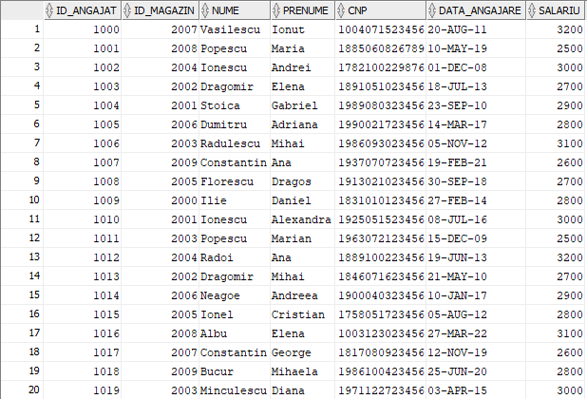

**LOCATII**

insert into Locatii (ID_Locatie, Oras, Strada, Numar)

values (Locatie_id.nextval, 'Buzau', 'Principala', 43);

insert into Locatii (ID_Locatie, Oras, Strada, Numar)

values (Locatie_id.nextval, 'Brasov', 'Libertatii', 17);

insert into Locatii (ID_Locatie, Oras, Strada, Numar)

values (Locatie_id.nextval, 'Timisoara', 'Mihai Viteazu', 9);

insert into Locatii (ID_Locatie, Oras, Strada, Numar)

values (Locatie_id.nextval, 'Cluj-Napoca', 'Avram Iancu', 32);

insert into Locatii (ID_Locatie, Oras, Strada, Numar)

values (Locatie_id.nextval, 'Iasi', 'Stefan cel Mare', 25);

insert into Locatii (ID_Locatie, Oras, Strada, Numar)

values (Locatie_id.nextval, 'Constanta', 'Mamaia', 7);

insert into Locatii (ID_Locatie, Oras, Strada, Numar)

values (Locatie_id.nextval, 'Sibiu', 'Victoriei', 12);

insert into Locatii (ID_Locatie, Oras, Strada, Numar)

values (Locatie_id.nextval, 'Galati', 'Dunarii', 19);

insert into Locatii (ID_Locatie, Oras, Strada, Numar)

values (Locatie_id.nextval, 'Ploiesti', 'Revolu?iei', 8);

insert into Locatii (ID_Locatie, Oras, Strada, Numar)

values (Locatie_id.nextval, 'Oradea', 'Unirii', 14);

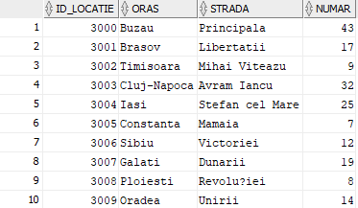

**MAGAZINE**

insert into Magazine (ID_Magazin, ID_Locatie, Nume, ID_Manager)

values (Magazin_id.nextval, 3005, 'Media Metropolis Constanta', 1002);

insert into Magazine (ID_Magazin, ID_Locatie, Nume, ID_Manager)

values (Magazin_id.nextval, 3002, 'Film Fortress Timisoara', 1005);

insert into Magazine (ID_Magazin, ID_Locatie, Nume, ID_Manager)

values (Magazin_id.nextval, 3008, 'Cinematic Stash Prahova', null);

insert into Magazine (ID_Magazin, ID_Locatie, Nume, ID_Manager)

values (Magazin_id.nextval, 3003, 'DVD Delight Cluj-Napoca', 1011);

insert into Magazine (ID_Magazin, ID_Locatie, Nume, ID_Manager)

values (Magazin_id.nextval, 3007, 'Blu-ray Bazar Galati', 1001);

insert into Magazine (ID_Magazin, ID_Locatie, Nume, ID_Manager)

values (Magazin_id.nextval, 3001, 'Blockbuster Bliss Brasov', null);

insert into Magazine (ID_Magazin, ID_Locatie, Nume, ID_Manager)

values (Magazin_id.nextval, 3006, 'Blu-Ray Boutique Sibiu', 1004);

insert into Magazine (ID_Magazin, ID_Locatie, Nume, ID_Manager)

values (Magazin_id.nextval, 3009, 'Just Watch Oradea', null);

insert into Magazine (ID_Magazin, ID_Locatie, Nume, ID_Manager)

values (Magazin_id.nextval, 3004, 'Blockbuster Bliss Iasi', 1017);

insert into Magazine (ID_Magazin, ID_Locatie, Nume, ID_Manager)

values (Magazin_id.nextval, 3000, 'Media Metropolis Buzau', 1008);

insert into Magazine (ID_Magazin, ID_Locatie, Nume, ID_Manager)

values (Magazin_id.nextval, 3009, 'Just Watch Oradea', 1008);

insert into Magazine (ID_Magazin, ID_Locatie, Nume, ID_Manager)

values (Magazin_id.nextval, 3009, 'Popcorn Time Oradea', null);

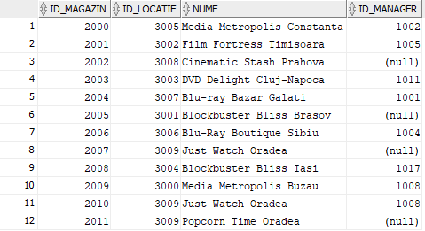

**CLIENTI**

insert into clienti (ID_CLIENT, NUME, PRENUME, EMAIL)

values (Client_id.nextval, 'Petrescu', 'Alin', 'petrescualin@gmail.com');

insert into clienti (ID_CLIENT, NUME, PRENUME, EMAIL)

values (Client_id.nextval, 'Ionescu', 'Maria', 'ionescumaria@gmail.com');

insert into clienti (ID_CLIENT, NUME, PRENUME, EMAIL)

values (Client_id.nextval, 'Popescu', 'Andrei', 'popescuandrei@gmail.com');

insert into clienti (ID_CLIENT, NUME, PRENUME, EMAIL)

values (Client_id.nextval, 'Stanescu', 'Elena', 'stanescuelena@gmail.com');

insert into clienti (ID_CLIENT, NUME, PRENUME, EMAIL)

values (Client_id.nextval, 'Mihai', 'Cristina', 'mihaicristina@gmail.com');

insert into clienti (ID_CLIENT, NUME, PRENUME, EMAIL)

values (Client_id.nextval, 'Georgescu', 'Alexandru', 'georgescualexandru@gmail.com');

insert into clienti (ID_CLIENT, NUME, PRENUME, EMAIL)

values (Client_id.nextval, 'Dumitrescu', 'Andreea', 'dumitrescuandreea@gmail.com');

insert into clienti (ID_CLIENT, NUME, PRENUME, EMAIL)

values (Client_id.nextval, 'Popa', 'Gabriel', 'popagabriel@gmail.com');

insert into clienti (ID_CLIENT, NUME, PRENUME, EMAIL)

values (Client_id.nextval, 'Radu', 'Mihaela', 'radumihaela@gmail.com');

insert into clienti (ID_CLIENT, NUME, PRENUME, EMAIL)

values (Client_id.nextval, 'Marinescu', 'Catalin', 'marinescucatalin@gmail.com');

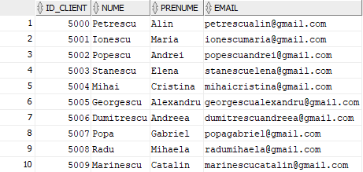

**COMENZI**

insert into Comenzi (ID_COMANDA, ID_MAGAZIN, ID_CLIENT, DATA_PLASARE_COMANDA, DATA_LIVRARE_COMANDA, STATUS_COMANDA)

values (Comanda_id.nextval, 2004, 5008, TO_DATE('2023-05-24', 'YYYY-MM-DD'), TO_DATE('2023-05-25', 'YYYY-MM-DD'), 'Procesare comanda');

insert into Comenzi (ID_COMANDA, ID_MAGAZIN, ID_CLIENT, DATA_PLASARE_COMANDA, DATA_LIVRARE_COMANDA, STATUS_COMANDA)

values (Comanda_id.nextval, 2006, 5001, TO_DATE('2023-05-22', 'YYYY-MM-DD'), TO_DATE('2023-05-26', 'YYYY-MM-DD'), 'Produse predate curierului');

insert into Comenzi (ID_COMANDA, ID_MAGAZIN, ID_CLIENT, DATA_PLASARE_COMANDA, DATA_LIVRARE_COMANDA, STATUS_COMANDA)

values (Comanda_id.nextval, 2003, 5009, TO_DATE('2023-05-23', 'YYYY-MM-DD'), TO_DATE('2023-05-30', 'YYYY-MM-DD'), 'Produse in depozitul curierului');

insert into Comenzi (ID_COMANDA, ID_MAGAZIN, ID_CLIENT, DATA_PLASARE_COMANDA, DATA_LIVRARE_COMANDA, STATUS_COMANDA)

values (Comanda_id.nextval, 2008, 5005, TO_DATE('2023-05-21', 'YYYY-MM-DD'), TO_DATE('2023-05-23', 'YYYY-MM-DD'), 'Produse in curs de livrare');

insert into Comenzi (ID_COMANDA, ID_MAGAZIN, ID_CLIENT, DATA_PLASARE_COMANDA, DATA_LIVRARE_COMANDA, STATUS_COMANDA)

values (Comanda_id.nextval, 2002, 5002, TO_DATE('2023-05-20', 'YYYY-MM-DD'), TO_DATE('2023-05-22', 'YYYY-MM-DD'), 'Produsele vor fi gata de ridicare din magazin');

insert into Comenzi (ID_COMANDA, ID_MAGAZIN, ID_CLIENT, DATA_PLASARE_COMANDA, DATA_LIVRARE_COMANDA, STATUS_COMANDA)

values (Comanda_id.nextval, 2007, 5006, TO_DATE('2023-05-19', 'YYYY-MM-DD'), TO_DATE('2023-05-31', 'YYYY-MM-DD'), 'Procesare comanda');

insert into Comenzi (ID_COMANDA, ID_MAGAZIN, ID_CLIENT, DATA_PLASARE_COMANDA, DATA_LIVRARE_COMANDA, STATUS_COMANDA)

values (Comanda_id.nextval, 2001, 5007, TO_DATE('2023-05-21', 'YYYY-MM-DD'), TO_DATE('2023-05-24', 'YYYY-MM-DD'), 'Produse predate curierului');

insert into Comenzi (ID_COMANDA, ID_MAGAZIN, ID_CLIENT, DATA_PLASARE_COMANDA, DATA_LIVRARE_COMANDA, STATUS_COMANDA)

values (Comanda_id.nextval, 2004, 5003, TO_DATE('2023-05-21', 'YYYY-MM-DD'), TO_DATE('2023-05-28', 'YYYY-MM-DD'), 'Produse in depozitul curierului');

insert into Comenzi (ID_COMANDA, ID_MAGAZIN, ID_CLIENT, DATA_PLASARE_COMANDA, DATA_LIVRARE_COMANDA, STATUS_COMANDA)

values (Comanda_id.nextval, 2009, 5004, TO_DATE('2023-05-24', 'YYYY-MM-DD'), TO_DATE('2023-05-24', 'YYYY-MM-DD'), 'Produse in curs de livrare');

insert into Comenzi (ID_COMANDA, ID_MAGAZIN, ID_CLIENT, DATA_PLASARE_COMANDA, DATA_LIVRARE_COMANDA, STATUS_COMANDA)

values (Comanda_id.nextval, 2000, 5009, TO_DATE('2023-05-24', 'YYYY-MM-DD'), TO_DATE('2023-05-27', 'YYYY-MM-DD'), 'Produsele vor fi gata de ridicare din magazin');

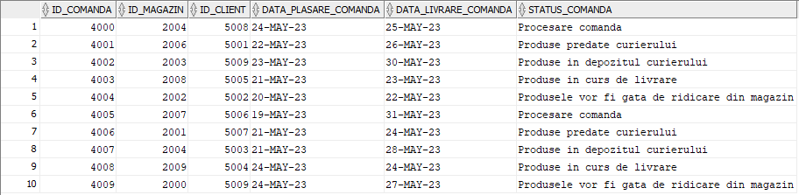

**PRODUSE**

insert into produse (ID_PRODUS, TIP_PRODUS, NUME_PRODUS, PRET)

values (Produs_id.nextval, 'DVD', 'Inception', 89);

insert into produse (ID_PRODUS, TIP_PRODUS, NUME_PRODUS, PRET)

values (Produs_id.nextval, 'Blu-Ray UHD', 'Avengers: Endgame', 120);

insert into produse (ID_PRODUS, TIP_PRODUS, NUME_PRODUS, PRET)

values (Produs_id.nextval, 'DVD', 'The Social Network', 45);

insert into produse (ID_PRODUS, TIP_PRODUS, NUME_PRODUS, PRET)

values (Produs_id.nextval, 'Blu-Ray 4k', 'Interstellar', 99);

insert into produse (ID_PRODUS, TIP_PRODUS, NUME_PRODUS, PRET)

values (Produs_id.nextval, 'Blu-Ray UHD', 'Mad Max: Fury Road', 75);

insert into produse (ID_PRODUS, TIP_PRODUS, NUME_PRODUS, PRET)

values (Produs_id.nextval, 'DVD', 'Gone Girl', 32);

insert into produse (ID_PRODUS, TIP_PRODUS, NUME_PRODUS, PRET)

values (Produs_id.nextval, 'Blu-Ray 4k', 'Dunkirk', 110);

insert into produse (ID_PRODUS, TIP_PRODUS, NUME_PRODUS, PRET)

values (Produs_id.nextval, 'DVD', 'La La Land', 27);

insert into produse (ID_PRODUS, TIP_PRODUS, NUME_PRODUS, PRET)

values (Produs_id.nextval, 'Blu-Ray UHD', 'Black Panther', 135);

insert into produse (ID_PRODUS, TIP_PRODUS, NUME_PRODUS, PRET)

values (Produs_id.nextval, 'DVD', 'The Grand Budapest Hotel', 62);

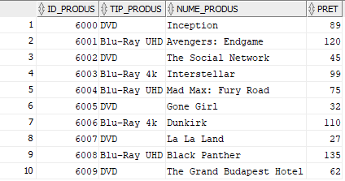

**PRODUS_COMANDA**

insert into Produs_Comanda (ID_PRODUS, ID_COMANDA, Cantitate)

values (6000, 4000, 1);

insert into Produs_Comanda (ID_PRODUS, ID_COMANDA, Cantitate)

values (6005, 4003, 1);

insert into Produs_Comanda (ID_PRODUS, ID_COMANDA, Cantitate)

values (6003, 4005, 2);

insert into Produs_Comanda (ID_PRODUS, ID_COMANDA, Cantitate)

values (6001, 4006, 5);

insert into Produs_Comanda (ID_PRODUS, ID_COMANDA, Cantitate)

values (6009, 4008, 1);

insert into Produs_Comanda (ID_PRODUS, ID_COMANDA, Cantitate)

values (6008, 4001, 2);

insert into Produs_Comanda (ID_PRODUS, ID_COMANDA, Cantitate)

values (6004, 4007, 3);

insert into Produs_Comanda (ID_PRODUS, ID_COMANDA, Cantitate)

values (6006, 4009, 2);

insert into Produs_Comanda (ID_PRODUS, ID_COMANDA, Cantitate)

values (6007, 4004, 1);

insert into Produs_Comanda (ID_PRODUS, ID_COMANDA, Cantitate)

values (6002, 4002, 1);

insert into Produs_Comanda (ID_PRODUS, ID_COMANDA, Cantitate)

values (6003, 4002, 1);

insert into Produs_Comanda (ID_PRODUS, ID_COMANDA, Cantitate)

values (6009, 4004, 3);

insert into Produs_Comanda (ID_PRODUS, ID_COMANDA, Cantitate)

values (6005, 4007, 1);

insert into Produs_Comanda (ID_PRODUS, ID_COMANDA, Cantitate)

values (6008, 4002, 1);

insert into Produs_Comanda (ID_PRODUS, ID_COMANDA, Cantitate)

values (6000, 4005, 9);

insert into Produs_Comanda (ID_PRODUS, ID_COMANDA, Cantitate)

values (6002, 4005, 2);

insert into Produs_Comanda (ID_PRODUS, ID_COMANDA, Cantitate)

values (6007, 4000, 2);

insert into Produs_Comanda (ID_PRODUS, ID_COMANDA, Cantitate)

values (6008, 4000, 7);

insert into Produs_Comanda (ID_PRODUS, ID_COMANDA, Cantitate)

values (6003, 4001, 10);

insert into Produs_Comanda (ID_PRODUS, ID_COMANDA, Cantitate)

values (6000, 4002, 1);

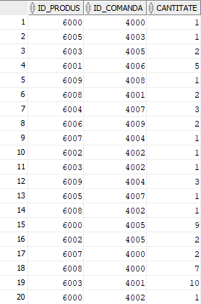

**PRODUS_MAGAZIN**

insert into produs_magazin (ID_PRODUS, ID_MAGAZIN, STOC)

values (6000, 2005, 78);

insert into produs_magazin (ID_PRODUS, ID_MAGAZIN, STOC)

values (6001, 2001, 43);

insert into produs_magazin (ID_PRODUS, ID_MAGAZIN, STOC)

values (6002, 2009, 105);

insert into produs_magazin (ID_PRODUS, ID_MAGAZIN, STOC)

values (6003, 2007, 92);

insert into produs_magazin (ID_PRODUS, ID_MAGAZIN, STOC)

values (6004, 2003, 17);

insert into produs_magazin (ID_PRODUS, ID_MAGAZIN, STOC)

values (6005, 2000, 124);

insert into produs_magazin (ID_PRODUS, ID_MAGAZIN, STOC)

values (6006, 2008, 5);

insert into produs_magazin (ID_PRODUS, ID_MAGAZIN, STOC)

values (6007, 2002, 89);

insert into produs_magazin (ID_PRODUS, ID_MAGAZIN, STOC)

values (6008, 2006, 1);

insert into produs_magazin (ID_PRODUS, ID_MAGAZIN, STOC)

values (6009, 2004, 130);

insert into produs_magazin (ID_PRODUS, ID_MAGAZIN, STOC)

values (6000, 2002, 42);

insert into produs_magazin (ID_PRODUS, ID_MAGAZIN, STOC)

values (6001, 2008, 77);

insert into produs_magazin (ID_PRODUS, ID_MAGAZIN, STOC)

values (6002, 2006, 13);

insert into produs_magazin (ID_PRODUS, ID_MAGAZIN, STOC)

values (6003, 2000, 108);

insert into produs_magazin (ID_PRODUS, ID_MAGAZIN, STOC)

values (6004, 2004, 61);

insert into produs_magazin (ID_PRODUS, ID_MAGAZIN, STOC)

values (6005, 2001, 29);

insert into produs_magazin (ID_PRODUS, ID_MAGAZIN, STOC)

values (6006, 2003, 73);

insert into produs_magazin (ID_PRODUS, ID_MAGAZIN, STOC)

values (6007, 2009, 96);

insert into produs_magazin (ID_PRODUS, ID_MAGAZIN, STOC)

values (6008, 2005, 8);

insert into produs_magazin (ID_PRODUS, ID_MAGAZIN, STOC)

values (6009, 2007, 115);

insert into produs_magazin (ID_PRODUS, ID_MAGAZIN, STOC)

values (6000, 2006, 93);

insert into produs_magazin (ID_PRODUS, ID_MAGAZIN, STOC)

values (6001, 2003, 57);

insert into produs_magazin (ID_PRODUS, ID_MAGAZIN, STOC)

values (6002, 2005, 19);

insert into produs_magazin (ID_PRODUS, ID_MAGAZIN, STOC)

values (6003, 2001, 114);

insert into produs_magazin (ID_PRODUS, ID_MAGAZIN, STOC)

values (6004, 2007, 80);

insert into produs_magazin (ID_PRODUS, ID_MAGAZIN, STOC)

values (6005, 2004, 32);

insert into produs_magazin (ID_PRODUS, ID_MAGAZIN, STOC)

values (6006, 2009, 68);

insert into produs_magazin (ID_PRODUS, ID_MAGAZIN, STOC)

values (6007, 2008, 105);

insert into produs_magazin (ID_PRODUS, ID_MAGAZIN, STOC)

values (6008, 2000, 11);

insert into produs_magazin (ID_PRODUS, ID_MAGAZIN, STOC)

values (6009, 2002, 76);

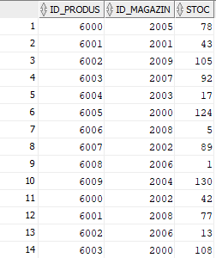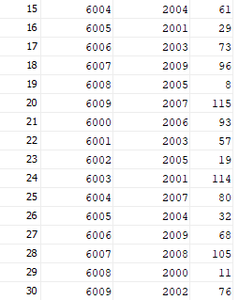

**EXERCITIUL 6**

**Scrieti un subprogram stocat independent care primeste ca parametru un nume de oras si care:**

* **Foloseste un tablou indexat pentru a afisa numele, prenumele si starea comenzilor clientilor.**
* **Foloseste un tablou imbricat pentru a afisa numele primilor 10 angajati in functie de salariu.**
* **Foloseste un vector pentru a afisa toate orasele in care exista magazine.**
* **Afiseaza un mesaj care sa ne informeze daca in orasul transmis ca parametru exista sau nu un magazin.**

create or replace procedure ex6_subprogram_stocat_independent

(v_nume_oras locatii.oras%type default 'Buzau')

is

type cl_com_rec is record (

Nume CLIENTI.NUME%TYPE,

Prenume CLIENTI.PRENUME%TYPE,

Status_comanda COMENZI.STATUS_COMANDA%TYPE

);

-- tablou indexat

type tablou_indexat is table of cl_com_rec

index by pls_integer;

t_indexat tablou_indexat;

-- tablou imbricat

type tablou_imbricat is table of angajati%rowtype;

t_imbricat tablou_imbricat := tablou_imbricat();

-- vector

type vector is varray(20) of locatii.oras%type;

t_vector vector := vector();

v_oras locatii.oras%type;

begin

-- tablou indexat

for i in (

select nume, prenume, status_comanda

from clienti cl, comenzi com

where cl.id_client = com.id_client

) loop

t_indexat(t_indexat.count + 1).Nume := i.Nume;

t_indexat(t_indexat.count).Prenume := i.Prenume;

t_indexat(t_indexat.count).Status_comanda := i.Status_comanda;

end loop;

for i in t_indexat.first..t_indexat.last loop

dbms_output.put_line(t_indexat(i).nume || ' ' || t_indexat(i).prenume

|| ' ' || t_indexat(i).status_comanda);

end loop;

dbms_output.new_line;

-- tablou imbricat

for i in (

select *

from (

select *

from angajati

order by salariu desc

) Top10Salarii

where rownum <= 10

) loop

t_imbricat.extend;

t_imbricat(t_imbricat.count) := i;

end loop;

for i in t_imbricat.first..t_imbricat.last loop

dbms_output.put_line(t_imbricat(i).nume || ' ' || t_imbricat(i).salariu);

end loop;

dbms_output.new_line;

-- vector

for i in (

select oras

from locatii l, magazine m

where l.id_locatie = m.id_locatie

order by oras

) loop

t_vector.extend;

t_vector(t_vector.count) := i.oras;

end loop;

for i in t_vector.first..t_vector.last loop

dbms_output.put_line(i || ' ' || t_vector(i));

end loop;

select oras into v_oras

from locatii

where upper(oras) = upper(v_nume_oras);

dbms_output.put_line('In ' || v_nume_oras || ' exista un magazin');

exception

when no_data_found then

dbms_output.put_line('Nu exista magazine in ' || v_nume_oras);

WHEN TOO_MANY_ROWS THEN

dbms_output.put_line('Exista mai multe magazine in ' || v_nume_oras);

WHEN OTHERS THEN

dbms_output.put_line('Alta eroare');

end ex6_subprogram_stocat_independent;

/

begin

ex6_subprogram_stocat_independent;

end;

/

begin

ex6_subprogram_stocat_independent(‘Craiova’);

end;

/

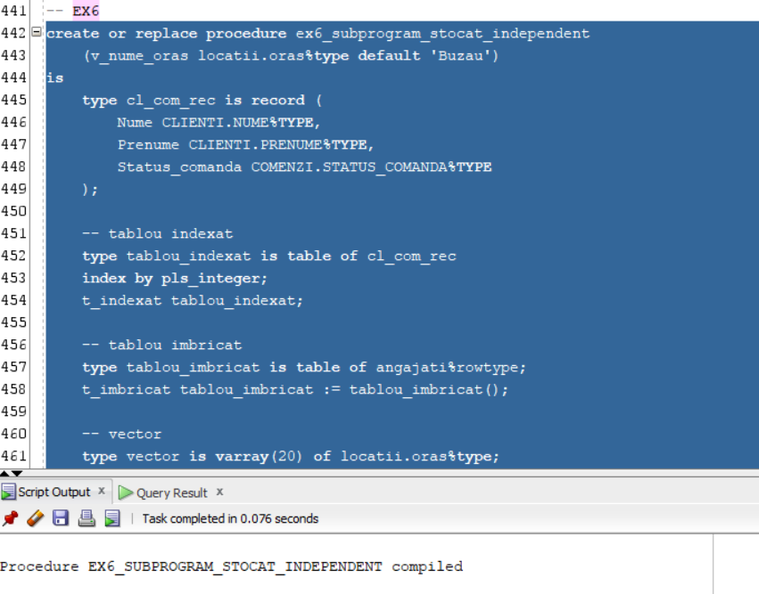

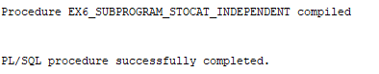

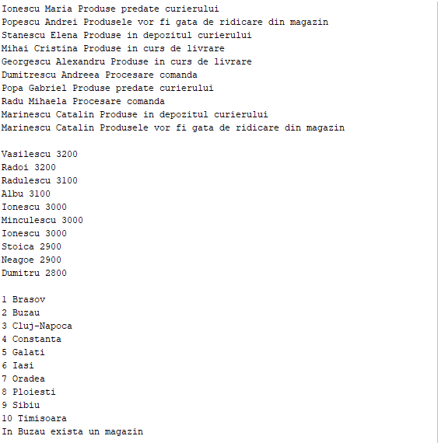

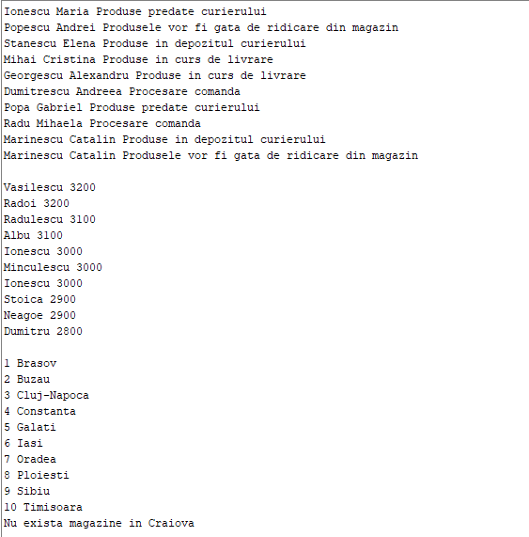

**EXERCITIUL 7**

**Sa se afiseze numele magazinelor si angajatii care lucreaza acolo. Folositi doua tipuri diferite de cursoare: unul dintre acestea sa fie parametrizat, dependent de celalalt cursor.**

create or replace procedure ex7_subprogram_stocat_independent is

cursor m is select id_magazin, nume

from magazine;

cursor a (param magazine.id_magazin%type) is

select nume, prenume, cnp

from angajati

where id_magazin = param;

v_id_magazin magazine.id_magazin%type;

v_nume_magazin magazine.nume%type;

begin

open m;

loop

fetch m into v_id_magazin, v_nume_magazin;

exit when m%notfound;

dbms_output.put_line('-----------------------------------------------');

dbms_output.put_line('Magazinul ' || v_nume_magazin);

dbms_output.put_line('-----------------------------------------------');

for i in a(v_id_magazin) loop

dbms_output.put_line(i.nume || ' ' || i.prenume);

end loop;

end loop;

end ex7_subprogram_stocat_independent;

/

begin

ex7_subprogram_stocat_independent;

end;

/

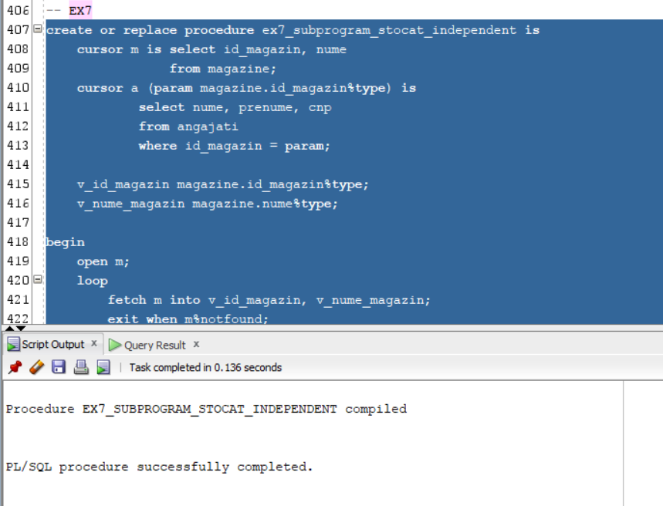

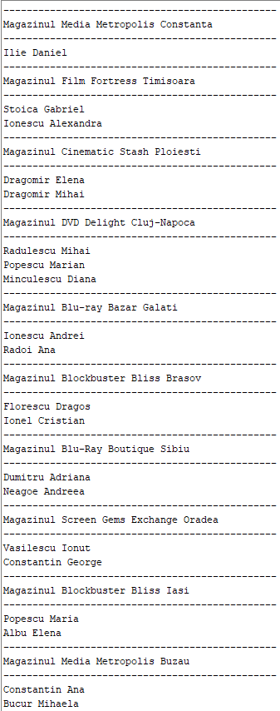

**EXERCITIUL 8**

**Scrieti un subprogram stocat independent care primeste ca parametru un ID de magazin si care returneaza un mesaj ce contine numele si prenumele managerului magazinului si orasul in care se afla acesta, daca se afla in Muntenia. Sa se trateze toate exceptiile in mod corespunzator.**

create or replace function ex8_functie

(v_id_magazin magazine.id_magazin%type default 6000)

return varchar2 is

v_nume_manager angajati.nume%type;

v_prenume_manager angajati.prenume%type;

v_oras locatii.oras%type;

fara_manager exception;

in_afara_munteniei exception;

fara_manager_in_afara_munteniei exception;

rezultat varchar2(1024);

begin

begin

select a.nume, a.prenume, oras into v_nume_manager, v_prenume_manager, v_oras

from angajati a, locatii l, magazine m

where a.id_angajat (+) = m.id_manager

and m.id_locatie = l.id_locatie

and m.id_magazin = v_id_magazin;

if v_nume_manager is null and v_prenume_manager is null

then if upper(v_oras) not in ('ARGES', 'BRAILA', 'BUZAU', 'CALARASI', 'DAMBOVITA',

'GIURGIU', 'IALOMITA', 'ILFOV', 'PRAHOVA', 'TELEORMAN')

then raise fara_manager_in_afara_munteniei;

end if;

end if;

if v_nume_manager is null and v_prenume_manager is null

then raise fara_manager;

end if;

if upper(v_oras) not in ('ARGES', 'BRAILA', 'BUZAU', 'CALARASI', 'DAMBOVITA',

'GIURGIU', 'IALOMITA', 'ILFOV', 'PRAHOVA', 'TELEORMAN')

then raise in_afara_munteniei;

end if;

rezultat := 'Magazinul cu ID ' || v_id_magazin || ' are ca manager pe ' ||

v_nume_manager || ' ' || v_prenume_manager || ' ' || ' si se afla in ' ||

'orasul ' || v_oras;

exception

when no_data_found

then dbms_output.put_line('Magazinul cu ID ' || v_id_magazin ||

' nu exista');

when fara_manager

then dbms_output.put_line('Magazinul cu ID ' || v_id_magazin ||

' nu are manager');

when in_afara_munteniei

then dbms_output.put_line('Magazinul cu ID ' || v_id_magazin ||

' nu se afla in Muntenia');

when fara_manager_in_afara_munteniei

then dbms_output.put_line('Magazinul cu ID ' || v_id_magazin ||

' nu are manager si nu se afla in Muntenia');

end;

return rezultat;

end ex8_functie;

/

begin

dbms_output.put_line(ex8_functie(2009));

end;

/

begin

dbms_output.put_line(ex8_functie(2077));

end;

/

begin

dbms_output.put_line(ex8_functie(2002));

end;

/

begin

dbms_output.put_line(ex8_functie(2007));

end;

/

begin

dbms_output.put_line(ex8_functie(2006));

end;

/

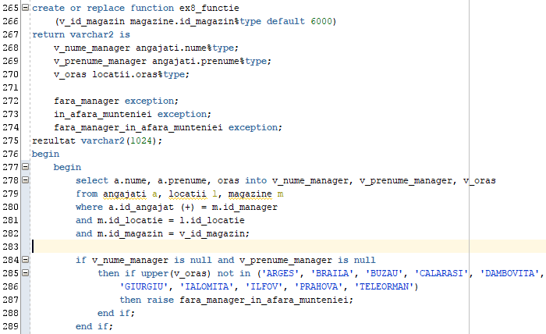

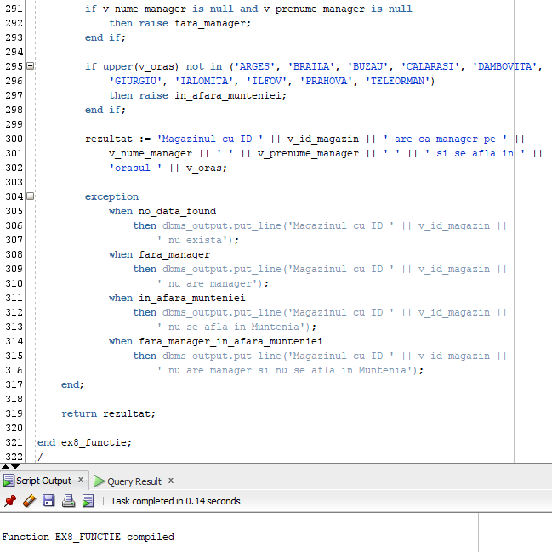

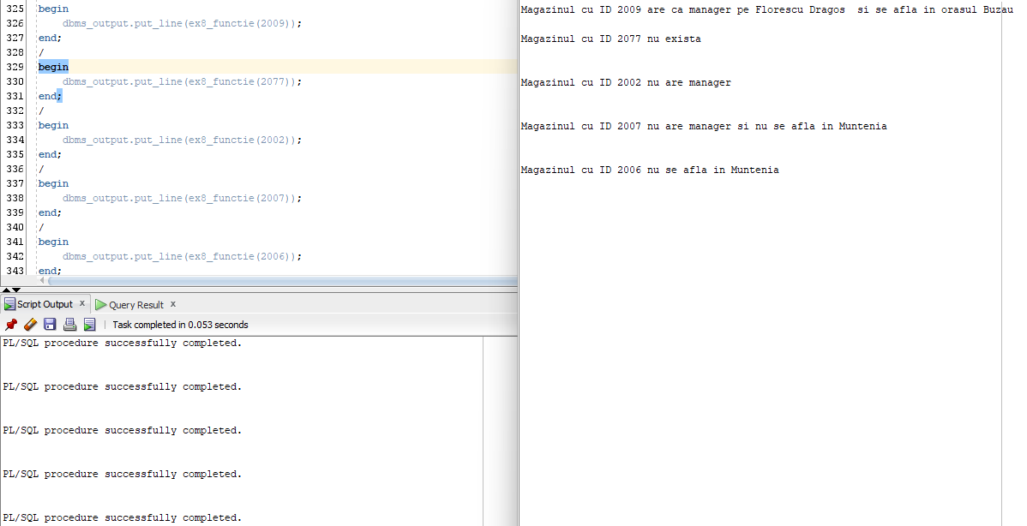

**EXERCITIUL 9**

**Scrieti un subprogram stocat independent de tip procedura care primeste ca parametru un nume de magazin si care:**

* **Afiseaza orasul in care se afla magazinul.**
* **Afiseaza produsele care se gasesc in magazine (ID, stoc, nume).**
* **Afiseaza un client care a cumparat produse din acel magazin**

create or replace procedure ex9_procedura

(v_nume_magazin magazine.nume%type default 'Nume magazin')

is

v_id_locatie magazine.id_locatie%type;

v_oras locatii.oras%type;

type rec_tablou_produse is record (

nume_client clienti.nume%type,

prenume_client clienti.prenume%type,

id_produs produs_magazin.id_produs%type,

nume_produs produse.nume_produs%type,

stoc produs_magazin.stoc%type

);

type tablou_produse is table of rec_tablou_produse;

t_produse tablou_produse := tablou_produse();

magazinul_nu_are_produse exception;

begin

begin

select m.id_locatie, oras into v_id_locatie, v_oras

from magazine m, locatii l

where upper(v_nume_magazin) = upper(m.nume)

and m.id_locatie = l.id_locatie;

exception

when no_data_found

then raise_application_error(-20000, 'Nu exista niciun magazin cu numele '

|| v_nume_magazin);

when too_many_rows

then raise_application_error(-20001, 'Exista mai multe magazine cu numele '

|| v_nume_magazin);

end;

begin

select cl.nume, cl.prenume, pm.id_produs, p.nume_produs, pm.stoc

bulk collect into t_produse

from produs_magazin pm, produse p, magazine m, comenzi com, clienti cl

where p.id_produs = pm.id_produs

and pm.id_magazin = m.id_magazin

and m.id_magazin = com.id_magazin

and com.id_client = cl.id_client

and m.nume = v_nume_magazin

and m.id_locatie = v_id_locatie;

if t_produse.count = 0

then raise magazinul_nu_are_produse;

end if;

dbms_output.put_line('In magazinul ' || v_nume_magazin || ' din '

|| v_oras || ' gasim urmatoarele produse: ');

for i in t_produse.first..t_produse.last loop

dbms_output.put_line('(ID: ' || t_produse(i).id_produs || ') ' ||

t_produse(i).stoc || ' x ' || t_produse(i).nume_produs);

end loop;

dbms_output.put_line(t_produse(1).nume_client || ' ' ||

t_produse(1).prenume_client || ' a comandat de la acest magazin');

exception

when magazinul_nu_are_produse

then dbms_output.put_line('Magazinul ' || v_nume_magazin

|| ' nu are niciun produs');

end;

end ex9_procedura;

/

begin

ex9_procedura;

end;

/

begin

ex9_procedura('DVD Delight Cluj-Napoca');

end;

/

begin

ex9_procedura('Just Watch Oradea');

end;

/

begin

ex9_procedura('Popcorn Time Oradea');

end;

/

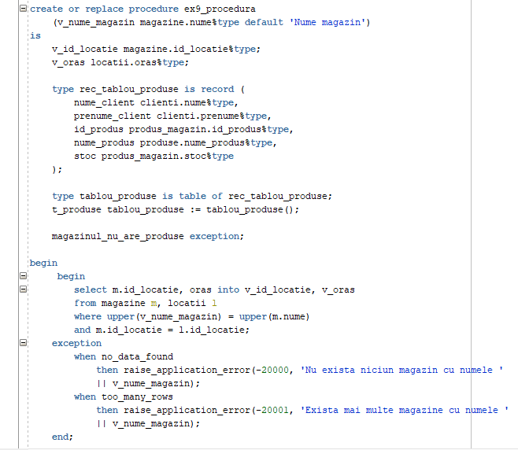

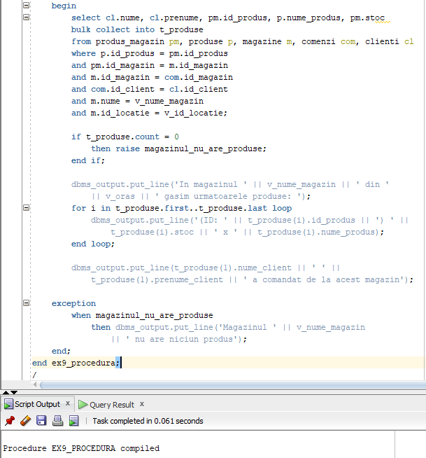

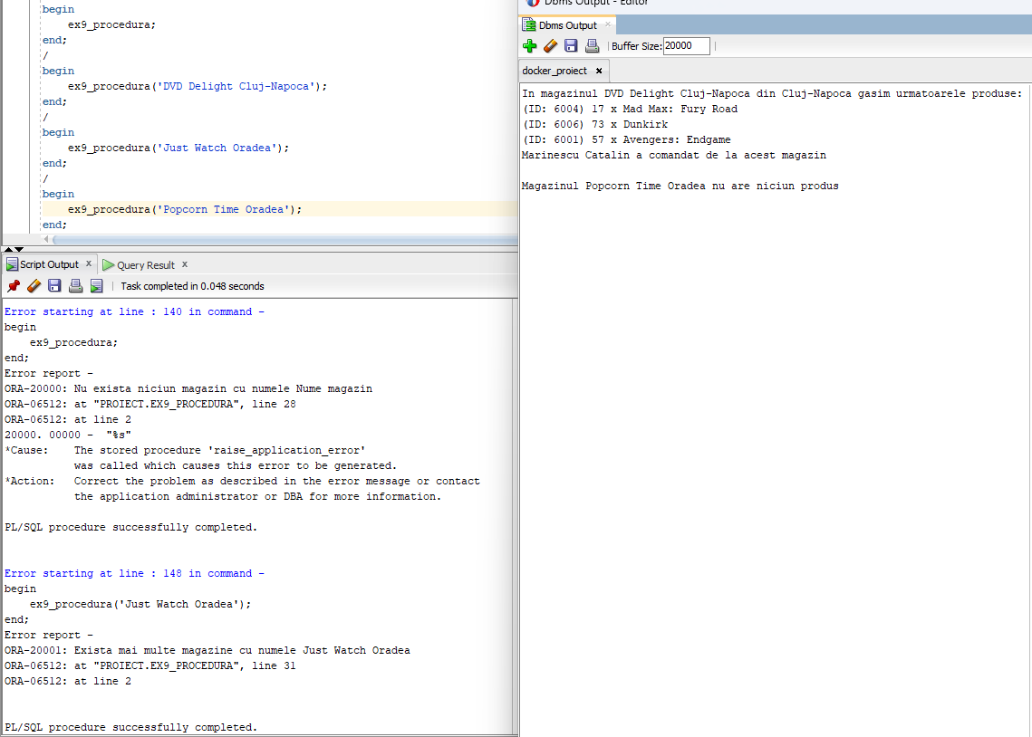

**EXERCITIUL 10**

**Scrieti un trigger la nivel de comanda care sa nu permita adaugarea unui nou angajat in week-end.**

create or replace trigger ex10_trigger

before insert on angajati

begin

if (to_char(sysdate, 'D') = 7)

or (to_char(sysdate, 'D') = 1)

then raise_application_error(-20005, 'Nu se pot adauga angajati in week-end');

end if;

end;

/

insert into Angajati (ID_Angajat, ID_Magazin, Nume, Prenume, CNP, Data_Angajare, Salariu)

values (Angajat_id.nextval, 2007, 'Nedelcu', 'Alexandru', 1854071523456, TO_DATE(sysdate, 'YYYY-MM-DD'), 3950);

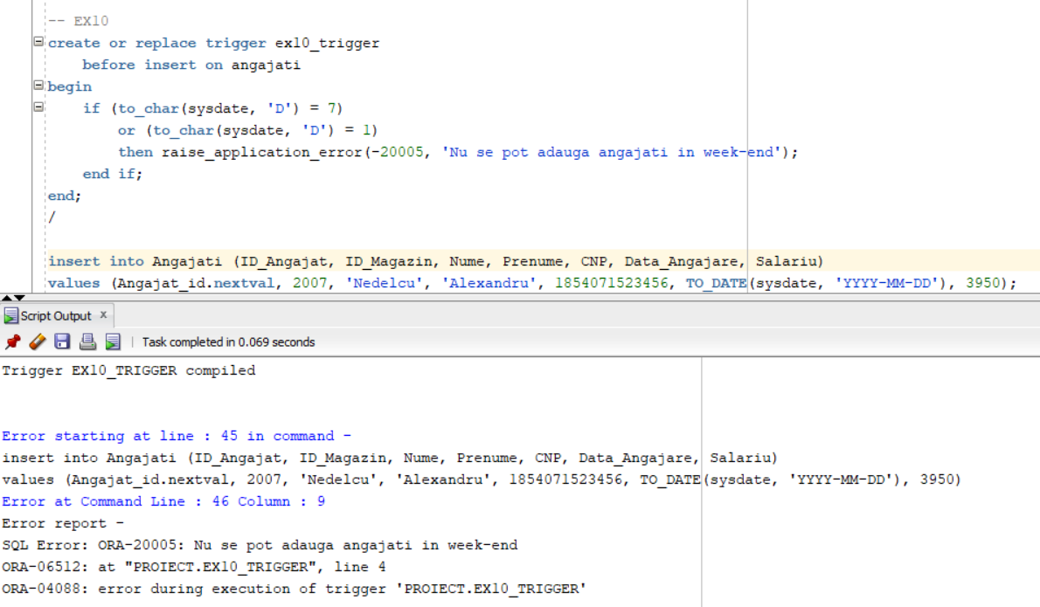

**EXERCITIUL 11**

**Scrieti un trigger la nivel de linie care sa nu permita marirea pretului unui produs in zilele de duminica.**

create or replace trigger ex11_trigger

before update of pret on produse

for each row

begin

if (:new.pret > :old.pret) and (to_char(sysdate, 'D') = 1)

then raise_application_error(-20005, 'Pretul nu poate fi marit in zilele'

|| ' de duminica');

end if;

end;

/

update produse

set pret = pret + 10

where id_produs = 6005;

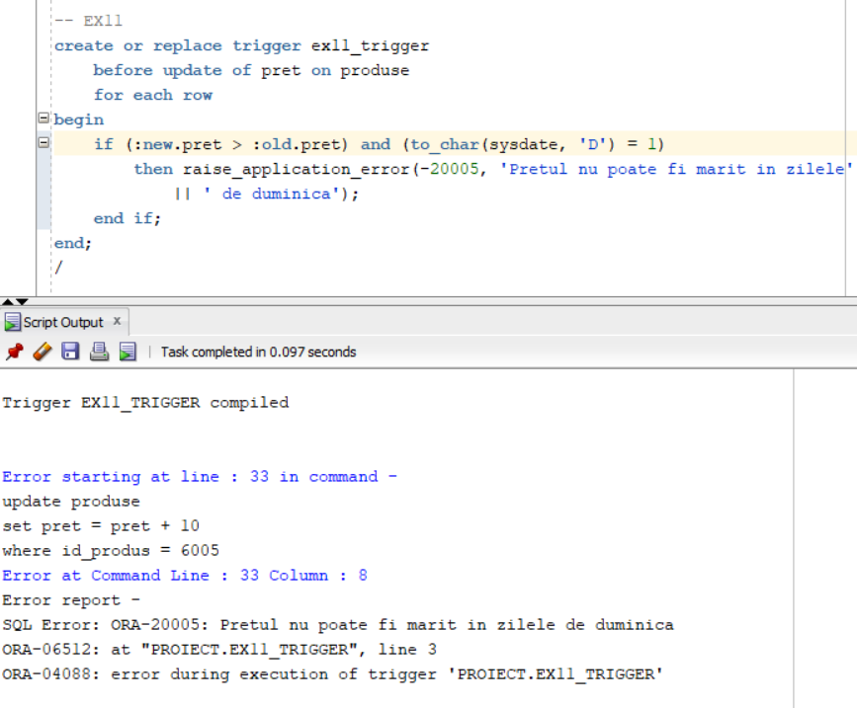

**EXERCITIUL 12**

**Scrieti un trigger care sa introduca date (numele utilizatorului, numele bazei de date, evenimentul sistem, numele obiectului, data si ora producerii evenimentului) intr-un tabel info_actiuni**

create table info_actiuni

(utilizator varchar2(30),

nume_bd varchar2(50),

eveniment varchar2(20),

nume_obiect varchar2(30),

ora timestamp

);

create or replace trigger ex12_trigger

after create or drop or alter on schema

begin

insert into info_actiuni

values (sys.login_user, sys.database_name, sys.sysevent, sys.dictionary_obj_name, current_timestamp);

end;

/

create table exemplu (

id number,

name varchar2(50)

);

drop table exemplu;

SELECT * FROM info_actiuni;

drop table audit_mra;

