Oracle Academy SQL and Java Courses

url: <http://ilearning.oracle.com/ilearn/en/learner/jsp/login.jsp?site=OracleAcad>

if you are asked to enter site: site= OracleAcad

For CMSC 201 course:

[Java Foundations - Student - English](http://ilearning.oracle.com/ilearn/en/learner/jsp/offering_details_home.jsp?classid=2035474609)

[Java Fundamentals - Student - English](http://ilearning.oracle.com/ilearn/en/learner/jsp/offering_details_home.jsp?classid=2031716777)

To Login:

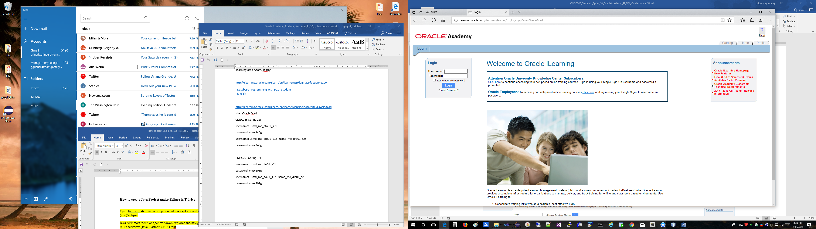

If course is not getting loaded, you need to download Flash player: <https://get.adobe.com/flashplayer/>

