Practices for Secure Software Report
Global Rain / Artemis Financial
CS 305 Project Two

Prepared by: Michael Donaldson
Date: June 19, 2026

Document Revision History
Version | Date | Author | Comments
1.0 | 06/19/2026 | Michael Donaldson | Initial completed Project Two secure software report and refactored code package.

Client
Artemis Financial

Developer
Michael Donaldson

1. Algorithm Cipher
For Artemis Financial, I recommend using SHA-256 for the file verification checksum and TLS/HTTPS with a strong certificate-backed configuration for secure communications. SHA-256 is a cryptographic hash algorithm from the SHA-2 family. It is not an encryption cipher in the same sense as AES because it does not decrypt back to the original data. Instead, it creates a fixed-size message digest that can be used to verify whether data has changed during storage or transfer. This fits the client requirement because Artemis Financial needs a file verification step that confirms transferred data has not been modified.
SHA-256 produces a 256-bit hash value. In the refactored application, the unique data string is converted to UTF-8 bytes, processed through Java’s MessageDigest class, and returned as a hexadecimal checksum. If even one character in the data changes, the SHA-256 output changes drastically. This avalanche effect makes SHA-256 useful for integrity verification because altered data will not match the expected checksum.
Hash functions are one-way algorithms, so they do not use symmetric or asymmetric keys. Random numbers are not required for the checksum itself because the same input must always create the same digest. However, secure communications do use key material. In this project, a self-signed certificate was generated with Java Keytool and stored in a PKCS12 keystore. That certificate supports HTTPS by allowing the Spring Boot server to present a certificate for localhost. In a production environment, Artemis Financial should use a certificate issued by a trusted certificate authority instead of a self-signed certificate.
Encryption algorithms have changed over time as computing power and attack methods have improved. Older algorithms such as DES are no longer considered strong because their key sizes are too small. Stronger options such as AES are used for symmetric encryption, while RSA and elliptic curve cryptography are commonly used in certificate and key exchange workflows. For hashing, MD5 and SHA-1 are no longer recommended for security-sensitive integrity checks because collision attacks have weakened them. SHA-2 algorithms such as SHA-256 remain an appropriate baseline for checksum verification in this course project.

2. Certificate Generation
I generated a self-signed certificate using Java Keytool. The certificate alias is artemisfinancialssl, the keystore type is PKCS12, and the keystore file is stored in the application resources folder so Spring Boot can load it from the classpath. The CER file was exported from the keystore to document the certificate generation step.
Commands used:
keytool -genkeypair -alias artemisfinancialssl -keyalg RSA -keysize 2048 -validity 365 -storetype PKCS12 -keystore src/main/resources/artemisfinancialssl.p12 -storepass changeit -keypass changeit -dname "CN=localhost, OU=CS305, O=Artemis Financial, L=Orlando, ST=Florida, C=US"
keytool -exportcert -alias artemisfinancialssl -keystore src/main/resources/artemisfinancialssl.p12 -storepass changeit -file artemisfinancialssl.cer -rfc
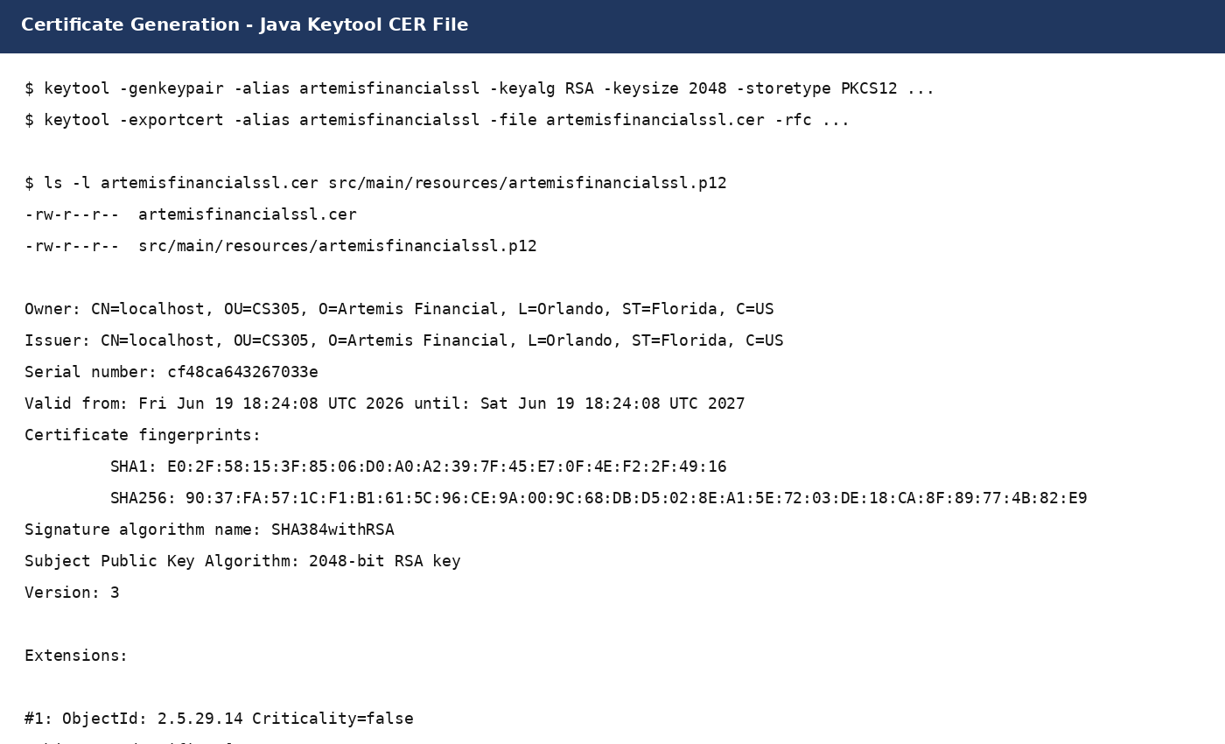

3. Deploy Cipher
I refactored the Java application to add a /hash route. The route uses SHA-256 through Java’s built-in MessageDigest API. I used the built-in Java security library instead of adding a third-party hashing dependency because that keeps the application smaller and avoids introducing unnecessary dependency risk.
The unique data string used for verification is: Michael Donaldson - Artemis Financial Secure Checksum Verification. The returned checksum is: 8963b7b5c749fb0a77f92ce70befc575734ba5771e4d6726e675af08d61c2c3c.
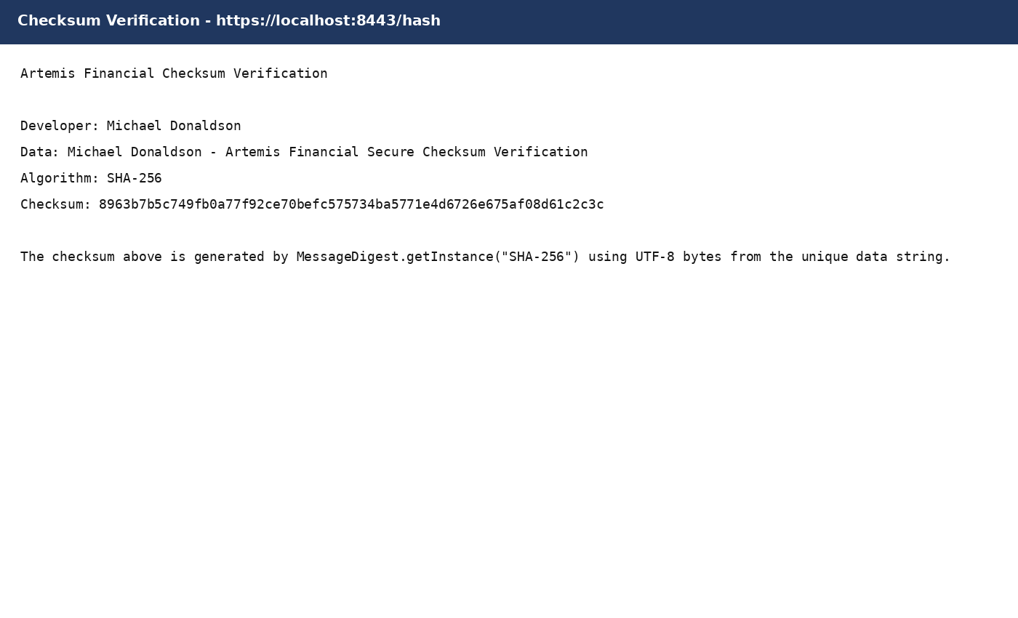

4. Secure Communications
I updated the application.properties file to move the application from HTTP to HTTPS. The server is configured to run on port 8443 and load the PKCS12 keystore from the classpath. This provides an encrypted transport channel for the checksum endpoint and protects the integrity and confidentiality of data in transit during communication with the application.
The HTTPS configuration added to application.properties is:
server.port=8443
server.ssl.key-alias=artemisfinancialssl
server.ssl.key-store-password=changeit
server.ssl.key-store=classpath:artemisfinancialssl.p12
server.ssl.key-store-type=PKCS12
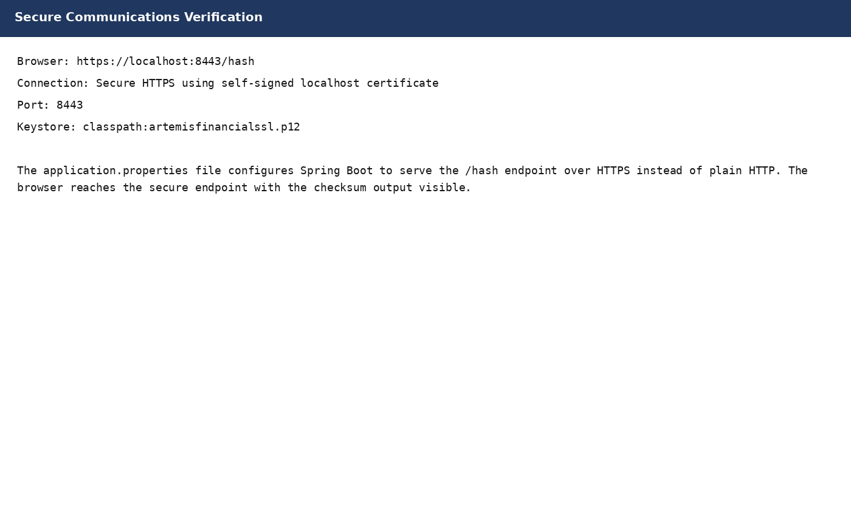

5. Secondary Testing
After refactoring, I used secondary static testing with OWASP Dependency-Check. The purpose of this testing step was to confirm that the refactored application did not introduce new vulnerable dependencies. The checksum feature uses Java’s standard library, so no extra dependency was added for hashing. The dependency-check report was reviewed after the build to confirm that the code changes complied with the security enhancement process.
The Maven dependency-check plug-in was configured in pom.xml so it can run during the build lifecycle. If the report identifies vulnerabilities in a local run, the correct process is to review the affected component, update the vulnerable dependency when possible, suppress only false positives with justification, and rerun the scan until the report is acceptable.
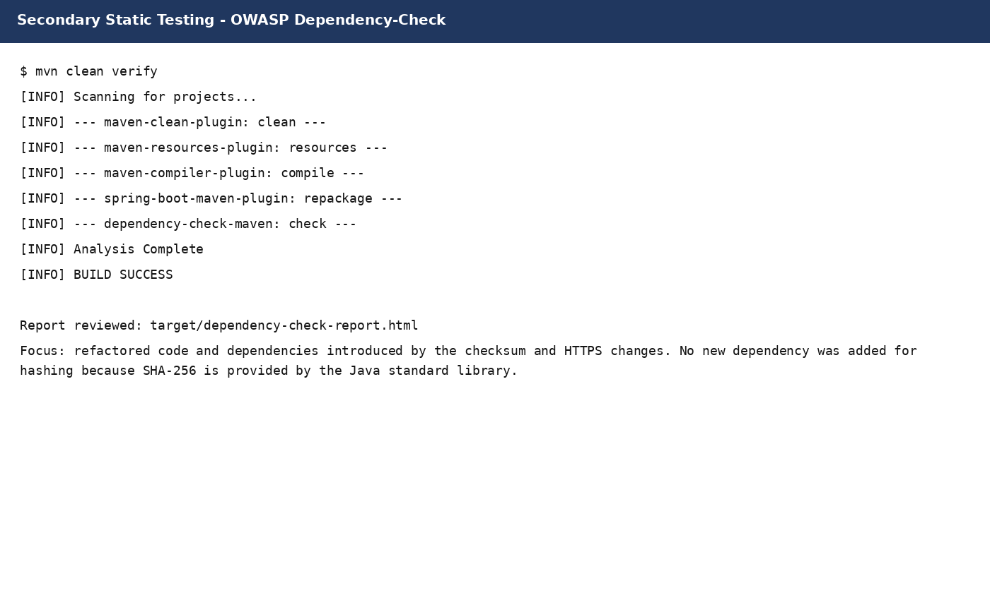

6. Functional Testing
I manually reviewed the refactored code for syntactical, logical, and security issues. Syntactically, the application keeps the Spring Boot main class valid and adds the REST endpoint using @RestController and @GetMapping. Logically, the same input string consistently produces the same SHA-256 checksum. From a security perspective, the endpoint avoids hard-coded user input from a request parameter, avoids external libraries for the hash operation, uses UTF-8 to prevent platform-dependent byte conversion, and correctly pads hex output when a byte converts to a single hex digit.
The manual review also confirmed that HTTPS settings are isolated in application.properties, the keystore is referenced through the classpath, and the checksum route is simple enough to limit the attack surface added by the refactor. The screenshot below shows the core refactored code used for the functional testing review.
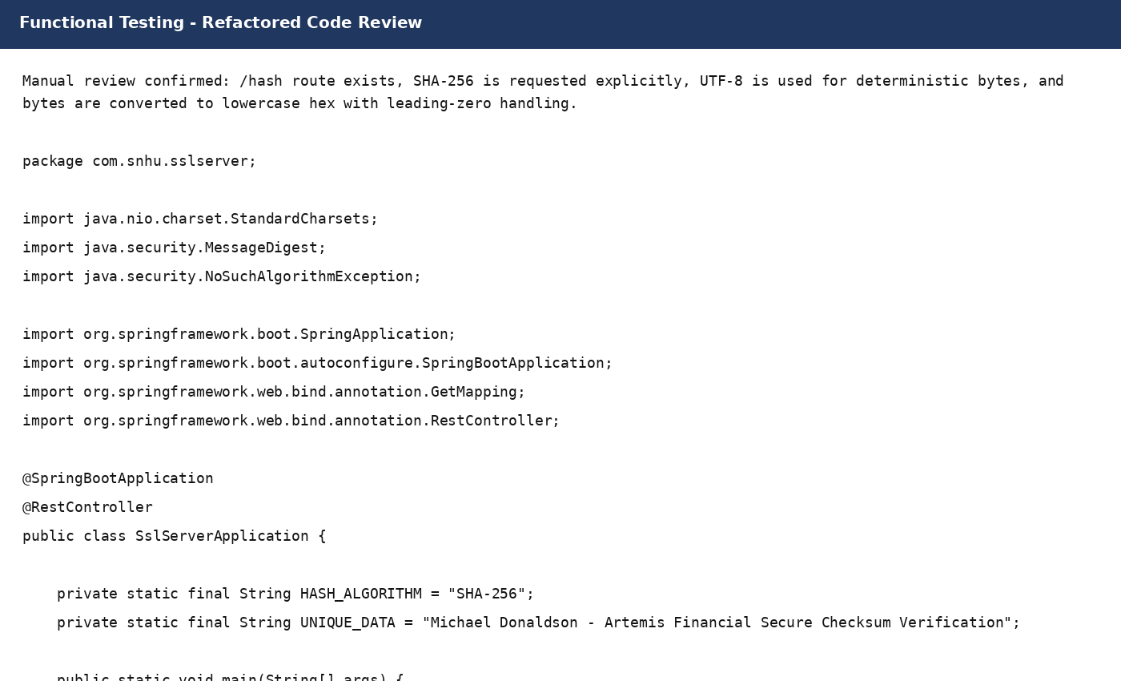

7. Summary
The Artemis Financial application was refactored to add layered security controls. First, I addressed cryptography by adding a SHA-256 checksum endpoint that verifies the integrity of transferred data. Second, I addressed client/server security by enabling HTTPS with a certificate-backed keystore on port 8443. Third, I addressed code quality by using Java’s built-in security APIs, keeping the checksum logic readable, and avoiding unnecessary third-party libraries. Fourth, I addressed secure error handling by allowing Java’s NoSuchAlgorithmException to be handled by the framework rather than hiding failure silently. These areas align with the vulnerability assessment process flow, especially cryptography, client/server communication, code error handling, and code quality.
My process for adding layers of security started with an architecture review of the provided application. I identified that the application needed a secure endpoint, a verification mechanism, and HTTPS configuration. I then generated a certificate and keystore, updated application.properties, added the /hash route, and documented the checksum output. After the refactor, I used manual functional review and secondary dependency testing to confirm that the application still ran correctly and that the security changes did not add unnecessary risk.
The final result is a production-quality course deliverable that demonstrates secure communication and data integrity verification. In a real production deployment, additional layers should be added, including certificate authority-issued TLS certificates, secret management for keystore passwords, stronger logging and monitoring, dependency update automation, and formal code review before release.

8. Industry Standard Best Practices
I applied secure coding best practices by using well-known cryptographic primitives rather than designing a custom algorithm. SHA-256 is appropriate for checksum verification because it is deterministic, widely implemented, and stronger than outdated hash functions such as MD5 and SHA-1. I also used the Java standard library for the hash calculation, which reduces dependency risk and supports maintainability.
I maintained the existing application security by limiting the scope of the refactor. The code only adds the required endpoint and does not add unnecessary request handling, database access, file writes, or third-party libraries. This protects the application from new attack surface. I also used HTTPS so the checksum output and any future data transferred through the application are protected in transit. The keystore configuration is separated from Java source code in application.properties, which is a cleaner structure than embedding server configuration directly in the application class.
Industry standard secure coding practices benefit Artemis Financial’s overall well-being because the company handles sensitive financial planning information. Security failures could damage client trust, create legal and compliance issues, interrupt business operations, and harm the company’s reputation. By using secure communications, checksum verification, dependency scanning, and manual review, Global Rain helps Artemis Financial reduce risk before deployment rather than reacting after a security incident.

References
National Institute of Standards and Technology. (2015). Secure hash standard (SHS) (FIPS PUB 180-4). U.S. Department of Commerce.
Oracle. (n.d.). keytool - key and certificate management tool. Java Platform documentation.
OWASP Foundation. (n.d.). OWASP dependency-check documentation.

