Algonquin College Logo

# SCHOOL OF ADVANCED TECHNOLOGY

### ICT - Applications & Programming

### Computer Engineering Technology – Computing Science



A11

Game Interface

Team:

Zhongyuan Sun - Id: 041030584

Game Proposal - NumPuz

***This template is suggested (not mandatory) to answer A11 Specification.***

|  |  |
| --- | --- |
| **Part**  **1** | **GUI Definition** |

**EXPLANATION**

*The purpose of this assignment is to define the elements of the GUI application to be used in your game implementation.*

* ***Example****:*

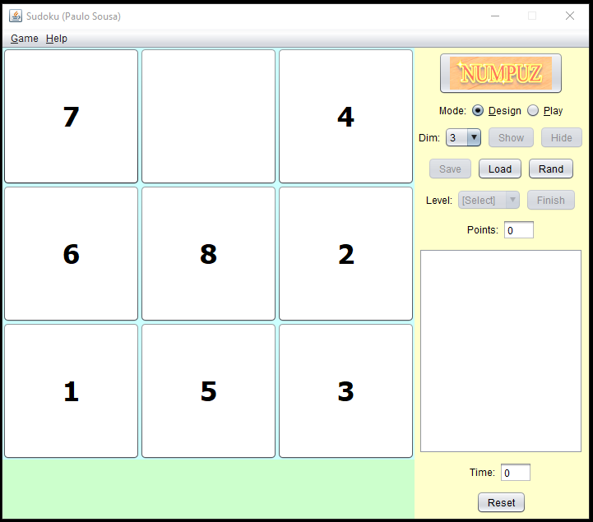

* ***Note****: The professor interface is also a proposal. It means that your own implementation can be different. What does matter is that the game functionality will be respected.*
  1. **Defining the Components**

**List of components**

The game is using Swing

javax.swing.JButton;

javax.swing.JFrame;

javax.swing.JLabel;

javax.swing.JMenu;

javax.swing.JMenuBar;

javax.swing.JMenuItem;

javax.swing.JPanel;

javax.swing.JDialog;

**Functionalities and Behaviors**

*What are the behaviors and functionalities that you will provide? How these elements are related with functionalities.*

* User can set the size of the game. the default size is 3x3
* Click “START” to start the game
* Click “RESET” to start a new game from beginning
* Click the number to slide the number to the empty space
* If the user wins, start a new game automatically

**Details**

*Drawn your interface (ex: in an image from Paint / Powerpoint slide, or any sketch tool), describing:*

* *Dim selection: JComboBox*
* *Buttons: Jbutton*
* *Menubar: JMenuBar*
  1. **User Manual**

**Basic cycle**

*Create a brief description about how your game can be used.*

***Example****: If you have to design the solution to be saved and played later, how are the stems. Most importantly, how someone can play the* ***NumPuz****.*

Click the number around the empty space to slide the number to the empty space.

**FINAL SUGGESTIONS**

*Here some ideas to think about your language....*

* *Try to create a game whose execution can be very intuitive (easy to be played).*
* *Remember that this game will be in fact implemented only in the next assignment.*

**References**

*[Include eventual references used here]*

Algonquin College

Fall, 2022