Report of the Week of February 17th

As I explained last week, the first step in making an actual simulation of the low to high-resolution multiple traveling salesman problem is to find the distances between sets of polygons. To do this, I changed the way that we model the greenhouse. The shape of the greenhouse is now fed into the program as a series of points. I decided to first model a greenhouse as a very simple series of rectangles as these have a low number of points and I was actually able to take the layout for an actual greenhouse plan as seen in [1]. On the left you can see my greenhouse model. On the right you can see the floor plan of an actual greenhouse.

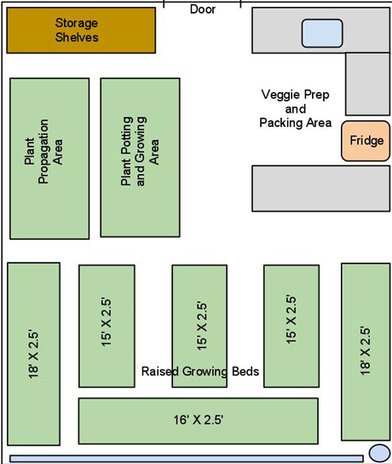

While there does seem to be a way to reasonably efficiently identify polygons in cv2, as seen in [2], I decided to model this manually as I can actually know the exact points that bound the polygons that the drones will travel between. In addition, this is a relatively simple model of a greenhouse for which the solution to the multiple traveling salesman problem is not immediately obvious. We also have a scale for how large the rectangles in the image actually are, so we can plan drone flight speeds for the simulation accordingly. I am trying to use this model to implement the algorithm described in [3] to move forward. This way, we will have a complete analogy of the multiple traveling salesman problem to an image consisting of polygons, and we can use heuristic algorithms that have already been developed for the multiple traveling salesman problem as a starting point in developing our own algorithm.

[1] New Year Plans and Projects (January 5, 2012). Lost Valley Gardens. https://lostvalleygardens.com/LVGblog/2012/01/05/new-year-plans-and-projects/

[2] Shahid, Khan. (December 5, 2022). How to detect polygons in image using OpenCV Python. https://www.tutorialspoint.com/how-to-detect-polygons-in-image-using-opencv-python

[3] Eldesbrunner, H. (December 20, 1983). Computing the Extreme Distances Between Two Convex Polygons. Technical University of Graz, http://acm.math.spbu.ru/~sk1/download/books/geometry/distance_O(log(n+m))_1985-J-02-ComputingExtremeDistances.pdf