South Valley Uni Data Base Project (Michael Emad)

Entities :
- Departments
- Professors
- Admin
- Students
- Courses
- Exams
- Question
- Evaluation

Business Rules & Relations :

- Admin & Departments → A dep can have one admin , admin lead one dep

- Professors & Departments → dep may have many prof , prof may belong to one dep
- students & Departments → students must belong to one dep , dep must have many students
- Course & Departments → course must belong to one dep , dep may have many courses
- Professors & Courses → prof may teach many courses , courses may taught by many prof
- Students & Courses → one student may enrol in many courses , courses may have many students
- Question & Courses → a question must belong to one courses , courses must have many question
- Exam & Courses → an exam must belong to one course , course may have many exams
- Exam & Question → exam must contain many questions, a question can appear in many exam

ERD :

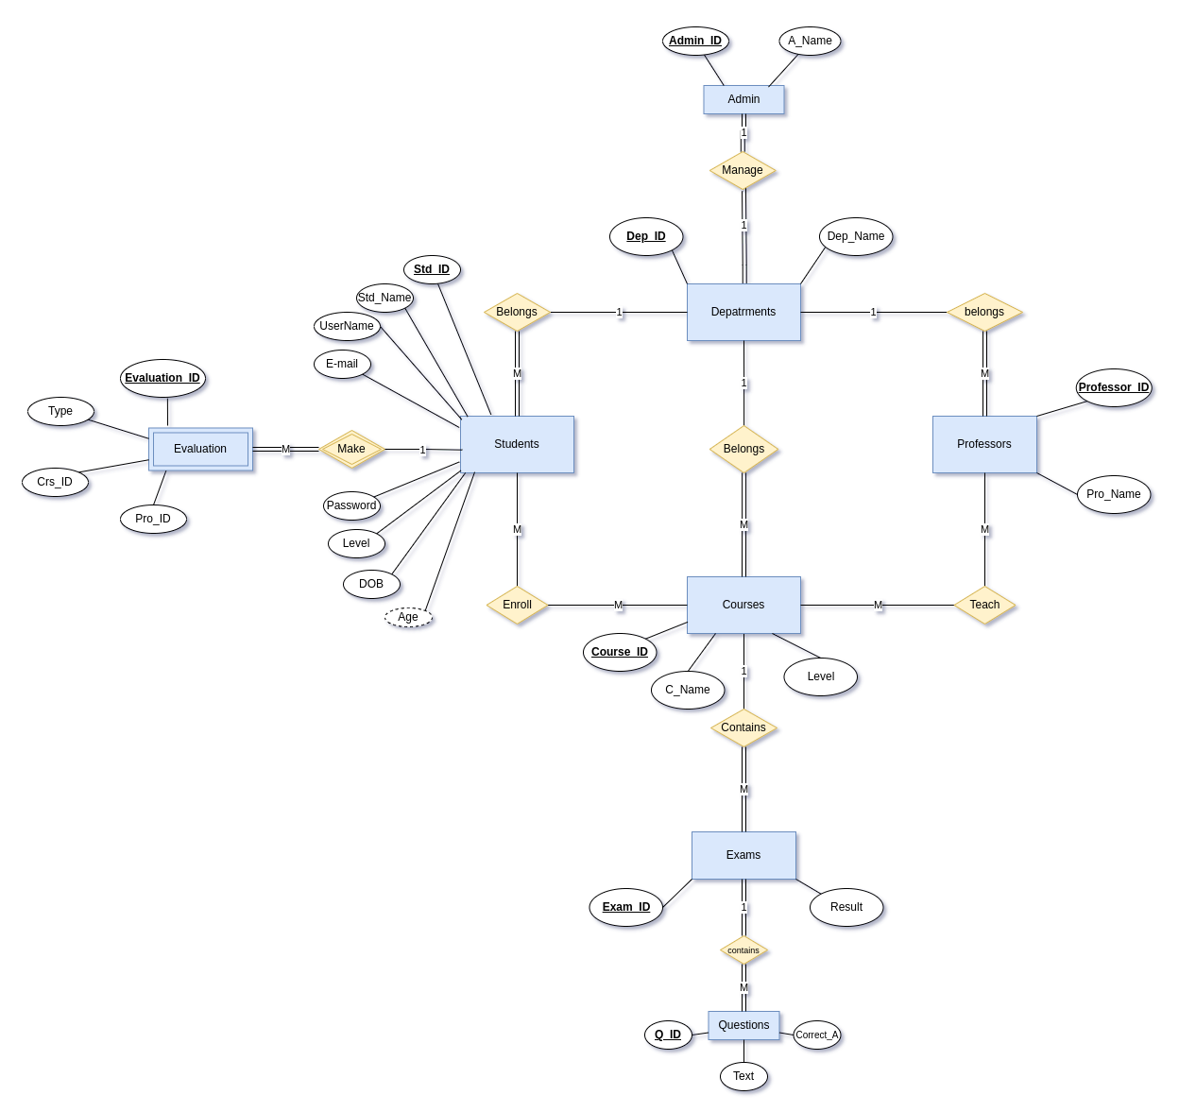

Mapping :

- Admin: [ # admin_ID , admin_name , dep_ID (fk) ]

- Departments: [ # dep_ID , dep_name , admin_ID (fk) ]

- Professors : [ # pro_ID , pro_name , dep_ID (fk) ]

- Students : [ # std_ID , std_name , username , email , password , level , dob , dep_ID (fk) ]

- Course : [ # course_ID , c_name , level , dep_ID (fk) ]

- ProfessorsCourse : [ # pro_course_ID , pro_ID (fk) , course_ID (fk) , academic_year ]

- StudentsCourse : [ # std_course_ID , std_ID (fk) , course_ID (fk) , academic_year ]

- Evaluation : [ # evaluation_ID , std_ID (fk) , type , course_ID , pro_ID , rating , comments ]

- Exam : [ # exam_ID , course_ID (fk) , std_ID , date , pro_ID , results ]

- Questions : [ # question_ID , exam_ID (fk) , text , type , correct_answer ]

Normalization :
- All tables in the third normal form (3NF), since there is no multi valued attributes or repeating group,there is no non-key attributes is partially dependent on the composite primary keys and no fake dependencies exist.

Queries :

- Write a query that enables the students to view their results per course

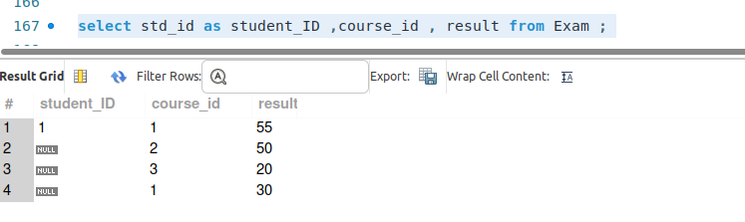

- Write a query that enables the head of department to see evaluation of each course and professor.

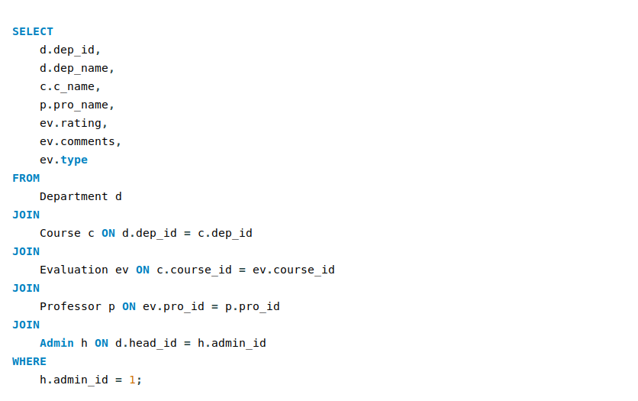

- Write a query that enables you to get top 10 high scores per course .

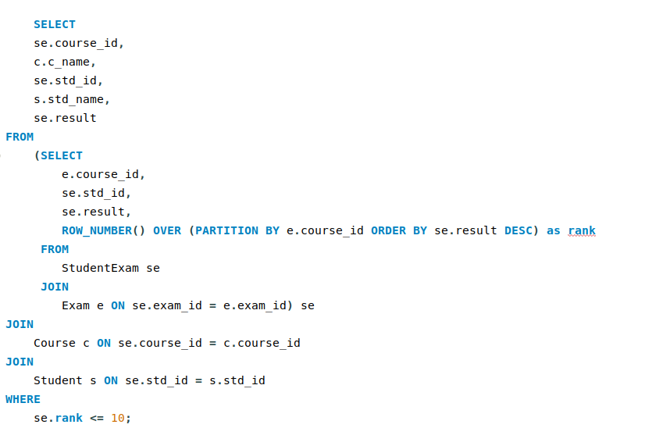

- Write a query to get the highest evaluation professor from the set of professors teaching the
same course .
