CS146-Lab1 Due: Feb-8-2016 Name:

Reading assignments:

Read chapter-1 and Java review Power points.

Answer the following questions in one word document. Then email it to me to [sjsumortezaie@gmail.com](mailto:sjsumortezaie@gmail.com)

The subject of your email must be CS146-Lab1. Please read the Format of the lab.

If you have any questions about the lab please send the question to [answerneededsoon@gmail.com](mailto:answerneededsoon@gmail.com)

1. What are the values of the following?

(a) 2 + 2 + "2"

(b) "" + Countries, where countries is an ArrayList ﬁlled with several strings

(c) "Hello" + new Greeter ("World")

Write a small sample program to ﬁnd out, and then explain your answers.

The following is the Greeter class that you need for part-c.

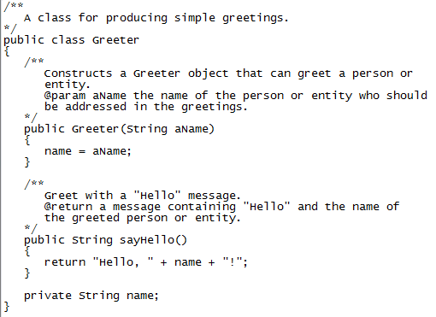

1. Write a simple generic version of method isEqualTo that compares its two arguments with the equals method and returns true if they’re equal and false otherwise. Use this generic method in a program that calls isEqualTo with a variety of built-in types, such as Object or Integer. What result do you get when you attempt to run this program?
2. Write a generic class Pair which has two type parameters—F and S— each representing the type of the first and second element of the pair, respectively. Add get and set methods for the first and second elements of the pair. [Hint: The class header should be public class Pair<F, S>.]