CS146-Lab2 Due: Feb-18-2016 Name:

Reading assignments:

Read chapter-2 and class lecture notes.

Answer the following questions in one word document. Then email it to me to [sjsumortezaie@gmail.com](mailto:sjsumortezaie@gmail.com)

The subject of your email must be CS146Lab2Section#. Please read the Format of the lab.

If you have any questions about the lab please send the question to [answerneededsoon@gmail.com](mailto:answerneededsoon@gmail.com)

1)

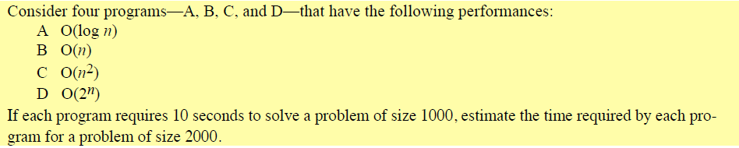

2)



3) 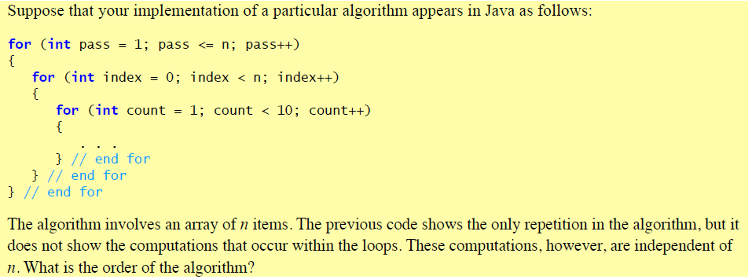

4)

Write Fibonacci algorithm both recursively and iteratively. Run both algorithm for different values of n and compare the running times. Show the complexity of solving this algorithm recursively and discuss if it is a good solution to write the code recursively.

5)

Solve factorial recursively and show its order of complexity and prove it.

6)

