CS146-Lab9 Due: April-27-2016 Name:

Reading assignments:

Read lecture notes and chapter-9

Answer the following questions in one word document. Then email it to me to [sjsumortezaie@gmail.com](mailto:sjsumortezaie@gmail.com)

The subject of your email must be CS146Lab9Section#. Please read the Format of the lab.

1. Write a program to solve the Dijkstra’s algorithm explained in class using adjacency matrix and the tables used.
2. Given the following graph, show the shortest path using Dijkstra’s algorithm. Show the steps that you should follow to get to the final table as we did in class. Also use the program in part-1 and show it gives you the same answer.

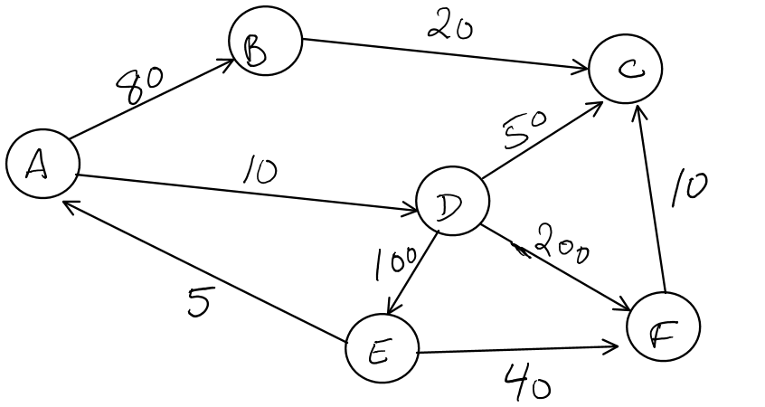

1. Find a minimum spanning tree for the graph in figure 9-84 (page 420) using prim’s algorithm.

What is the total cost of all paths of this minimum spanning tree?