Morse Code

Computer Science 2030

30 April 2019

**Team Members**:

* Andrew Fuller
* Bando Arsene
* Coghan Spery
* Victor Hernandez
* Michael Kessel

**ADT Summary**

The goal of our abstract data type is to encode and decode messages in both Morse code to English and English to Morse code. It takes a file input from the user and reads the elements into to the program where they can be translated into their wanted state. It accomplishes this translation through the use of a Binary Search Tree set up so that the right node is a dash and the left node is a dot from each root.

**Data Items**

Node – A structure that is used in the creation of nodes within a binary search tree. The tree is traversed by having a dot represent the left node and a dash as the right node from the root. The nodes are inserted within the tree with the following diagram before a message is decoded.

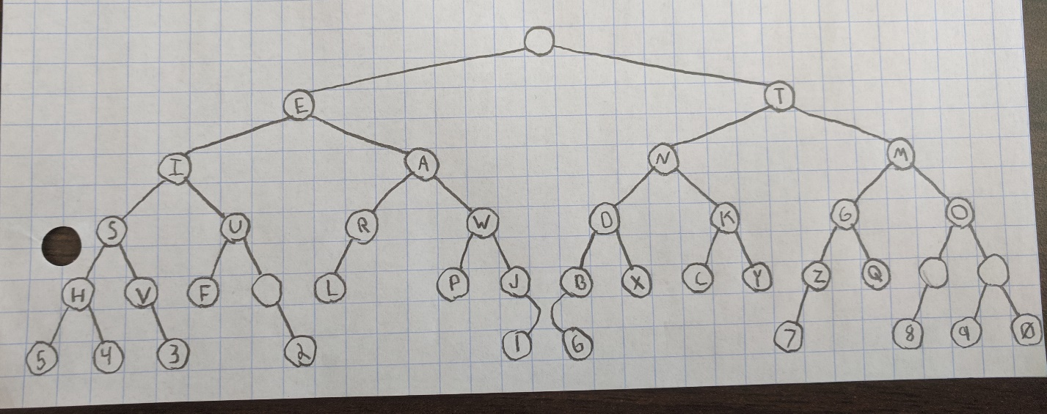

Encode – A function that contains a switch table with character values for the use of turning separate characters into the Morse code counter parts. The function is passed a single parameter of a character value where it traverses the pre-defined cases to find the correct translation to Morse code. All cases are pre-defined for upper- and lower-case letters, numbers, and punctuation marks that are used commonly within English text.

**Operations**

Build_Search (Node head, letter)

* Parameters: The head Node and the character value that is being searched for.
* Use: Searches for a Node with a specific value within the given tree. The Node passed is the node at the head of the tree you are searching, and the letter is a character value that is being looked for. Once the Node is found, the Node is returned.

Add_Dot (Node parent, Node dot)

* Parameters: The parent Node and the child dot Node that is about to be added to the parent Node.
* Use: Function that will add a child Node to a given parent Node as a Node representing a dot within the tree.

Add_Dash (Node parent, Node dash)

* Parameters: The parent Node and the child dash Node that is about to be added to the parent Node.
* Use: Function that will add a child Node to a given parent Node as a Node representing a dash within the tree.

Create_Tree (Node head)

* Parameters: Node representing the head of the tree that is being created
* Use: Creates a binary tree in the form of a Morse search tree. Creates a new node with a pre-defined value that is to be inserted into the tree. Uses the add_dot, add_dash, and build_search functions to define the position of the node being added and repeats this process until all pre-defined values are entered into the tree.

Search (Node head, Morse)

* Parameters: The Node representing the head and a character value
* Use: The function to iterate through the tree; takes the dot or dash value, and returns a reference to the respective child Node

Decode (input_file, Node head)

* Parameters: a string containing the name of the file to be opened, and the Node representing the head of tree.
* Use: Traverses the created Morse tree to find the character values so that it can translate Morse code to English text. Three separate cases are used to handle all unique cases that may be entered to traverse the tree including a case for invalid characters. To find the spaces between words and newlines the following rules are implemented with the use of a counter.
  + 3 spaces will create a space signaling a new word.
  + 7 spaces will create a new line of text.

Encode (letter)

* Parameters: a character that will be used to traverse the cases within the switch statement.
* Use: A character valued is passed to the function where the value will be used to traverse the switch statement until the correct case is found and correct operation is taken. All operations use a cout statement to output the correct translation to Morse code and a break statement to exit the search.

**Example**

For an example of going from English to Morse Code the following was entered into a text file.

“If everyone is thinking alike, then somebody isn't thinking.

- George S. Patton

Success is how high you bounce when you hit bottom.

- George S. Patton”

With the following output:

.. ..-. . ...- . .-. -.-- --- -. . .. ... - .... .. -. -.- .. -. --. .- .-.. .. -.- . --..-- - .... . -. ... --- -- . -... --- -.. -.-- .. ... -. .----. - - .... .. -. -.- .. -. --. .-.-.- -....- --. . --- .-. --. . ... .-.-.- .--. .- - - --- -. ... ..- -.-. -.-. . ... ... .. ... .... --- .-- .... .. --. .... -.-- --- ..- -... --- ..- -. -.-. . .-- .... . -. -.-- --- ..- .... .. - -... --- - - --- -- .-.-.- -....- --. . --- .-. --. . ... .-.-.- .--. .- - - --- -.

For an example of going from Morse to English the following was entered into a text file.

.. ..-. -.-- --- ..- .- .-. . .-.. ..- -.-. -.- -.-- . -. --- ..- --. .... - --- .... .- ...- . -..

.-.. .. ...- . -.. .. -. .--. .- .-. .. ... .- ... .- -.-- --- ..- -. --. -- .- -. --..--

- .... . -. .-- .... . .-. . ...- . .-. -.-- --- ..- --. --- ..-. --- .-. - .... . .-. . ... -

--- ..-. -.-- --- ..- .-. .-.. .. ..-. . --..-- .. - ... - .- -.-- ... .-- .. - ....

-.-- --- ..- --..-- ..-. --- .-. .--. .- .-. .. ... .. ... .- -- --- ...- . .- -... .-.. .

..-. . .- ... - .-.-.- -....- -....- . .-. -. . ... -

.... . -- .. -. --. .-- .- -.-- --..-- .---- ----. ..... -----

With the following output:

IF YOU ARE LUCKY ENOUGH TO HAVEDLIVED IN PARIS AS A YOUNG MAN, THEN WHEREVER YOU GO FOR THE REST OF YOUR LIFE, IT STAYS WITH YOU, FOR PARIS IS A MOVEABLE FEAST. --ERNEST HEMINGWAY, 1950

Custom Characters:

|  |  |  |  |  |  |  |
| --- | --- | --- | --- | --- | --- | --- |
| Morse | --..- | -.-.- | -.--. | -.--- | -..-. | -..-- |
| English | @ | $ | % | & | ( | ) |

**Improvement**

* To allow the tree nodes to have multiple parts of information so that the letter value and Morse value can fit into a single node and, in the end, allow a single tree to be the only data item translating from Morse to English or English to Morse. We could implement this by allowing the Node struct to have two parts of information and, during the creation of each node, assign the info for Morse value and letter value while still allowing the structure of the tree to follow the dot and dash rules.