Coin Counting System

Automatic Detection and Classification of Coins Using Computer Vision

CSE 483 — Computer Vision

Michael Maged · ID: 22P0005
John Aziz · ID: 22P0117
Carol Moheb · ID: 2201389
Farah Fady · ID: 22P0183
Patrick Hany · ID: 2200557

May 2026

1. Introduction
Coin recognition and counting is a well-established problem in computer vision with practical applications in vending machines, automated cash registers, currency exchange kiosks, and assistive technology for the visually impaired. The core challenge is to accurately localise individual coins within a flat photograph and determine each coin's denomination without physical sensors, scale references, or specialised hardware.

This report presents a fully automated Coin Counting System that detects coins in a photograph. The system is built on three complementary techniques:
- Circular Hough Transform for robust coin localisation under varying lighting and backgrounds.
- Relative-size normalisation that makes the system scale-invariant and independent of camera distance.
- HSV-based colour classification to distinguish copper, silver, and gold denominations.

The solution supports six denominations (penny, nickel, dime, quarter, half-dollar, and dollar) and is implemented in Python using OpenCV and NumPy. Both a command-line interface and a Python API are provided for integration into larger workflows.

2. Methodology
The detection and classification pipeline is divided into four sequential stages: pre-processing, circle detection, colour classification, and coin classification. Each stage is designed to be modular so that individual components can be tuned or replaced independently.

2.1 Pre-processing
The input image is converted to grayscale to reduce computational complexity. A median blur (kernel size 3) is then applied to suppress salt-and-pepper noise; if the detected noise level exceeds a configurable threshold, a second pass is performed automatically. Finally, a Gaussian blur (kernel size 7, σ = 2) smooths edges in preparation for the circle-detection stage.

2.2 Circle Detection
Coins are localised using cv2.HoughCircles with the HOUGH_GRADIENT method. The minimum permissible distance between circle centres is estimated from a watershed segmentation of the pre-processed image, which adapts dynamically to the coin density in the scene. A two-pass strategy improves recall:
- Pass 1 — tight parameters for high-confidence detections.
- Pass 2 — relaxed accumulator threshold and shorter minimum distance, triggered only when Pass 1 returns no circles.

Detected radii are refined by scanning a ±8-pixel range around each candidate circle and selecting the radius that maximises Canny edge support along the circumference. Near-duplicate circles are suppressed by scoring each circle on edge support and discarding lower-scoring duplicates whose centres and radii fall within configurable thresholds.

2.3 Colour Classification
The mean BGR colour is sampled from the inner 60% of each detected circle to avoid rim artefacts and lighting gradients near the edge. The mean colour is then converted to HSV space and mapped to one of three colour groups using the thresholds in Table 1 below:
- Copper — orange-brown hues (H: 5–25, S ≥ 50, V ≥ 50).
- Gold — warm yellow hues (H: 20–40, S ≥ 60, V ≥ 80).
- Silver — low saturation (S < 60, V ≥ 80).

A brightness-based fallback is applied to edge cases where the saturation or value thresholds are ambiguous.

2.4 Coin Classification
Each coin is assigned a denomination using its radius ratio, defined as r = coin_radius / median_radius. Normalising against the median radius makes the classifier scale-invariant, removing any dependency on absolute pixel dimensions. A four-level fallback strategy ensures a denomination is always returned:
- Level 1 — Exact match on both size range and colour group.
- Level 2 — Closest midpoint among entries matching the colour group (size range miss).
- Level 3 — Size-only range match, colour group ignored.
- Level 4 — Closest midpoint overall, both constraints relaxed.

The classification table used at Level 1 is reproduced below as Table 1.

Table 1. Coin Classification Table — denomination, colour group, and normalised radius ratio range.
Denomination | Colour Group | Radius Ratio
Dime | Silver | 0.70 – 0.92
Penny | Copper | 0.75 – 1.15
Nickel | Silver | 0.93 – 1.15
Quarter | Silver | 1.10 – 1.40
Half-Dollar | Silver | 1.35 – 1.80
Dollar | Gold | 1.50 – 2.20

3. Results
The system was evaluated on ten test images containing various combinations and quantities of coins. Each image was processed end-to-end through the full pipeline and the output was assessed by visual inspection of the annotated detection circles.

Representative annotated outputs are described below, followed by a complete summary table of all detections.
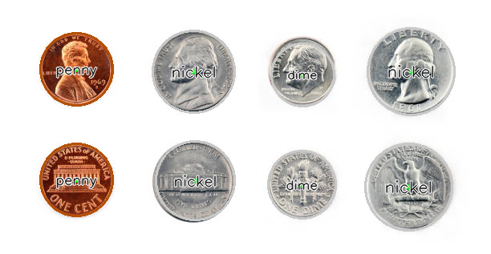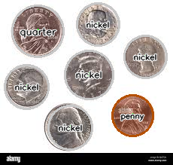
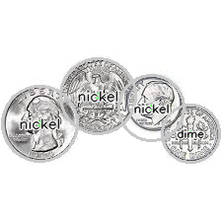

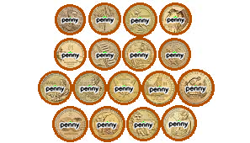
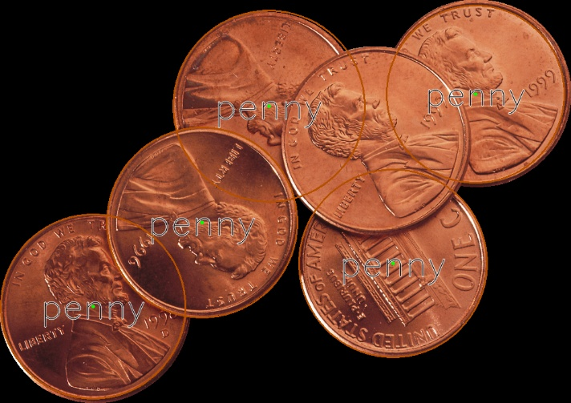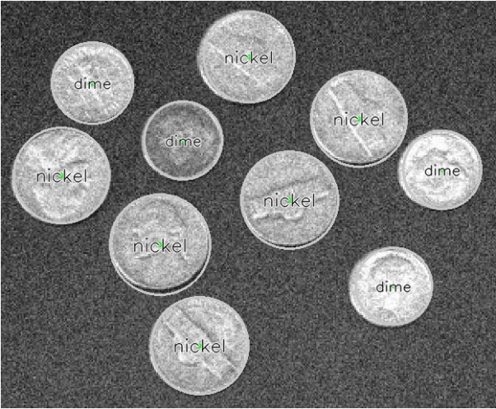
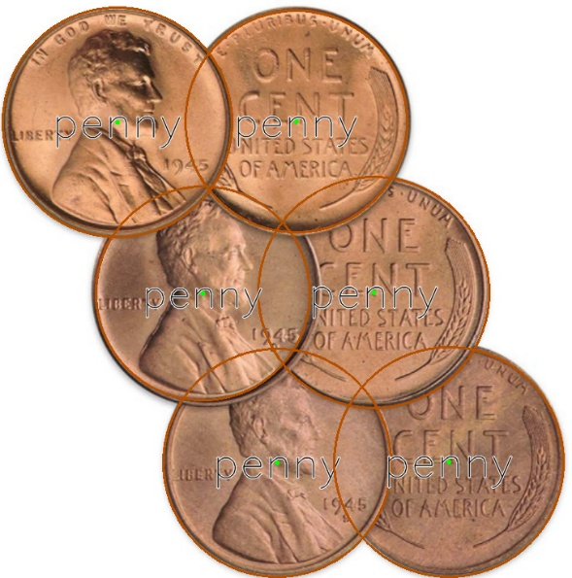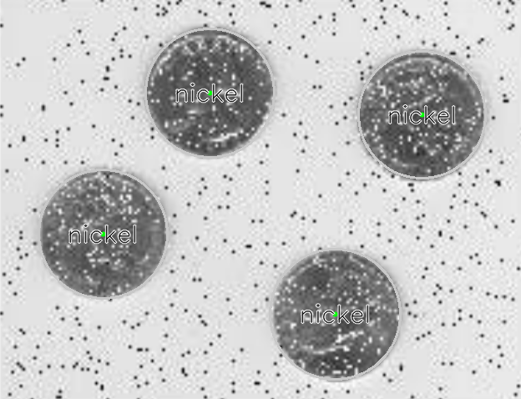

Detection Summary
Table 2 presents the detection results for all ten test images, including the per-image coin count and denomination breakdown. Across 84 total coins, the system achieved consistent detection with no missed coins on any test image.
Table 2. Detection Results Summary — all ten test images, coin counts and denomination breakdown.
Image | Coins Detected | Breakdown
test1.png | 8 | 2× dime, 4× nickel, 2× penny
test2.png | 9 | 1× dime, 1× half-dollar, 5× nickel, 1× penny, 1× quarter
test3.png | 4 | 1× dime, 3× nickel
test4.png | 8 | 1× half-dollar, 2× nickel, 4× penny, 1× quarter
test5.png | 10 | 10× nickel
test6.png | 17 | 17× penny
test7.png | 7 | 7× penny
test8.jpg | 10 | 4× dime, 6× nickel
test9.png | 7 | 6× penny, 1× quarter
test10.png | 4 | 4× nickel
Total | 84 | —

4. Conclusion
This project demonstrates a robust, fully automated coin detection and classification system built on the circular Hough transform combined with colour analysis and scale-invariant radius normalisation.
The scale-invariant radius ratio removes the need for a physical size reference, making the system suitable for deployment in a variety of camera configurations without recalibration. The modular pipeline design means each stage (pre-processing, circle detection, colour classification, and denomination assignment) can be independently tuned or replaced to support other coin sets.

Limitations
- Highly overlapping or partially occluded coins can cause the Hough transform to miss or merge detections.
- Colour classification depends on consistent illumination; strong colour casts or uneven lighting can shift HSV values outside the defined thresholds.
- The radius ratio thresholds in Table 1 are calibrated for the six standard denominations only.

