Software Requirements Specification
Non-Profit Organization Management System
Course | CSE336 Software Design Patterns, Major Assessment Task (Part 1)
Milestone | Phase 1 (due last lecture before the midterm)
Version | 1.2
Date | 25 October 2026
Repository | https://github.com/Michael-Maged/Design-Patterns

Team
Student | Name | Module
1 |  | Donation Management
2 |  | Volunteer Management
3 | Michael Maged | Event Management
4 |  | Beneficiary Management
5 |  | Communication
6 |  | Core, Facade, Control Panel

Revision history
Version | Date | Change
0.1 | 24 Oct 2026 | Module split and pattern plan agreed (design spec).
0.2 | 24 Oct 2026 | Events module and shared core implemented.
1.0 | 25 Oct 2026 | Volunteers module implemented. First full SRS written.
1.1 | 25 Oct 2026 | Purpose rewritten; references moved to the end; class diagrams added as figures; placeholder sections for modules still in progress.
1.2 | 29 Oct 2026 | Volunteers code rewritten in the Java style used in the course labs; Figure 4 and NFR-06 updated to match.

Contents
1. Introduction 5
1.1 Purpose 5
1.2 Scope 5
1.3 Definitions and abbreviations 5
1.4 How this document is organized 6
2. Overall Description 6
2.1 Product perspective 6
2.2 Product functions 7
2.3 User classes 7
2.4 Operating environment 8
2.5 Design and implementation constraints 8
2.6 Assumptions and dependencies 8
2.7 Delivery phases 9
3. Functional Requirements 9
3.1 Shared core (Student 6) 9
3.2 Donation management (Student 1) 10
3.3 Volunteer management (Student 2) 10
3.4 Event management (Student 3) 12
3.5 Beneficiary management (Student 4) 13
3.6 Communication (Student 5) 13
3.7 Phase 2 outline 13
4. Client Requirements 14
5. Non-Functional Requirements 15
6. External Interface Requirements 16
6.1 User interface 16
6.2 Software interfaces 17
6.3 Hardware and communication interfaces 17
7. Data Requirements and Look-up Tables 17
7.1 Main entities 17
7.2 Look-up tables (CRUD) 18
8. Design Patterns 18
8.1 Where each pattern is used 18
8.2 Pattern details for the finished modules 19
9. Class Diagrams 21
9.1 Shared core 22
9.2 Event management 23
9.3 Volunteer management 24
9.4 Donation management 25
9.5 Beneficiary management 25
9.6 Communication 25
9.7 Overall system 25
10. Verification and Acceptance 26
10.1 Events demo 26
10.2 Volunteers demo 26
10.3 Donations demo 27
10.4 Beneficiaries demo 27
10.5 Communication demo 27
10.6 Control panel and look-up tables 27
10.7 Acceptance for Phase 1 27
11. Appendix A: Traceability Matrix 28
A.1 Assignment brief to requirements and code 28
A.2 Phase 1 rubric to this document 29
12. Appendix B: Phase 1 Status and Open Items 29
B.1 Finished 29
B.2 Still needed for Phase 1 29
B.3 Known limitations 30
13. References 30

1. Introduction

1.1 Purpose
This Software Requirements Specification (SRS) defines the functional and non-functional requirements of the Non-Profit Organization Management System, release 1, which corresponds to Phase 1 of the CSE336 Major Assessment Task. It states what the system must do, the quality attributes it must have, and the constraints it is built under. It does not describe how individual classes are coded, except where a design pattern is itself a requirement of the assignment.
The intended audience is the development team, who use it as the agreed baseline for building and integrating the modules, and the course instructor and teaching assistants, who use it to evaluate the delivered system. Each requirement carries a unique identifier so that it can be traced to its implementation (Appendix A) and to the scenario that verifies it (Section 10).

1.2 Scope
The system helps a non-profit run its day-to-day work from one program. It covers five areas named in the assignment brief:
- Donation management
- Volunteer management
- Event management
- Beneficiary management
- Communication with donors, volunteers, attendees and beneficiaries
The system is a Java console application with in-memory storage. It does not connect to a real database, payment gateway, e-mail server, SMS provider or social media API. Those are simulated by printing what would be sent. A payment module and admin pages are Phase 2 items and are only outlined here (Section 3.7).
The main goal of the project, as stated in the brief, is a design that is flexible, maintainable and reusable. The design patterns used to achieve that are part of the requirements (Section 8), not an afterthought.

1.3 Definitions and abbreviations
Term | Meaning
Attendee | A person registered (or waiting) for an event.
Beneficiary | A person or family that receives resources or services from the organization.
Donor | A person or organization that gives money, checks or goods.
In-kind donation | A donation of goods or services instead of money, recorded with an estimated value.
EventBus | The single system-wide notification hub. Modules publish messages on it and other modules subscribe.
Facade | The one class the control panel calls. It hides the module services behind a simple interface.
Look-up table | A small list of reference values (event types, skills, task categories, donation types, need categories) that an administrator can add to, edit or remove from without changing code.
MVC | Model-View-Controller. Data and rules (model), screens (view) and input handling (controller) are kept in separate classes.
Task | A unit of volunteer work with a required skill, a day and a category.
Waitlist | A first-in, first-out queue of people who asked to attend a full event.
SRS | Software Requirements Specification (this document).
FR / NFR / CR | Functional, non-functional and client requirement.

1.4 How this document is organized
Section 2 describes the system as a whole and who uses it. Section 3 lists the functional requirements module by module. Section 4 lists the extra requirements collected beyond the brief. Sections 5 to 7 cover quality attributes, interfaces and data. Section 8 explains where each design pattern is used and why. Sections 9 and 10 present the class diagrams and explain how each requirement is checked. The appendices trace every brief item to requirements and code and summarize what is finished for Phase 1. Section 13 lists the references used.
Sections for modules that are still being built are kept as headed placeholders, so each team member knows where their part goes.
Each functional requirement has a priority and a status:
- Priority: Must (needed for the milestone), Should (expected, can slip to the next phase), Could (nice to have).
- Status: Done (implemented and shown in a demo), In progress, Planned.

2. Overall Description

2.1 Product perspective
The system is a new, self-contained program. It is split into one shared core and five feature modules. Each module is a Java package under org.nonprofit and is owned by one student. Figure 1 shows the layers and how they depend on each other.
Modules never call the Communication module directly. When something happens that someone should hear about (a donation arrives, a volunteer is assigned, an event moves), the module publishes a message on the EventBus. The Communication module subscribes and decides how to deliver it. This keeps the modules independent, so one student's changes do not break another student's code.
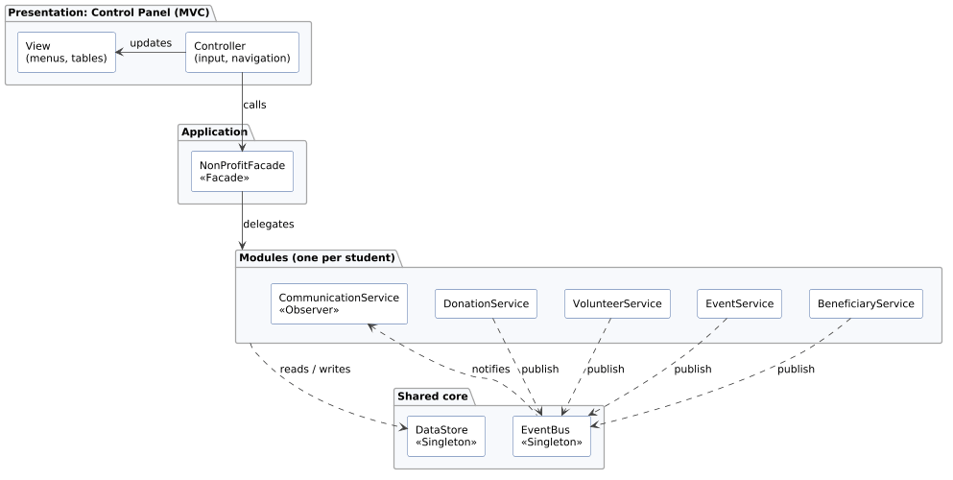
Figure 1. System architecture

2.2 Product functions
At a high level the system lets staff:
- record donors and donations of different kinds, and print receipts and yearly tax statements;
- keep volunteer profiles, assign volunteers to tasks using a chosen rule, log their hours and print certificates;
- create fundraisers, workshops and outreach programs, sell tickets with add-ons, manage capacity and a waitlist, check people in and send reminders;
- record beneficiaries and their needs, hand out resources fairly when supplies are short, and report on program impact;
- send messages by e-mail, SMS or social media depending on who the recipient is;
- manage the look-up tables used by all of the above from a control panel.

2.3 User classes
User class | Description | Main modules | Technical skill
Administrator | Manages look-up tables and system settings. In Phase 2 also uses the admin pages. | Core | Medium
Donation officer | Records donations and issues receipts and tax documents. | Donation | Low
Volunteer coordinator | Maintains volunteer profiles, creates tasks, picks the assignment rule, logs hours, issues certificates. | Volunteer | Low
Event coordinator | Creates events, handles registration, check-in, changes and reminders. | Event | Low
Program officer | Records beneficiaries and needs, distributes resources, produces impact reports. | Beneficiary | Low
Communications officer | Sends broadcasts and reviews the message log. | Communication | Low

Donors, volunteers, attendees and beneficiaries do not log in. They are people the system stores and contacts, not operators. In this phase all operators use the same control panel with no login (see 2.5).

2.4 Operating environment
- Java SE 17 or later (the code is compiled with --release 17).
- Any operating system that runs a JDK: Windows, macOS or Linux.
- A text console. VS Code with the Java extension pack is the team's editor, but no IDE is required.
- No external libraries, frameworks or build tools.

2.5 Design and implementation constraints
ID | Constraint
C-1 | Language is Java. Source lives in SDP/src, compiled classes in SDP/bin.
C-2 | The design patterns in Section 8 must be used where they fit naturally. A pattern used in a way that does not fit is treated as a defect.
C-3 | Storage is in memory only. Data is lost when the program exits.
C-4 | E-mail, SMS, social media and payments are simulated with console output.
C-5 | No authentication or user accounts in Phase 1.
C-6 | Each student owns one package. Module code goes through a feature branch and a pull request into main.
C-7 | Class diagrams are produced from the source with the team's UML generator and stored in output/ as PlantUML files.

2.6 Assumptions and dependencies
- One person operates the system at a time, so there is no concurrent editing.
- Dates and times are entered by the operator. The system does not read the clock for business rules; reminder checks are given "now" explicitly so they can be tested.
- Amounts are in a single currency (shown as $).
- Every person has a name. E-mail and phone are optional, but a person with no e-mail cannot be reached by e-mail, and so on for SMS.
- Modules depend only on the shared core (Person, ContactPreference, EventBus, SystemEvent, SystemEventType, SystemObserver) and never on each other's classes. Links between modules use IDs or names (for example a volunteer task stores the event name, not an Event object).

2.7 Delivery phases
Phase | Due | Content
1 | Last lecture before midterm | Class diagrams; Strategy, Observer, Decorator, Factory, Singleton; MVC; user control panel; client requirements; CRUD look-up tables.
2 | Last lecture before final | Command, Adapter, Facade, Template Method, Iterator, State, Proxy; admin pages; payment module; core module management; whole system working.

Template Method and Facade are already used in Phase 1 because the brief names them for the modules. They are graded in Phase 2.

3. Functional Requirements

3.1 Shared core (Student 6)
ID | Requirement | Priority | Status
FR-CORE-01 | Every person in the system (donor, volunteer, attendee, beneficiary) shall have an ID, a name, an optional e-mail, an optional phone number and a preferred contact method (e-mail, SMS or social media). A person without a name shall be rejected. | Must | Done
FR-CORE-02 | There shall be exactly one EventBus in the running program. Any module can publish a message on a topic, and any module can subscribe to or unsubscribe from a topic. | Must | Done
FR-CORE-03 | Each bus message shall carry a topic, a text, an optional single recipient and the object it is about. A message with no recipient is meant for everyone linked to that object (for example all attendees of an event). | Must | Done
FR-CORE-04 | A subscriber that subscribes or unsubscribes while a message is being delivered shall not cause an error or a skipped delivery. | Should | Done

To be completed by Student 6 (Core and Control Panel). Fill this in when the module is merged into main, using the same table layout as Section 3.3 (ID, requirement, priority, status).
It should cover, at least:
- the DataStore singleton that holds every module's records
- the NonProfitFacade and the operations it exposes
- the MVC control panel: models, views, controllers, menu structure and input validation
- the scripted App --demo mode

Topics currently defined on the bus:
Topic | Published by | Meaning
DONATION_RECEIVED | Donation | A donation was recorded.
VOLUNTEER_ASSIGNED | Volunteer | A volunteer was given a task.
RESOURCE_DISTRIBUTED | Beneficiary | Resources were handed to a beneficiary.
URGENT_NEED | Beneficiary | A high-urgency need was recorded.
EVENT_REGISTERED | Event | A person got a ticket.
EVENT_UPDATED | Event | An event's date or place changed.
EVENT_REMINDER | Event | A reminder is due.
EVENT_CANCELLED | Event | An event was cancelled.
WAITLIST_PROMOTED | Event | A person moved from the waitlist to registered.

3.2 Donation management (Student 1)
To be completed by Student 1 (Donation Management). Fill this in when the module is merged into main, using the same table layout as Section 3.3 (ID, requirement, priority, status).
It should cover, at least:
- donor records and donation history
- donation amounts, dates and types (online, check, in-kind) and how new types are added
- donation receipts and yearly tax documents
- publishing DONATION_RECEIVED on the EventBus

3.3 Volunteer management (Student 2)
ID | Requirement | Priority | Status
FR-VOL-01 | The system shall store volunteers with contact details, a set of skills, the days of the week they are available and the task categories they prefer. Volunteer IDs are generated in the form VOL-n. | Must | Done
FR-VOL-02 | Volunteers shall be contacted by SMS unless another contact method is given. | Should | Done
FR-VOL-03 | Skills and categories shall be compared without regard to case or surrounding spaces ("First Aid" equals "first aid"). An empty skill or category shall be rejected. | Must | Done
FR-VOL-04 | The coordinator shall be able to add and remove skills, available days and preferred categories on an existing volunteer. | Must | Done
FR-VOL-05 | The system shall store tasks with a name, required skill, day of week, category and, optionally, the name of the event the task belongs to. Task IDs are generated in the form TSK-n. A task without a name or day shall be rejected. | Must | Done
FR-VOL-06 | The system shall assign a task to a volunteer using the current assignment rule. Three rules shall be available: | Must | Done
 | (a) Skill-based: the volunteer must have the required skill and be available that day. The one with the most logged hours is chosen.
 | (b) Availability-based: any volunteer available that day qualifies. The one with the fewest unfinished tasks is chosen.
 | (c) Preference-based: the volunteer must be available that day and prefer the task's category. Someone who also has the skill is chosen first, then the one with the fewest unfinished tasks.
FR-VOL-07 | The coordinator shall be able to change the assignment rule at any time, including by typing its name ("skill", "availability", "preference"). An unknown name shall be rejected with a message. | Must | Done
FR-VOL-08 | A volunteer shall have at most one unfinished task per day. Volunteers already booked on the task's day shall not be considered. | Must | Done
FR-VOL-09 | The coordinator shall be able to see who the current rule would pick for a task without assigning it. | Should | Done
FR-VOL-10 | If no volunteer fits, the task shall stay unassigned and the coordinator shall be told. Assigning a task that already has a volunteer shall be refused. | Must | Done
FR-VOL-11 | The coordinator shall be able to assign every open task in one action and see how many were filled. | Should | Done
FR-VOL-12 | The coordinator shall be able to unassign a task that is not yet completed. | Should | Done
FR-VOL-13 | Every successful assignment shall publish VOLUNTEER_ASSIGNED on the bus, addressed to the volunteer. | Must | Done
FR-VOL-14 | The coordinator shall be able to log the hours worked on a task, with a date. The task must have a volunteer, must not already be completed, and the hours must be positive. Logging hours marks the task completed. | Must | Done
FR-VOL-15 | The system shall show each volunteer's total hours, and a leaderboard of the top N volunteers by hours. | Must | Done
FR-VOL-16 | The system shall issue an hours certificate showing total hours and number of completed tasks. A volunteer with no logged hours shall not get one. | Must | Done
FR-VOL-17 | The system shall issue an event participation certificate listing the tasks and hours a volunteer worked at a named event. A volunteer who did no task at that event shall not get one. | Must | Done
FR-VOL-18 | All certificates shall share one layout: title, recipient, achievement text, then issue date and signature line. | Must | Done
FR-VOL-19 | Removing a volunteer shall return their unfinished tasks to the open pool. Their completed tasks and hours stay on record. | Should | Done

3.4 Event management (Student 3)
ID | Requirement | Priority | Status
FR-EVT-01 | The system shall create three kinds of event: fundraiser, workshop and outreach program. Each has a name, date and time, location and capacity. Event IDs are generated in the form EVT-n. | Must | Done
FR-EVT-02 | Events shall be created through an EventFactory, from a type value or from typed text such as "workshop" or "outreach program". Unknown text shall be rejected. | Must | Done
FR-EVT-03 | An event with no name or a capacity of zero or less shall be rejected. | Must | Done
FR-EVT-04 | Each kind of event shall keep its own details: a fundraiser has a money goal and the amount pledged so far; a workshop has a topic and an instructor; an outreach program has a target community. | Must | Done
FR-EVT-05 | A fundraiser shall show progress towards its goal as a percentage. A negative goal or a pledge of zero or less shall be rejected. | Should | Done
FR-EVT-06 | Default ticket prices shall be $100 for a fundraiser, $25 for a workshop and free for an outreach program. The base price can be changed per event. | Should | Done
FR-EVT-07 | Registering a person shall issue a ticket. The person may add any mix of VIP seating (+$50), meal (+$15) and parking (+$10). The ticket's price and description shall reflect every add-on chosen. | Must | Done
FR-EVT-08 | Registering for a cancelled event shall be refused. Registering someone who is already registered or already waiting shall be reported, not duplicated. | Must | Done
FR-EVT-09 | When an event is full, a new registration shall go on the waitlist and the person shall be told their position. | Must | Done
FR-EVT-10 | When a registered person cancels, the first person on the waitlist shall be registered automatically with the add-ons they originally chose, and only that person shall be notified. | Must | Done
FR-EVT-11 | A person on the waitlist shall be able to leave it. | Should | Done
FR-EVT-12 | Staff shall be able to check in a registered person. Checking in someone who is not registered shall be refused. | Must | Done
FR-EVT-13 | The system shall print an attendance report per event listing each registered person, their ticket, its price, whether they checked in, who is waiting, the attendance rate and total ticket revenue. | Must | Done
FR-EVT-14 | Rescheduling, relocating or cancelling an event shall notify every registered person with the old and new values, and shall publish the change on the bus. | Must | Done
FR-EVT-15 | Staff shall be able to send a reminder for one event, or for every event that starts within a given time window (for example the next 24 hours). Cancelled and past events are skipped. | Must | Done
FR-EVT-16 | The system shall list all events and list upcoming events in date order. | Should | Done
FR-EVT-17 | Every registration and waitlist promotion shall publish a bus message addressed to the person concerned. | Must | Done

3.5 Beneficiary management (Student 4)
To be completed by Student 4 (Beneficiary Management). Fill this in when the module is merged into main, using the same table layout as Section 3.3 (ID, requirement, priority, status).
It should cover, at least:
- beneficiary records and their needs (category, quantity, urgency)
- recording the distribution of resources and services
- the rule used when resources are limited
- monitoring and evaluating program impact (reports)
- publishing RESOURCE_DISTRIBUTED and URGENT_NEED

3.6 Communication (Student 5)
To be completed by Student 5 (Communication). Fill this in when the module is merged into main, using the same table layout as Section 3.3 (ID, requirement, priority, status).
It should cover, at least:
- e-mail, SMS and social media channels and how a channel is chosen per recipient
- message composition (signature, urgent tag, footer)
- which EventBus topics are handled and what message each one produces
- manual broadcasts and the message log

3.7 Phase 2 outline
These are listed so the Phase 1 design leaves room for them. They are not part of Phase 1.
ID | Requirement
FR-P2-01 | Admin pages to manage users, look-up tables and system settings.
FR-P2-02 | Payment module for online donations and paid tickets, behind an adapter so different (simulated) payment providers can be swapped in.
FR-P2-03 | Undo for the last few operations in the control panel (Command pattern).
FR-P2-04 | Event and donation life cycles modelled as states (for example draft, open, full, closed, cancelled).
FR-P2-05 | Access control in front of sensitive operations such as deleting records (Proxy pattern).
FR-P2-06 | All modules wired together through the facade and working from the control panel.

4. Client Requirements
The brief asks us to extend the basic requirements with requirements collected from users. We put together the list below from how the brief's user roles (donation officer, volunteer coordinator, event coordinator, program officer) would actually work with the system, and from talking through each module's day-to-day use as a team. We will confirm them with the client and update this section if anything changes.
ID | Requirement | Asked for by | Why | Covered by | Status
CR-01 | When an event is full, let people join a waitlist and give them the seat automatically if someone cancels. Tell them when it happens. | Event coordinator | Full workshops lose people who would have come if a seat opened up, and staff were contacting them by hand. | FR-EVT-09, FR-EVT-10 | Done
CR-02 | Show a fundraiser's progress towards its money goal. | Event coordinator | The coordinator announces progress during the event. | FR-EVT-05 | Done
CR-03 | Send reminders for every event in the next day in one step instead of one by one. | Event coordinator | Reminders were being forgotten for smaller events. | FR-EVT-15 | Done
CR-04 | Show a leaderboard of volunteers by hours. | Volunteer coordinator | Used for the yearly volunteer thank-you evening and to spot people who are doing too much. | FR-VOL-15 | Done
CR-05 | Do not book a volunteer for two tasks on the same day. | Volunteer coordinator | Double booking happened often when tasks were assigned on paper. | FR-VOL-08 | Done
CR-06 | Let the coordinator see who would be picked before confirming an assignment. | Volunteer coordinator | They want to check the choice before the volunteer gets a message. | FR-VOL-09 | Done
CR-07 | Give a certificate for helping at a specific event, not only for total hours. | Volunteer coordinator | Students need proof of participation for university community-service credit. | FR-VOL-17 | Done
CR-08 | Mark online donations as recurring monthly and show that on the receipt. | Donation officer | Monthly donors are the most reliable income and need to be thanked differently. | Section 3.2 | Planned
CR-09 | Track donation campaign goals with a progress percentage. | Donation officer | Same need as CR-02 but for campaigns that run outside events. | Section 3.2 | Planned
CR-10 | When a beneficiary has a high-urgency need, alert volunteers straight away. | Program officer | Urgent needs (medicine, rent) cannot wait for the weekly meeting. | Section 3.5, Section 3.6 | Planned
CR-11 | Keep a log of every message sent so staff can check what someone was told. | Communications officer | Donors and attendees sometimes say they were never contacted. | Section 3.6 | Planned
CR-12 | Let the administrator add new event types, skills, task categories, donation types and need categories without a programmer. | Administrator | The organization's programs change every year. | Section 7.2 | Planned

5. Non-Functional Requirements
ID | Category | Requirement | How it is met / checked
NFR-01 | Extensibility | Adding a new event type, donation type, ticket add-on, assignment rule, allocation rule, certificate, report or communication channel shall need a new class plus at most one line in an existing factory or enum. No existing service code shall change. | Factory, Strategy, Decorator and Template Method (Section 8). Checked in review.
NFR-02 | Maintainability | Each module shall depend only on the shared core, never on another module. | Package imports checked in review. Modules talk through the EventBus.
NFR-03 | Maintainability | Classes shall be small and single-purpose. Every class shall have a header comment saying what it does and, where it applies, which pattern role it plays. | Code review.
NFR-04 | Reusability | The Person base class, the EventBus and the look-up tables shall be shared by all modules instead of each module writing its own. | Shared core package.
NFR-05 | Reliability | Invalid data (empty names, negative amounts, zero capacity, unknown IDs, unknown type names) shall be rejected with a clear message at the point it enters the model. No object shall be left half-updated after a rejected operation. | Validation in constructors and services. Shown in the demos.
NFR-06 | Reliability | Lists returned to callers shall be copies or read-only, so code outside a class cannot change its data without going through its rules. | Getters return copies (new ArrayList<>(...)) or read-only views (Collections.unmodifiable...).
NFR-07 | Usability | Every menu screen shall show its title, numbered options and a way back. Results shall be printed as aligned text tables. | Control panel view classes.
NFR-08 | Usability | Dates shall be shown as yyyy-MM-dd HH:mm and money with two decimals. | Format strings in model summary() methods.
NFR-09 | Performance | With the expected data size (hundreds of people, tens of events), every operation shall complete without a noticeable delay on a normal laptop. | In-memory maps keyed by ID.
NFR-10 | Portability | The program shall build and run with only a standard JDK 17 on Windows, macOS or Linux. | No external libraries.
NFR-11 | Testability | Business rules that depend on time shall take "now" as a parameter so demos give the same output every run. | sendUpcomingReminders(now, window), dates passed to logHours.
NFR-12 | Privacy | Contact details shall be used only to send messages through the Communication module. Messages are printed, never sent outside the program. | Simulated channels.

6. External Interface Requirements

6.1 User interface
The user interface is a text console control panel built on MVC (see Section 3.1).
To be completed by Student 6 (Core and Control Panel). Fill this in when the module is merged into main.
It should cover, at least:
- the main menu and one sub-menu per module, with a screen example for each
- how errors and invalid input are shown
- how results (lists, reports, certificates) are laid out

Until the control panel is built, each module can be run on its own through its demo class (Section 10).

6.2 Software interfaces
- Module services. Each module exposes one service class (DonationService, VolunteerService, EventService, BeneficiaryService, CommunicationService). The facade calls only these.
- EventBus. subscribe(topic, observer), unsubscribe(topic, observer), publish(message). Topics are listed in Section 3.1.
- Java standard library only (java.time, java.util).

6.3 Hardware and communication interfaces
None. E-mail, SMS, social media and payment providers are simulated (constraint C-4).

7. Data Requirements and Look-up Tables

7.1 Main entities
Entity | Key attributes | Module
Person (abstract) | id, name, email, phone, preferredContact | Core
Volunteer | skills, available days, preferred categories, tasks, hour log | Volunteer
Task | id, name, required skill, day, category, event name, assigned volunteer, completed | Volunteer
HourEntry | task, hours, date | Volunteer
Event (abstract) | id, name, date and time, location, capacity, base ticket price, cancelled, registrations, waitlist, checked-in set | Event
Fundraiser / Workshop / OutreachProgram | goal and amount raised / topic and instructor / target community | Event
Attendee | inbox of notifications | Event
Ticket | price, description, event, holder | Event

To be completed by Student 1, 4 and 5 (Donation, Beneficiary, Communication). Fill this in when the module is merged into main.
It should cover, at least:
- the entities of each module with their key attributes, in the table above

IDs are generated by the system with a prefix per entity (VOL-, TSK-, EVT-, ATT-, and so on) and are never reused while the program runs.

7.2 Look-up tables (CRUD)
A look-up table is a short list of values that other records refer to, such as event types, ticket add-ons, skills, task categories, donation types, need categories and contact methods. The administrator shall be able to create, read (list), update (rename) and delete the values in each table from the control panel.
To be completed by Student 6 (Core and Control Panel). Fill this in when the module is merged into main.
It should cover, at least:
- the list of tables, their starting values and which module uses each
- rules for duplicates, empty values, renaming and deleting a value that is in use

The Volunteers module already stores skills and task categories as plain text so that they can come from these tables without code changes.

8. Design Patterns

8.1 Where each pattern is used
Pattern | Rubric | Module | Classes | Problem it solves here
Factory | Phase 1 (0.5) | Event | EventFactory, EventType, Fundraiser, Workshop, OutreachProgram | The control panel only knows the text the user typed. The factory turns it into the right event class so no other code needs a switch on event type.
Decorator | Phase 1 (1) | Event | Ticket, BasicTicket, TicketDecorator, VipTicket, MealTicket, ParkingTicket, TicketAddOn | A ticket can have any mix of add-ons. One subclass per combination would mean 8 classes for 3 add-ons. Decorators stack instead, each adding its price and description.
Observer | Phase 1 (1) | Event | Event (subject), EventObserver, Attendee, EventBusNotifier | When an event changes, everyone registered must hear about it, without Event knowing who they are or how they want to be told.
 |  | Core | EventBus, SystemObserver, SystemEvent | Lets every module announce things without depending on the Communication module.
Strategy | Phase 1 (1) | Volunteer | AssignmentStrategy, SkillBasedAssignment, AvailabilityBasedAssignment, PreferenceBasedAssignment, AssignmentMode | Coordinators use different rules for different situations (qualified people for the medical tent, anyone free for setting up chairs). The rule is a separate object that can be swapped while the program runs.
Template Method | Phase 2 (1) | Volunteer | Certificate, HoursCertificate, EventParticipationCertificate | Every certificate has the same layout. issue() is final and fixes the order of the steps; subclasses fill in only the title and achievement and can override the eligibility check.

The table lists the patterns in the finished code only. Each remaining module adds its own rows when it is merged:
- Student 1: Factory (DonationFactory) and Template Method (receipts and tax statements).
- Student 4: Strategy (allocation rules) and Template Method (impact reports).
- Student 5: Strategy (channels) and Decorator (message content).
- Student 6: Singleton (DataStore), Facade (NonProfitFacade) and MVC (control panel).

8.2 Pattern details for the finished modules
Factory (Events). EventFactory has a private constructor and two static create methods. One takes an EventType, the other takes the user's text and parses it with EventType.fromString, which accepts different cases, extra spaces and "outreach program". The factory also generates the event ID. The event constructors are package-private, so code outside the package cannot skip the factory.
Decorator (Events). Ticket is the component interface. BasicTicket is general admission at the event's base price. TicketDecorator holds a wrapped Ticket and forwards every call to it; VipTicket, MealTicket and ParkingTicket add their surcharge and text. TicketAddOn is an enum where each value knows which decorator to apply, so EventService builds a ticket by looping over the chosen add-ons. Example: Parking(Meal(VIP(Basic))) at a fundraiser costs 100 + 50 + 15 + 10 = $175.
Observer (Events). Event keeps a list of EventObservers. Registering a person attaches them and cancelling detaches them. reschedule, relocate, cancel and remind call notifyObservers. Two kinds of observer exist: Attendee, which stores the note in its inbox, and EventBusNotifier, which forwards the change to the system EventBus with the matching topic. Observers are copied before notifying so one can detach during the loop.
Singleton (Core). EventBus has a private constructor and a volatile static instance created on first use with double-checked locking.
Strategy (Volunteers). VolunteerService is the context. It holds one AssignmentStrategy, skill-based by default, and passes it the task and the volunteers who are free that day. Each strategy filters and ranks in its own way (FR-VOL-06). AssignmentMode maps menu text to a new strategy object. In the demo the same "Medical tent" task goes to three different people under the three rules.
Template Method (Volunteers). Certificate.issue() is final. It checks isEligible() and then builds the certificate in a fixed order: border, title(), recipient(), achievement(), signature(), border. title() and achievement() are abstract. isEligible(), recipient() and signature() are hooks with defaults. HoursCertificate overrides eligibility to need at least some hours; EventParticipationCertificate needs at least one task at the named event.

9. Class Diagrams
The class diagrams are generated from the source code with the team's UML generator and kept as PlantUML files in output/. Inside each diagram the classes are grouped by the pattern they take part in, and each class shows its pattern role as a stereotype (for example <<Singleton>>, <<Decorator>>, <<Strategy>>). Attributes and operations are shown with their types and visibility (+ public, - private, # protected, ~ package).

9.1 Shared core
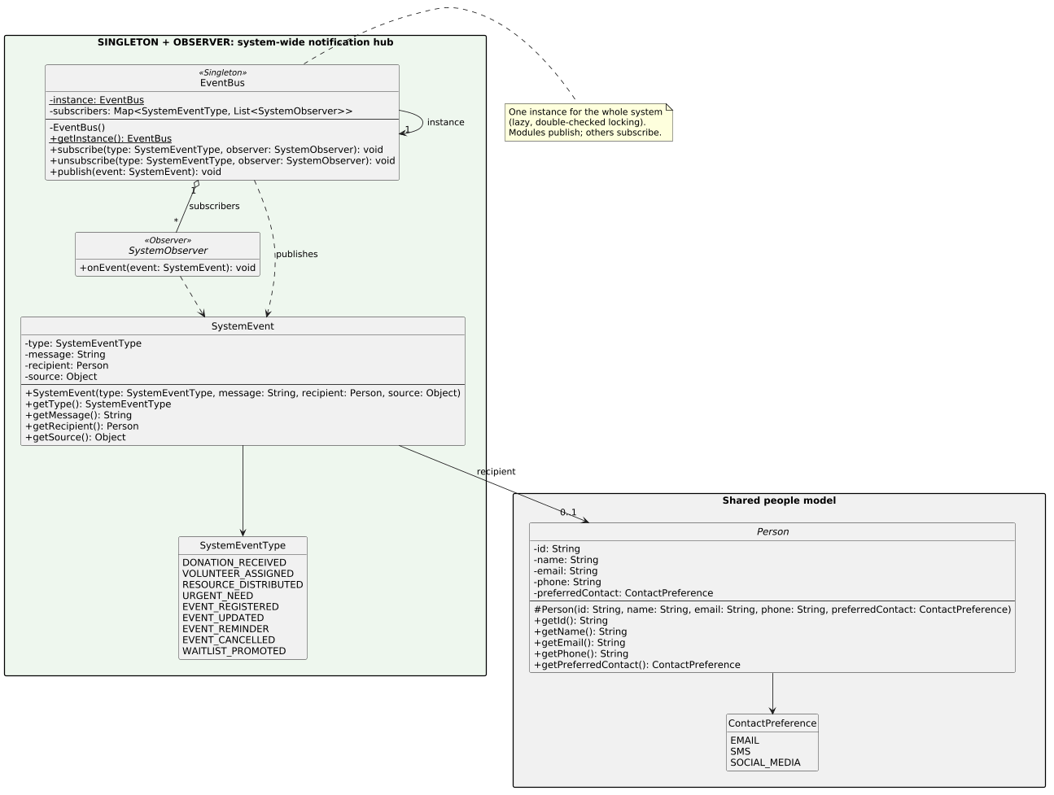
Figure 2. Shared core (output/core.puml)

9.2 Event management
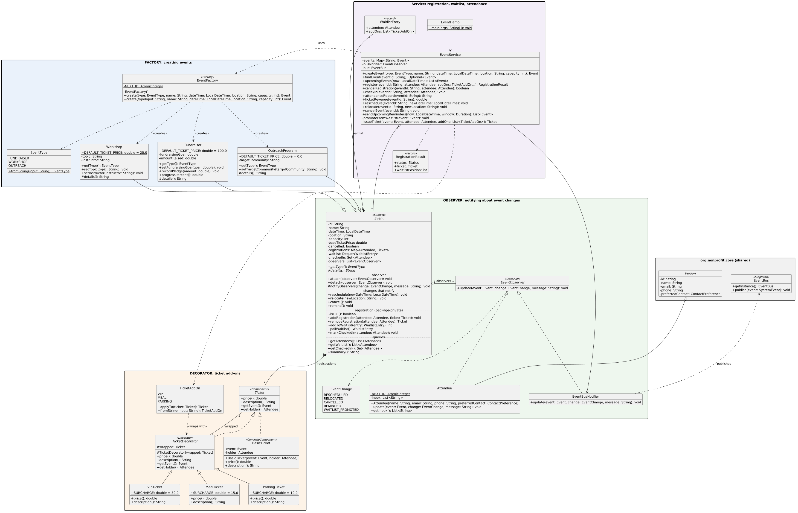
Figure 3. Events module: Factory, Observer and Decorator (output/event.puml)

9.3 Volunteer management
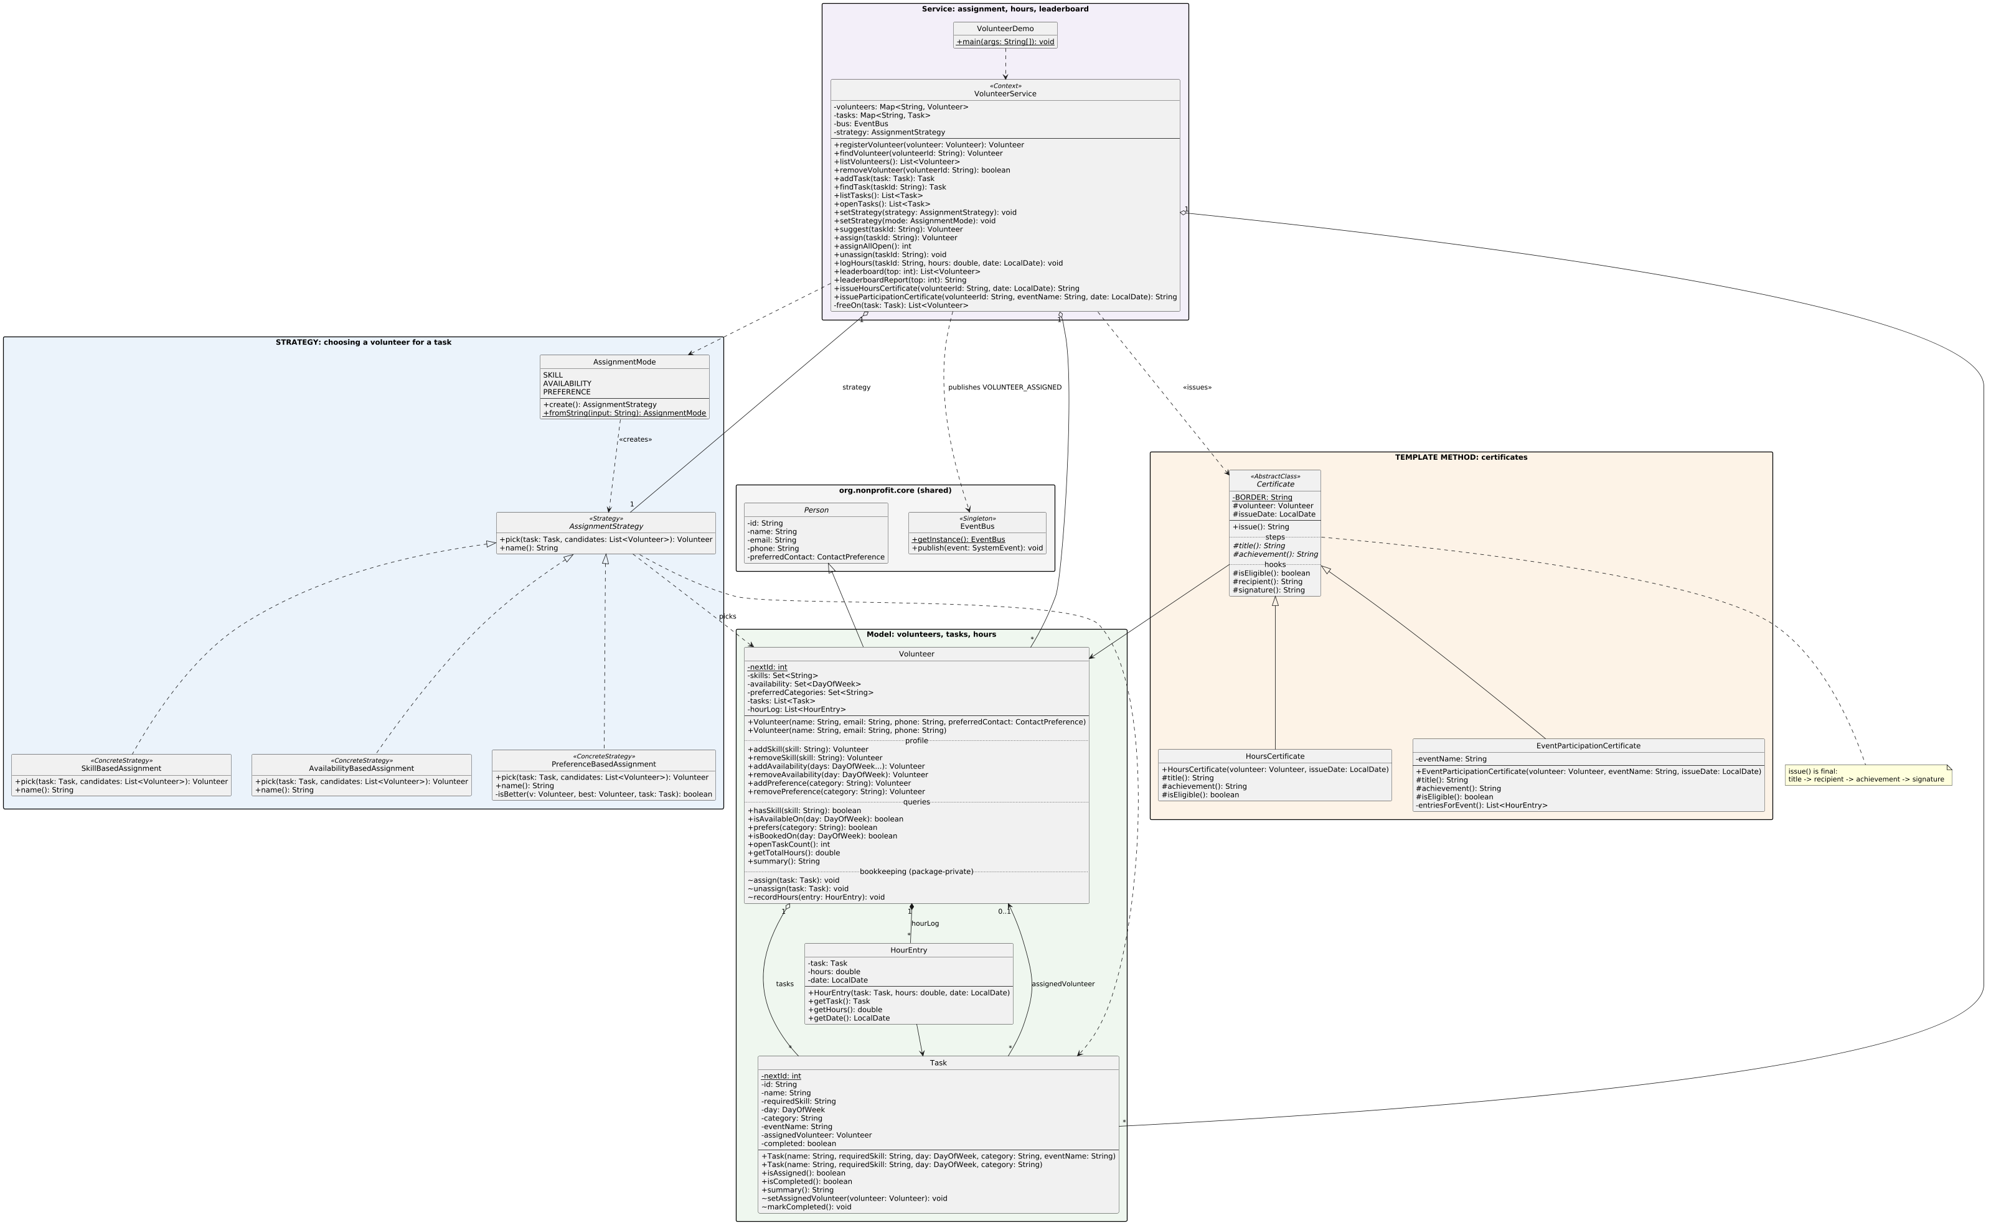
Figure 4. Volunteers module: Strategy and Template Method (output/volunteer.puml)

9.4 Donation management
To be completed by Student 1. Add the generated output/donation.puml diagram here.

9.5 Beneficiary management
To be completed by Student 4. Add the generated output/beneficiary.puml diagram here.

9.6 Communication
To be completed by Student 5. Add the generated output/communication.puml diagram here.

9.7 Overall system
To be completed by Student 6. Add the generated output/overall.puml diagram here, showing every package and the links between them.

10. Verification and Acceptance
There is no unit-test framework (constraint C-1, no external libraries). Each module has a demo class that runs a fixed scenario and prints the result of every rule, so a reviewer can check the output against this document. The demo output is the same on every run because times are passed in explicitly (NFR-11).
Build and run from the SDP folder:
javac --release 17 -d bin $(find src -name "*.java")
java -cp bin org.nonprofit.event.EventDemo
java -cp bin org.nonprofit.volunteer.VolunteerDemo
The whole project currently compiles with no errors and no warnings under javac -Xlint:all.

10.1 Events demo
Step | What it shows | Requirements | Expected result
1 | Create one event of each kind, two of them from typed text | FR-EVT-01, 02, 04 | Three events listed with their own details.
2 | Register three people with different add-ons; build one ticket by hand | FR-EVT-06, 07 | Prices $100, $150, $175 and $125.
3 | Fill a 2-seat workshop, waitlist two, try a duplicate, then cancel one | FR-EVT-08, 09, 10 | Positions 1 and 2, "ALREADY_WAITLISTED", first waiting person promoted and told.
4 | Reschedule and relocate the gala | FR-EVT-14 | All three attendees and the bus receive both changes.
5 | Reminders for the next 24 hours | FR-EVT-15 | Only the workshop is reminded.
6 | Check in two people, record pledges, print reports | FR-EVT-05, 12, 13 | 2/3 checked in (67%), revenue $425.00, 50% of goal.
7 | Cancel an event, then try to register | FR-EVT-08, 14 | Attendee notified; registration rejected.
8 | Compare two getInstance() calls | FR-CORE-02 | Same instance.

10.2 Volunteers demo
Step | What it shows | Requirements | Expected result
1 | Create three volunteers and some past and booked tasks | FR-VOL-01 to 05, 13, 14 | Profiles printed with hours and open tasks; assignments appear on the bus.
2 | Ask the three rules about the same task | FR-VOL-06, 09 | Skill-based picks Karim, availability-based picks Nour, preference-based picks Sara.
3 | Choose a rule from typed text and assign | FR-VOL-07, 13 | "preference" assigns Sara.
4 | Assign all open Saturday tasks | FR-VOL-08, 10, 11 | 2 tasks filled, "Second medic" left open because everyone is booked that day.
5 | Log hours and show the leaderboard | FR-VOL-14, 15 | Karim 11.0 h, Sara 8.0 h, Nour 4.0 h.
6 | Issue both certificates, then one for a newcomer | FR-VOL-16, 17, 18 | Two certificates with the same layout; newcomer refused.
7 | Remove two volunteers | FR-VOL-19 | Their unfinished task returns to the pool.

10.3 Donations demo
To be completed by Student 1. List the demo steps, the requirements each one shows and the expected result, as in 10.1.

10.4 Beneficiaries demo
To be completed by Student 4. List the demo steps, the requirements each one shows and the expected result, as in 10.1.

10.5 Communication demo
To be completed by Student 5. List the demo steps, the requirements each one shows and the expected result, as in 10.1.

10.6 Control panel and look-up tables
To be completed by Student 6. List the menu walk-through and the CRUD steps on each look-up table, with the expected result.

10.7 Acceptance for Phase 1
Phase 1 is accepted when:
- every Must requirement in Sections 3.1 to 3.6 is Done, including the sections still marked as placeholders;
- the program compiles with no errors and App --demo runs every module;
- every pattern in the Phase 1 rubric is visible in the demo output;
- every module has a class diagram in output/, plus the overall diagram;
- the look-up tables can be created, listed, renamed and deleted from the control panel.

11. Appendix A: Traceability Matrix

A.1 Assignment brief to requirements and code
Brief item | Requirements | Implemented in | Status
Track donor information, donation amounts and types | Section 3.2 | org.nonprofit.donation | Planned
Generate donation receipts and tax documents | Section 3.2 | org.nonprofit.donation | Planned
Flexible donation methods (online, checks, in-kind) | Section 3.2 | org.nonprofit.donation | Planned
Volunteer information, skills and availability | FR-VOL-01 to 04 | Volunteer | Done
Assign volunteers by preferences and qualifications | FR-VOL-05 to 12 | VolunteerService, AssignmentStrategy and its three rules | Done
Track volunteer hours and generate certificates | FR-VOL-14 to 18 | VolunteerService.logHours, Certificate and subclasses | Done
Create, manage and track events | FR-EVT-01 to 06, 16 | EventFactory, Event and subclasses, EventService | Done
Event registration, ticketing and attendance | FR-EVT-07 to 13 | EventService, Ticket decorators | Done
Event reminders and communications to attendees | FR-EVT-14, 15, 17 | Event observers, EventBusNotifier, EventService.sendUpcomingReminders | Done
Beneficiary information and needs | Section 3.5 | org.nonprofit.beneficiary | Planned
Track distribution of resources and services | Section 3.5 | org.nonprofit.beneficiary | Planned
Monitor and evaluate program impact | Section 3.5 | org.nonprofit.beneficiary | Planned
Communication between organization and all groups | Section 3.6 | org.nonprofit.communication, EventBus | Partly (bus done)
E-mail, SMS and other forms of communication | Section 3.6 | org.nonprofit.communication | Planned
Social media outreach | Section 3.6 | SocialMediaChannel | Planned
Class diagrams | Section 9 | output/*.puml | Partly
Implementation code | Section 3 | SDP/src | Partly
Client requirements | Section 4 |  | Written; 7 of 12 done

A.2 Phase 1 rubric to this document
Rubric item | Marks | Where in this SRS | Where in the code | Status
Class diagram | 2 | Section 9 | output/ | Core, Events, Volunteers done
Strategy pattern | 1 | 8.1, 8.2, FR-VOL-06/07 | org.nonprofit.volunteer.AssignmentStrategy | Done
Observer pattern | 1 | 8.1, 8.2, FR-EVT-14, FR-CORE-02 | Event, EventObserver, EventBus | Done
Decorator pattern | 1 | 8.1, 8.2, FR-EVT-07 | Ticket, TicketDecorator | Done
Factory pattern | 0.5 | 8.1, 8.2, FR-EVT-02 | EventFactory | Done
Singleton pattern | 0.5 | 8.1, 8.2, FR-CORE-02 | EventBus | Done
MVC | 2 | Section 3.1, 6.1 | Control panel | Planned
User control panel | 1 | Section 3.1, 6.1 | Control panel | Planned
Client requirements | 0.5 | Section 4 | See CR table | Written; partly implemented
CRUD look-up tables | 0.5 | Section 7.2 | Core | Planned

12. Appendix B: Phase 1 Status and Open Items

B.1 Finished
- Shared core: Person, ContactPreference, EventBus (Singleton and Observer), SystemEvent, SystemEventType, SystemObserver.
- Events module: all of FR-EVT-01 to 17, with Factory, Decorator and Observer, a demo and a class diagram. Merged into main (pull request #1).
- Volunteers module: all of FR-VOL-01 to 19, with Strategy and Template Method, a demo and a class diagram. On branch volunteers, waiting for review.

B.2 Still needed for Phase 1
Item | Owner | Rubric marks at stake
MVC control panel over the facade (Section 3.1) | Student 6 | 3 (MVC 2 + control panel 1)
CRUD look-up tables (Section 7.2) | Student 6 | 0.5
DataStore singleton (Section 3.1) | Student 6 | Part of Singleton
Donation module | Student 1 | Part of Factory, diagrams
Beneficiary module | Student 4 | Part of Strategy, diagrams
Communication module | Student 5 | Part of Strategy and Decorator, diagrams
Overall class diagram | Student 6 | Part of class diagram (2)
Confirm client requirements with the client | All | Client requirements (0.5)
Fill in student names on the title page and in the README | All

B.3 Known limitations
- Data is not saved between runs (C-3).
- Volunteer availability is by day of the week, not by date or time slot. A volunteer who can work only some Saturdays cannot be described yet.
- A volunteer task refers to its event by name, not by ID, because modules may not depend on each other (2.6). Renaming an event does not rename its tasks.
- The Events module keeps attendees' notifications in an in-memory inbox and prints them. Real delivery waits for the Communication module.

13. References
- CSE336 Software Design Patterns, Major Assessment Task, Part 1 (assignment brief and Phase 1 / Phase 2 evaluation criteria), Fall 2026.
- CSE336 Software Design Patterns, lecture slides, Fall 2026.
- E. Gamma, R. Helm, R. Johnson and J. Vlissides, Design Patterns: Elements of Reusable Object-Oriented Software. Reading, MA: Addison-Wesley, 1994.
- E. Freeman and E. Robson, Head First Design Patterns, 2nd ed. Sebastopol, CA: O'Reilly Media, 2020.
- M. Fowler, UML Distilled: A Brief Guide to the Standard Object Modeling Language, 3rd ed. Boston, MA: Addison-Wesley, 2003.
- C. Larman, Applying UML and Patterns: An Introduction to Object-Oriented Analysis and Design and Iterative Development, 3rd ed. Upper Saddle River, NJ: Prentice Hall, 2004.
- I. Sommerville, Software Engineering, 10th ed. Boston, MA: Pearson, 2015.
- R. S. Pressman and B. R. Maxim, Software Engineering: A Practitioner's Approach, 9th ed. New York, NY: McGraw-Hill, 2019.
- K. Wiegers and J. Beatty, Software Requirements, 3rd ed. Redmond, WA: Microsoft Press, 2013.
- IEEE Std 830-1998, IEEE Recommended Practice for Software Requirements Specifications. New York, NY: IEEE, 1998.
- ISO/IEC/IEEE 29148:2018, Systems and software engineering: Life cycle processes, Requirements engineering. Geneva: ISO, 2018.
- G. E. Krasner and S. T. Pope, "A cookbook for using the model-view-controller user interface paradigm in Smalltalk-80," Journal of Object-Oriented Programming, vol. 1, no. 3, pp. 26-49, 1988.

