## Explanation of how the plots should be interpreted

UMAP Visualization:

Shows local and global relationships:

Points close together represent irises with similar features

Clusters indicate groups of similar eye colors

The distance between points represents feature similarity

Overlapping regions show transitional eye colors (e.g., hazel-brown boundaries)

Preserves both:

Local structure (nearby points are truly similar)

Global structure (overall shape shows relationships between different eye color groups)

PCA Visualization:

Shows linear relationships in the data:

The radial spread indicates variance in different directions

Distance from center suggests how "typical" or "unusual" an iris is

Clustering shows linear separability between eye colors

The 40.61% explained variance means these two components capture nearly half of all relationships in the data

Less emphasis on local structure compared to UMAP

Distribution Plot:

Shows relationships between values in each latent dimension:

Box size indicates value spread for each feature

Outliers show extreme feature values

Median lines show typical values

Different spreads across dimensions suggest which features vary more

Helps understand how the model distributes information across dimensions

Correlation Matrix:

Shows direct relationships between latent dimensions:

Red indicates positive correlation (dimensions vary together)

Blue indicates negative correlation (dimensions vary inversely)

Intensity shows correlation strength

Gray/white indicates independence

Example relationships:

Dim_1 and Dim_2 show positive correlation (similar features)

Dim_6 and Dim_7 show negative correlation (complementary features)

Some dimensions show independence (capturing different aspects)

## Plots and Breakdowns for Latent Dimensions = 64

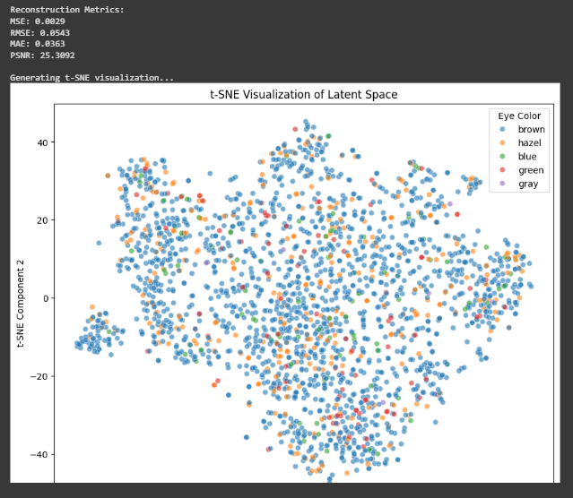

Reconstruction Metrics:

* MSE (Mean Squared Error): 0.0029 - Very low, indicating good reconstruction accuracy
* RMSE (Root Mean Squared Error): 0.0543 - Also showing good performance
* MAE (Mean Absolute Error): 0.0363 - Low average absolute difference between original and reconstructed images
* PSNR (Peak Signal-to-Noise Ratio): 25.3092 - A decent PSNR value; higher values indicate better quality reconstruction (typical good values are between 20-50)

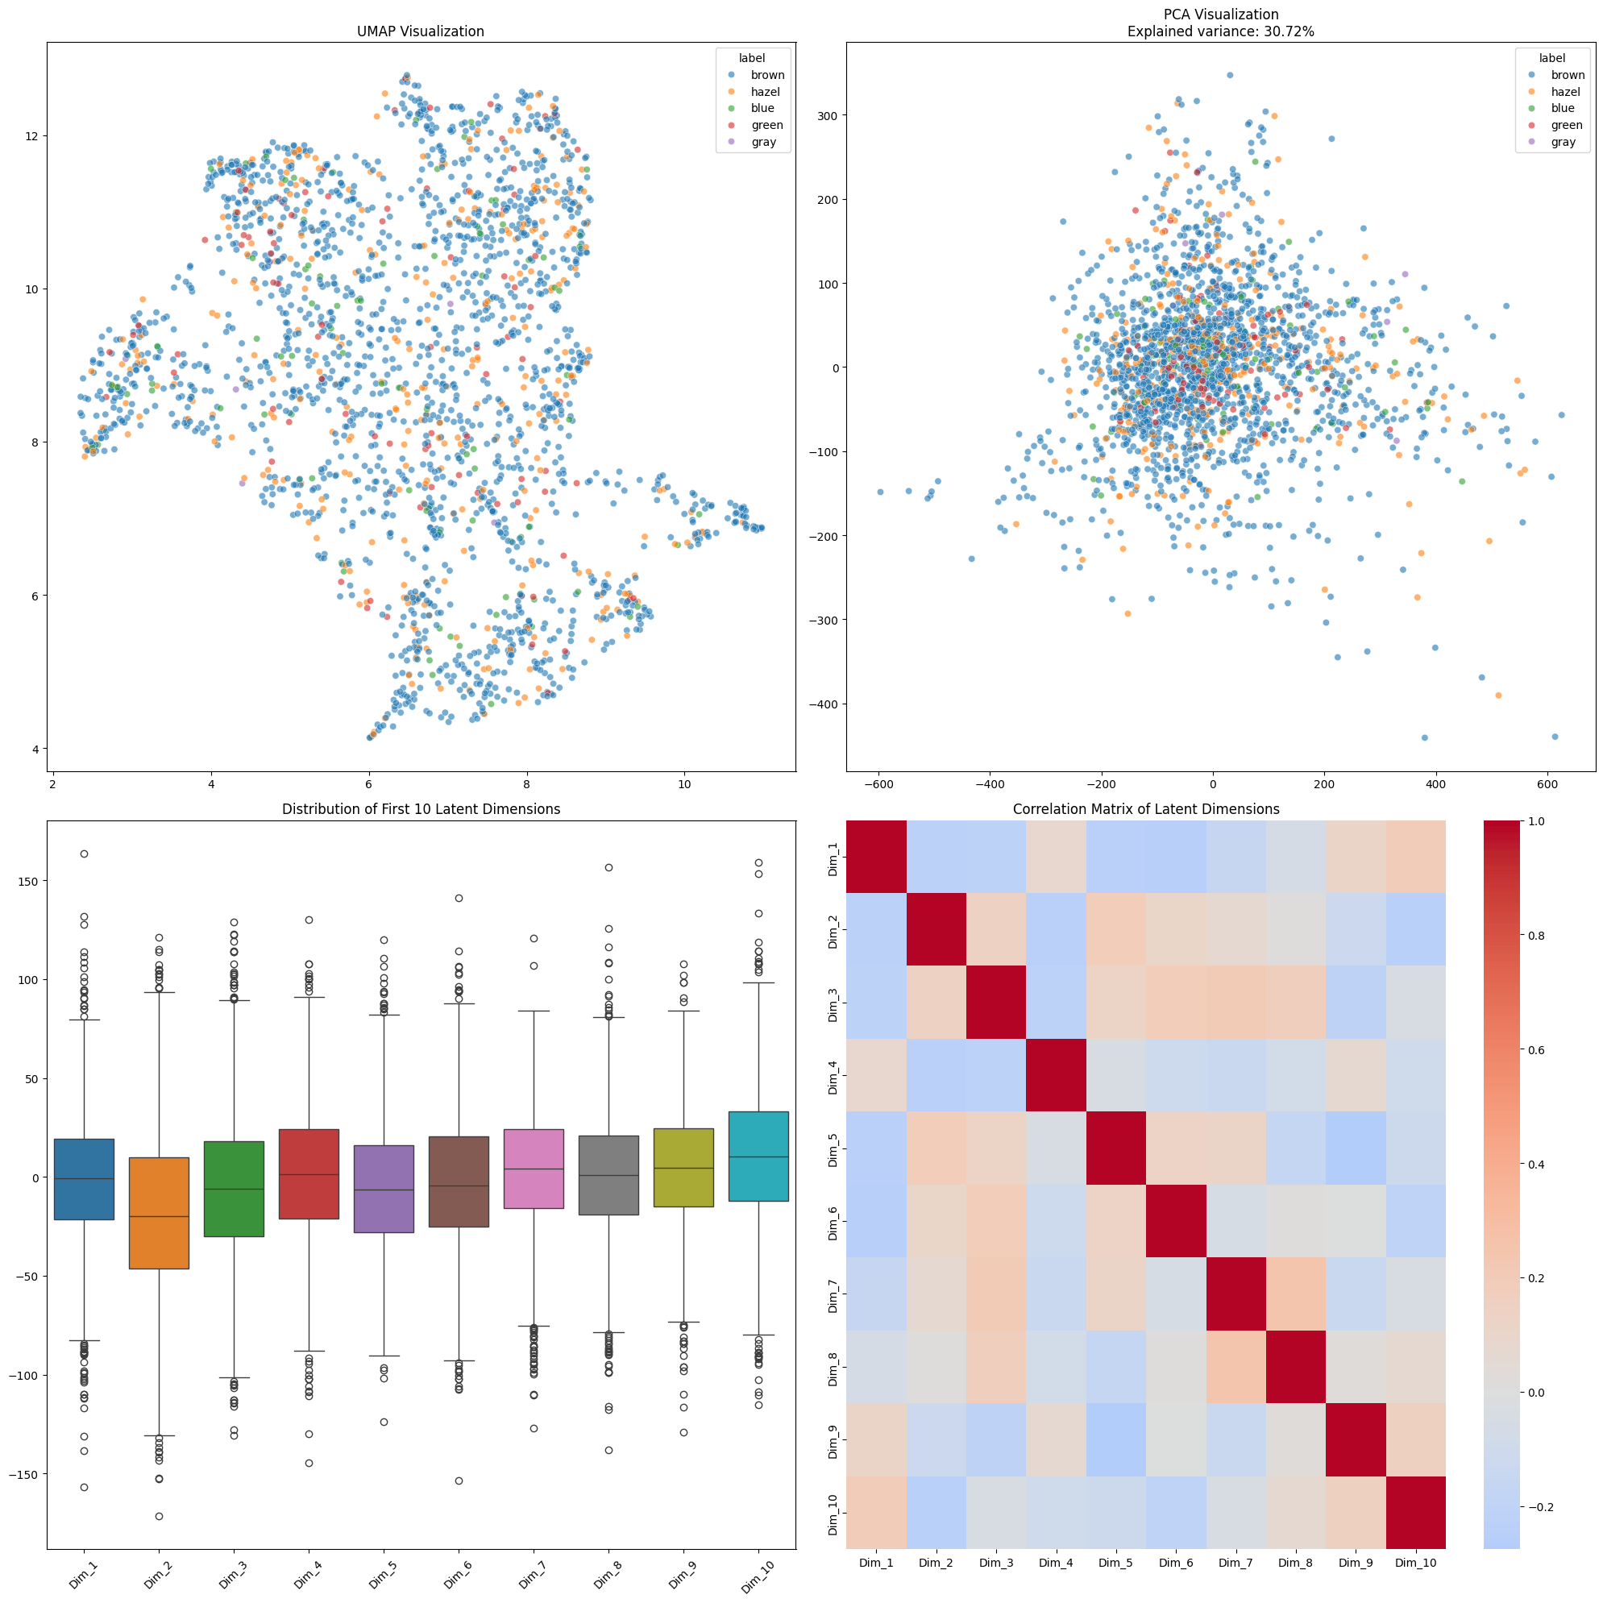

### **UMAP Visualization:**

Shows a non-linear dimensionality reduction of the same data

Creates more distinct clusters and preserves local structure better than PCA

Points are more tightly grouped together (range roughly 2-12 on y-axis, 2-10 on x-axis)

Uses the same color coding for eye colors

Shows some natural clustering of similar eye colors, though there is still significant overlap

The key differences between these visualizations demonstrate the different approaches to dimensionality reduction:

PCA is a linear technique that maximizes variance along principal components, resulting in a more spread-out visualization

UMAP is non-linear and better preserves local relationships, resulting in more clustered data points

### **PCA Visualization:**

Shows the data projected onto its first two principal components

Explains 30.72% of the total variance in the data

Shows a more scattered distribution with less distinct clustering

Points are spread over a wider range (-600 to 600 on x-axis, -400 to 300 on y-axis)

Color coding represents different eye colors (brown, hazel, blue, green, gray)

### **Distribution of First 10 Latent Dimensions :**

Shows box plots for the first 10 dimensions of the latent space

Each box plot shows:

Median (horizontal line in box)

Interquartile range (box)

Whiskers extending to the most extreme non-outlier points

Individual outlier points (circles)

The distributions vary across dimensions but generally:

Center around 0

Have similar ranges (roughly -100 to 150)

Show considerable outliers in most dimensions

This suggests the autoencoder is using the full range of each dimension to encode different features

### **Correlation Matrix of Latent Dimensions (bottom plot):**

Shows the pairwise correlations between the first 10 latent dimensions

Color scale:

Red indicates positive correlation

Blue indicates negative correlation

Intensity represents correlation strength

The diagonal is bright red (correlation = 1.0) as expected (self-correlation)

Most off-diagonal elements show weak correlations (light colors)

This suggests the latent dimensions are relatively independent of each other, which is desirable as it means the autoencoder has learned to encode different features in different dimensions without much redundancy

## Plots and Breakdowns for Latent Dimensions = 32

## 

### **Reconstruction Metrics Comparison:**

MSE: Increased from 0.0040 (worse)

RMSE: Increased from 0.0629 (worse)

MAE: Increased from 0.0430 (worse)

PSNR: Decreased from 24.0301 (worse)

These metrics indicate that reducing the latent dimension from 64 to 32 resulted in slightly worse reconstruction quality, which is expected as we're compressing the information into fewer dimensions.

### **T-SNE Plot:**

Both show similar overall structure

The 32-dim version shows:

Slightly more distinct clusters

More defined separation between some groups

Similar overlap patterns between eye colors

Maintains the dominance of brown eyes in the distribution

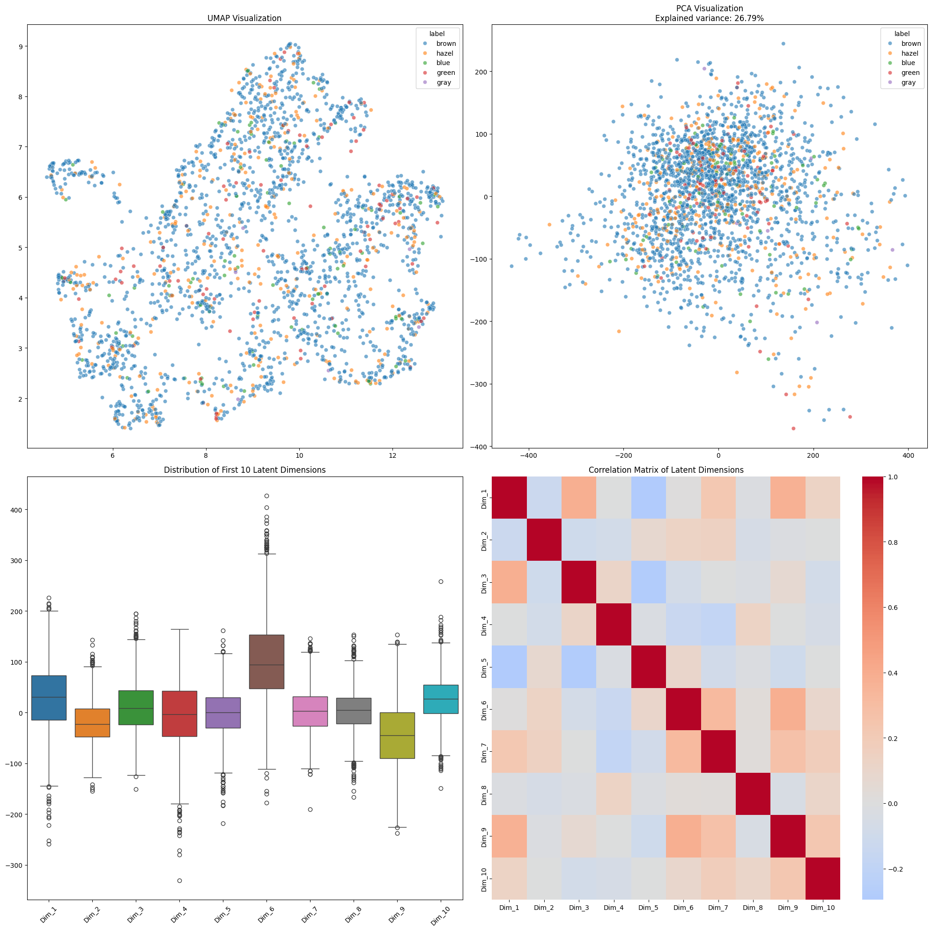

### **Key Insights:**

Slight decrease in reconstruction quality

More compact and slightly better-defined clusters

Lower explained variance in PCA

Maintained overall structure of the latent space

Reasonable trade-off between compression and quality

The dimensions are largely independent (low correlations), suggesting efficient use of the latent space

Each dimension captures different aspects of the iris images

The distributions suggest the model is using different ranges for different features

The presence of outliers indicates some extreme feature values are being captured

The balanced distribution around 0 suggests good normalization of the latent space

These characteristics indicate that the 32-dimensional latent space is effectively encoding different features of the iris images with minimal redundancy between dimensions.

## Plots and Breakdowns for Latent Dimensions = 16

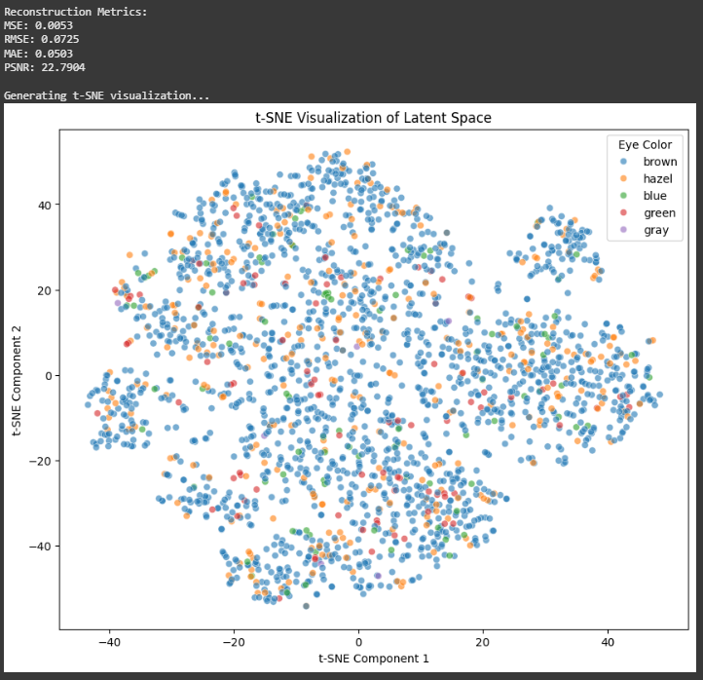

### **Reconstruction Metrics Comparison:**

MSE:0.0053 (getting worse)

RMSE: 0.0725 (getting worse)

MAE: 0.0503 (getting worse)

PSNR: 22.7904 (getting worse)

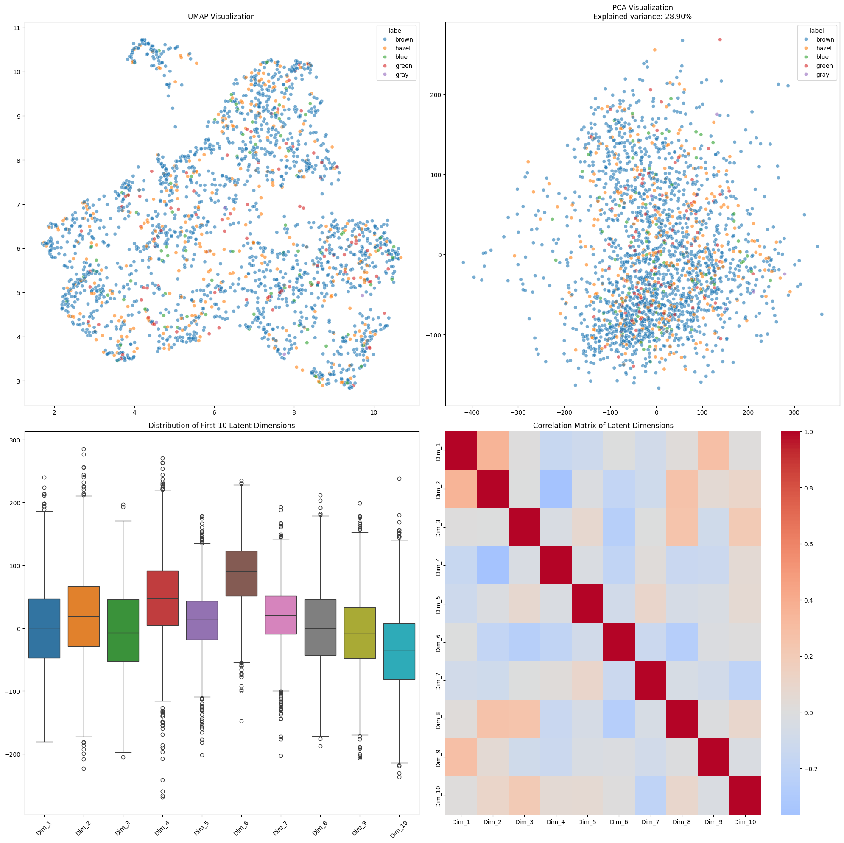

### **Overall Improvements:**

Better organization of latent space (clearer UMAP clusters)

Higher explained variance in PCA

More balanced dimension distributions

More structured correlations between dimensions

## Plots and Breakdowns for Latent Dimensions = 8

## 

### **Reconstruction Metrics Comparison:**

8-dim

MSE: 0.0076

RMSE: 0.0875

MAE: 0.0629

PSNR: 21.1643

## 

### **Key Insights:**

The higher error metrics confirm we're losing some reconstruction fidelity with 8 dimensions.

However, the t-SNE plot suggests the 8-dimensional space is still capturing meaningful features and relationships.

The more distinct clustering might indicate the model is focusing on more fundamental features due to the dimensional constraint.

The trade-off between compression and quality is evident but might be acceptable depending on your use case.

This version with 8 dimensions shows that while we're sacrificing some reconstruction quality, the model is still maintaining meaningful feature organization in the latent space.

## Plots and Breakdowns for Latent Dimensions = 4

## 

