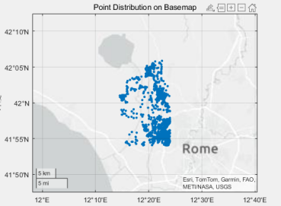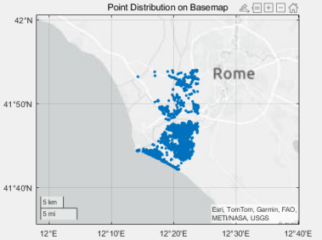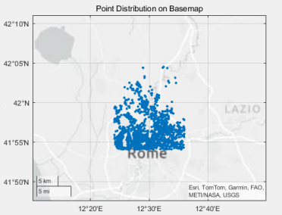
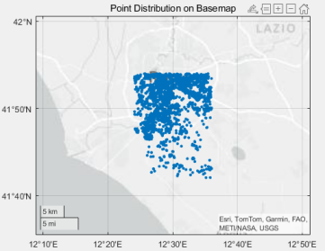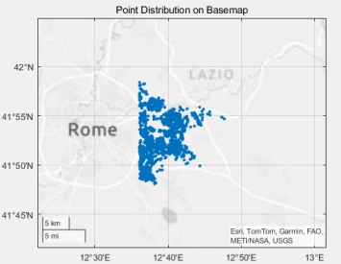

Sample1:
Location_data r1_user1 r2_user1 r3_user1 r4_user1 r5_user1
EM 6780.442 4838.205 3973.737 7333.614 3981.395
EM+BR 6690.871 4824.508 3707.945 6835.940 3923.438
LPCA 6557.884 4678.792 3395.098 6868.331 3740.234

Sample2:
Location_data r1_user2 r2_user2 r3_user2 r4_user2 r5_user2
EM 6585.667 5288.604 3583.123 6816.501 3275.262
EM+BR 6280.301 5239.704 3498.550 6563.294 3172.402
LPCA 6177.441 5139.951 3310.204 6529.143 3017.918

