Spring 2023 Final Project Report

for

Team (2): Elastomer Behavior in Hydrogen Environment

Team members

1. Isabella Alvarado (*Lead*)
2. Josh Kuriakose
3. Micheal O’Brien
4. Jordan Price

Submitted in partial fulfillment of the requirements for MSEN 402

Department of Materials Science and Engineering Texas A&M University

5/2/2023

Course Instructors:

Dr. Kadri Can Atli and Prof. Jim Mabe

Internal Advisor(s): Dr. Raymundo Case, Dr. James Paramore

External Advisor(s): Dr. Ricardo Pardey, Mr. Arturo Ruiz-Aparicio, Mr. Charlie Ribardo Project Sponsor: BP America

# Acknowledgements

This work would not be possible without the financial support of BP America, the sponsor of this capstone project. The advice and guidance provided by our external advisors at BP, namely Dr. Ricardo Pardey, Mr. Arturo Ruiz-Aparicio, and Mr. Charlie Ribardo, have all contributed greatly to our continued progress on this project. Furthermore, the guidance and internal mentorship of Dr. Raymundo Case and Dr. James Paramore, as well as the granted laboratory access of Dr. Paramore and ARL South have been invaluable to the success of this project. Without the continued support of our various advisors, this project would surely fail.

# Table of Contents

**Acknowledgements** **2**

**Table of Contents** **3**

**List of Figures** **4**

**List of Tables** **5**

**Executive Summary** **6**

**1. Introduction** **7**

**2. Problem** **8**

2.1 Problem Statement 8

2.2 Complexity 8

2.3 Scope 8

2.4 Constraints 9

**3. Methodology/Approach** **10**

3.1 Alternatives 10

3.2 Selected Approach 10

**4. Project Schedule** **12**

**5. Technical Description** **12**

5.1 Experimental apparatus setup and autoclave design 13

5.2 Rapid Gas Decompression (RGD) 14

5.3 Permeability 16

5.4 Aging 19

5.5 Results 20

**6. Skill and Capabilities Used** **22**

**7. Standards and Codes** **23**

**8. Consideration of Risk** **24**

**9. Recognition of Ethical and Professional Issues** **25**

**10. Economic Analysis and Broader Impact** **26**

10.1 Cost Analysis 26

10.2 Broader Impact 26

**11. Conclusions and Recommendations** **28**

**12. Future Works** **28**

**13. List of Appendices** **29**

**14. References** **30**

# List of Figures

|  |  |
| --- | --- |
| *Figure 1. Gantt chart of our expected project schedule for the rest of the semester. . . Completed tasks are in gray, continuing tasks are in light blue and deadlines . are in dark blue.* | 12 |
| *Figure 2. Schematic drawing of reactor setup.* | 13 |
| *Figure 3. Mean values for diffusivity in EPDM together with the value predicted by . molecular dynamics plotted against the square of the diameter. The solid line . represents the fit to experimental data for all gasses.* | 15 |
| *Figure 4. The o-ring fixture fully opened (left), with o-rings secured inside (middle), and closed (right). This fixture will go inside our autoclave.* | 16 |
| *Figure 5. Prototype permeability cell design. Pressurized hydrogen will flow into the . top hole, contact the sample and permeate through it, then be measured by a . sensor connected to the bottom.* | 17 |
| *Figure 6. ASTM standard design for our permeability cell.* | 17 |
| *Figure 7. Volumetric flow sensor to be used to measure the permeability of hydrogen . through the membrane.* | 18 |
| *Figure 8. Plot of engineering stress and strain for control and aged samples.* | 20 |

# List of Tables

|  |  |
| --- | --- |
| *Table 1. Dimensions of the two autoclaves provided for the project.* | 10 |
| *Table 2****.*** *Weight % composition of Hastelloy C-276* | 14 |
| *Table 3. This table shows the testing parameters for RGD. These parameters will be the. same for the pure hydrogen and hydrogen mixture.* | 15 |
| *Table 4. This table shows the testing parameters for permeability testing.* | 19 |
| *Table 5. This table shows the dimensions of the control and aged dogbone samples.* | 19 |
| *Table 6. Table 6. UTS values for control and aged samples* | 20 |
| *Table 7. Results from statistical analysis done in Minitab* | 21 |
| *Table 8. Side-by-side comparisons for each component of our project regarding the desired outcomes vs the actual outcomes.* | 22 |
| *Table 9. Standards and Codes we are following for this project. Highlighted items are used in Section 5, Technical Description.* | 23 |
| *Table 10. Predicted risks that could hinder the project’s successful completion.* | 24 |
| *Table 11. Total cost breakdown for the project to date.* | 26 |

# Executive Summary

Hydrogen exposure can degrade elastomers used in many processing facilities. Elastomer degradation leads to the failure of seals, linings, and other parts. Their failure can lead to hydrogen loss and pose a major risk to employees, as well as monetary loss and environmental damage. Using hydrogen will require processing facilities to replace parts regularly as they degrade, increasing waste and cost. Investigating this phenomenon will give a better understanding to manufacturers and begin the process of creating better elastomers for these applications. The small hydrogen molecule can penetrate the polymer matrix with relatively low activation energy. Under high external pressure, the polymer’s internal pressure is small. Hydrogen molecules present in the surrounding environment congregate in the polymer matrix. When the external pressure decreases, the polymer’s internal pressure increases relative to its surroundings, and the hydrogen quickly evacuates the elastomer. This is where voids and cracks can form. Our approach was to characterize the degradation of these elastomers in a hydrogen environment and design a permeation cell. We designed a permeation cell in order to measure hydrogen permeation through elastomers. We 3D printed our permeation cell and validated its functionality. We decided to age the Viton samples in a specialty gas mixture made from 98% hydrogen, 1.5% nitrogen, and 0.5% methane. We left the samples in this environment for about 56 hours at 100°C and at 100 bar. After we tensile tested the aged samples and compared them with our control group. After performing this experiment, we know hydrogen does affect the strength of elastomers. This will lay the groundwork for continuation of the project and will allow for other researchers at Texas A&M to continue our work. Additionally, this can lead to designing better elastomers to withstand hydrogen environments and assessing the working time that an elastomer seal can be used under hydrogen exposure.

# Introduction

Hydrogen is used widely in the refining of diesel fuels for the removal of sulfur and other unwanted contaminants. According to the U.S. Energy Information Administration [[2](https://www.zotero.org/google-docs/?vzsJlQ)], “Refinery demand for hydrogen has increased as demand for diesel fuel has risen both domestically and internationally, and as sulfur-content regulations have become more stringent.” As industrial uses for hydrogen continue to develop, the proper containment and transportation of hydrogen as a pressurized gas continues to be important to reduce costs and keep factory operations safe. One major area of concern in the transportation of hydrogen is the elastomers such as O-rings and seals in piping. Elastomers provide flexibility and are readily available for manufacturers. They are also not as brittle as metals. Exposure to hydrogen gas and pressurization and depressurization cycles can degrade these elastomers. Over time this can cause damage and leaks in manufacturing infrastructure.

Elastomers in contact with hydrogen before and during rapid decompression events degrade and lose integrity. The interaction depends on multiple factors including temperature, pressure, and hydrogen concentration. Key factors that affect degradation are depressurization rate and frequency, material type, seal constraints, and thermodynamics [[3](https://www.zotero.org/google-docs/?LC42Vd)]. Elastomeric hoses, linings, and o-rings come in contact with hydrogen gas. Understanding the interaction between the elastomer and gas is important to safely operate BP America’s processing facilities. Cyclic depressurization can cause cavitation and internal stresses that can damage the polymer matrix. Hydrogen and the polymer matrix reach a pressure-dependent saturation concentration if the two reach equilibrium. Over-saturation occurs when the external pressure decreases. Bubbles and cavities form within the matrix to increase the internal pressure to counteract the decrease in external pressure [[3](https://www.zotero.org/google-docs/?broken=EvmN1J)].

Recent studies theorize that the highly crosslinked networks are so tight that the hydrogen molecule doesn’t as easily permeate the polymer matrix. The elastomer that we evaluated was a fluoroelastomer Viton. Originally, we were also going to evaluate ethylene propylene diene (EPDM) and hydrogenated acrylonitrile butadiene (HNBR). However, we ran into supply issues. All three elastomers are commonly used in industry because they have a high temperature and oxidative resistance while maintaining elastic properties [[3](https://www.zotero.org/google-docs/?5xwhrW)]. Most importantly, all three are highly crosslinked.

This project was significant because it explored how much hydrogen can degrade Viton. Time constraints forced us to age at only one pressure and one temperature. To get the most significant results we aged the dog bones at a high temperature and a high pressure. We saw that aging the dog bones decreased the elastomer’s ultimate tensile stress. Overall, we proved that hydrogen will degrade Viton in a relatively short amount of time. Additionally, another group can easily continue this project because of the work we completed over the year. The findings from this project can also be used in future research to find a material that can withstand hydrogen, leading to fewer parts being used and reducing waste.

# Problem

## Problem Statement

Elastomers can degrade when under rapid hydrogen compression and decompression cycles for long periods of time, resulting in weak, brittle elastomers that are ineffective gas barriers. This impacts the safety and long-term usability of elastomer seals in processing equipment that uses hydrogen. Further study of this phenomenon would help model this degradation and help the production of more durable, long-lasting elastomer seals.

## Complexity

The phenomenon we are studying between hydrogen and the given elastomers is complex due to the multiple factors that contribute to the degradation itself. The main factors that need to be observed to understand this interaction are frequency and rate of depressurization, material type, quantity of degradation, and thermodynamics. Each factor can also have varying degrees of complexity.

Additionally, we set out to design our own permeability testing apparatus. We needed to consider metal’s tendencies to embrittlement when exposed to hydrogen when we designed our apparatus. We also had to consider the safety and functionality of Dr. Paramore’s lab, which we were not familiar with.

Finally, there are no existing standards to test elastomers in a hydrogen environment. Most standards that exist for testing elastomers in a gaseous environment are for carbon dioxide. We are modifying these standards to work for our experiment by analyzing hydrogen permeation rates through our materials and the effect of temperature on our tests. We will talk about our method more later in this report.

## Scope

We planned to perform tests on three elastomers, ethylene propylene diene monomer rubber (EPDM), hydrogenated acrylonitrile butadiene rubber (HNBR), and fluoroelastomer (FKM), but due to constraints with our supplier we only tested FKM. We validated the prototype design we constructed for permeability studies, is now capable of performing RGD, and ran preliminary aging tests under hydrogen exposure. We then characterized the tensile strength of our samples to observe their mechanical properties and determine if our testing had any effect. These tests were carried out in an environment that simulates processing plant conditions to evaluate the properties of the elastomers in these specific scenarios. Another form of evaluation is through modeling and simulation. Although this technique may prove useful in other scenarios, we will not be implementing it here in our lab, and no results will be generated computationally. We believe this would take far longer than the time we have allotted and could better be addressed by students under a different discipline. The goal of our lab is to characterize our samples. We did not seek ways to prevent degradation or reinforce the elastomers in any way through this experiment. Again, this would require extensive chemical and material analysis that is more suited to a long-term research project and is not what we seek to address. Our primary concern was to observe the properties of the elastomers in specific environments so we can better predict the life cycle for these elastomers.

## Constraints

The largest constraint for this project was safety as hydrogen is very dangerous. We chose our lab space and all equipment purchases with safety in mind. Our lab space required a hydrogen exhaust system installed. All of our equipment needed to be able to withstand hydrogen embrittlement. Additionally, the concern for safety meant that time-constrained us as well. We were only allowed to be in the lab with Dr. Paramore or his graduate student present. Safety also constrained our material selection process. All of our fittings and equipment needed to be made of stainless steel. All fittings and equipment also needed to be rated for over 1450 psi and 100°C. Because of our material requirements material accessibility and limited options also constrained us.

The budget was also a constraint for us. Ideally, all materials would be made of Hastelloy. However, Hastelloy fittings and regulators were not in our budget. Additionally, our project would have benefitted from a stainless steel programmable regulator to perform all tests. Then we would not have to be in the lab when all the tests were running. However, this also was not in the budget.

Though we have these various constraints, we still worked to produce quality results and conclusions on the 3 elastomers chosen.

# Methodology/Approach

## Alternatives

The first alternative method that could provide meaningful results is exposing the elastomers in manners similar to how they would be used in an industrial setting and characterizing them after use. For example, the elastomers could be used to seal a hydrogen pressure vessel and the elastomer could be characterized as time progresses. However, we believe this method would take longer to see effects. Instead, we tested the elastomers in much harsher conditions to increase the hydrogen’s negative effects on the elastomers.

The second alternative regards the RGD cycles. The single-cycle RGD is when the chamber is pressurized for around 24 hours, and rapidly decompressed once. Our literature review showed that multiple, short-term cycles have a greater effect on elastomer integrity, so we will be doing 8 cycles at one hour per cycle.

The third alternative was using o-rings for both aging and RGD. We already have some o-rings from a previous year. We do have enough for both RGD and aging experiments. However, tensile testing the o-rings would be difficult, as we would have to consider purchasing or designing a mount for o-ring testing.

Another alternative was our choice in autoclave. Dr. Case provided an autoclave from a previous capstone group, referred to as autoclave 1. Dr. Paramore also volunteered a reactor in his lab that can be functionalized as an autoclave. From here will be referring to it as autoclave 2. Autoclave 1 is large and can fit many samples but it is not outfitted with a thermocouple or pressure sensing and regulation. We are required to heat or cool our samples depending on our tests and maintain a constant atmosphere. Therefore, we would need to purchase or design a heating and cooling system and a pressure regulation system to use autoclave 1. Autoclave 2 is already outfitted with a thermocouple and pressure gauge that has a digital readout, as well as an electric heater and insulation capable of the temperatures required. Therefore, to save money we will use autoclave 2. Below are both autoclaves’ dimensions.

*Table 1. Dimensions of the two autoclaves provided for the project.*

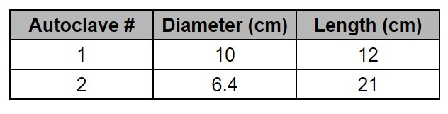

## Selected Approach

We planned to study degradation of elastomers in a hydrogen environment with 3 methods. We planned to use RGD, a permeability study, and aging with an arrhenius approach. For RGD and aging we used autoclave 2. Autoclave 2 is already outfitted with a heating and cooling system and saves money and time.

We used one elastomer for our tests, fluoroelastomer (FKM). The elastomer is tightly crosslinked and industry commonly uses them for processes. BP provided the elastomers from their supplier Green Tweed.

For each experiment we used a different shape sample. For RGD we planned to use o-rings. We would place the o-rings in a contraption and then place the contraption inside the autoclave. A previous team designed the contraptions that we will be using for RGD. For permeability we would use elastomer discs. We chose the disc shape to fit our permeation cell design. Finally, for aging we used ASTM Type IV dog bones. After aging we tensile tested the dog bones. Type IV dogbones are the standard for elastomers and we can easily test them with the tensile machines we have available to us.

For RGD, we planned to pressurize and depressurize an autoclave with hydrogen gas while our elastomer samples were inside autoclave 2. The RGD testing would be done following Norsok m710 standard and ISO 23936-2 and the testing parameters are shown in Table 2 below. We made some minor adjustments to the standards to fit with hydrogen. Both standards use carbon dioxide as their gas. Per standard each sample would soak in hydrogen for 60 hours. Then, following standards each cycle is 1 hour with a total of 8 hours and the decompression rate is 20 bar/min (9). Once the samples undergo RGD testing, the effects depressurization has on the elastomers should be visually examined for swelling and cracking, as well as any warping in the shape of the O-ring. Due to a regulator recall that we will discuss later, we were not able to complete RGD testing.

For the permeability study, we designed a testing apparatus to be used in Dr. Paramore’s hydrogen lab. The apparatus measures permeability using the differential pressure method, which uses the sample as a barrier and measures the flow of hydrogen gas through the sample with pressure sensors. Our present design discussed later ended in prototyping stages, and which we validated by testing the fit in our test cell with a 3D printed prototype that will not be pressurized. We then made some modifications, and moving forward, would get it machined from the Zachry machine shop in 316 stainless steel and begin permeation testing.

Our design, which is discussed in more detail later, is based on a cell that is designed to be used with oxygen. The elastomer sample is held in place in between the steel pieces and acts as a pressure barrier between the sides of the cell, and the flow from high to low pressure is measured by a flow sensor that is incorporated into the ventilation in place in the lab. The testing parameters we intend to use are discussed in the technical description section. The permeability samples will be disks following ASTM D1434.

For aging, we intended to use an Arrhenius equation to predict the effects of temperature and pressure on the properties of the sample, to find an analog relationship with time. With this approach we would test samples for a lower amount of time and understand their properties after many hours. The testing parameters that were provided by BP are listed in Table 5 in the technical description. We were able to age at a single extreme time and temperature, though, and test the effects on the mechanical properties of the polymers with tensile testing.

The times, temperatures and pressures tested our samples under will be discussed in the technical description.

For all the studies we performed, the control sample is a novel polymer sample taken directly from the supplier. We performed tensile tests and used the mechanical properties we found as the control numbers.

# Project Schedule

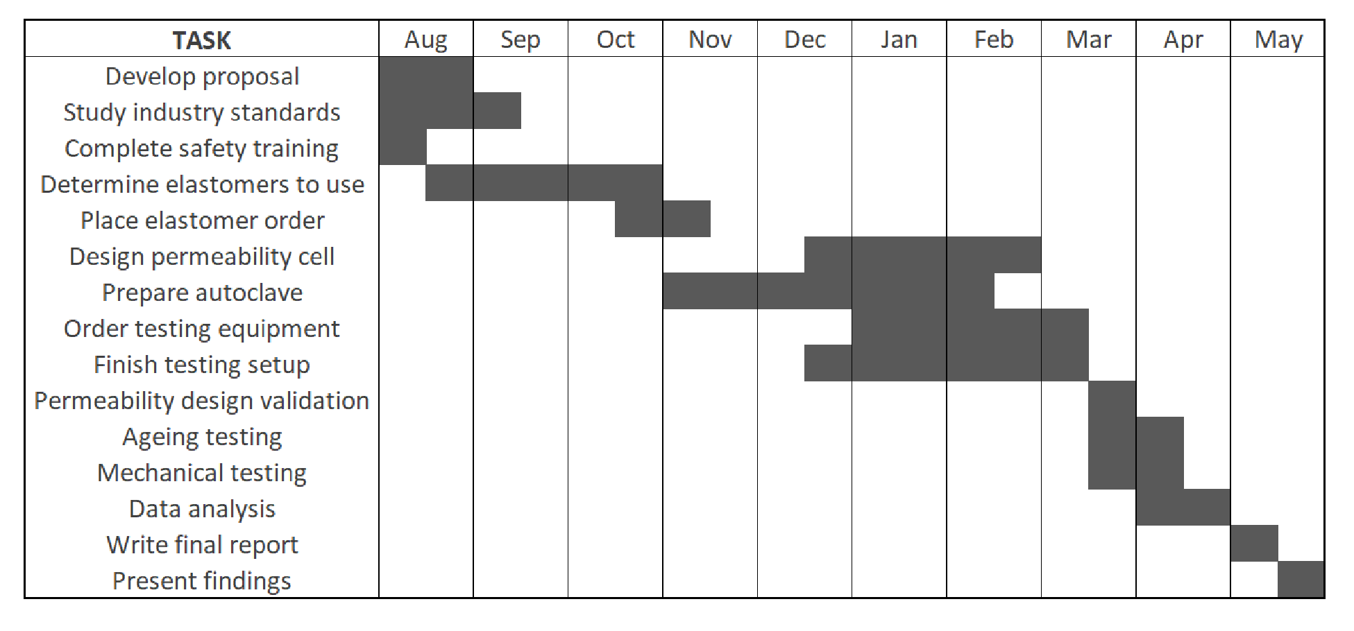

*Figure 1. Gantt chart of our final project schedule for the rest of the semester. Completed tasks are in gray.*

It is worth noting that we fell significantly behind our intended schedule for the semester. There is a sharp transition line in our Gantt chart above, which is when we received our samples from Green Tweed, in mid-March. From there, we did the best we could to validate our testing setup and prototype in order to have some results by April. All things considered, we believe that given another month we could have expanded on our aging study and finished our permeability testing apparatus.

# Technical Description

We planned to study the degradation of these elastomers in a hydrogen environment with 3 methods: Rapid Gas Decompression (RGD), Aging using the Arrhenius approach, and a Permeability study. Due to shipping delays and specific equipment recalls and considering our own safety, we were only able to perform aging.

## Experimental apparatus setup and autoclave design

To test RGD and aging, we have an autoclave set up in Dr. Paramore’s lab along with our hydrogen tanks. This is one of two autoclaves we selected from as we also have one in our possession that was provided by Dr. Case (as described earlier in section 3.1). As seen in Table 1 above, Dr. Case’s autoclave is larger in diameter but shorter in length with the overall volume being comparable to Dr. Paramore’s. However, unlike Dr. Case’s, the autoclave in Dr. Paramore’s lab is already equipped with a heating unit and thermocouple, both of which are required to run our RGD and aging tests. It is also important to note that our “autoclave” in Dr. Paramore’s lab is a mini reactor from *Parr* that we functionalized to be used as an autoclave.

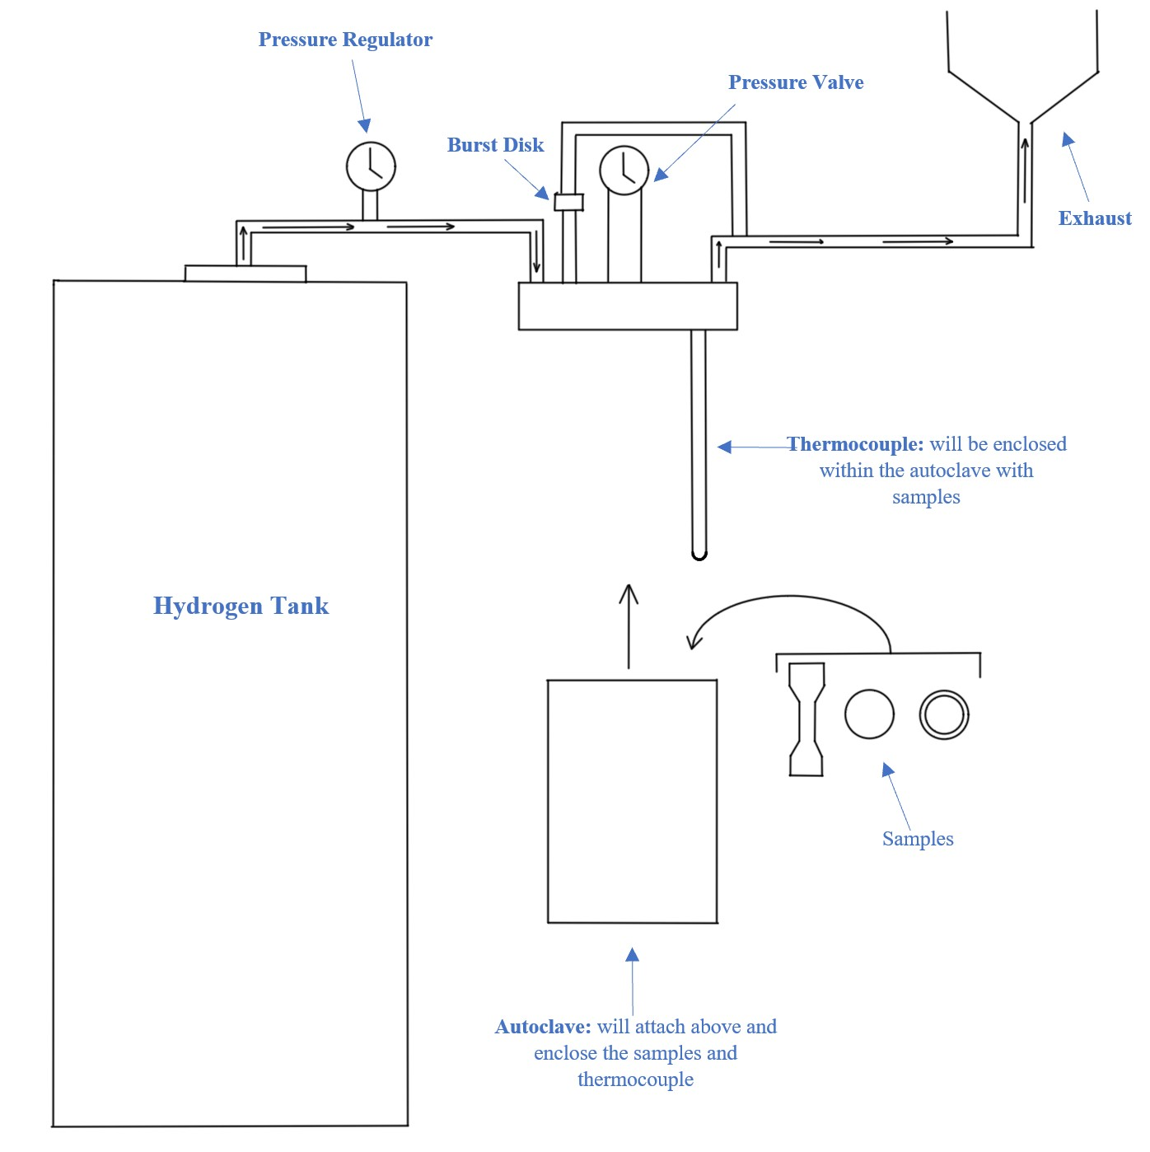

*Figure 2. Schematic drawing of reactor setup.*

The reactor is made of Hastelloy C-276 which is suitable for hydrogen loading, as it is resistant to hydrogen embrittlement. However, despite Hastelloy C-276 being the safest material to use, it is expensive and difficult to obtain and machine. Thus, after a literature review [[4](https://www.zotero.org/google-docs/?0eA8Tz)] and a discussion with our faculty mentor, we have confirmed 316 stainless steel as a viable replacement to Hastelloy for the rest of our fittings. This material selection will allow us to remain within our budget.

*Table 2****.*** *Weight % composition of Hastelloy C-276 [*[*5*](https://www.zotero.org/google-docs/?wz8pmA)*]*



## Rapid Gas Decompression (RGD)

Rapid Gas Decompression is a method of studying hydrogen degradation where a sample is pressurized and then rapidly decompressed in a particular gas atmosphere. Under pressure, the gas permeates through the sample, and when decompressed, the gas suddenly expands and causes voids to form in the samples. There are two components to an RGD test: a soaking period and decompression cycles. In the soaking period, the sample is placed under pressure for a period of time to allow the gas time to diffuse through the sample matrix. After the sample is “soaked”, pressure is released rapidly, the sample is inspected, and the autoclave is repressurized. Afterward, we would visually inspect the sample for voids and characterize them via optical microscopy and/or SEM. The intention was to utilize this material to model the interaction between hydrogen and the polymer matrix by analyzing the effect of frequency and rate of depressurization.

There are two standards that can be followed for RGD: Norsok M-710 and ISO 23936-2. However, these standards are for carbon dioxide gas (there are not any for hydrogen) and because there are operational limitations, we are following a modified industry standard for testing RGD with hydrogen. Thus, in our experiment, we had planned to do a 60-hour soaking period and 8 one-hour pressurization cycles with a decompression rate of 20 bar/minute. It is important to note that hydrogen is a smaller molecule compared to carbon dioxide and is expected to diffuse through our elastomers far more rapidly than carbon dioxide. This expectation is further backed by a study done by the Los Alamos National Laboratory [[6](https://www.zotero.org/google-docs/?CTgqEt)]. As seen in Figure 2 taken from the study, the mean diffusivity for hydrogen is significantly higher than for carbon dioxide. Therefore, it is possible that RGD hydrogen tests can be done with a shorter soaking period and fewer decompression cycles. All testing parameters are highlighted in Table 3.

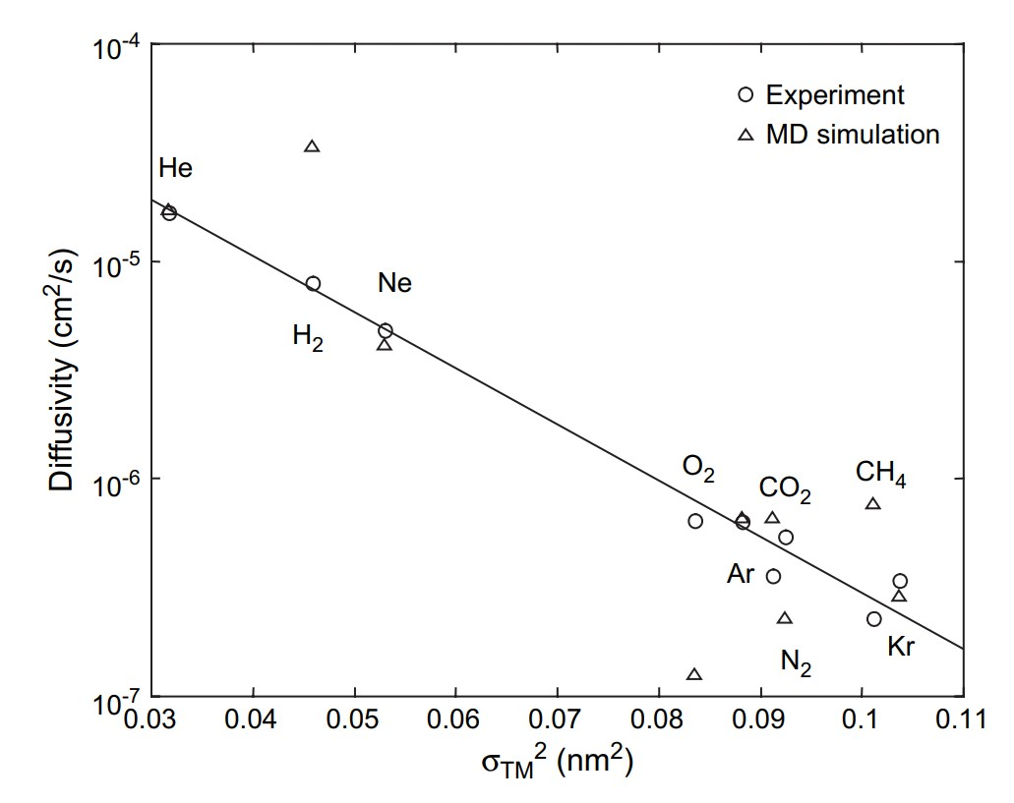

*Figure 3. Mean values for diffusivity in EPDM together with the value predicted by molecular dynamics plotted against the square of the diameter. The solid line represents the fit to experimental data for all gasses.* [[7](https://www.zotero.org/google-docs/?kZIaIo)].

*Table 3. This table shows the planned testing parameters for RGD. These parameters would remain for the pure hydrogen and hydrogen mixture.*

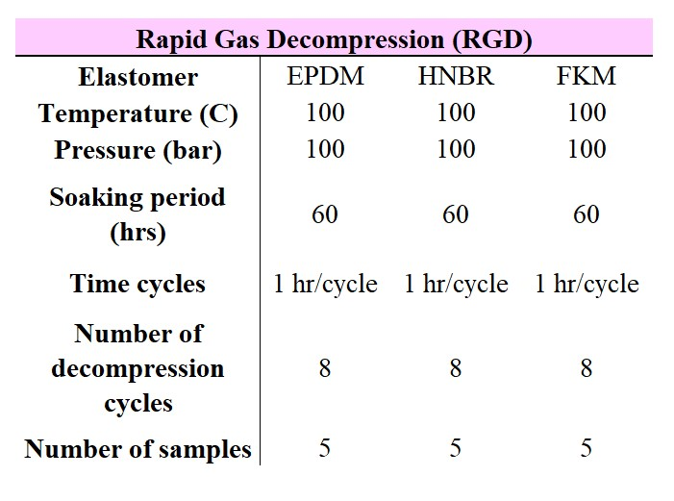

Before any testing, we calculated the number of pressurizations we could do per tank before the pressure dropped below 100 bar. The calculations were done assuming ideal gas conditions:

𝑃𝐹𝑖𝑛𝑎𝑙 = 𝑃𝐼𝑛𝑖𝑡𝑖𝑎𝑙 − 𝑃𝑅𝑒𝑎𝑐𝑡𝑜𝑟𝑇𝑅𝑒𝑎𝑐𝑡𝑜𝑟𝑇𝐶𝑦𝑙𝑖𝑛𝑑𝑒𝑟𝑉𝐶𝑦𝑙𝑖𝑛𝑑𝑒𝑟𝑉𝑅𝑒𝑎𝑐𝑡𝑜𝑟 (Eq. 1)

According to our calculations, we could do around 33 pressurizations per tank, equivalent to around four full RGD tests per tank. We only needed to do two tests for each material.

As mentioned earlier, the RGD tests would be conducted using the autoclave. In order to effectively and safely control the pressure, we ordered a single-stage pressure regulator fitted to the hydrogen tanks to ensure that the system stays below a safe pressure threshold. We also have a burst disk (Figure 2) that will safely evacuate the reactor if excess pressure is reached to protect the equipment. For RGD we will only be testing o-rings and will be using an o-ring fixture made of 316 stainless steel to keep our samples separated within the autoclave (Figure 4). This will allow hydrogen to distribute uniformly to the elastomers during pressurization. When decompressing there is also a concern for the hydrogen to solidify within the autoclave. After analyzing a phase diagram for hydrogen, it was confirmed that the testing conditions for RGD will not cause solidification [[8](https://www.zotero.org/google-docs/?pQbAxZ)].

However, the regulator we ordered that was designed for hydrogen loading was recalled and we were not given notice, despite numerous attempts to reach out for an update. As a result, we were not able to complete any RGD tests with hydrogen. Despite this setback, we were still able to do safety testing and validate functionality via Ar gas using a brass regulator. With this testing, we verified that we were able to pressurize at elevated temperatures, hold pressure and temperature for long periods of time, and safely depressurize at a controlled rate, which we could then do with hydrogen gas once we have an appropriate regulator.

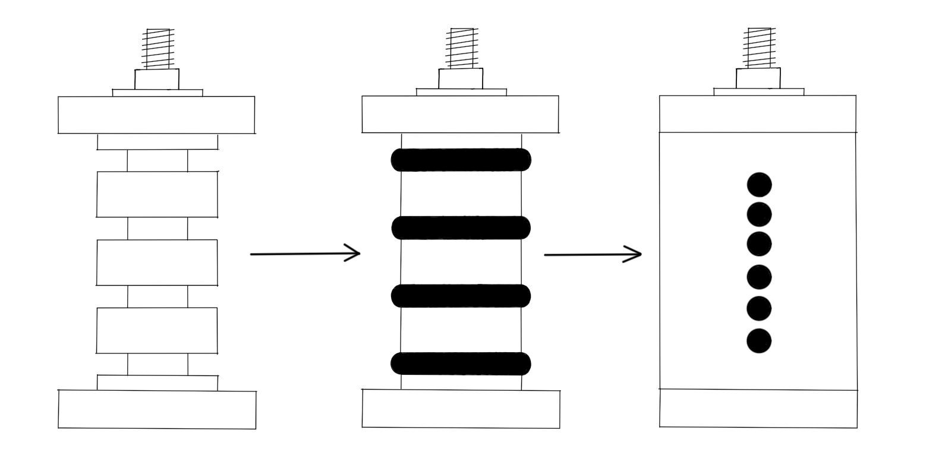

*Figure 4. This is a schematic drawing for the o-ring fixture. The o-ring fixture fully opened (left), with o-rings secured inside (middle), and closed (right). This fixture will go inside our autoclave.*

## Permeability

To test permeability, we followed ASTM D1434 - 82 (2003) for our apparatus design and sample dimensions. We asked for 3 mm thick disks of our chosen elastomers, which were closer to 2.50 mm. This is not an issue, and with only minor adjustments to the apparatus, we were able to get a permeability cell working that fit the samples we received. Moving forward, this apparatus should be machined out of 316 SS with ¼ NPT threading on the top and bottom. Then, samples could be locked into the apparatus shown below in Figure 4, and the inlet (top) side could be pressurized with our autoclave setup up to 50 bar. The walls are 10mm all the way around, which will easily withstand the pressures the setup will be subjected to [[9](https://www.zotero.org/google-docs/?oiOsbK)]. More images of the design and the prototype we 3D printed can be found in Appendix A.

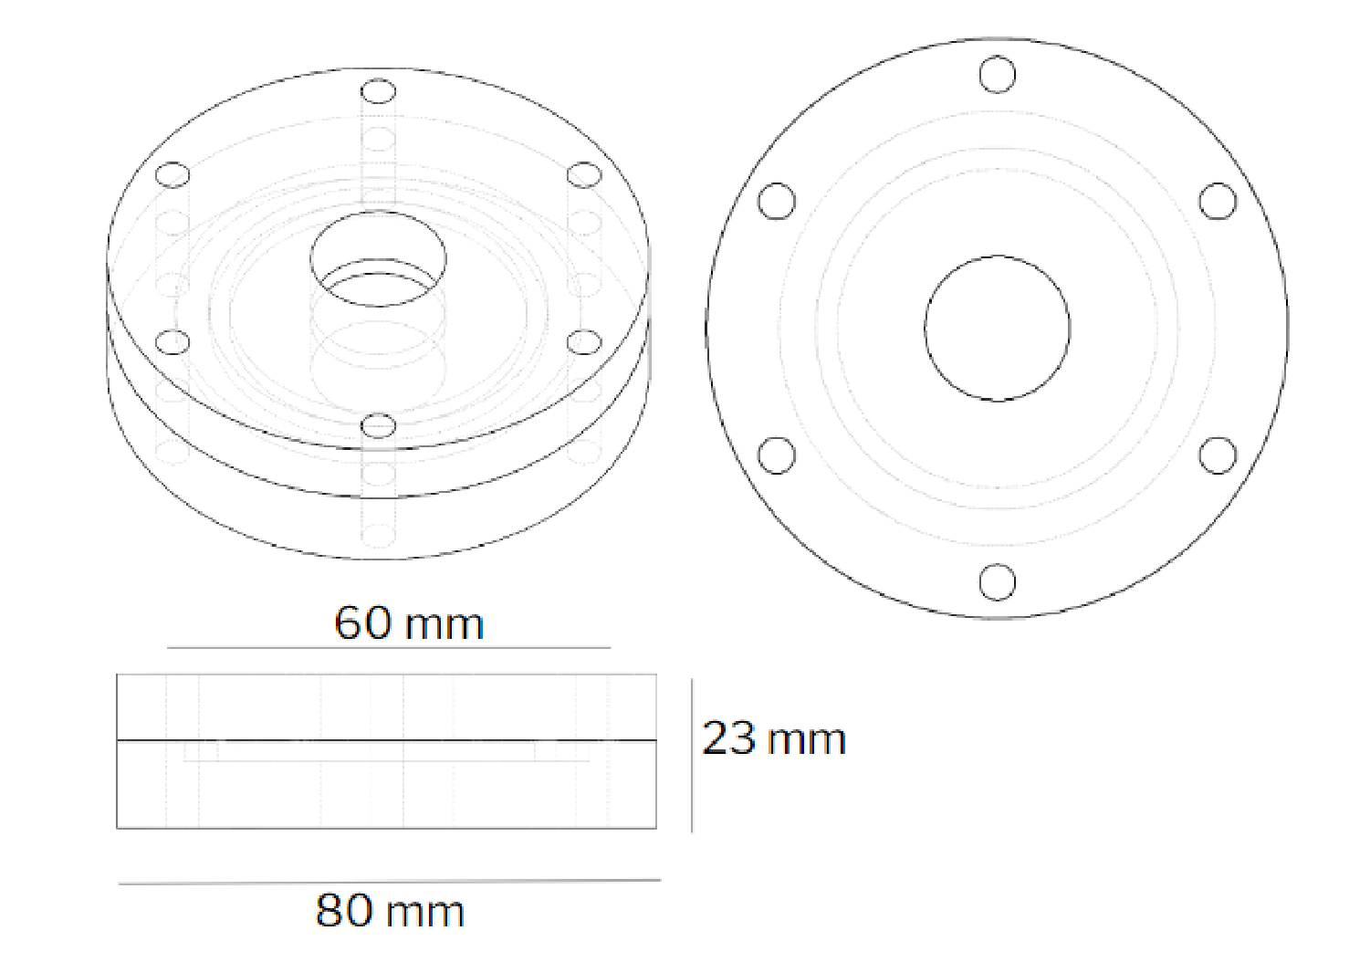

*Figure 5. Prototype permeability cell design. Pressurized hydrogen will flow into the top hole, contact the sample and permeate through it, then be measured by a sensor connected to the bottom.*

The outlet would flow through a volumetric flow sensor. Our cited standard recommends using a mercury pressure scale fixed to the outlet of the permeability cell, as can be seen in Figure 5.

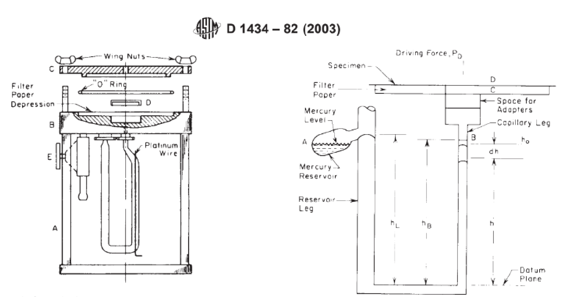

*Figure 6. ASTM standard design for permeability cells.*

However, due to limited access to precision glassware and space constraints for our experimental setup, we have elected to use a digital volumetric flow sensor that will have a digital readout, like the one in Figure 6.

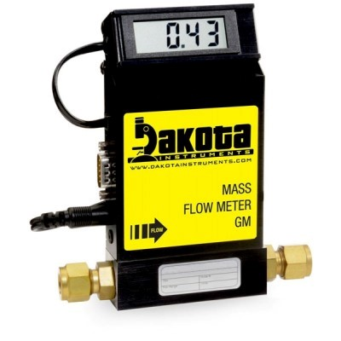

*Figure 7. Volumetric flow sensor to be used to measure the permeability of hydrogen through the membrane.*

This flow sensor [[10](https://www.zotero.org/google-docs/?o2izDv)] would greatly simplify the apparatus setup required to measure the permeability of hydrogen through the elastomer sample, and is well within our budget. Currently, we have designed a prototype based on the drawing shown above and it has been 3D printed with FDM in PLA plastic. With the prototype we have confirmed that the tolerances used are adequate and the pieces can be fastened together with 6M machine screws. We could then have a second prototype machined from Delrin resin to test that the gas seals all hold low pressure, which will translate to high pressure stainless steel for the final piece. Our limiting factor to the progress of the permeability test cell design has been the delivery of our samples, and we will address that in the risk assessment portion of this report. All used pressures, temperatures and gas concentrations are presented in Table 4 below, in a full-factorial test grid consisting of 8 individual studies.

*Table 4. This table shows the testing parameters for permeability testing.*

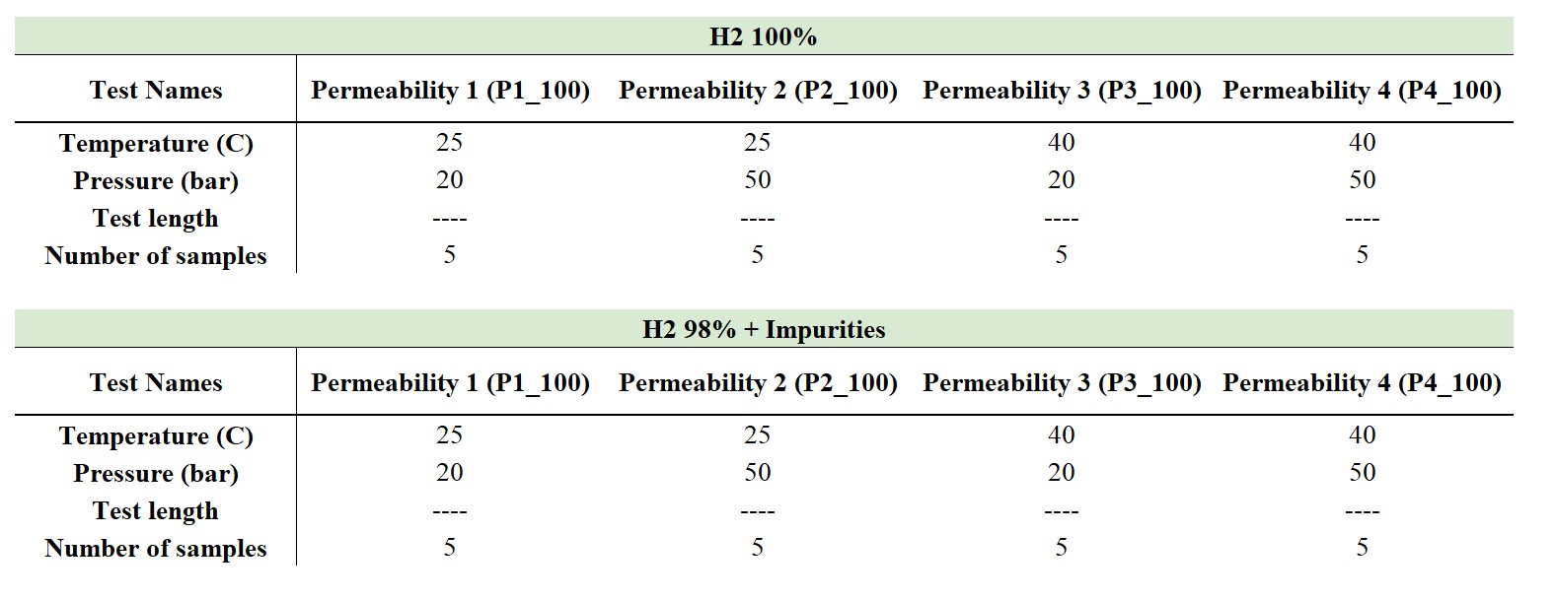

## Aging

For aging, we had intended to age all three materials at three different temperatures (60oC, 800oC, 100oC) for a set time before tensile testing, then construct an Arrhenius plot from the data to further model the interaction between hydrogen and the polymer matrix. This would have also allowed us to establish the operating conditions as well. However as we faced more and more delays with the regulator(we also were only sent one material from BP, which was FKM) and timing became a more apparent concern, we sought an alternative approach. Instead of applying the Arrhenius approach, we decided to only test at a single pressure and temperature and then report any changes in the material’s properties after tensile testing. There was also a concern that the conditions would not be enough to see any change. Therefore, to accelerate the aging effects we loaded the samples at 100oC and 100 bar (1450 psi).

To test without a regulator, we had to connect our autoclave system directly to the tank. Obviously, there were safety concerns so to validate this setup we initially tested the elevated conditions with Ar gas. The test was a success as we were able to hold the desired pressure and temperature without any leakage or signs of instability. Before we tested with hydrogen we used a vacuum pump to evacuate out the Ar and any remaining gas. Then we flushed the system twice with hydrogen at 1000 psi. Afterward, we placed five dogbone samples in our autoclave and aged them for about 56 hours.

Once aged we tensile tested them with a 50 mm/min strain rate per ASTM D638-22. The dimensions of the dog bone samples are provided in Table 5 below.

*Table 5. This table shows the dimensions of the control and aged dogbone samples.*

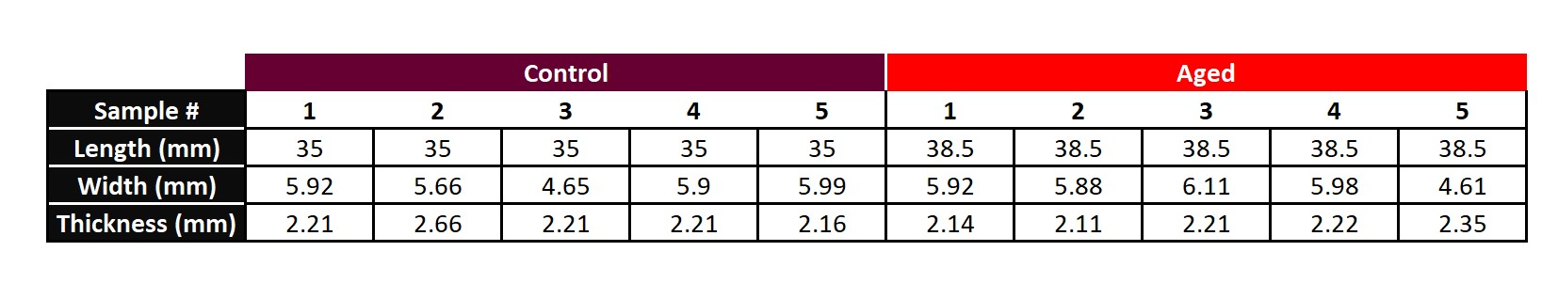

## Results

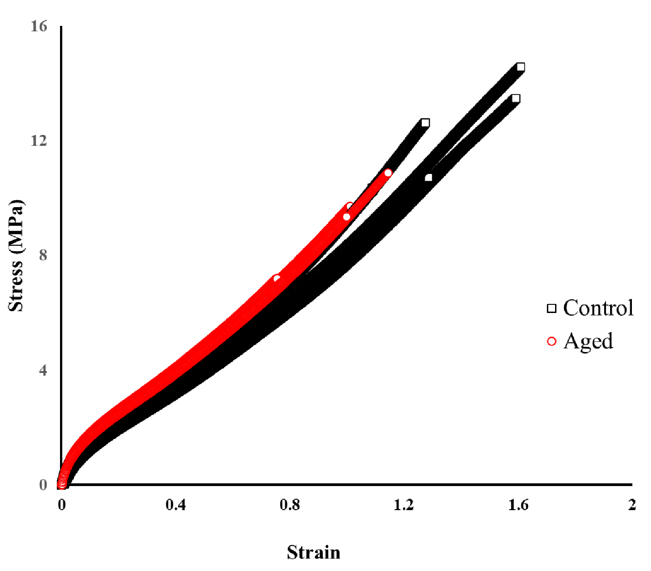

*Figure 8. Plot of engineering stress and strain for control and aged samples.*

*Table 6. UTS values for control and aged samples*

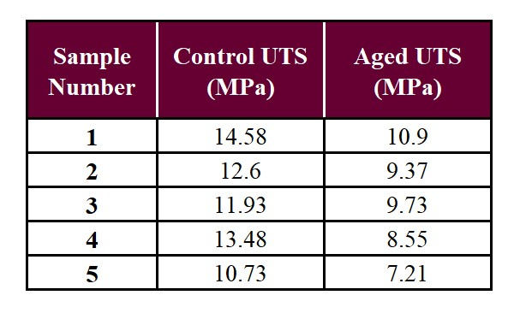

The resulting data from the tensile tests were processed and the engineering stress and strain were plotted for each sample (Figure 8). From initial observation, there are visible overlaps among the control samples and aged samples respectively. This is good as there was clear consistency between our samples with no significant outliers. Furthermore, it is also important to note that there is also some overlap between the aged and control samples with the overall shape of the curve. Though it was not calculated for this analysis it is interesting to see that the modulus for all the samples was relatively the same. However, the aged samples did exhibit weaker mechanical strength (Table 6). This weakening and similar modulus indicates that the hydrogen successfully permeated through but was only able to loosen the bonds thereby allowing the polymer matrix to maintain its overall structure and natural behavior. Yet, it is clear that the loosening of said bonds was enough to observe a decrease in mechanical strength. After calculating the averages, we found that there was a 27.7% decrease, which is a significant amount. We further validated these results by running a statistical analysis of the data via Minitab. As shown in Table 7. the p-value was below 0.05 and the t-value was well above 1.96. Thus, we can also conclude and confirm that our results are statistically significant.

*Table 7. Results from statistical analysis done in Minitab*

(

a

)

(

b

)

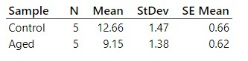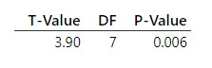

We also placed o-rings with the dogbone samples because the testing conditions we chose for the aging (100oC, 100 bar) were the same for RGD. As mentioned earlier in section 5.2, the 60-hour soaking period that we had planned for if we had tested RGD was arbitrarily decided based on the standard for CO2 and the diffusivity data we found from a study done by the Los Alamos National Laboratory [[6](https://www.zotero.org/google-docs/?CTgqEt)]. So by including the o-rings in with the dogbone samples and after seeing a clear decrease in strength after only 56 hours we were also able to validate the 60-hour soaking period as enough time for hydrogen to permeate through the materials before undergoing the decompressions cycles. Furthermore, this also proves our assumption that the soaking period could be further shortened as well if needed, though this would need to be confirmed with more tests and trials.

*Table 8. Side-by-side comparisons for each component of our project regarding the desired outcomes vs the actual outcomes.*

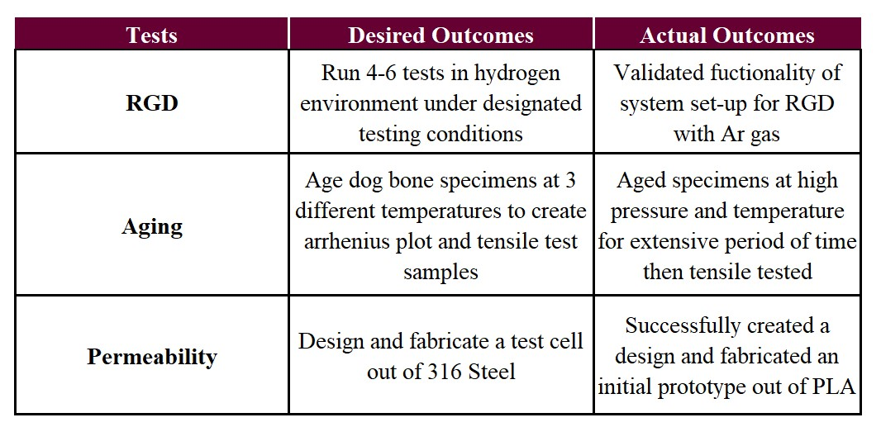

# Skill and Capabilities Used

Knowledge about polymers, diffusion, and degradation was highly valuable for this project. MSEN 250 (Soft Matter) and MSEN 420 (Polymer Science) were useful to understand polymeric behavior. MSEN 305 (Kinetics of Materials) was useful in understanding the diffusion mechanisms. Finally, MSEN 320 (Deformation and Failure of Materials) was useful to understand any deformation that occurs in the polymer’s matrix.

As for technical skills, we needed to know how to safely handle hydrogen, as it is explosive and dangerous to deal with. We also needed to know how to perform tensile tests. Knowledge of CAD design systems and machining/fabrication techniques were also be used in the permeability cell design, and knowledge of high-pressure pipe fittings including NPT threaded fittings and Swagelok (Yor-Lok) tube fittings was used to integrate the reactor into the lab ventilation setup.

# Standards and Codes

*Table 9. Standards and Codes we are following for this project. Highlighted items are used in Section 5, Technical Description.*

|  |  |
| --- | --- |
| ISO 2782 | Governs rubber that is vulcanized and thermoplastic. This standard discusses how to determine the permeability of gasses. |
| ISO 23936 - 2 | Discusses the petroleum, petrochemical, and natural gas industry standards. Part 2 discusses non-metallic materials in contact with media related to oil and gas production. |
| NORSOK M-710 | Discusses the procedure and testing parameters for Rapid Gas Decompression |
| ASTM D2240 | Discusses the standard method for hardness testing. An equivalent ISO standard also exists, but BP uses the ASTM equivalent. |
| ASTM D6147-97 | This standard guides testing vulcanized rubber and thermoplastic elastomers’ force decay in compression |
| ASTM D412-16 | Discusses testing vulcanized rubber and thermoplastic elastomers' tensile strength. |
| ASTM D471-16 | This standard is used to evaluate the effect of liquids on elastomers. |
| ASTM D1434 - 82 | This standard discusses the determination of the permeation of hydrogen through thin films, and defines the permeation cell geometry we will follow. |
| ASTM D638 - 22 | This standard guides tensile testing of polymer ‘dogbone’ samples |

# Consideration of Risk

*Table 10. Predicted risks that could hinder the project’s successful completion.*

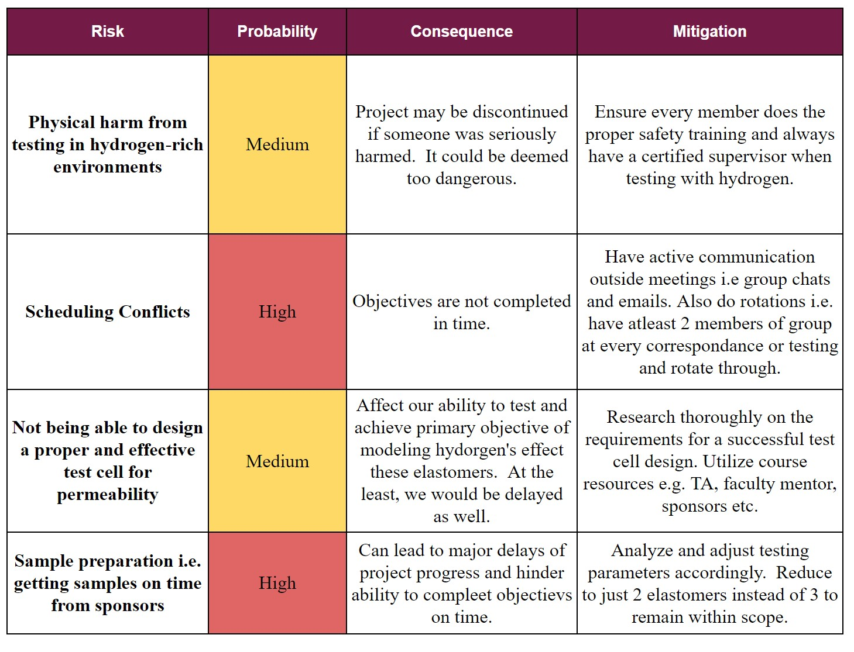

As seen above in Table 10, the main risks that are apparent to our project’s success are outlined and defined. Unfortunately, despite all the planning and our best efforts to envision all risks, we were still not able to anticipate everything i.e. the recall on our regulator and receiving only one elastomer to test.

The most apparent physical risk we faced is the danger involved with handling hydrogen. Hydrogen is odorless, colorless, and tasteless. It is also highly flammable and can cause asphyxiation during long-term exposure. Therefore, it is important that the design of the experiment limits this risk and meets the necessary safety precautions. To address this, the team participated in online safety training for hydrogen use through BioRaft as well as on-site training in Dr. Paramore’s research lab, which is equipped to test in hydrogen environments [[12](https://www.zotero.org/google-docs/?emLiZh)]. We have also confirmed with Parr that the reactor we are using in Dr.

Paramore’s lab is able to safely handle hydrogen loading for our desired testing conditions

[[13](https://www.zotero.org/google-docs/?IWtcih)].

Because the phenomenon between hydrogen and elastomers occurs internally within BP’s facilities, there are no apparent impacts on the public outside of the facility. However, it is important to note that misunderstanding this phenomenon can pose a risk to the safety of BP’s processing facilities and workers when these elastomers degrade in key components of the facility.

# Recognition of Ethical and Professional Issues

A potential ethical issue we could face is providing incorrect feedback from inaccurate results or falsely assumed standards, as we adjusted the standards provided for our use with hydrogen slightly. If inaccurate data is given, this may cause issues in the workplace, including compromising the safety of the workers. Fortunately, the basis of the standards used is from ISO, NORSOK, and ASTM, which are all trustworthy sources. Not only that, but these standards back up the tests and results we are doing, so this ethical issue is not fully in our hands.

# Economic Analysis and Broader Impact

## Cost Analysis

*Table 11. Total cost breakdown for the project to date.*

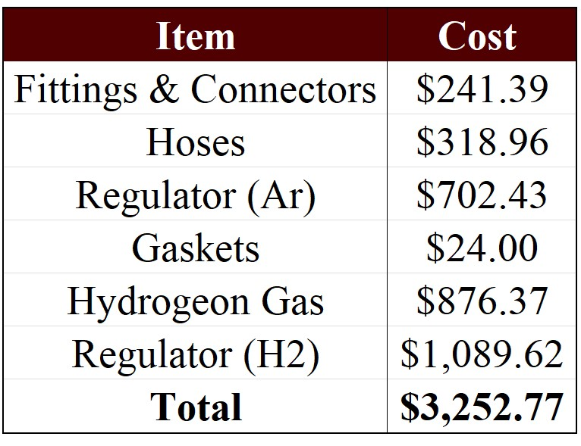

Overall, we were well below the budget. We purchased items such as hoses, nuts, fittings, and two regulators. The majority of our budget went into our experiment setup. We also used our budget to purchase our hydrogen gas. We used equation 1 to calculate how much hydrogen we needed to purchase. Ultimately, we calculated we needed three K tanks of pure hydrogen and two K tanks of the specialty gas mixture for the original experiments we planned to run. In the end, we used less than one tank of the specialty mixture gas. Allowing any team after us to use the rest of the hydrogen.

Overall, we used about 65.0.6% of our semester budget. Both the table and the percentage calculation does not include taxes or shipping costs.

## Broader Impact

For the industry’s economic benefit, the goal was to do a more extensive study on the life cycle of the elastomers. This is crucial to do as all elastomers degrade and need to be replaced over time, and studying this phenomenon will help understand and improve the elastomer service life prediction. Overall, if the elastomer life cycle is improved, the company will save time and money and reduce waste.

Furthermore, when considering the global and economic impact, it can be both direct and indirect. For example, indirectly, these elastomers are commonly used in BP’s processing facilities so if hydrogen continues to degrade elastomers as it has been observed, there can be major consequences. These consequences can result in a significant monetary loss for the company and in turn, inflate costs globally. Furthermore, any damage to these materials can also lead to potential leakage, causing environmental risks. Directly, however, it is also important to consider the environmental impact that comes from the continuous and frequent disposal of these elastomers due to their lowered life cycle from hydrogen degradation. Polymers commonly end up as waste if not recycled. The constant need to replace these elastomeric parts puts a direct strain on the global ecosystem.

Regarding cultural, political, and social factors, there is minimal impact. The direct impact from the degradation of these elastomers on society is marginal at best and would be more indirect.

Overall, these elastomers are used internally in various components of the facilities so the resulting impact tends to be indirect. However, as discussed earlier there are still relevant sources for more direct impact, and is equally as important to be considered and made aware of when proceeding forward with the next phases of this project.

# Conclusions and Recommendations

As highlighted in Table 8. we did not achieve all the desired outcomes we had set out to do. However, despite that setback, we were still able to get data and have what we believe are conclusive results. Based on our analysis, we can confirm that hydrogen does permeate through and cause significant degradation to the polymer matrix. We can also conclude that even materials that are commercially accepted and used can still be susceptible to hydrogen degradation. Despite not being able to do RGD, the results from aging did give insight into RGD regarding hydrogen and the standards we had set.

Though we were also not able to machine a stainless steel prototype for permeability, we can conclude that stainless steel will resist embrittlement, be machinable and cheap enough to make a test cell from, and withstand pressurization [[9](https://www.zotero.org/google-docs/?MtM39D)]. Our design should also work within its tolerances as well based on our initial 3D-printed prototype.

We recommend further research into the specific mechanisms for degradation in order to develop a material more suitable for use in high-pressure, high-temperature hydrogen environments. We also recommend attempting preliminary studies with helium if still limited by operational capabilities due to the danger involved with hydrogen.

# Future Works

Future work would comprise running full RGD tests on all three elastomers with hydrogen once the regulator arrives. We would also qualitatively analyze and model the degradation between hydrogen and elastomers. We would also validate the testing conditions we decided on for RGD.

For permeability, we would fabricate our design out of stainless steel and use it to measure permeation through discs made of the designated elastomers to test. This would be another set of data to help model the interaction between hydrogen and the polymer matrix.

Regarding aging, we would actually test with the Arrhenius approach to help determine the life cycles for these elastomers under hydrogen exposure.

Finally, once this interaction is fully modeled, future work could look into ways of improving the materials in their resistance to hydrogen degradation.

# List of Appendices

Appendix A: Additional images of prototype design and fabrication

# References

1. [DES. *Constant Temperature Accelerated Life Testing using the Arrhenius Relationship*.](https://www.zotero.org/google-docs/?mQhKm8)

[Delserro](https://www.zotero.org/google-docs/?mQhKm8)  [Engineering](https://www.zotero.org/google-docs/?mQhKm8)  [Solutions.](https://www.zotero.org/google-docs/?mQhKm8)

[https://www.desolutions.com/blog/2013/08/constant-temperature-accelerated-life-t esting-using-the-arrhenius-relationship/ (accessed 2023-03-02).](https://www.zotero.org/google-docs/?mQhKm8)

1. [*Hydrogen for refineries is increasingly provided by industrial suppliers*. https://www.eia.gov/todayinenergy/detail.php?id=24612 (accessed 2023-03-02).](https://www.zotero.org/google-docs/?mQhKm8)
2. [Wilson, M. A.; Frischknecht, A. L. High-Pressure Hydrogen Decompression in Sulfur Crosslinked Elastomers. *Int. J. Hydrog. Energy* **2022**, *47* (33), 15094–15106. https://doi.org/10.1016/j.ijhydene.2022.03.015.](https://www.zotero.org/google-docs/?mQhKm8)
3. [Zhang, D.; Liu, W.; Qian, Y.; Que, J. Permeation of Hydrogen in Hastelloy C-276 Alloy at High Temperature. *Fusion Sci. Technol.* **2015**, *67* (3), 681–684. https://doi.org/10.13182/FST14-T109.](https://www.zotero.org/google-docs/?mQhKm8)
4. [C-276.Pdf.](https://www.zotero.org/google-docs/?mQhKm8)

[https://www.haynesintl.com/docs/default-source/pdfs/new-alloy-brochures/corrosio n-resistant-alloys/brochures/c-276.pdf (accessed 2022-12-07).](https://www.zotero.org/google-docs/?mQhKm8)

1. [Rutherford, S. W.; Limmer, D. T.; Smith, M. G.; Honnell, K. G. Gas Transport in](https://www.zotero.org/google-docs/?mQhKm8)

[Ethylene–Propylene–Diene (EPDM) Elastomer: Molecular Simulation and Experimental Study.](https://www.zotero.org/google-docs/?mQhKm8)  [*Polymer*](https://www.zotero.org/google-docs/?mQhKm8) [**2007**,](https://www.zotero.org/google-docs/?mQhKm8)  [*48*](https://www.zotero.org/google-docs/?mQhKm8)  [(22),](https://www.zotero.org/google-docs/?mQhKm8)  [6719–6727. https://doi.org/10.1016/j.polymer.2007.07.020.](https://www.zotero.org/google-docs/?mQhKm8)

1. [Rutherford, S. W.; Limmer, D. T.; Smith, M. G.; Honnell, K. G. Gas Transport in](https://www.zotero.org/google-docs/?mQhKm8)

[Ethylene–Propylene–Diene (EPDM) Elastomer: Molecular Simulation and Experimental Study.](https://www.zotero.org/google-docs/?mQhKm8)  [*Polymer*](https://www.zotero.org/google-docs/?mQhKm8) [**2007**,](https://www.zotero.org/google-docs/?mQhKm8)  [*48*](https://www.zotero.org/google-docs/?mQhKm8)  [(22),](https://www.zotero.org/google-docs/?mQhKm8)  [6719–6727. https://doi.org/10.1016/j.polymer.2007.07.020.](https://www.zotero.org/google-docs/?mQhKm8)

1. [Züttel, A. Hydrogen Storage Methods. *Naturwissenschaften* **2004**, *91*, 157–172. https://doi.org/10.1007/s00114-004-0516-x.](https://www.zotero.org/google-docs/?mQhKm8)
2. [*Stainless Steel Pipes - Allowable Pressure vs. Schedule and Size*. https://www.engineeringtoolbox.com/stainless-steel-pipes-pressure-ratings-d_346.ht ml (accessed 2023-03-02).](https://www.zotero.org/google-docs/?mQhKm8)
3. [*GM1 Series - Hydrogen Mass Flow Meter - Aluminum, Low Flow, With or Without LCD Readout,*](https://www.zotero.org/google-docs/?mQhKm8) [*1/4*](https://www.zotero.org/google-docs/?mQhKm8) [*Inch*](https://www.zotero.org/google-docs/?mQhKm8) [*Compression*](https://www.zotero.org/google-docs/?mQhKm8) [*Fittings,*](https://www.zotero.org/google-docs/?mQhKm8) [*0-5VDC*](https://www.zotero.org/google-docs/?mQhKm8) [*Analog*](https://www.zotero.org/google-docs/?mQhKm8) [*Output*. https://www.dakotainstruments.com/mass-flow/mass-flow-meters/hydrogen/6agm1 al5-hd (accessed 2023-03-02).](https://www.zotero.org/google-docs/?mQhKm8)
4. [Laboratories, M. *MycoScience - Accelerated Aging Testing For Medical Devices*. MycoScience. https://mycoscience.com/accelerated-aging-testing-for-medical-devices/ (accessed 2022-12-07).](https://www.zotero.org/google-docs/?mQhKm8)
5. [James Paramore. Video Call With Dr. Paramore on September 12th, 2022 at 4 PM., 2022.](https://www.zotero.org/google-docs/?mQhKm8)
6. [Collins, C. Parr Gasket Material Inquiry, 2023.](https://www.zotero.org/google-docs/?mQhKm8)

Appendix A: Additional images of prototype design and fabrication

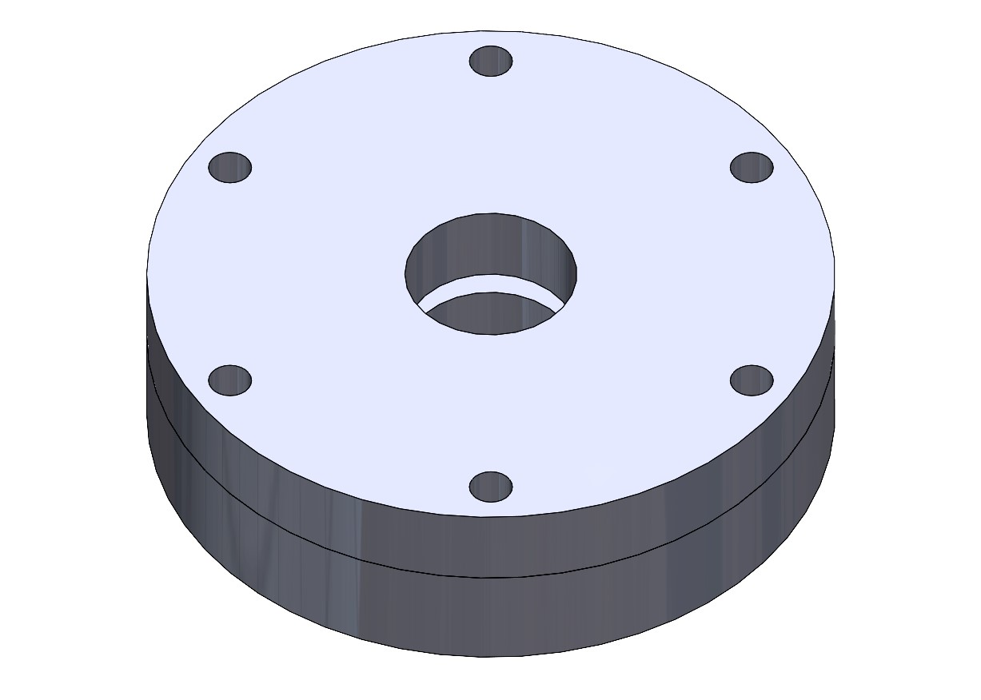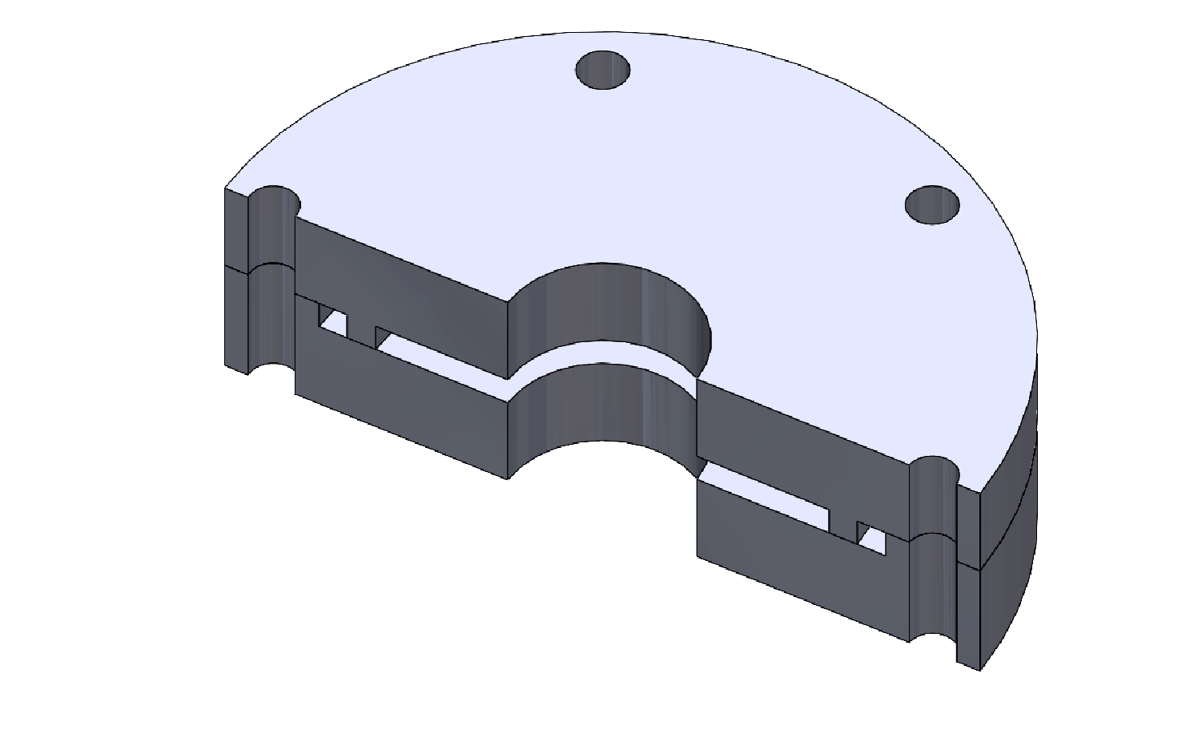

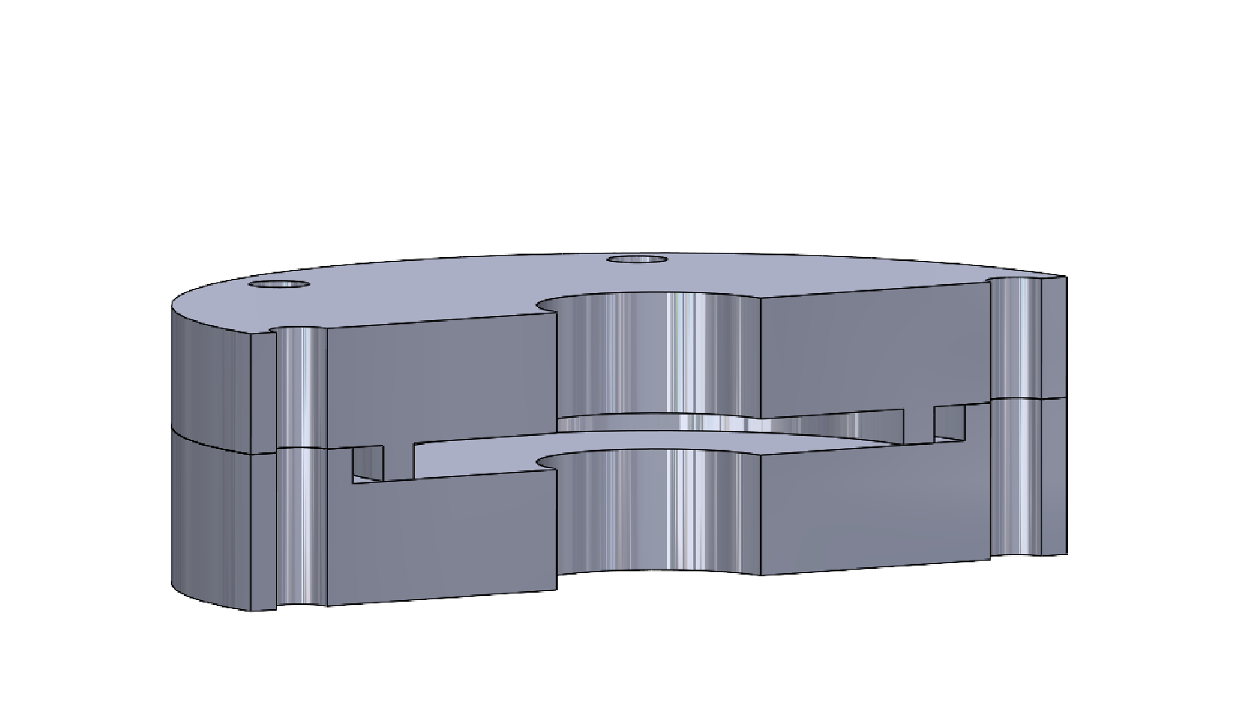

*Figure A1-A3. Solidworks design reference images*

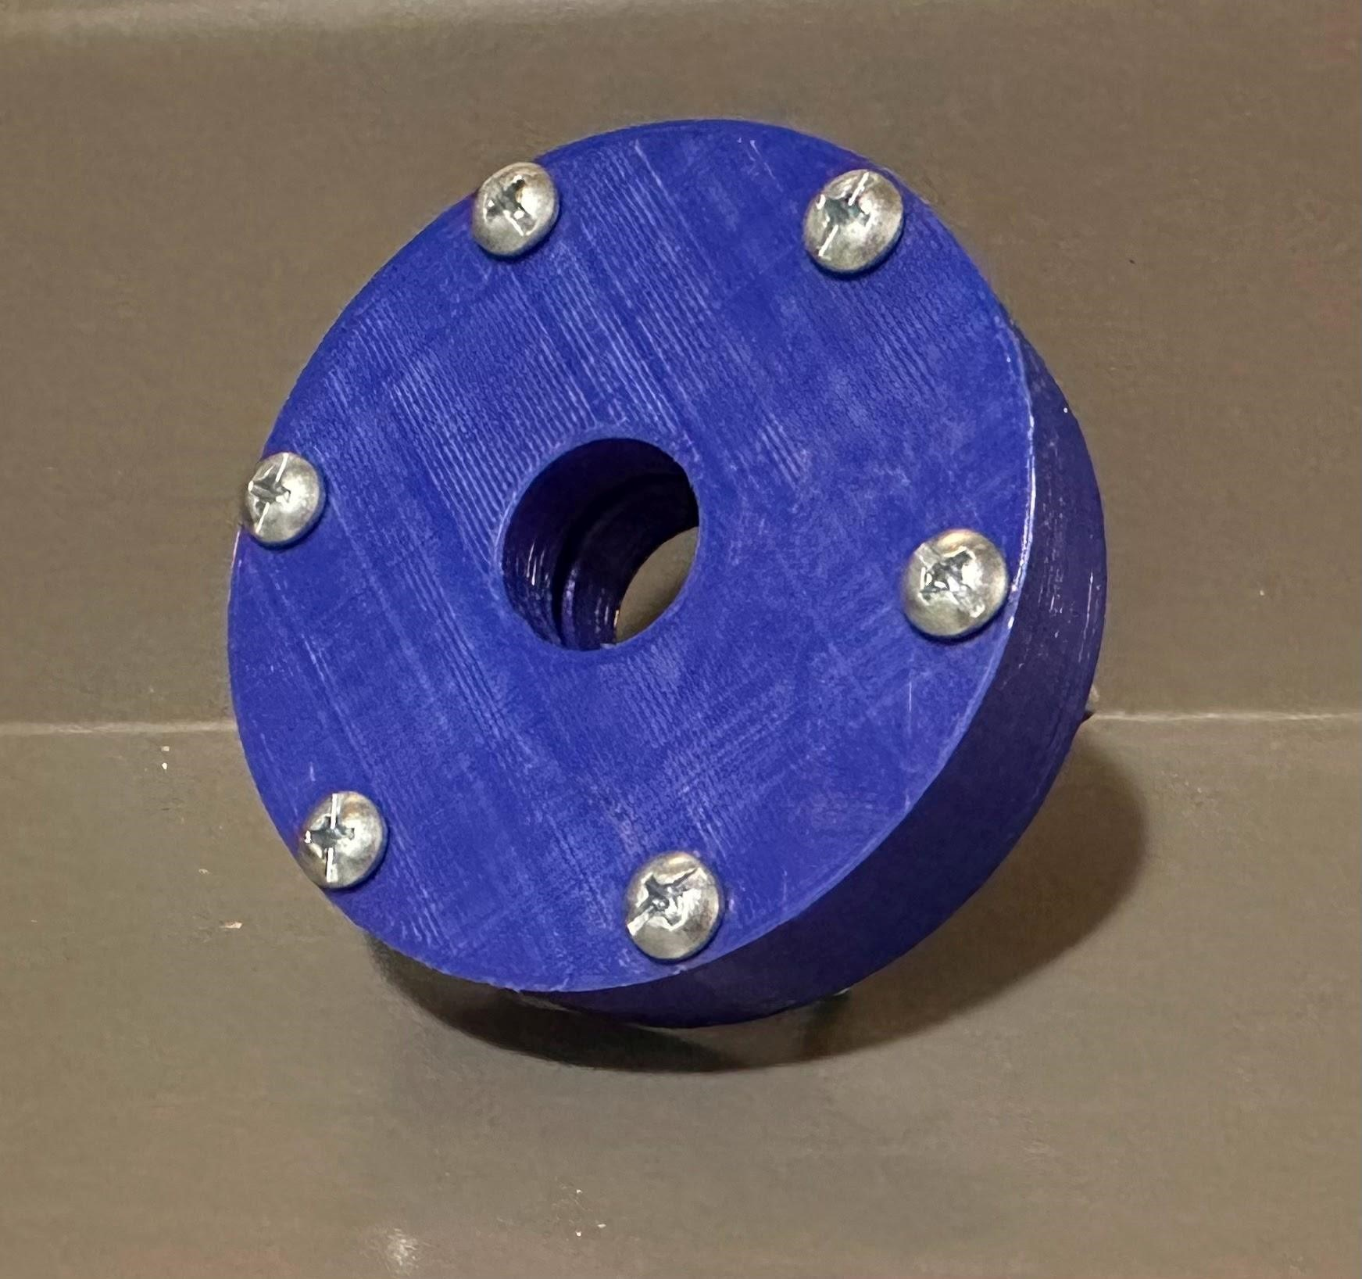

*Figure A4. 3D printed prototype of the permeability cell design.*