**Streets_By_City(incity varchar);**

This function lists the street in a given city.

EX: select * from Streets_By_City('Richardson');

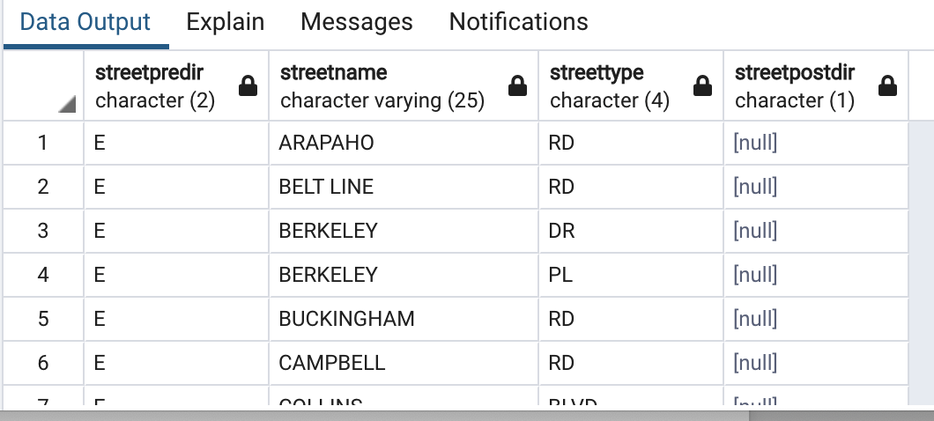

**Voters_On_Block(instreetnumber int, instreetname varchar, instreettype varchar, incity varchar);**

This function returns the voters on the same block for a given address. The address must consist of a street number and street name, optionally a street type and city may be provided. The optional street information will help filter for popular street names.

EX: select * from voters_on_block(2217, '%shady%');

select * from voters_on_block(2217, '%shady%', 'DR');

select * from voters_on_block(2217, '%shady%', 'DR', 'Rich%');



**Zips_By_City(incity varchar);**

This function will list the zip codes for a given city.

EX: select * from Zips_By_City('Richardson');

