GAME3110 – Assignment 4

Name: Tuan Minh Vu

Postman: <https://www.postman.com/collections/374e269ead04e4518202>

Source Code: <https://github.com/Michael-TuanMinh/LambdaFunctions-Database>

1. **User Manager**

<https://r7hp7byop1.execute-api.us-east-1.amazonaws.com/default/UserManager>

* Register: use PUT request and need to send Username, Password, Email in the body

* Retrieve user’s profile: use GET request and need to send Username as a parameter

* Update user’s profile: use POST request and need to send Username, Password, Email in the body

* Login/ Logout

<https://nhgg4aqoy7.execute-api.us-east-1.amazonaws.com/default/LogInOut>

For logout, using GET request and send Username as a parameter

1. **Score Manager**

<https://ceqc731jn9.execute-api.us-east-1.amazonaws.com/default/ScoreManager>

* Update score: use PUT request and send GameName, Username, Score in the body

* Get score: use GET request and send GameName, and Username as parameters

1. **Analytic**

<https://pdy578o7qj.execute-api.us-east-1.amazonaws.com/default/EventsManager>

* Store event: It loops through Users table and RemoteSettings table to check if game and username exist. Use PUT request and send GameName, Username, EventName, and EventParameter in the body. Only GameInstalled, GameDeleted, GameStart, GameOver, ItemPurchased events are supported.

* Get events: use GET request

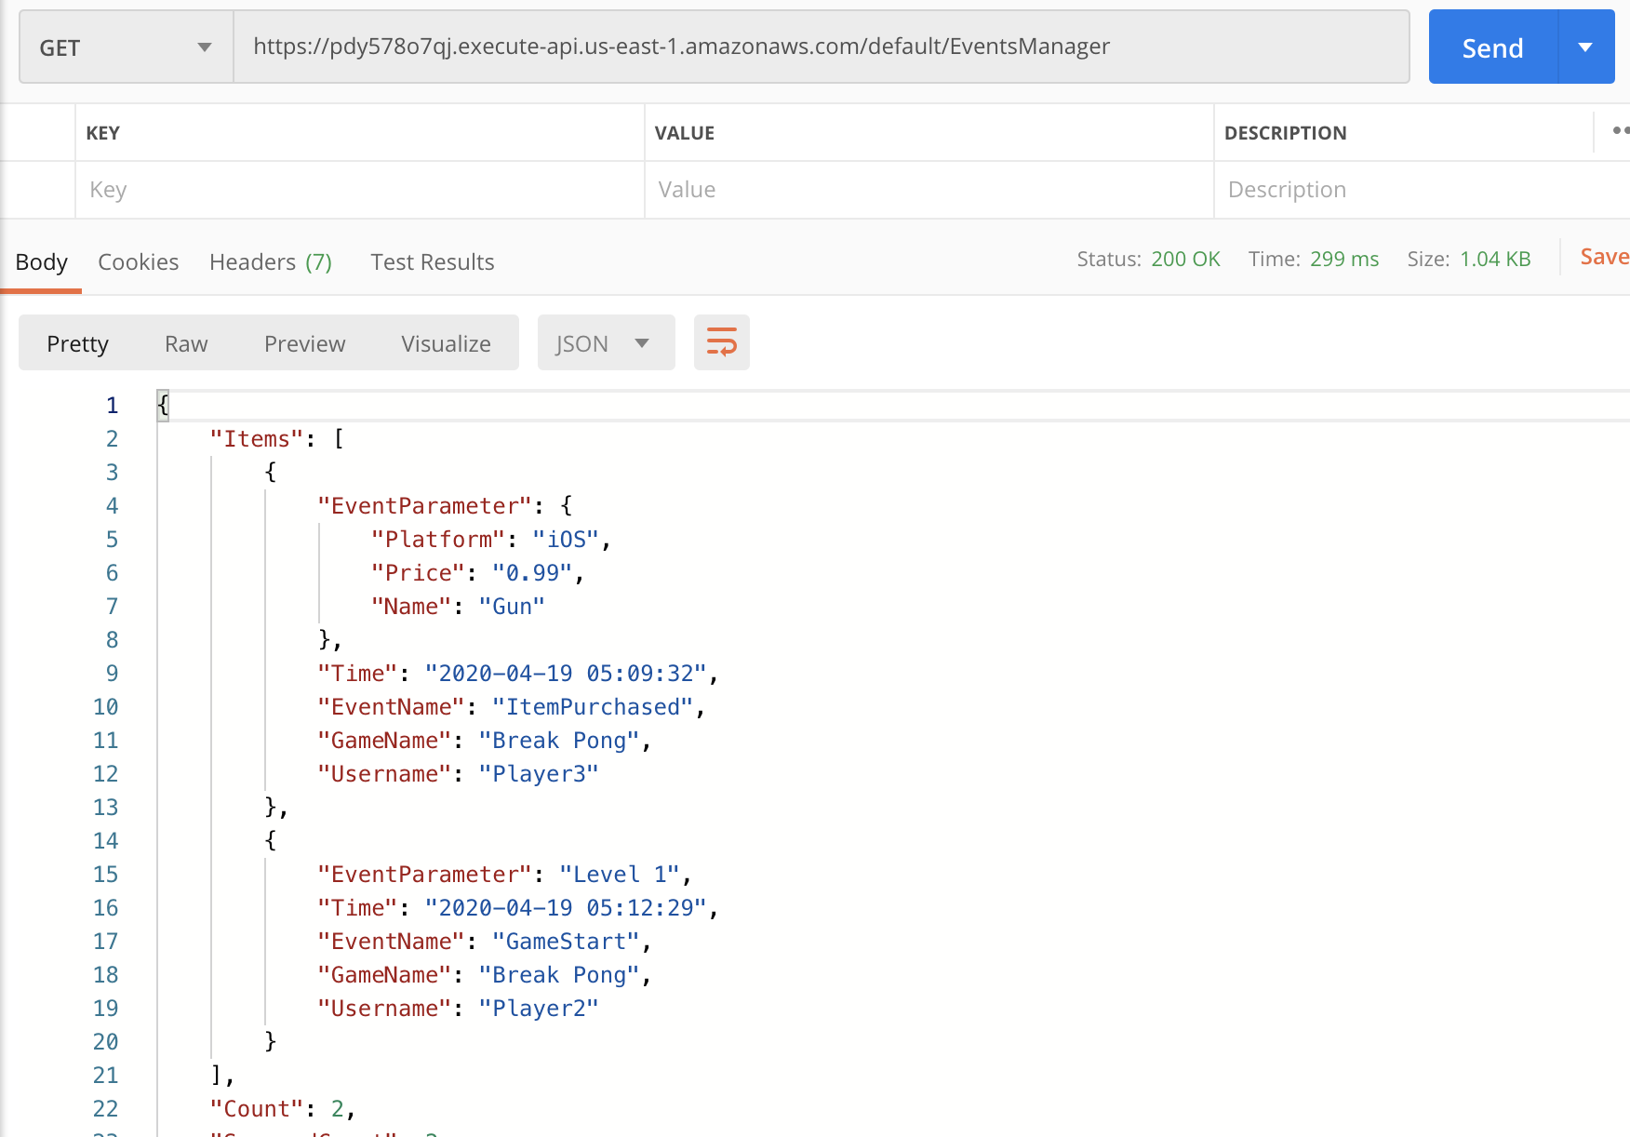

1. **Remote Settings**

<https://tfxqez6dpd.execute-api.us-east-1.amazonaws.com/default/AddRemoteSettingProperty>

* Update Property: using PUT request and send 3 inputs (GameName, Property, Value) in the body. For example:

* Get Properties: using GET request and require GameName as a parameter.

