

[Pawel Janicki](https://www.paweljanicki.jp/projects_lutoscratch_en.html)



[Inner Sound: Altered States of Consciousness in Electronic Music and Audio-Visual Media : Weinel, Jonathan: Amazon.co.uk: Books](https://www.amazon.co.uk/Inner-Sound-Consciousness-Electronic-Audio-Visual/dp/019067119X)

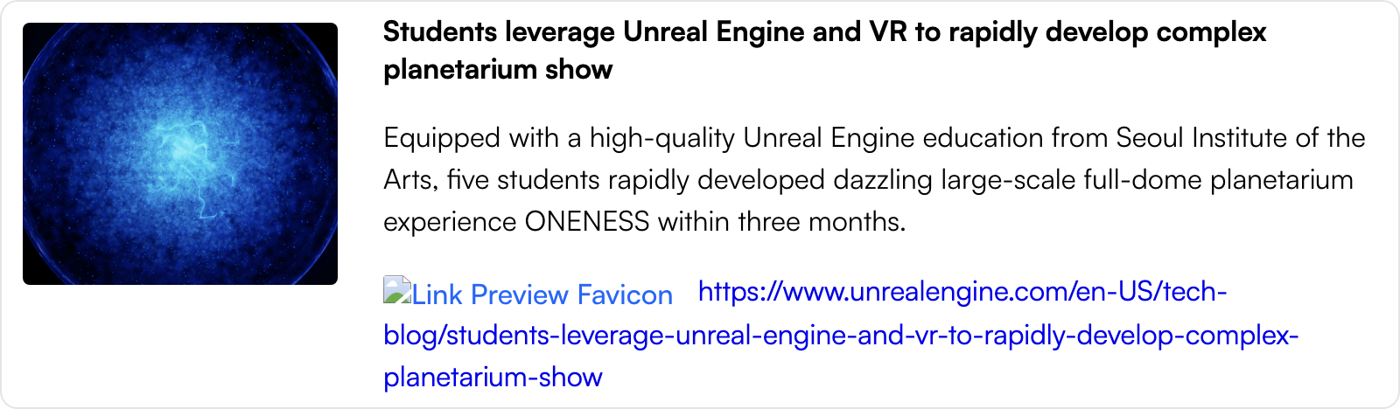

[Students leverage Unreal Engine and VR to rapidly develop complex planetarium show](https://www.unrealengine.com/en-US/tech-blog/students-leverage-unreal-engine-and-vr-to-rapidly-develop-complex-planetarium-show)

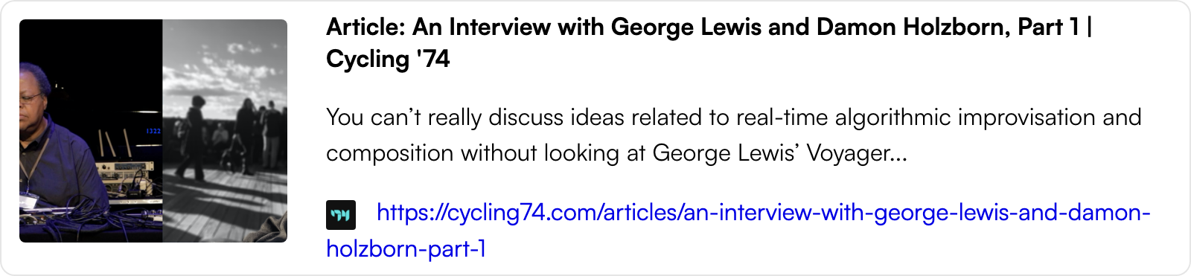

[Article: An Interview with George Lewis and Damon Holzborn, Part 1 | Cycling '74](https://cycling74.com/articles/an-interview-with-george-lewis-and-damon-holzborn-part-1)

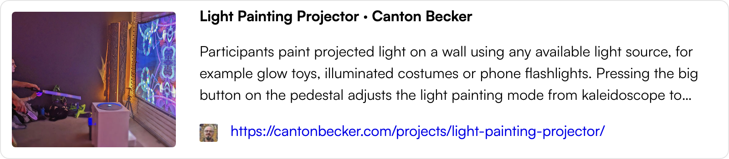

[Light Painting Projector · Canton Becker](https://cantonbecker.com/projects/light-painting-projector/)