Immigration Detention Centers Analysis

Michael Ale

2025-04-26

# 1. Importing Necessary Libraries

#tinytex::install_tinytex(force = TRUE)  
library(tidyverse)

## ── Attaching core tidyverse packages ──────────────────────── tidyverse 2.0.0 ──  
## ✔ dplyr 1.1.4 ✔ readr 2.1.5  
## ✔ forcats 1.0.0 ✔ stringr 1.5.1  
## ✔ ggplot2 3.5.2 ✔ tibble 3.2.1  
## ✔ lubridate 1.9.3 ✔ tidyr 1.3.1  
## ✔ purrr 1.0.2   
## ── Conflicts ────────────────────────────────────────── tidyverse_conflicts() ──  
## ✖ dplyr::filter() masks stats::filter()  
## ✖ dplyr::lag() masks stats::lag()  
## ℹ Use the conflicted package (<http://conflicted.r-lib.org/>) to force all conflicts to become errors

library(dplyr)

# 2. Loading the Dataset

df <- read.csv("immigration-detention.csv")  
head(df)

## X  
## 1 These statistics are made available to the public pursuant to H.R. 1158 Sec. 218 - Department of Homeland Security Appropriations Act, 2020. ) *The information in this report is subject to change.  
## 2 ICE FACILITIES DATA, FY25  
## 3 ICE Enforcement and Removal Operations Data, FY2025  
## 4 This list is limited to facilities that have a population count of greater than or equal to 1 as the time of the data pull. This list does not include HOLD, HOSPITAL, HOTEL, ORR, or MIRP facilities.   
## 5 Data Source: ICE Integrated Decision Support (IIDS), 03/17/2025  
## 6 Name  
## X.1 X.2 X.3 X.4 X.5 X.6 X.7  
## 1   
## 2   
## 3   
## 4   
## 5   
## 6 City State Level A Level B Level C Level D Last Inspection End Date

# 3. Cleaning the Dataset

### 3.1 Removing Headers in First Few Rows

df <- read.csv("immigration-detention.csv", skip = 6)  
head(df)

## Name City State Level.A Level.B  
## 1 ADAMS COUNTY DET CENTER NATCHEZ MS 1876.461078 266.431138  
## 2 ADELANTO ICE PROCESSING CENTER ADELANTO CA 6.401198 4.323353  
## 3 ALAMANCE COUNTY DETENTION FACILITY GRAHAM NC 4.329341 3.461078  
## 4 ALEXA$NDRIA STAGING FACILITY ALEXANDRIA LA 137.520958 47.413174  
## 5 ALLEGANY COUNTY JAIL BELMONT NY 1.221557 0.018000  
## 6 ALL%EN PARISH PUBLIC SAFETY +COMPLEX OBERLIN LA 101.311377 30.251497  
## Level.C Level.D Last.Inspection.End.Date  
## 1 6.724551 4.257485 45673  
## 2 22.604790 32.634731 45491  
## 3 6.083832 6.185629 45554  
## 4 76.005988 52.485030 45533  
## 5 0.000000 0.000000 <NA>  
## 6 33.766467 10.664671 45638

colnames(df)

## [1] "Name" "City"   
## [3] "State" "Level.A"   
## [5] "Level.B" "Level.C"   
## [7] "Level.D" "Last.Inspection.End.Date"

dim(df)

## [1] 134 8

### 3.2 Handling Special characters in Name

df$Name<- iconv(df$Name,from = "",to = "UTF-8", sub = "")  
df$Name <- gsub("[^A-Za-z ]", "", df$Name)#this ensures only A to Z and a to z character is in the dataframe  
head(df$Name)

## [1] "ADAMS COUNTY DET CENTER" "ADELANTO ICE PROCESSING CENTER"   
## [3] "ALAMANCE COUNTY DETENTION FACILITY" "ALEXANDRIA STAGING FACILITY"   
## [5] "ALLEGANY COUNTY JAIL" "ALLEN PARISH PUBLIC SAFETY COMPLEX"

### 3.3 Handling Blanks in Name,City and State

# Name  
df <- df %>% mutate(Name = if_else(Name == "", "Unknown", Name))  
  
# City  
df$City <- trimws(df$City)  
df <- df %>%  
 mutate(City = if_else(Name == "GEAUGA COUNTY JAIL" & City == "", "CHARDON", City))  
  
# State  
df$State <- trimws(df$State)  
df <- df %>%  
 mutate(State = if_else(City == "ATLANTA", "GA", State),  
 State = if_else(City == "ENCINAL", "TX", State)) # <-- Corrected to TX

### 3.4 Handling Dates

df <- df %>%  
 mutate(Last.Inspection.End.Date = as.Date(as.numeric(Last.Inspection.End.Date), origin = "1899-12-30"))

## Warning: There was 1 warning in `mutate()`.  
## ℹ In argument: `Last.Inspection.End.Date =  
## as.Date(as.numeric(Last.Inspection.End.Date), origin = "1899-12-30")`.  
## Caused by warning in `as.Date()`:  
## ! NAs introduced by coercion

# Fix Nevada separately  
df <- df %>%  
 mutate(Last.Inspection.End.Date = if_else(  
 Name == "NEVADA SOUTHERN DETENTION CENTER",  
 as.Date("2024-09-19"),  
 Last.Inspection.End.Date  
 ))

# 4.Analyze the Data

### 4.1 Create Total Population Column

df <- df %>%  
 mutate(Total.Population = Level.A + Level.B + Level.C + Level.D)

### 4.2 Top 10 Facilities by Population

top_10_facilities <- df %>%  
 arrange(desc(Total.Population)) %>%  
 slice_head(n = 10)

### 4.3 Top 10 States by Number of Detention Centers

Each_state_detention_center <- df %>%  
 group_by(State) %>%  
 summarise(Detention_center_count = n()) %>%  
 arrange(desc(Detention_center_count)) %>%  
 slice_head(n = 10)

### 4.4 Top 10 States By Population in Detention Centers

State_total_population <- df %>%  
 group_by(State) %>%  
 summarise(Total = sum(Total.Population, na.rm = TRUE)) %>%  
 arrange(desc(Total)) %>%  
 slice_head(n = 10)

# 5. Visualization

### 5.1 Top 10 Largest Detention Facilities by Population

ggplot(data = top_10_facilities, mapping = aes(x = reorder(Name, Total.Population), y = Total.Population)) +  
 geom_bar(stat = "identity", fill = "black") +  
 geom_text(aes(label = round(Total.Population)), hjust = -0.5, size = 3) +  
 coord_flip() +  
 labs(title = "Top 10 Detention Facilities by Total Population",  
 x = "Detention Facility",  
 y = "Total Population") +  
 theme_minimal() +  
 theme(  
 panel.background = element_rect(fill = "white"),#while saving image i wasn't getting clear plotting so fixing it white solve the issue  
 plot.background = element_rect(fill = "white")  
 )

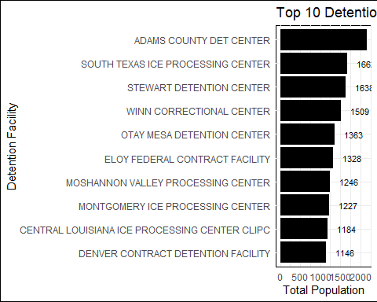

### 5.2 Top 10 States by Number of Detention Centers

ggplot(data = Each_state_detention_center,mapping = aes(x = reorder(State, Detention_center_count), y = Detention_center_count)) +  
 geom_bar(stat = "identity", fill = "steelblue") +  
 geom_text(aes(label = Detention_center_count), hjust = -0.2, size = 3) + #adding text on each bar  
 coord_flip() + #it flips the axes as when names were not clear.  
 labs(title = "Top 10 States With Highest Number Of Detention centers",  
 x = "State",  
 y = "Number Of Detention Centers") +  
 theme_minimal()+  
 theme_minimal() +  
 theme(  
 panel.background = element_rect(fill = "white"),#while saving image i wasn't getting clear plotting so fixing it white solve the issue  
 plot.background = element_rect(fill = "white")  
 )

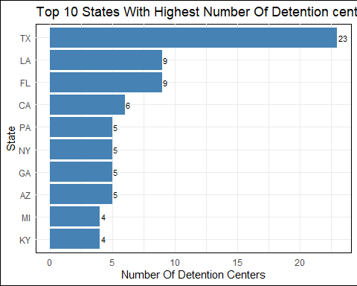

### 5.3 Top 10 States by Population in Detention Centers

ggplot(data = State_total_population, aes(x = reorder(State, Total), y = Total)) +  
 geom_bar(stat = "identity", fill = "steelblue") +  
 geom_text(aes(label = round(Total)), hjust = -0.2, size = 3) +  
 coord_flip() +  
 labs(title = "Top 10 States With Highest Population in Detention Centers",  
 x = "State",  
 y = "Total Population in Detention Centers") +  
 theme_minimal()

