**Amazon Books Bestselling Data Analysis 2009-2019**

**Images from Unsplash**

**A Report by Michael Yousuf**

**INTRODUCTION**

One of the top online retailers in the world, amazon is recognized for its international consumers' ability to purchase books online. Amazon Book, one of its many chains, was established in November 2015 and sells books online. The data for this project, which spans a decade and was scraped from Amazon's webpages using the scrapy package of Python, will examine trends among the top-selling books from 2009 to 2019.

Seven columns and over 1,000 rows of the scraped data were cleaned and prepared for analysis using Python. Various exploratory analyses were conducted to determine which books receive the greatest sales, reviews, and ratings. most books are rated between 4.6 and 4.8 out of 5 according to the data's total rating count.

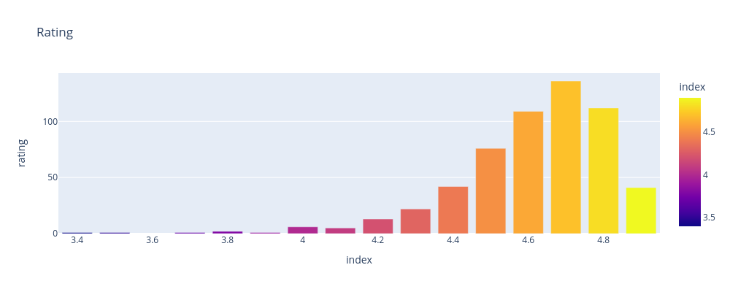Figure 1: Rating count for Amazon top Bestselling books from 2009-2019

Accordingly, "Where the crawdads sing" by Delia Owens, "The silent Patient" by Alex Michaelides, and "Becoming" by Michelle Obama are among the top 10 books with the highest average ratings from the list of bestsellers on Amazon.

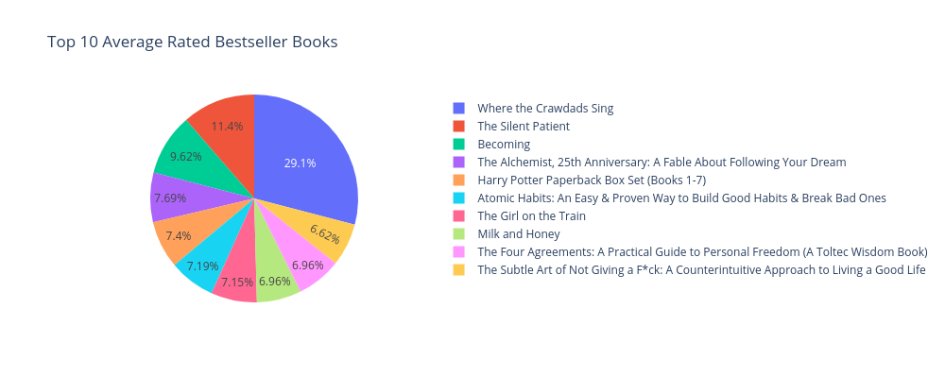Figure 2: Top 10 Average Rated Bestseller Books

Three of the top ten best-selling writers on Amazon are Rick Riordan, Jeff Kinney, and Suzanne Collins, and their books are most book sales.

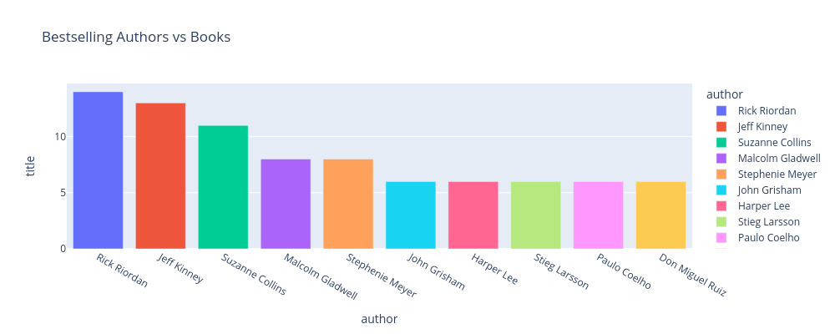

Figure 3: Top 10 Bestselling Authors

However, three of the top ten writers on Amazon with the highest average price for bestsellers are Tony Hsieh, Jamie Ford, and Guiness World Records. The following graph displays the top 10 bestsellers with the highest price average.

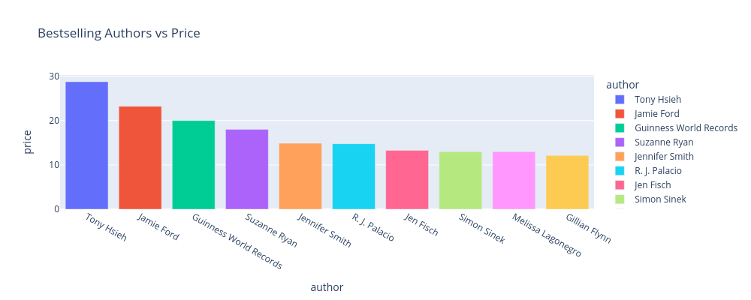

Figure 4: Top 10 Highest Average Price Bestseller Authors

Regarding the most popular books, the top 10 most expensive books on Amazon are shown in the figure below.

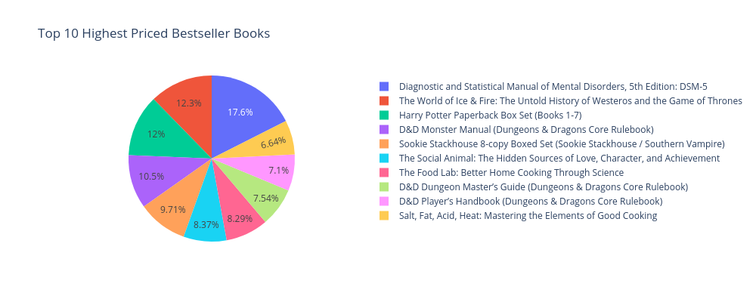

Figure 5: Highest Priced Bestselling Books

**EXAMINATION OF ASSOCIATION BETWEEN RATING, REVIEW AND PRICE**

Analysis of the relationship between price and rating suggests that there is a steadily rising relationship between them.

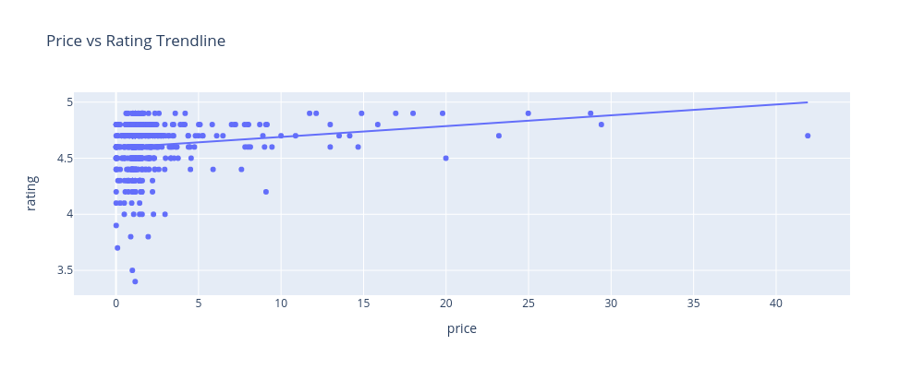

Figure 6: Price and Rating Association

In the list of writers with average ratings and reviews, A.J. Finnn has the highest rating and the most reviews, David Goggins has the second-lowest rating and Michelle Obama has the second-highest rating and third-highest reviews.

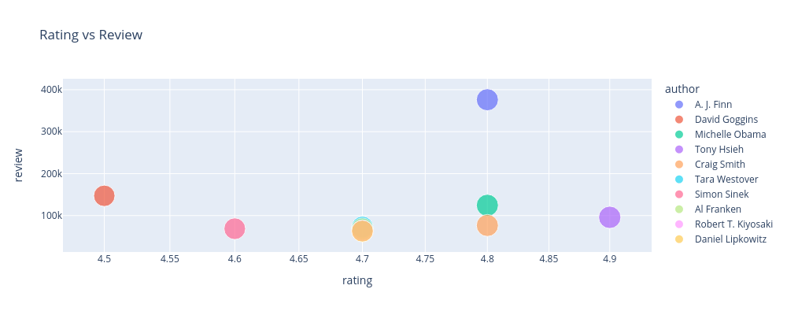

Figure 7: Rating vs Reviews in relation to Authors

With a minor improvement in their relationship, price and review association exhibits the same tendencies as price and rating relationship.

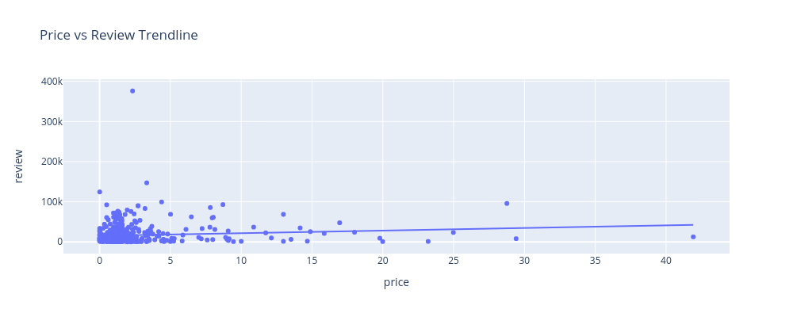

Figure 8: Price and Reviews Relationship

**YEARLY AVERAGE PRICE, RATING, AND REVIEW ANALYSIS**

The annual average price trends show a rise from 2009 to 2019 except for the years 2012 and 2015 where it shows slight decrease.

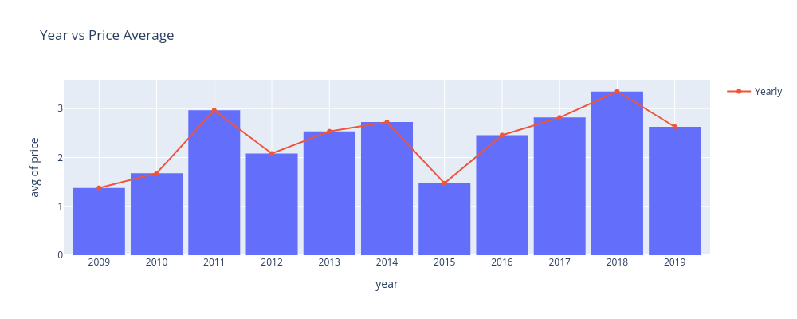

Figure 9: Annual Average Price Trends from 2009-2019

In contrast to the average price, the average review shows a consistent rise over time.

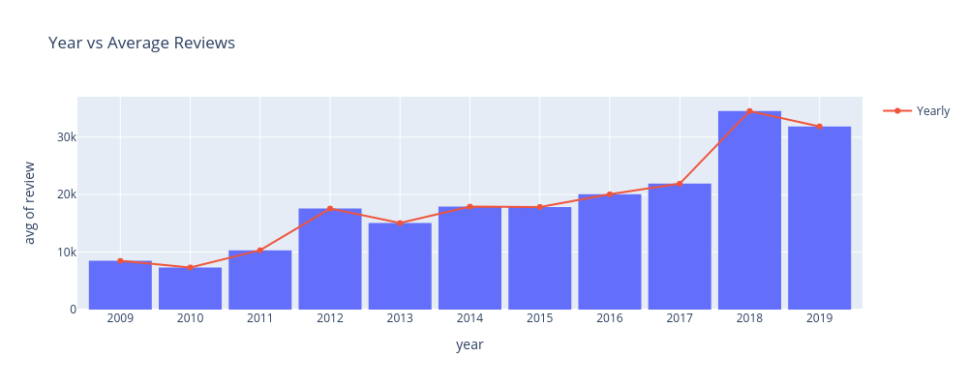

Figure 10: Annual Average Reviews Trends from 2009-2019

But the yearly rating patterns show steady movement, except a minor increase from 2013.

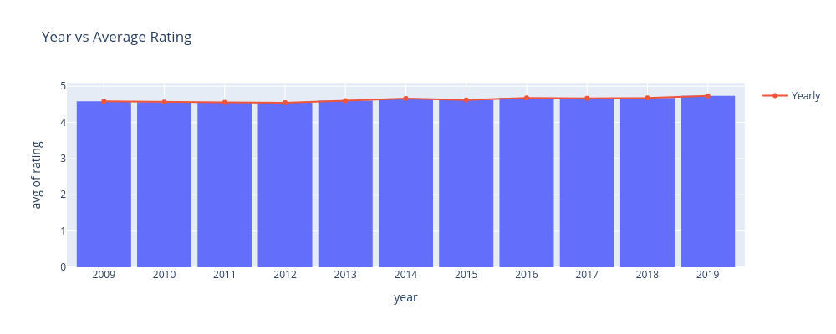

Figure 11: Annual Average Price Trends from 2009-2019

**CONCLUSIONS**

* The top three most expensive books on Amazon are The World of Ice, Diagnostic and Statistical Manual of Mental Disorders, and Harry Potter Paperback Box Set.
* There is a strong relationship between Price and Ratings and the Reviews.