Stories about the Empty Dishes: African Food production vs African Food Supply

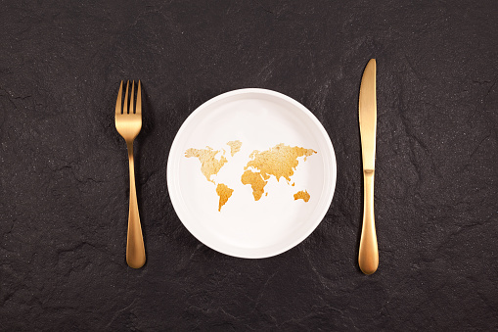

Image by ALEKSEI BEZRUKOV

The United Nations has informed us that by 2030, when the sustainable development objective will have been met, hunger would have been eradicated from the planet and will be a thing of the past. This is the narrative of food insecurity in Africa. Recently, the World Food Programme informed us that these objectives are not likely to be met for a number of reasons. One of the key causes of food insecurity in Africa and the imbalance between its food supply and production chains is changes in the global food markets. If the balance between circumstances for food production and supply is neglected, this forecast will continue to have an impact on the conditions of food insecurity in the majority of African states. African food production and consumption trends that are declining and growing, respectively, would be symptomatic of these situations.

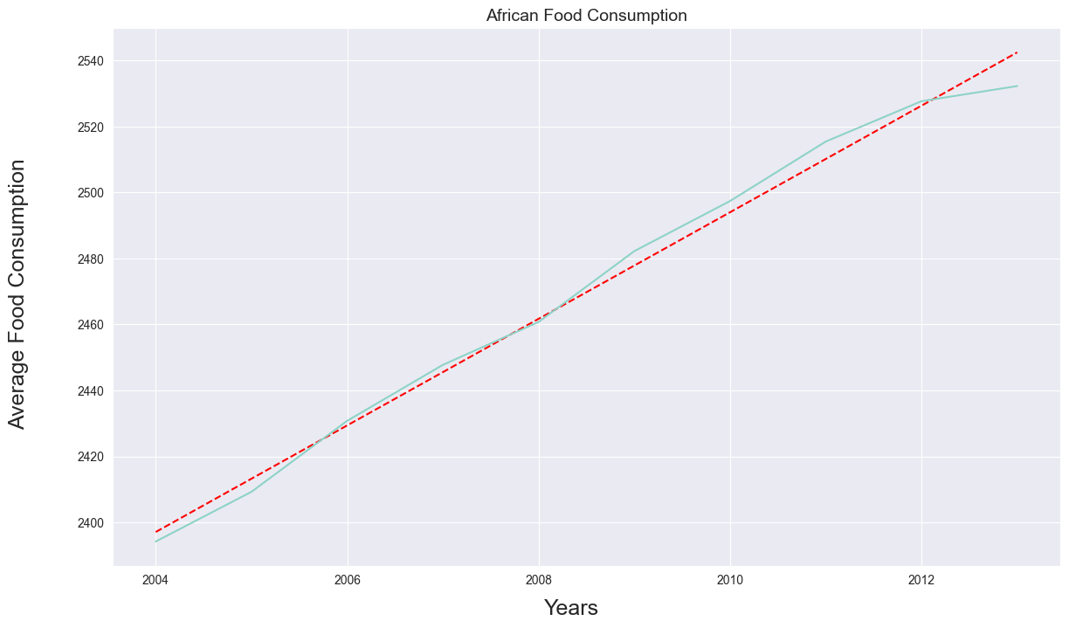
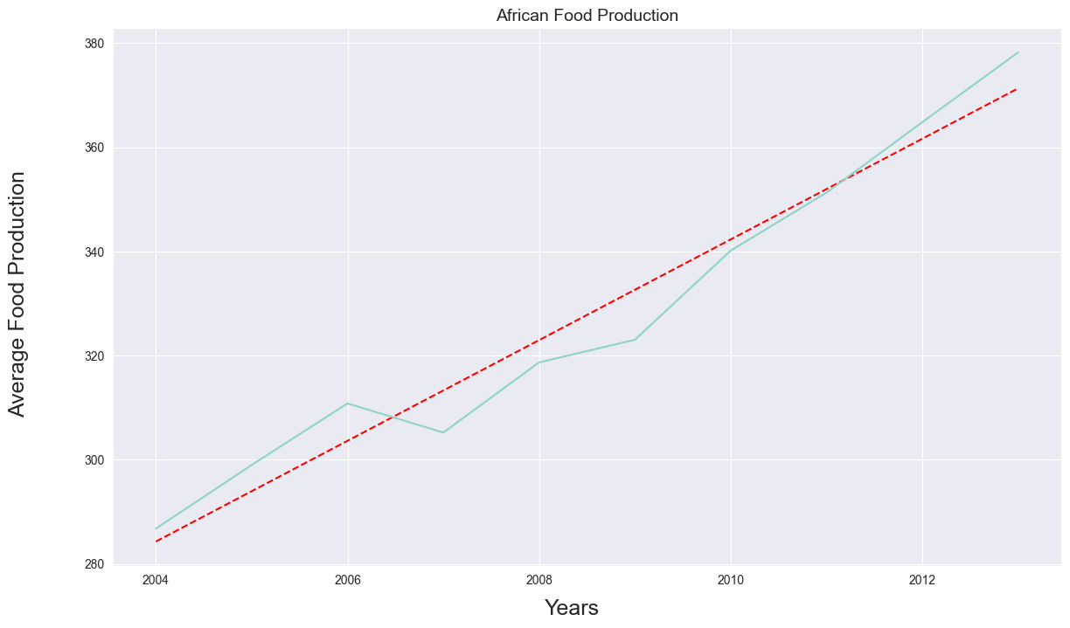

In keeping with this, food shortages are a reality that Africans are currently experiencing. The continent's average food production and supply levels are out of balance, and the low food production rate and rising consumption rates are signs of the continent's food vulnerabilities.

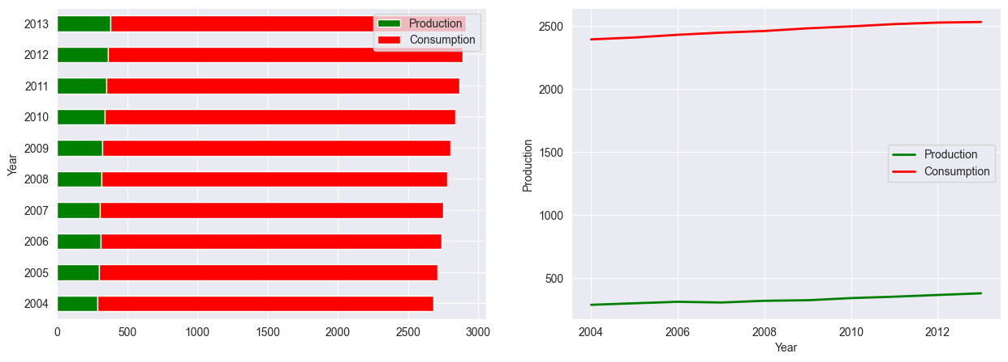
Except for Nigeria, Egypt, and South Africa, which have the greatest rates of food production from 2004-2013, the bulk of African nations are unable to produce enough food to sustain their inhabitants despite rising food demand and population numbers.

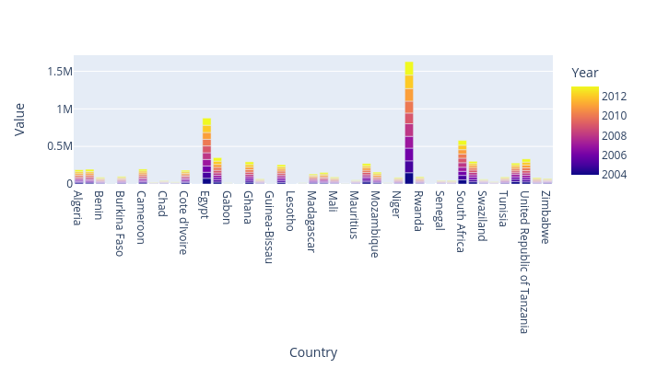

With the exception of few northern African nations like Egypt, Algeria, Morocco, and Tunisia and some western nations, most sub-Saharan African nations have the lowest levels of food supply since rising production was unable to keep up with the even faster rise in demand.

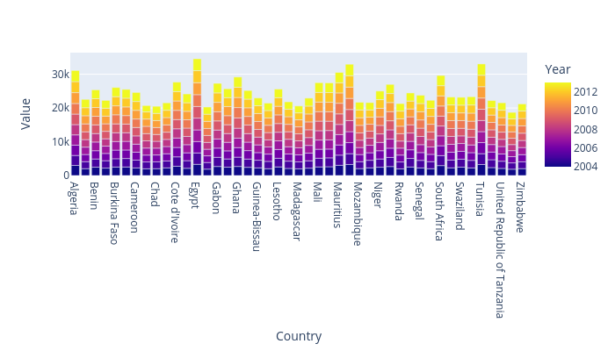
Egypt is the top-delivering nation in Africa in 2012, supplying roughly 3561 metric tons of feed products, followed by Tunisia with 3390 and Morocco with 3366.

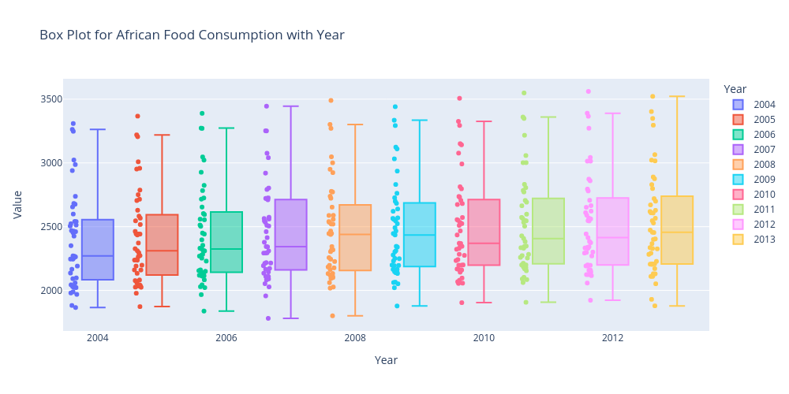
To sum up, it is suggested that Africa should expand food production to keep up with the rising demand for food supply among its people.

