GOAT: The never-ending emotion of modern Football fans
The term “greatest of all time” was created to designate the greatest football player in history. Since the beginning of the FIFA World Cup, it has been used to denote the player with the best performance worldwide, inspiring fans to share their sentiments and emotions on various social media platforms. The audience can’t stop watching while their favorite players play football in the stadium without tweeting about it on Twitter, the social networking site with 430 million users worldwide.
Thousands of tweets have been written on Twitter since the FIFA World Cup in Qatar began this year. The sentiments about the greatest player of this year that have been shared on Twitter since November 20, 2022, include both favorable and negative ones, as well as neutral ones and those who choose to remain so in all circumstances. Who would be the greatest individual of all time if that were the case?
In order to respond to the aforementioned query, 50K tweets are extracted from Twitter using the snscrape Python library and saved as one file that focuses on Messi, Ronaldo, and the youngest of them all, Mbappe. The Python programming language is used to analyze the wordcloud, the number of times each player’s name is mentioned, the amount of tweets, retweets, and likes.
With the development of technology, posting one’s emotions on social media platforms is not difficult. Users can tweet from anywhere thanks to various socially connected technology like mobile phones. The following statistic image serves as an example, showing that 37.8% of tweets come from Android users, with 46.6% coming from iPhone users. 47.4% of the tweets published utilizing various technological sources are therefore neutral, 39% are positive, and the remaining fraction is negative in nature.
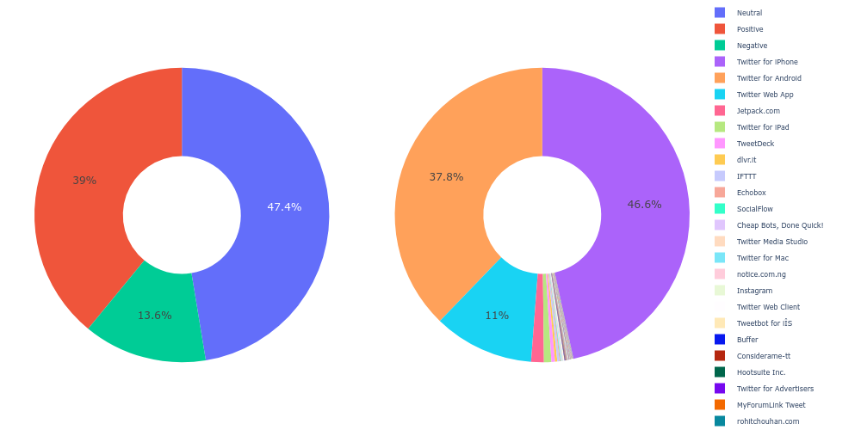
To this reason, Ronaldo and Lionel Messi have both been hailed as the greatest players in history. Recently, it has become clear that younger stars like Kylian Mbappe are on the verge of challenging for the title of "Greatest of All Time." Our wordcloud image’s evidence shows that Mbappe is the greatest player and has been mentioned in tweets more than 30,000 times. The role Mbappe played in helping the France National Team qualify for the Qatar 2022 World Cup and the team’s continued progress toward the semifinals were factors in the considerable coverage of tweets for Mbappe.
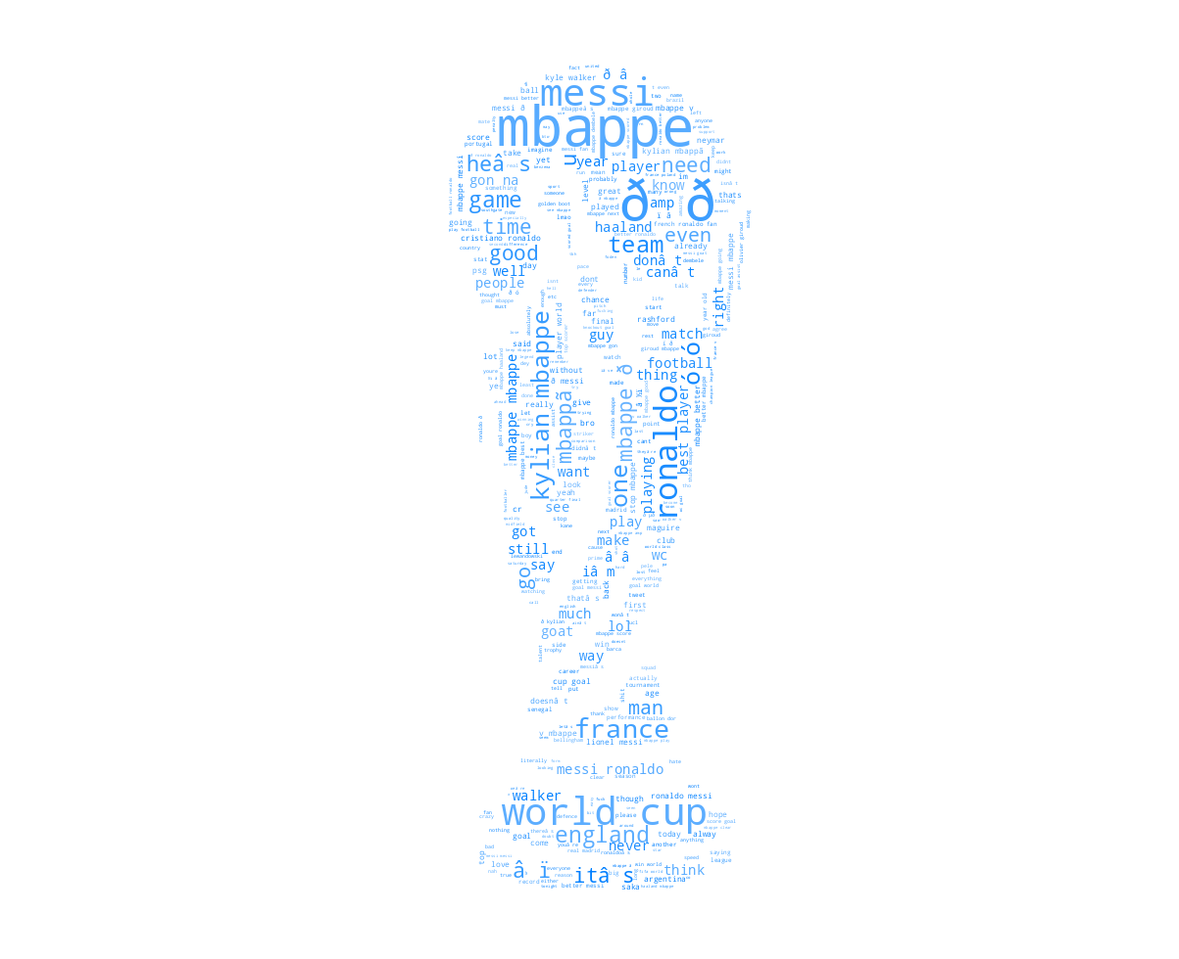
Unquestionably, Mbappe had his best World Cup performance to date. This young star was highlighted more frequently by
football fans due to a variety of qualities, including his ability to manage the ball beneath his feet, assist in a goal, attempt a shot on goal, and score the best goal for his club. With more than 13K tweet mentions, Messi is the second-most referenced player, while Cristiano Ronaldo is third with 9K.
On December 4, when his side defeated Poland’s national team by a score of 3:1 and Mbappe scored twice for his team, these aspects of Mbappe’s play were shown to be genuine. The time series graph below serves as an example.

