Github repo: https://github.com/Michael0x18/ECE554SP26_Minilab1a/tree/master
I created this repository by using the Github UI
I added the files by copying them into a cloned repo and pushing them

Transcript with IP:
# do run.do
# ** Warning: (vlib-34) Library already exists at "work".
# Model Technology ModelSim - Intel FPGA Edition vlog 10.5b Compiler 2016.10 Oct 5 2016
# Start time: 16:14:03 on Feb 05,2026
# vlog -reportprogress 300 -work work addsb_bb.v addsb.v fifo.sv mac.sv mult_mod_bb.v mult_mod.v tb.sv fifo2_bb.v fi
fo2.v Minilab0.v
# -- Compiling module addsb
# ** Warning: addsb.v(40): (vlog-2275) 'addsb' already exists and will be overwritten.
# -- Compiling module addsb
# -- Compiling module FIFO
# -- Compiling module MAC
# -- Compiling module mult_mod
# ** Warning: mult_mod.v(40): (vlog-2275) 'mult_mod' already exists and will be overwritten.
# -- Compiling module mult_mod
# -- Compiling module tb
# -- Compiling module fifo2
# ** Warning: fifo2.v(40): (vlog-2275) 'fifo2' already exists and will be overwritten.
# -- Compiling module fifo2
# -- Compiling module Minilab0
#
# Top level modules:
# addsb
# mult_mod
# tb
# fifo2
# End time: 16:14:03 on Feb 05,2026, Elapsed time: 0:00:00
# Errors: 0, Warnings: 3
# vsim -L /home/michael2/Documents/intelFPGA/18.1/modelsim_ase/altera/verilog/altera_mf -L /home/michael2/Documents/
intelFPGA/18.1/modelsim_ase/altera/verilog/220model work.tb -voptargs="+acc"
# Start time: 16:14:03 on Feb 05,2026
# Loading sv_std.std
# Loading work.tb
# Loading work.Minilab0
# Loading work.MAC
# Loading work.FIFO
# ** Warning: (vsim-3116) Problem reading symbols from linux-gate.so.1 : can not open ELF file.
# ** Warning: (vsim-3116) Problem reading symbols from /lib/libpthread.so.0 : module was loaded at an absolute addre
ss.
# ** Warning: (vsim-3116) Problem reading symbols from /lib/librt.so.1 : module was loaded at an absolute address.
# ** Warning: (vsim-3116) Problem reading symbols from /lib/libdl.so.2 : module was loaded at an absolute address.
# ** Warning: (vsim-3116) Problem reading symbols from /lib/libm.so.6 : module was loaded at an absolute address.
# ** Warning: (vsim-3116) Problem reading symbols from /lib/libc.so.6 : module was loaded at an absolute address.
# ** Warning: (vsim-3116) Problem reading symbols from /lib/ld-linux.so.2 : module was loaded at an absolute address
.
# Yahoo! All tests passed!
# ** Note: $finish : tb.sv(66)
# Time: 2185 ns Iteration: 0 Instance: /tb
# 1
# Break in Module tb at tb.sv line 66
add wave -position insertpoint \
sim:/tb/clk \
sim:/tb/HEX0 \
sim:/tb/HEX1 \
sim:/tb/HEX2 \
sim:/tb/HEX3 \
sim:/tb/HEX4 \
sim:/tb/HEX5 \
sim:/tb/LEDR \
sim:/tb/KEY \
sim:/tb/SW
restart -f
# Closing VCD file "dump.vcd"
run -all
# ** Warning: (vsim-3116) Problem reading symbols from linux-gate.so.1 : can not open ELF file.
# ** Warning: (vsim-3116) Problem reading symbols from /lib/libpthread.so.0 : module was loaded at an absolute addre
ss.
# ** Warning: (vsim-3116) Problem reading symbols from /lib/librt.so.1 : module was loaded at an absolute address.
# ** Warning: (vsim-3116) Problem reading symbols from /lib/libdl.so.2 : module was loaded at an absolute address.
# ** Warning: (vsim-3116) Problem reading symbols from /lib/libm.so.6 : module was loaded at an absolute address.
# ** Warning: (vsim-3116) Problem reading symbols from /lib/libc.so.6 : module was loaded at an absolute address.
# ** Warning: (vsim-3116) Problem reading symbols from /lib/ld-linux.so.2 : module was loaded at an absolute address
.
# Yahoo! All tests passed!
# ** Note: $finish : tb.sv(66)
# Time: 2185 ns Iteration: 0 Instance: /tb
# 1
# Break in Module tb at tb.sv line 66

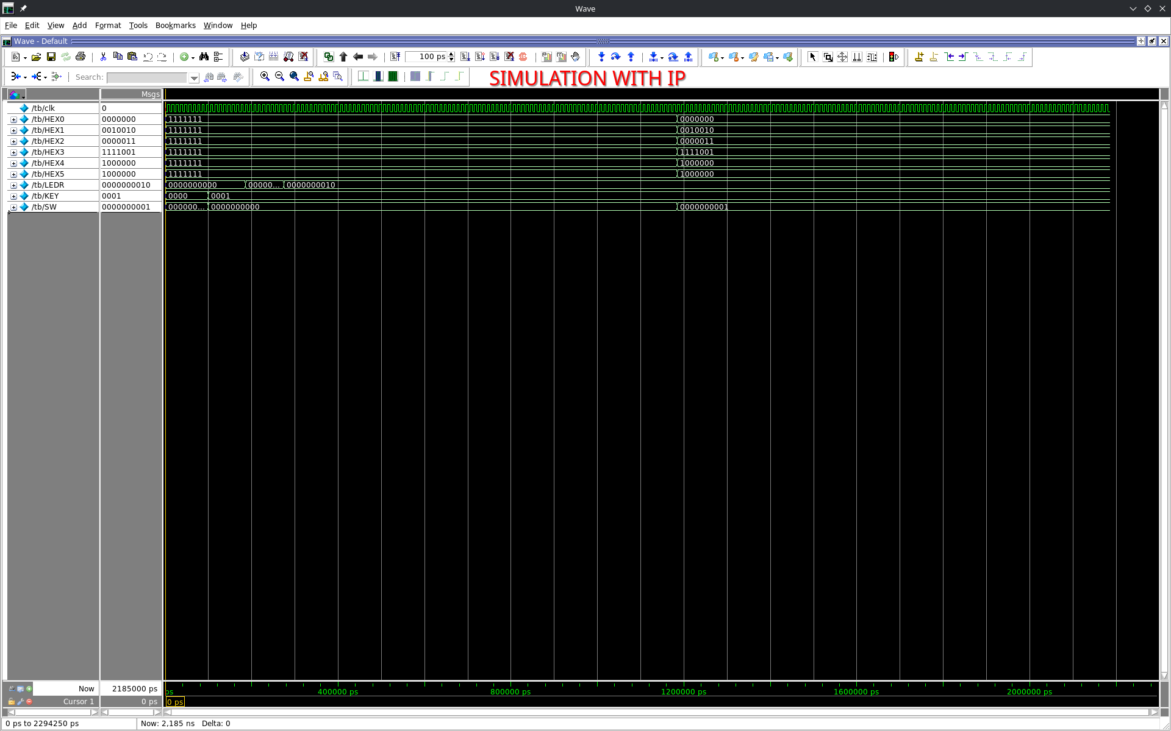
Above is a screenshot of the waves with the IP

Simulation without IP:
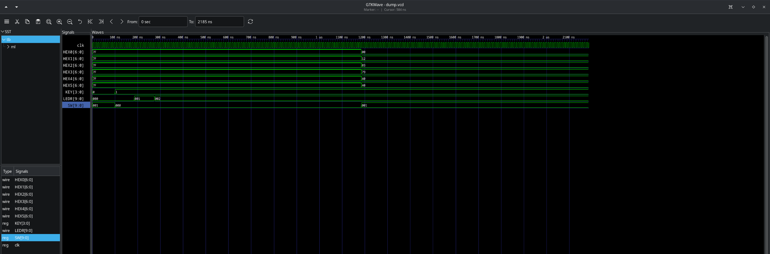

michael2@himring-2 ~/D/C/E/1a_actually0 (master)> iverilog -g2012 *.sv Minilab0.v && ./a.out && gtkwave dump.vcd
VCD info: dumpfile dump.vcd opened for output.
Yahoo! All tests passed!
tb.sv:66: $finish called at 2185 (1ns)
Transcript without IP (using our files)

