Program 1:
package java_tuts;

public class OMRKing1 {
public static void main(String[] args) {

Son1 s1 = new Son1();
s1.bike();
s1.bike("KTM Duke");

Son2 s2 = new Son2("RC Boy");
s2.bike();
s2.bike("RC 390");

Father f = new Son2();
f.oldBike();
}
}

class GrandFather {
GrandFather() {
System.out.println("GrandFather constructor");
}

void oldBike() {
System.out.println("GrandFather: Royal Enfield 1983");
}
}

class Father extends GrandFather {
Father() {
System.out.println("Father constructor");
}

Father(String name) {
System.out.println("Father constructor with name: " + name);
}

void oldBike() {
System.out.println("Father: Royal Enfield 2002");
}
}

class Son1 extends Father {
Son1() {
super();
System.out.println("Son1 constructor");
}

void bike() {
System.out.println("Son1: KTM 390");
}

void bike(String model) {
System.out.println("Son1: " + model);
}
}

class Son2 extends Father {
Son2() {
super();
System.out.println("Son2 constructor");
}

Son2(String nick) {
super(nick);
System.out.println("Son2 constructor with nick: " + nick);
}

void bike() {
System.out.println("Son2: RC KTM 390");
}

void bike(String model) {
System.out.println("Son2: " + model);
}

void oldBike() {
System.out.println("Son2: Modified old bike");
}
}
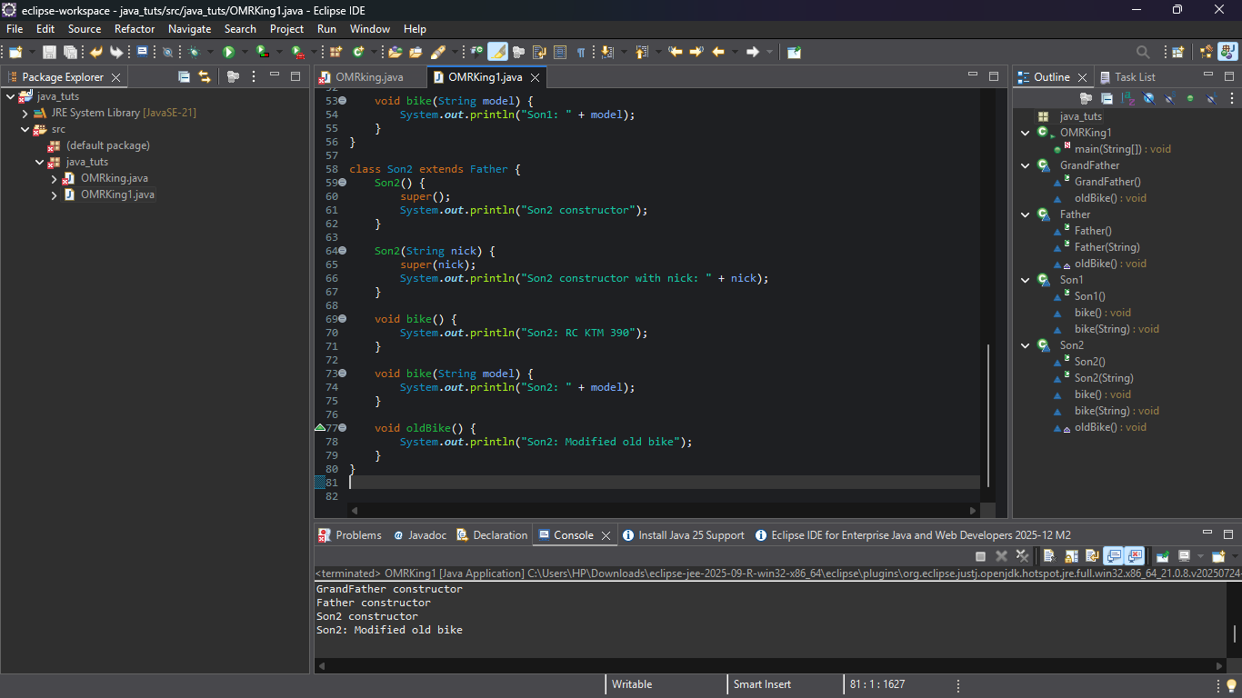
Program 2:

package java_tuts;

class Student {
private String name;
private int age;

void setName(String name) {
this.name = name;
}

void setAge(int age) {
this.age = age;
}

String getName() {
return name;
}

int getAge() {
return age;
}
}

public class EncapsulationDemo {
public static void main(String[] args) {

Student s = new Student();
s.setName("Michael");
s.setAge(19);

System.out.println("Name: " + s.getName());
System.out.println("Age: " + s.getAge());
}
}
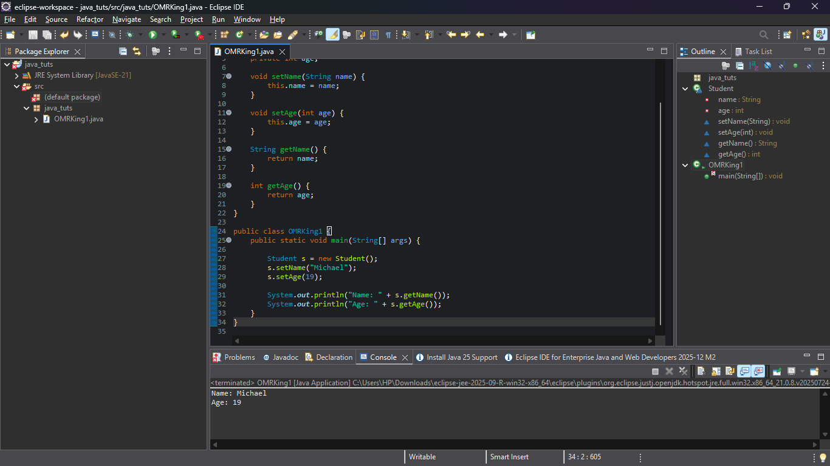

Program 3:

package java_tuts;
abstract class Vehicle {
abstract void start();
abstract void stop();
}

class Car extends Vehicle {
void start() {
System.out.println("Car started.");
}

void stop() {
System.out.println("Car stopped.");
}

void setSpeed(int speed) throws Exception {
if (speed < 0) {
throw new Exception("Speed cannot be negative.");
}
System.out.println("Speed set to " + speed);
}
}

public class AbstractionExceptionDemo {
public static void main(String[] args) {

Vehicle v = new Car();

v.start();

try {
((Car) v).setSpeed(100);
((Car) v).setSpeed(-20);
} catch (Exception e) {
System.out.println("Error: " + e.getMessage());
} finally {
v.stop();
System.out.println("Finished.");
}
}
}

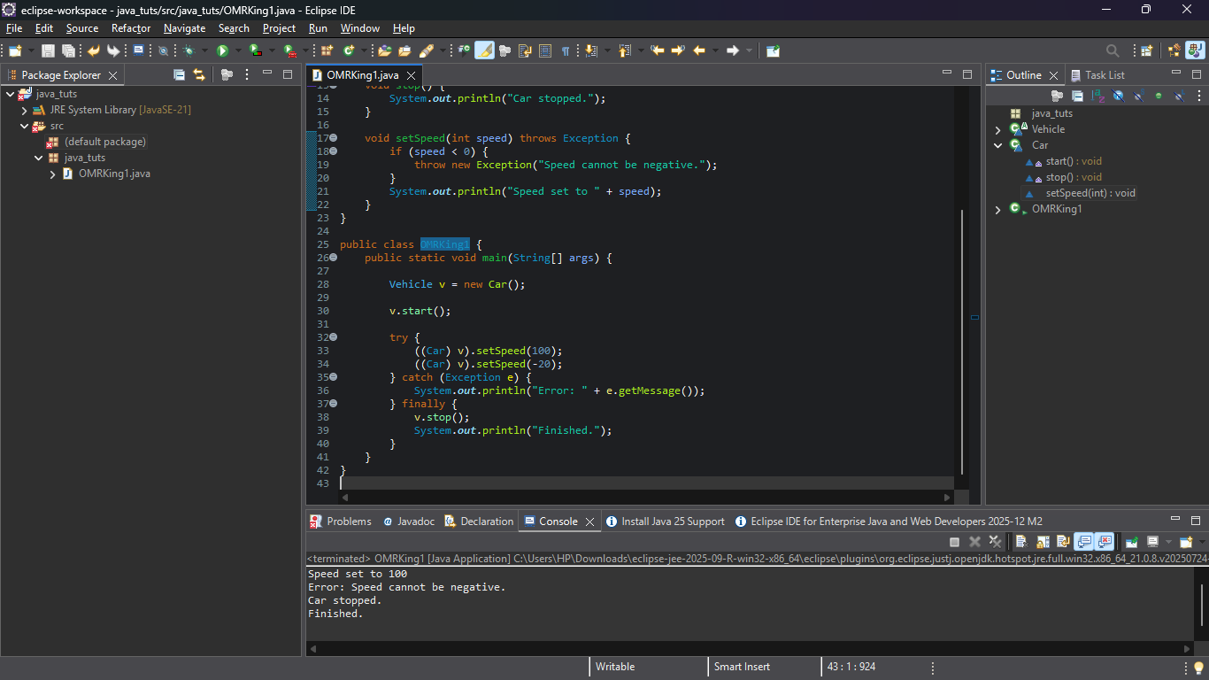
Program 4: calculator:

class BasicCalculator {
// Addition
int add(int a, int b) {
return a + b;
}

// Subtraction
int subtract(int a, int b) {
return a - b;
}
}

class AdvancedCalculator extends BasicCalculator {
// Multiplication
int multiply(int a, int b) {
return a * b;
}

// Division
double divide(int a, int b) {
if (b == 0) {
System.out.println("Error: Division by zero is not allowed!");
return 0;
}
return (double) a / b;
}
}

public class CalculatorDemo {
public static void main(String[] args) {
AdvancedCalculator calc = new AdvancedCalculator();

System.out.println("Addition: " + calc.add(10, 5));
System.out.println("Subtraction: " + calc.subtract(10, 5));
System.out.println("Multiplication: " + calc.multiply(10, 5));
System.out.println("Division: " + calc.divide(10, 5));
}
}
