Program 1:
Package java_tuts;

public class OMRKing1 {
public static void main(String[] args) {

try {
Son1 s1 = new Son1();
s1.bike();

Son2 s2 = new Son2();
s2.bike();
s2.oldBike();

} catch (Exception e) {
System.out.println("Something went wrong: " + e);
} finally {
System.out.println("Program ended — finally block executed.");
}
}
}

class GrandFather {
void oldBike() {
System.out.println("Royal Enfield 1983");
}
}

class Father extends GrandFather {
void oldBike() {
System.out.println("Royal Enfield 2002");
}

void showFatherMessage() {
System.out.println("This is Father class message");
}
}

class Son1 extends Father {
void bike() {
System.out.println("KTM 390");
super.showFatherMessage();
super.oldBike();
}
}

class Son2 extends Father {
void bike() {
System.out.println("RC KTM 390");
super.showFatherMessage();
}

void oldBike() {
System.out.println("Son2 also has an upgraded bike:");
super.oldBike();
}
}

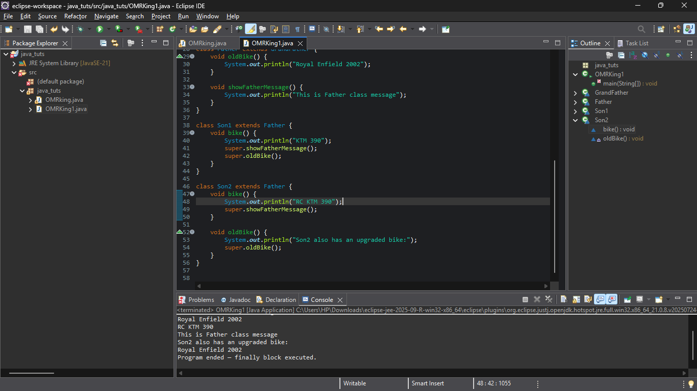
Program 2:
package java_tuts;
public class OMRking {
public static void main(String[] args) {

Program1 program=new Program1(100);
program.addition();
}
}
class Program1{
int marks=95; //class variable
//user def methods
protected void addition(){
int result= marks*100;
System.out.println(result);
//method local inner class
class InsideClass{
void division(){
System.out.println("method Local inner class output");
}
}
}
//initi block
{
System.out.println("Welcome...!");
String date="19th Nov 2025";
System.out.println(date);
}
//constru //def //parame
public Program1() {
System.out.println("Iam a def const..");
}
public Program1(int a){
a=marks+a;
System.out.println(a);
}
}
