CHESTER M. MENDOZA
JAY MICHAEL CASTILLO

WEB HOSTING SERVICES: VERCEL

This is the main dashboard of Vercel. From here, you can create or import a new project to deploy your website.
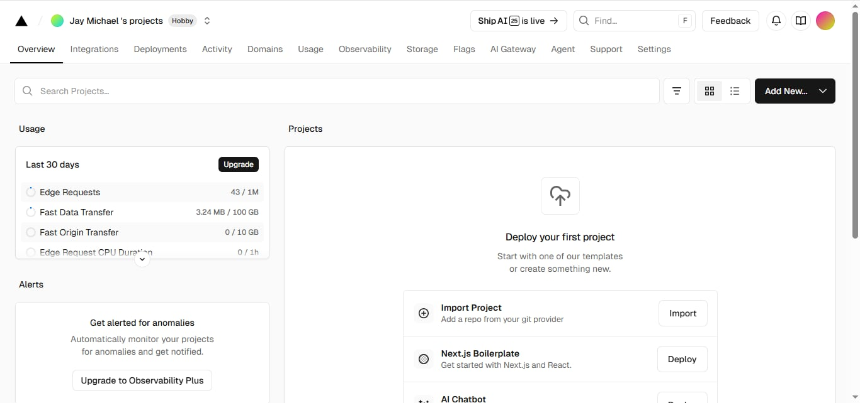

This page shows the new project setup. The GitHub repo is connected, and the project name jmc-portfolio is added before clicking Create.
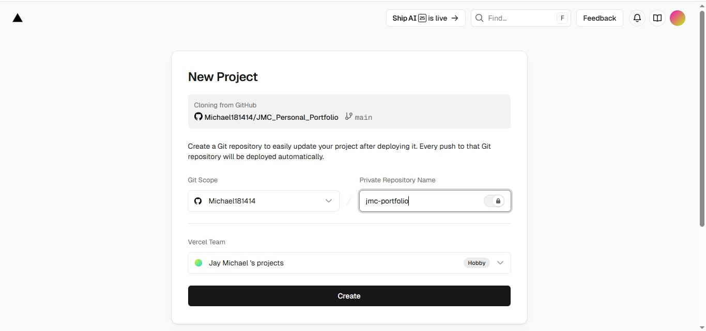

This part shows the deployment in progress. Vercel is building and uploading the website to make it live online.
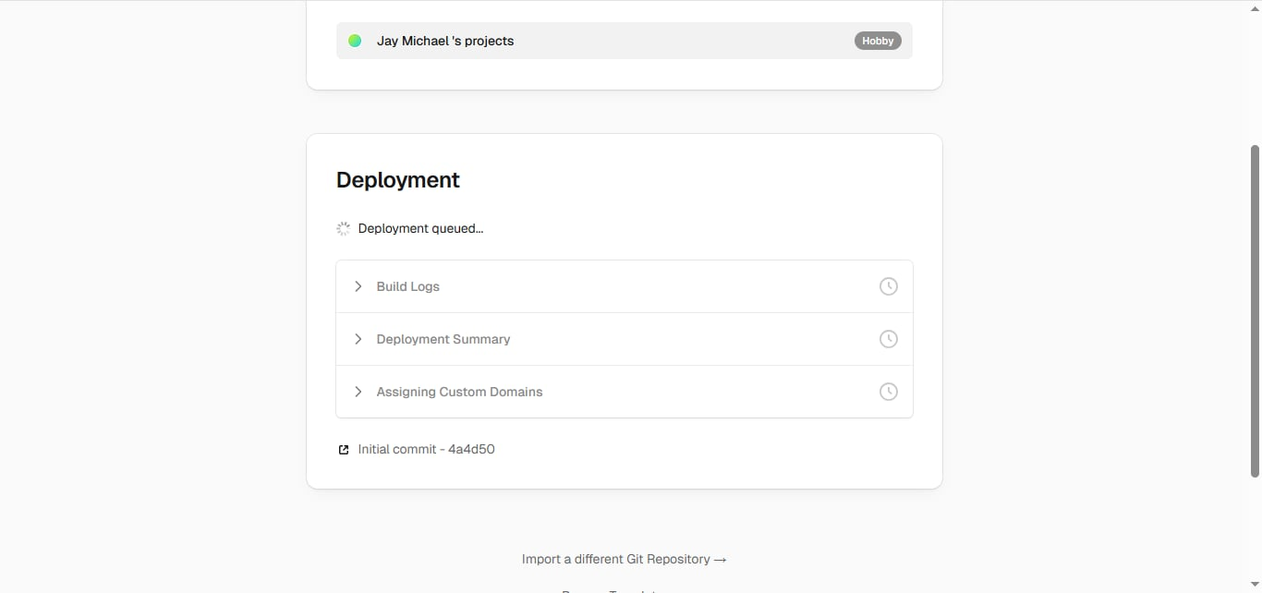

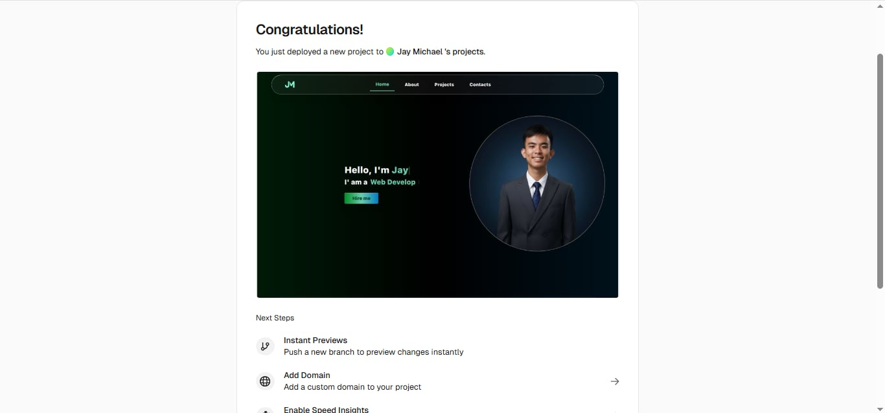
This page shows the successful deployment. The website is now live, and you can see the preview of your portfolio.

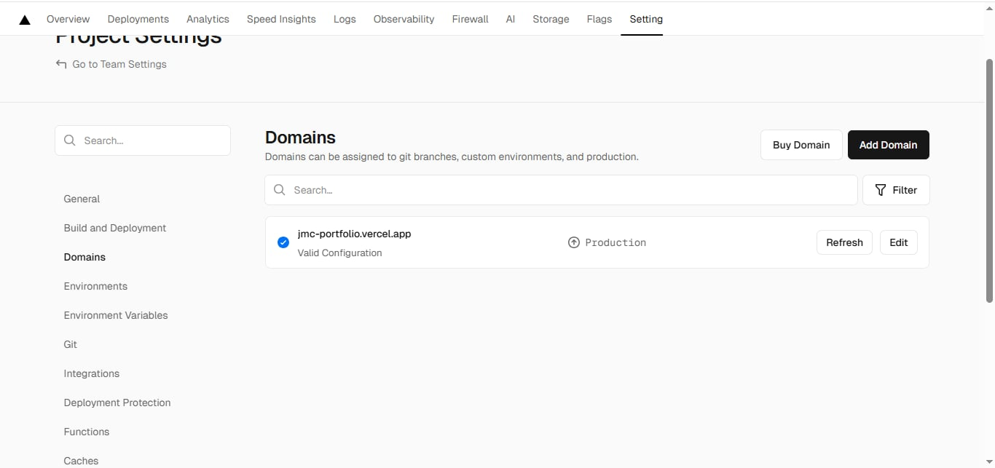
This is the domain page. It shows the project’s link jmc-portfolio.vercel.app which means the site is now live and working.

