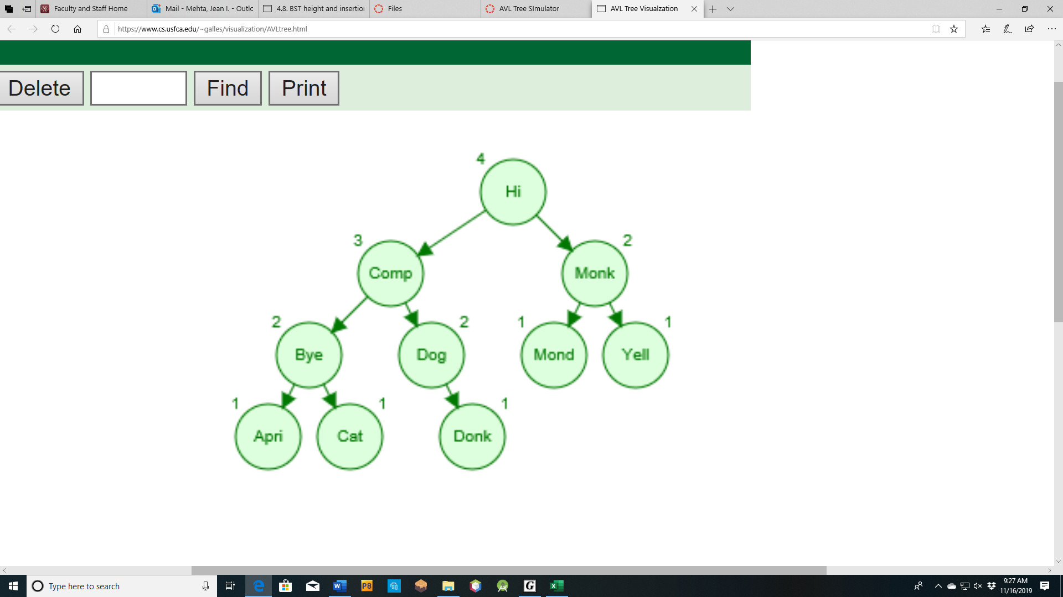

AVL tree for input file words2

Height = 3

String Accesses (comparisons to find the word)

Hi 1

Computer 2

Monkey 2

Bye 3

Dog 3

Monday 3

Yellow 3

April 4

Cat 4

Donkey 4

Total Accesses =29. Average = 29/10=2.9