Wiki: <https://en.wikipedia.org/wiki/QR_decomposition>

<https://en.wikipedia.org/wiki/Householder_transformation>

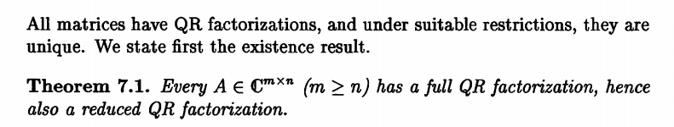

**Lemma 1**: QR decompostion $A=QR$ is unique whent the matrix $A$ is inveritble with the requirement of positive diagonal entry for upper-triangular matrix $R$.

**Lemma 2**: thin or reduced QR decompostion $A=QR=\left[Q_{1},Q_{2}\right]\left[\begin{matrix}R_{1} \\ 0\end{matrix}\right]=Q_{1}R_{1}$ is unique when A is full rank n.

where *R*1 is an *n*×*n* upper triangular matrix, *0* is an (*m* − *n*)×*n* zero matrix, *Q*1 is *m*×*n*, *Q*2 is *m*×(*m* − *n*), and *Q*1 and *Q*2 both have orthogonal columns.

**Lemma 3**: $R_{1}$ is equal to the upper triangular factor of the [Cholesky decomposition](https://en.wikipedia.org/wiki/Cholesky_decomposition) of $A^{H}A$  (= $A^{T}A$ if *A* is real) if we require that the diagonal elements of *R*1 are positive.

Note: HouseHolder reflection is also widely used for **tridiagonalization** of **symmetric matrices** and for transforming **non-symmetric matrices to a Hessenberg form**.

|  |  |
| --- | --- |
| $$A_{k+1}=P_{k+1}AP_{k+1}$$ | (1‑1) |

# General least square problem

|  |  |
| --- | --- |
| $$Ax=b$$ | (1‑1) |

Where matrix $A$ is $m×n$, $x$ is one $n×1$ vector, and b is $m×1$ vector

## Overdetermined

If the linear equations are overdetermined ($m≥n$) (exactly, overdetermine means $m>n$), the least square solution is

|  |  |
| --- | --- |
| $$\hat{x}=A^{†}b \\ ={\left(A^{H}A\right)}^{-1}A^{H}b \\ ={\left(A^{H}A\right)}^{-1}A^{H}Ax \\ =x$$ | (1‑2) |

So the problem becomes to caculate the inverse of matrix $A^{H}A$.

By using QR decomposition, the least sqaure equation becomes to

|  |  |
| --- | --- |
| $$QRx=b$$ $$≪=≫Rx=Q^{H}b$$ $$≪=≫R_{1}x=Q_{1}^{H}b$$ | (1‑3) |

The equation (1‑3) can be solved by backward-substitution (for upper-triangular system). (same result can be got by using equation (1‑2)).

## Underdetermined (rare)

If the linear equations are underdetermined ($m<n$), the least square solution is

|  |  |
| --- | --- |
| $$\hat{x}=A^{†}b \\ =A^{H}{\left(AA^{H}\right)}^{-1}b \\ =A^{H}{\left(AA^{H}\right)}^{-1}Ax \\ ≈x$$ | (1‑4) |

By using EQ decompostion for $A^{H}$, the equation (1‑1) becomes to

|  |  |
| --- | --- |
| $${\left(QR\right)}^{H}x=b$$ $$≪=≫R^{H}Q^{H}x=b$$ $$≪=≫Q^{H}x={\left(R^{H}\right)}^{-1}b$$ | (1‑5) |

The ${\left(R^{H}\right)}^{-1}b$ can be calulated by forward-substitution (for lower-triangular system).

Another alternative slolution is to directly calculate the LQ decompostion of $A$.

|  |  |
| --- | --- |
| $$LQx=b$$ $$≪=≫Qx=L^{-1}b$$ $$≪=≫x=Q^{H}L^{-1}b$$ | (1‑6) |

The $L^{-1}b$ can be calcualted by forward-subsitution.

Another alternative slolution is to directly calculate the RQ decompostion of $A$.

|  |  |
| --- | --- |
| $$RQx=b$$ $$≪=≫Qx=R^{-1}b$$ $$≪=≫x=Q^{H}R^{-1}b$$ | (1‑7) |

The $R^{-1}b$ can be calcualted by backward-subsitution.

# QR deocomposition (QRD)

In [linear algebra](https://en.wikipedia.org/wiki/Linear_algebra), a **QR decomposition** (also called a **QR factorization**) of a [matrix](https://en.wikipedia.org/wiki/Matrix_(mathematics)) is a [decomposition of a matrix](https://en.wikipedia.org/wiki/Matrix_decomposition) *A* into a product *A* = *QR* of an [orthogonal matrix](https://en.wikipedia.org/wiki/Orthogonal_matrix) *Q* and an [upper triangular matrix](https://en.wikipedia.org/wiki/Upper_triangular_matrix) *R*. QR decomposition is often used to solve the [linear least squares](https://en.wikipedia.org/wiki/Linear_least_squares_(mathematics))problem, and is the basis for a particular [eigenvalue algorithm](https://en.wikipedia.org/wiki/Eigenvalue_algorithm), the [QR algorithm](https://en.wikipedia.org/wiki/QR_algorithm).

# QRD for complex rectangular matrix (overdetermined)

Generally, we can factor a complex *m*×*n* matrix $A$, with *m* ≥ *n*, as the product of an *m*×*m* [unitary matrix](https://en.wikipedia.org/wiki/Unitary_matrix) *Q* and an *m*×*n* upper triangular matrix *R*. As the bottom (*m*−*n*) rows of an *m*×*n* upper triangular matrix consist entirely of zeroes, it is often useful to partition*R*, or both *R* and *Q*:

|  |  |
| --- | --- |
| $$A=QR=\left[Q_{1},Q_{2}\right]\left[\begin{matrix}R_{1} \\ 0\end{matrix}\right]=Q_{1}R_{1}$$ | (3‑1) |

where *R*1 is an *n*×*n* upper triangular matrix, *0* is an (*m* − *n*)×*n* zero matrix, *Q*1 is *m*×*n*, *Q*2 is *m*×(*m* − *n*), and *Q*1 and *Q*2 both have orthogonal columns.

[Golub & Van Loan (1996](https://en.wikipedia.org/wiki/QR_decomposition#CITEREFGolubVan_Loan1996), §5.2) call *Q*1*R*1 the *thin QR factorization* of *A*; Trefethen and Bau call this the *reduced QR factorization*.[[1]](https://en.wikipedia.org/wiki/QR_decomposition#cite_note-Trefethen-1) If *A* is of full [rank](https://en.wikipedia.org/wiki/Matrix_rank) *n* and we require that the diagonal elements of *R*1 are positive, then $R_{1}$ and $Q_{1}$ are unique, but in general *Q*2 is not. is then equal to the upper triangular factor of the [Cholesky decomposition](https://en.wikipedia.org/wiki/Cholesky_decomposition) of $A^{H}A$  (= $A^{T}A$ if *A* is real).

# QRD for complex rectangular matrix (underdetermined)

If the matrix $A$ is underdetermined (m<n), RQ or LQ decomposition can be used to slove the equation.

# HouseHolder Reflection/Transformation

## Geometry illustration

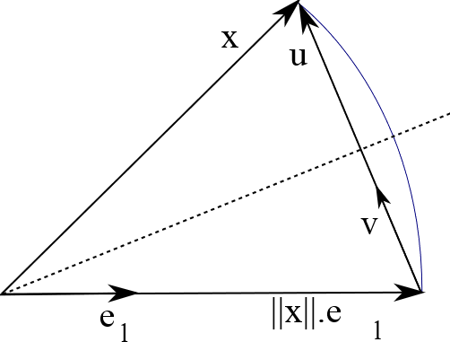

Figure 1, Geometry illustraction of HouseHolder Reflection

For real maxtrix/vector, as shown in Figure 1, in order to rotate the vecotr $x_{k×1}$ to one specific place by followding operation.

|  |  |
| --- | --- |
|  | (5‑1) |

Where $e_{1}={\left[1, 0,0,…,0\right]_}^{H}$ is one unit vector. The vector $u$ is orthogonal to hyperplane, and $v$ is one unit vector which is collinear with $u$, which can be calculated by

|  |  |
| --- | --- |
|  | (5‑2) |

Then the operation (5‑1) can be rewrite to

|  |  |
| --- | --- |
|  | (5‑3) |

Where $P$ is called **Householder matrix**.

For complex matrix, one only need to modify the equation (5‑2) to

|  |  |
| --- | --- |
|  | (5‑4) |

Where $x={\left[\left|x_{1}\right|e^{jθ_{1}}, x_{2},…,x_{k}\right]}^{T}$.