**CNN.ipynb:**

In this program, the 100 images were loaded rather than just 10. The accuracy at the end was 87% as seen in Figure 1.

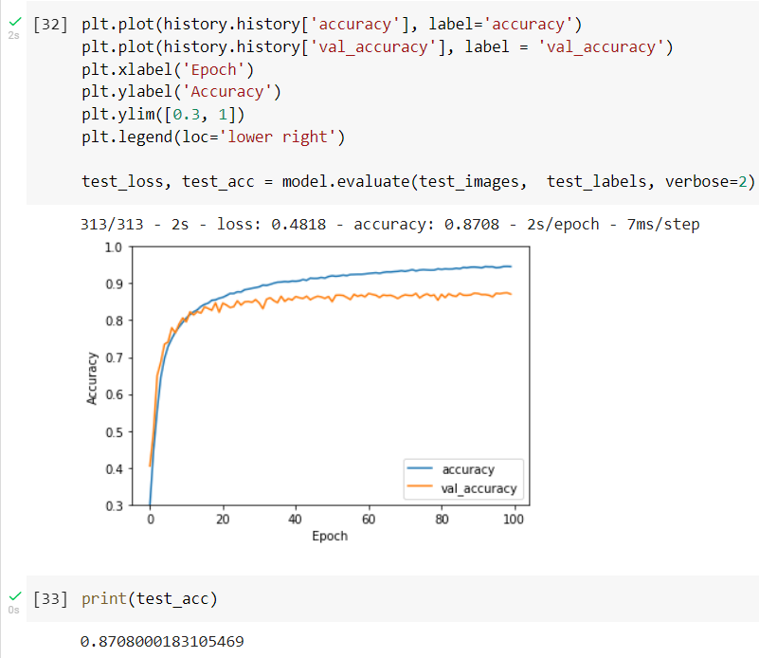

Figure 1: The accuracy test of the CNN code.

**Balloon Flight:**

In the balloon flight game, the changes from the original code made were more high scores, lives, speed it up, and different way to score. More high scores can be added just by editing the high scores text file. Just adding more 0s, or any number, will create more high scores because the python code will read the text file and add in more high scores for you. The lives were hard to implement because every pixel that the balloon touches of the obstacles, you would lose a life. So, if a player were to go through and obstacle, they could end up losing more than 50 lives. The solution was to have a health bar rather than to have live. For the speed it up, the obstacles would travel more greater amounts of pixels the higher the score was. This causes the game to get increasingly more difficult as the player scores more. As for the different way to score, points are scored if the obstacle passes the balloon, rather than when it reaches the left most of the window.

The code in Figure 2 shows the variables. The width and heigh decide the size of the window. The balloon, bird, tree, and house are the obstacles. Images are loaded as the variable and are places in specific locations. The rest of the variable are used for game play.

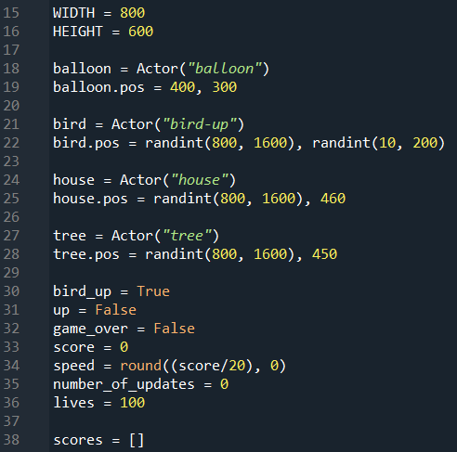

Figure 2: The variables that are used for this game.

The update high scores function is used to write in a player’s score into a text file if the score is high enough. Users need to make user the file is in the right location. The function opens the high scores text file and reads the scores into an array. Then if the score that the player gets is higher than any of the numbers in the array, it writes in the high score after checking each of the numbers. The display high scores function is used to show the high scores. This function will be used later to display scores when the game ends.

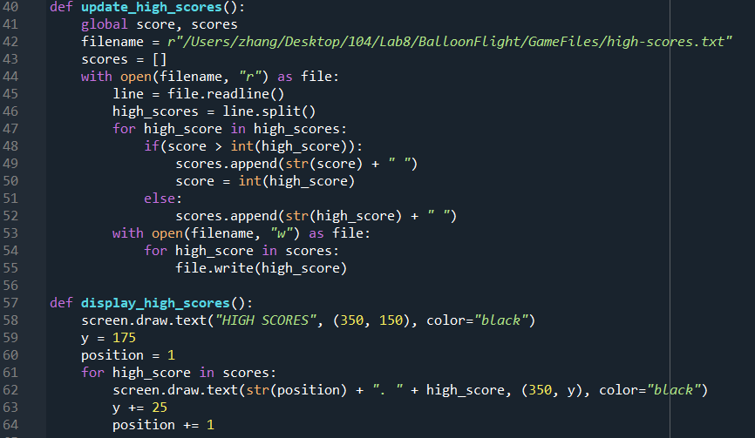

Figure 3: The function used to write and display scores.

In Figure 4, the draw function is used to place images from the image folder. Its also used to draw text such as the score. The on mouse down function moves the balloon up when the mouse is clicked and the on mouse up stops the balloon from moving up when the mouse is not clicked. The flap function swaps the images of a bird with its wings down and a bird with its wing up. This creates the illusion of the bird flying.

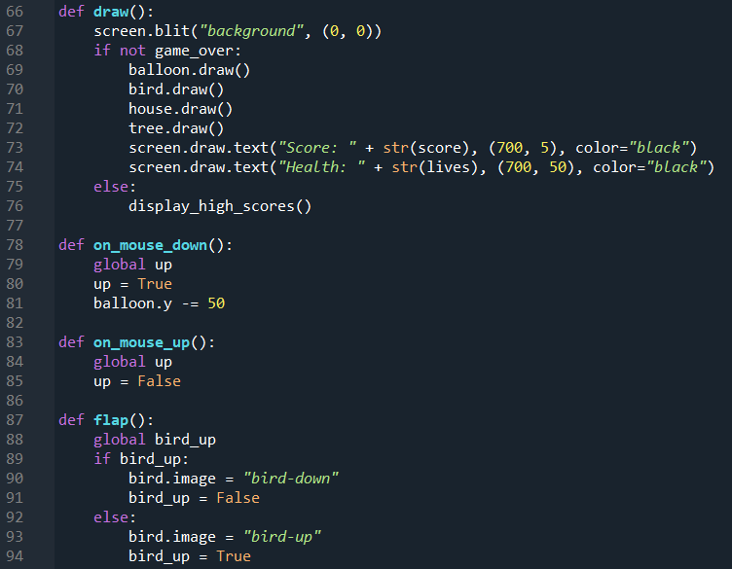

Figure 4: More functions to make the game run.

The update function is what creates changes within the game. If the balloon is not moving up, then it is slowly moving down. If there are no obstacles, some are created. It also updates the movement of the obstacles. Using the score variable, the speed can be changed by setting an equation for how many pixels the obstacles move. Another thing the update function updates is if the balloon collides with an obstacle. This will cause the balloon to lose health and if the health reaches 0, then game over.

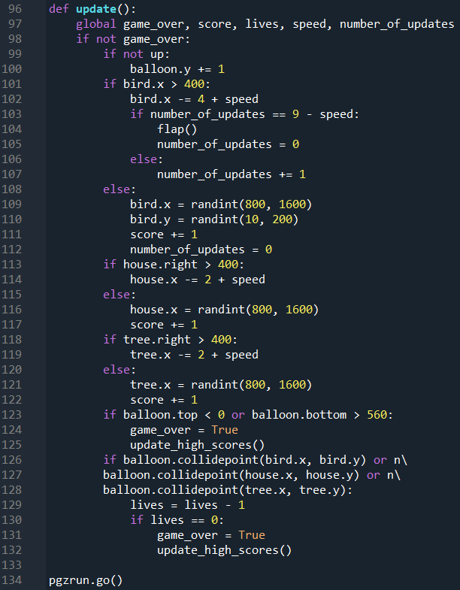

Figure 5: The function that makes changes.