**pH Line Up**

Purpose:

To create a pH indicator from red cabbage and use it to test a variety of household products and foods.

Hypothesis:

Because red cabbage contains anthocyanin, it will change colour depending on the pH of the substance tested.

Materials:

* 10 250 ml mason jars for holding substances
* 10 substances for testing:

1. Tap water
2. Filtered water
3. Lemon juice
4. White vinegar
5. Baking soda
6. Dish soap
7. Banana
8. Shampoo
9. Lotion
10. “All-Natural Kitchen and Bath Cleaner”

* Red cabbage for juicing
* Food processer for chopping the cabbage
* Pot and stove for cooking the cabbage
* Water for helping to chop the cabbage, and for dissolving the baking soda
* Marker for numbering the glasses
* Coffee filter and sieve for filtering cabbage juice
* Bowl for cabbage juice
* Cup for measuring amounts
* Whisk for mixing baking soda in water
* Stainless steel spoons for mixing cabbage juice with thick liquids
* Cell phone for taking pictures
* 15 ml. scoop for scooping cabbage juice

Procedure:

1. Chop up pieces of cabbage and put them in the food processor. Chop them in the food processor until very fine. Place filtered water in as needed.
2. Boil the cabbage bits for 2-3 minutes. Place in the sieve + coffee filter and drain out the juice, into the bowl.
3. Number the jars, in correct order.
4. Place 15 ml of each substance into the labelled jars, (except baking soda and banana).
5. Mash banana and put 15 ml into a jar.
6. Dissolve 3 ml of baking soda into 30 ml of water. Put 15 ml of this solution in the jar.
7. One by one pour 15 ml of cabbage juice into each substance. Stir with spoon if necessary.
8. Record colours and observations about substances and the colour changes that occur.

Observations:

The numbers correspond to the numbered steps of the Procedure.

1. This went fine, the only problem may have been that our water was not perfectly neutral.
2. This went well, but it smelled awful! The cabbage juice was very dark.
3. The jars were laid out, and had the appropriate numbers written on them
4. We used a small measuring cup to measure out exactly 15 ml of each substance and poured it into the jar.
5. We broke a small piece off a banana, placed it in a small container, and mashed it with a fork. We measured 15 ml of it with a scoop, and placed it in its jar.
6. We put 3 ml. of baking soda in a small cup, and 30 ml of water (keeping with the 10:1 ratio). We then whisked it until it was fully dissolved, and then poured 15 ml into a jar.
7. We poured 15 ml of cabbage juice into each sample to be tested.

|  |  |  |  |
| --- | --- | --- | --- |
| Substance | How it was prepared | Colour change/observations | Problems |
| Tap water | Straight from tap | Became blue | None |
| Filtered water | From filtered water tap | Became a pale blue | None |
| Lemon juice | From bottle | Became pinkish-red | None |
| White vinegar | From jug | Became purply-red | None |
| Baking soda | Measured 3 ml. of powder, poured proper ratio of water, and measured into jar | Became deep blue teal | Finding the correct ratio |
| Dish soap | From bottle | Became a very deep purple | None |
| Banana | Was put in a container, mashed, and put in jar | Became a light purple | Getting exactly 15 ml. |
| Shampoo | From bottle | Became violet | Mixing it all together was difficult |
| Lotion | Squirted from tube | A very pale purple | The lotion was opaque, so it was hard to see the right colour |
| Kitchen/Bath cleaner | Poured from bottle | Deep green teal | None |

1. Recorded on a table very similar to the one above.

Questions:

* What was the strongest base and acid tested here?
* Looking at the charts of pH indication, the baking soda was the strongest base, and lemon juice was the strongest acid.
* What colour does it turn above 7 pH? Below?
* It gets closer to pink/red the more acidic, and closer to yellow the more basic.

Conclusion:

The more acidic substances became pinkish red, the basic substances became more green (and yellow which my mom found when she tested bleach, which wasn’t really part of this lab), and neutral substances became blue. This demonstrated that the anthocyanin molecule changes shape in response to the change of pH, which shows up as a change in colour.

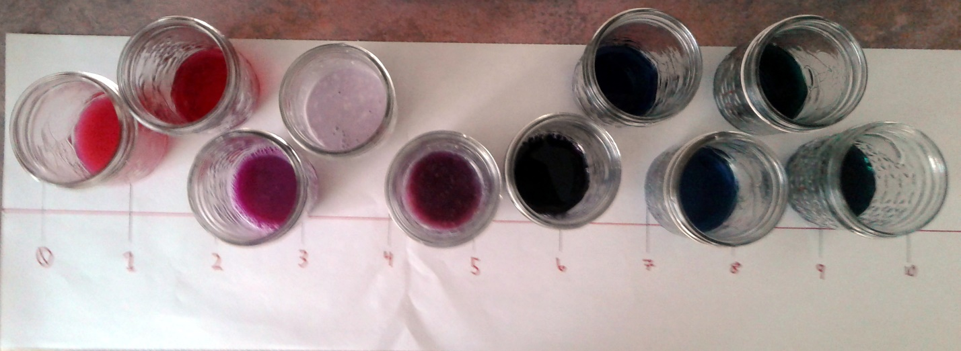

I think my results are accurate for the most part because even though I changed the recommended amounts to use (because my mom didn’t want me using so much) I kept the ratio the same, and made sure that the containers and measuring cup were always kept clean and dry. However my measurements may have been slightly off on occasion, and may have possibly become contaminated 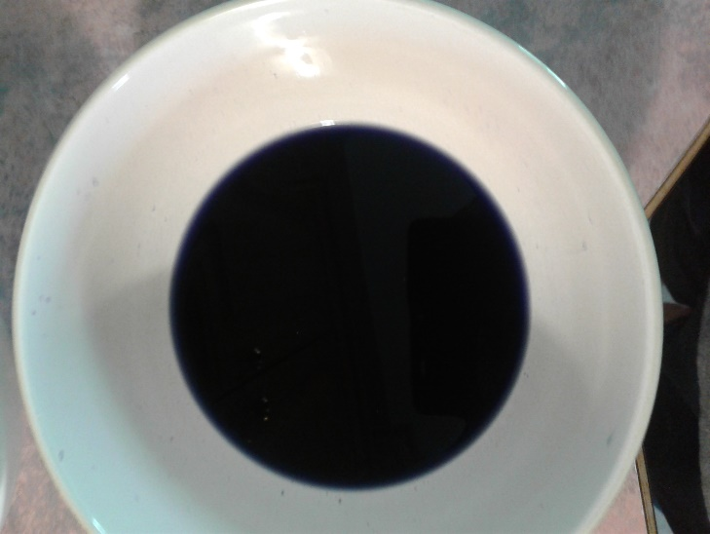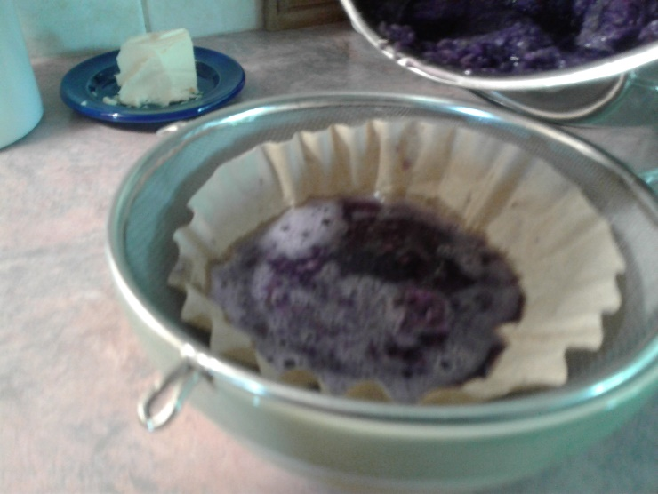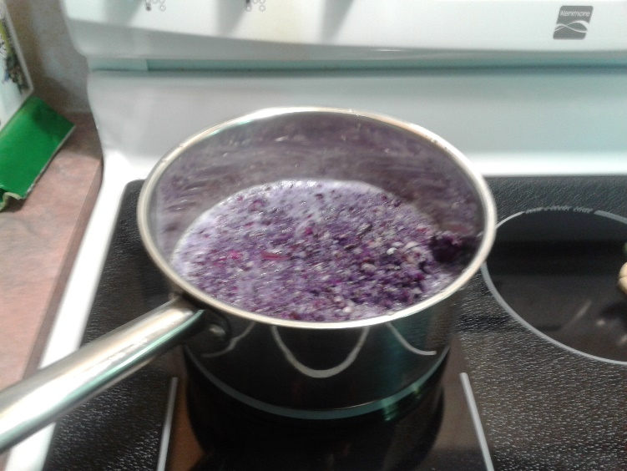from the air, or what I stirred them with.

