MAT 303 Module One Problem Set Report

Multiple Regression

Michael Arellano
Michael.arellano1@snhu.edu
Southern New Hampshire University

Introduction

The dataset that I am exploring in this week’s problem set is data that can be used to study the fuel economy of a car. The dataset contains multiple variables like miles per gallon and quarter mile time that are related with fuel economy and will aid me in my analysis. My results can be used to predict fuel economy and help car makers better understand the factors that are associated with better fuel economy. The type of analysis that I will be running in this problem set is exploratory analysis. Looking over the questions, I see that I am asked to summarize the dataset create visualizations like scatterplots which are all part of an exploratory analysis. Another analysis that I will be using running is correlation analysis, visualizing and analyzing the relationships between variables in the dataset will help get a good idea on what better fuel economy is. Lastly, I will run a predictive analysis and will use multiple regression models to predict fuel economy and identify variables that best explain the variance in fuel economy.

Data Preparation

I have been asked to analyze mpg, hp, and drat. Mpg is the fuel economy in miles per gall, hp is the gross horsepower and it measures the theoretical output of an engine’s power output, and drat is the rear axle ratio which identifies the number of turns of the drive shaft for every one rotation of the wheel axle. A vehicle that has a high ratio would provide more torque. Some other important variables to note are weight, quarter mile time, and the engine volume. There are 32 rows and 12 columns present in the mtcars dataset. My response variable is going to be miles per gallon (mpg) and my predictor variables are going to be rear axle ratio (drat) and horsepower (hp).

Multiple Regression Model

Correlation Analysis

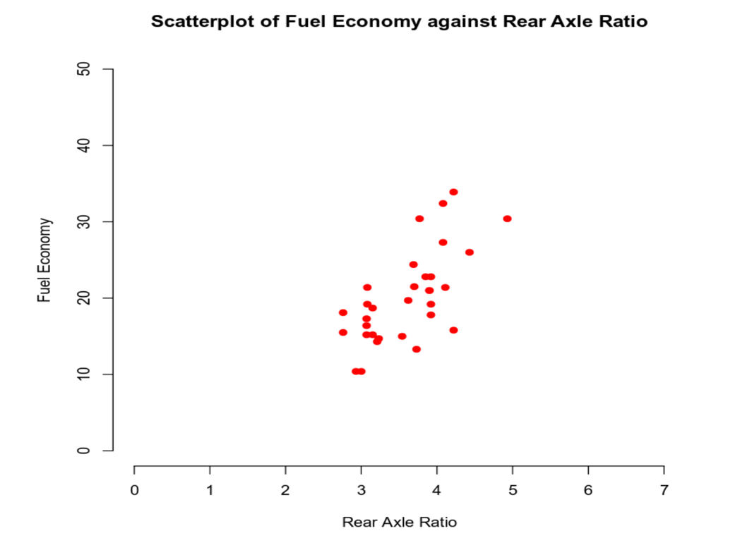
After creating a scatterplot of fuel efficiency (mpg) against rear axle ratio (drat), I can say that as the ratio increases so does the fuel efficiency so there is a positive relationship between the two variables. I noticed that the relationship is not fully linear there seems to be some spread within the data but overall, it does seem to be moving upward. Since I know that vehicles with higher ratios provide more torque, it is safe to assume that vehicles are more fuel efficient with higher torque.

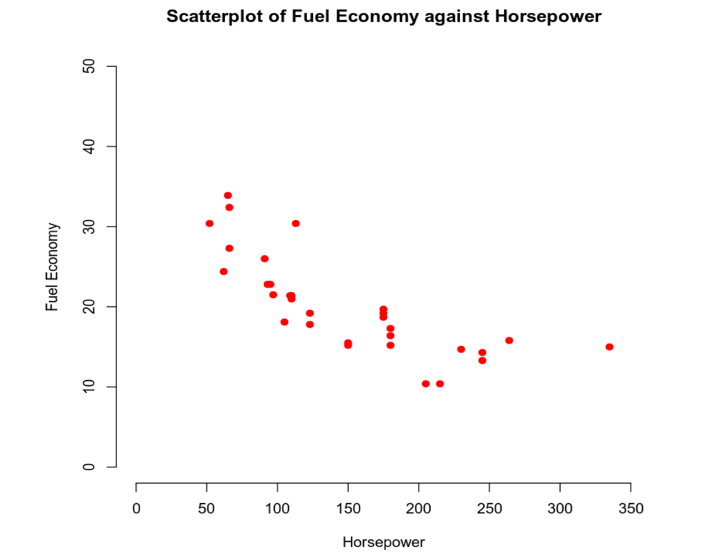

Now looking at the scatterplot I created of fuel efficiency (mpg) against horsepower (hp), I can say that as the horsepower increases the fuel efficiency decreases making it a negative relationship between the two variables. I can clearly see that vehicles with lower horsepower have higher fuel efficiency and unlike the previous scatter plot this one does show a stronger linear relationship. As for the Pearson Correlation Coefficients, the coefficient between fuel efficiency and rear axle ratio is 0.6812. The coefficient for fuel efficiency and horsepower is -0.7762. The strength in the relationship between mpg and drat is somewhat strong but I would not consider it fully strong, as for the relationship between horsepower and mpg I would consider this a strong negative relationship. The coefficients supporting my assumptions of mpg increasing as drat increases and mpg decreasing as hp increases.

Reporting Results

The general form equation of a multiple regression model is $E\left(y\right)=β_{0}+ β_{1}x_{1}+β_{2}x_{2}$.
The prediction regression model equation is $\hat{y}= \hat{β_{0}}+\hat{β_{1}}x_{1}+\hat{β_{2}}x_{2}$. Where $\hat{y}$ is the predicted value of the fuel economy, $x_{1}$ is rear axle ratio, and $x_{2}$ is horsepower.
$\hat{β_{0}}$, $\hat{β_{1}}$, and $\hat{β_{2}}$ are the estimates of $β_{0}$, $β_{1}$, and $β_{2}$.

The prediction model equation after obtaining the outputs from my R script is:
$$\hat{y}= 10.789861 +4.698158X_{1}-0.051787X_{2}$$

The R-squared value is 0.7412 and the adjusted R-squared value is 0.7233. The R-squared value measures the ratio of total variance in the response variable that is explained by the predictor variables. I would interpret these statistics by saying that 74.12% which is relatively strong, of the variance in mpg (fuel efficiency) is explained by the predictor variables drat (rear axle ratio) and hp (horsepower). The adjusted R-squared value tells me that 72.33% of the variance in mpg (fuel efficiency) is explained by the predictor variables after adjusting for the number of predictor variables I used. Since the adjusted R-squared value is only slightly lower than the R-squared, I can conclude that the variables used in the model have a meaningful contribution and are not unnecessary.

Using the prediction model equation above with I outputs plugged in. The beta estimate for rear axle ratio is 4.698158, this means that for every one-unit increase in rear axle ratio the fuel economy increases by 4.698158 assuming that horsepower doesn’t change. As for horsepower, the beta estimate is -0.051787. This means that for every one-unit increase in horsepower the fuel economy decreases by 0.051787 assuming that rear axle ratio doesn’t change.

A fitted value is the predicted value of my response variable produced by my regression model when specific values are plugged into my predictor variables. So, since my regression model is
$\hat{y}= 10.789861 +4.698158X_{1}-0.051787X_{2}$. The fitted value would be the result when I plug in values into $X_{1}$ and $X_{2}.$ A residual is basically the error or the difference between the actual value and the predicted value. So, our predicted value is going to be $\hat{y}$ and the residual is y - $\hat{y}$.

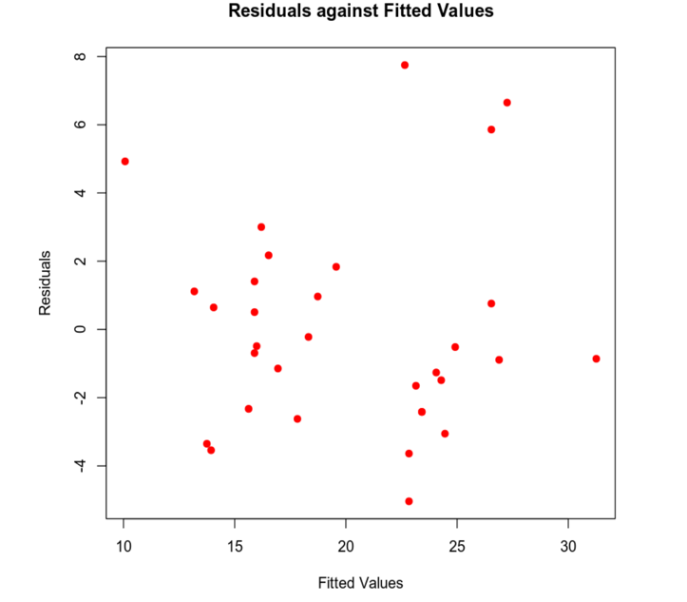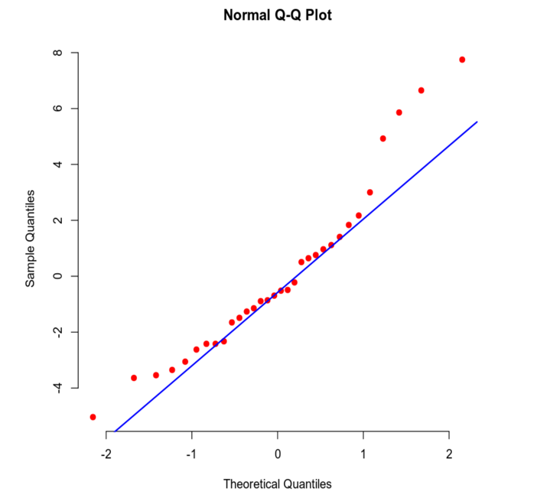

Looking at my scatterplot, I can see that the residuals are randomly scattered with no particular pattern. The main thing to note is that there is no funnel or cone shape in the residuals which means heteroscedasticity. The spread of the residuals looks to be fairly consistent across the fitted values, but the variance does seem to increase at times, so it is safe to assume that the plot suggests a slight violation of homoscedasticity rather than perfect homoscedasticity. As for Q-Q plot, I can clearly see that in the lower and upper tails of the points stray away from the reference line. If residuals are normal than the output should be points falling along with the line. In our plot the points do follow the line, but they start deviating on the lower and upper tails. This suggests that the residuals are roughly normal but there could be outliers.

Evaluating Model Significance

The null hypothesis is that the model is not useful therefore, all slope parameters $β_{1}$, $β_{2}$ are equal to zero. The alternative hypothesis is that at least one of the $β_{i}$ equals zero, for i = 1,2. The F-statistic is 41.52 and the p-value is $3.081 × {10}^{-9}$. $3.081 × {10}^{-9}$ is much smaller than 0.05 so we can reject the null hypothesis. There is strong evidence that at a 5% level of significance the model is significant, meaning that a relationship exists between the response variable and at least one of the predictor variables.

The individual beta test for rear axle ratio starts with the null hypothesis being $β_{drat}=0$ and the alternative hypothesis being $β_{drat}≠0$. From my output I know that the p-value for drat is 0.000467, since this value is less than 0.05 then we can reject the null hypothesis. Rear axle ratio is significant at the 5% significance level. There is strong evidence that shows rear axle ratio has a relationship with the response variable.

The individual beta test for horsepower starts with the null hypothesis being $β_{hp}=0$ and the alternative hypothesis being $β_{hp}≠0$. From my output I know that the p-value for hp is $5.17 × {10}^{-6}$, since this value is less than 0.05 then we can reject the null hypothesis. Horsepower is significant at the 5% significance level. There is strong evidence that horsepower has a relationship with the response variable.

The interval for rear axle ratio is (2.6734, 6.7229), this interval means that the actual effect rear axle ratio has on mpg is between 2.6734 and 6.7229. Identifying that 0 is not in this interval we can conclude that rear axle ratio is significant at a 5% significance level. The interval for horsepower is (−0.0676, −0.0360), this interval means that the actual effect horsepower has on mpg is between -0.0676 and -0.0360. 0 also isn’t present in this interval meaning that horsepower is significant at a 5% significance level. Another way to interpret these intervals is that for one-unit increase in rear axle ratio, mpg increases about between 2.6734 and 6.7229. As for horsepower for one-unit increase of horsepower, mpg decreases about between 0.0360 and 0.0676.

Making Predictions Using the Model

So, if we are assuming that this car achieves an average of 20.5 miles per gallon. If a car has a rear axle ratio of 3.15 and a horsepower of 120, the predicted fuel efficiency in miles per gall is 19.3747. The residual for this observation is $20.5-19.3747=1.1253$. Since the residual is positive this means that the fuel efficiency is about 1.1253 mpg higher than the model predicted.

The 95% prediction interval for the car is (12.6449, 26.1045). What this interval means is that I am 95% confident that the mpg of a single car will fall between 12.6449 and 26.11045. As for the 95% confidence interval, it is almost like the prediction interval. Although, the difference is that instead of looking at a single car we are going to be looking at the average mpg of all cars. So, we are 95% confident that the true average mpg of all cars with the characteristics given to us falls between 17.5716 and 21.1777. The prediction interval is wider than the confidence interval because it considers the uncertainty in estimating the regression mean and the variability of individual outcomes. The confidence interval only considers the uncertainty in estimating the mean.

Conclusion

Based on the analysis that I have performed I would recommend using this model. The regression model used appears to be statistically significant and explain a big portion of the variability in fuel efficiency. When using a 5% significance level I can see that the p-value of $3.081 × {10}^{-9}$ is much less than 0.05, meaning that the model is significant. I now know that one of the predictor variables either rear axle ratio or horsepower has a relationship with fuel economy. I can also look at other statistics to support my conclusion and look at the R-squared value and adjusted R-squared value. Since the R-squared value is 0.7412 I know that 74.12% of the variability in miles per gallon is explained by the predictor variables rear axle ratio and horsepower. Considering the number of variables we used, we can look at our adjusted R-squared value and see that it is 0.7233 or 72.33% of the variability in miles per gallon when adjusted. Since the percentage changes very little, I concluded that the variables used in the model have a meaningful contribution. Lastly, I also conducted individual beta tests for both my predictor values and identified them as significant at the 5% significance level. Rear axle ratio had a p-value of 0.000467 and horsepower had a p-value of $5.17 × {10}^{-6}$, considering that these values are both less than 0.05 they are statistically significant. Diving deeper and looking at the confidence intervals of each variable, both intervals do not include zero further supporting the conclusion that these variables have meaningful relationships with the response variable.

The prediction regression equation used is:

$$\hat{y}= 10.789861 +4.698158X_{1}-0.051787X_{2}$$

What this equation means is that for every one-unit increase in rear axle ratio the fuel economy has an average increase of approximately 4.698158 miles per gallon, assuming that horsepower doesn’t change. It also tells me that for every one-unit increase in horsepower the fuel economy has an average decrease of approximately 0.051787 miles per gallon, assuming that rear axle ratio doesn’t change. The model can be used to make predictions of fuel efficiency for cars with specific values for rear axle ratio and horsepower in mind. For example, a car with a rear axle ratio of 3.15 and horsepower of 120 has a predicted fuel efficiency of approximately 19.37 miles per gallon. When analyzing Homoscedasticity, when the variance of residuals is constant, I created a scatterplot of residuals against fitted values that supported me in determining if the residuals have a constant variance across the fitted values. There is no clear funnel or cone shape within the residuals which would suggest heteroscedasticity, which is the variance of residuals is either increasing or decreasing. The plot shows that the variance does increase slightly rather than remaining perfectly constant so I would not consider this a complete violation but rather a mild violation. As for the Q-Q plot analyzed, if residuals are normally distributed then the points should be very close to the line, in the plot you can clearly see that the points are lie close to the line in the central area but deviate towards the lower and upper tails. This could possibly be due to outliers and means that the residuals are roughly normally distributed but could include outliers.

The practical importance of the analyses that were performed is to understand and predict fuel efficiency in vehicles. I identified rear axle ratio and horsepower as significant predictor values of fuel efficiency, meaning that this model is a useful tool in determining what mechanical characteristics influence the miles per gall of a car. For car makers and businesses, these insights can be used to improve fuel efficiency in specific car models but also predict what the fuel efficiency could be based on their mechanical characteristics. Car makers will have support when dealing with design choices and aid consumers when comparing vehicles. In conclusion, the regression analysis conducted helps evaluate the relationship between fuel economy and vehicle characteristics like rear axle ratio and horsepower, allowing for car makers and manufacturers to implement data-driven decision making in their design process.

